Sexual violence or harassment
between children

Protocols

This exemplar should be modified to fit the circumstances of your school and should be linked to your Safeguarding Policy and other relevant policies.
March 2019

Contents

Part 1: Protocols
1.1 Introduction and aims | Page 2
1.2 Definitions | Page 2
1.3 School initial action flow chart | Page 3
1.4 Involving other agencies
1.5 Planning and recording | Page 4
1.6 Ongoing school actions
1.7 Further advice and references | Page 7
Part 2: Resources
2.1 Initial response record | Page 8
2.2 Brook traffic light tool | Page 10
2.3 Risk Assessment | Page 14
2.4 Serious incident chronology | Page 20
2.5 Ongoing support record - victim | Page 22
2.6 Ongoing support record – alleged perpetrator | Page 24

Sexual violence or harassment between children

Part 1: Protocols

  - Introduction and aims

Sexual violence and sexual harassment are not acceptable and will not be tolerated. Especially important is not to pass off any sexual violence or harassment as ‘banter’, ‘part of growing up’ or ‘having a laugh’. The following is based on advice given in the document Sexual violence and sexual harassment between children in schools and colleges, advice for governing bodies, proprietors, headteachers, principals, senior leadership teams and designated safeguarding leads (DfE, May 2018). This protocol aims to provide a framework for a consistent, confident response to alleged incidents of sexual harassment or violence between children. It will be followed by senior staff in the event that an allegation of sexual violence or sexual harassment between students is brought to the attention of the school. Allegations will be investigated and actions taken separately from any investigations or actions taken by outside agencies, such as social care or the police.

  - Definitions

The above government guidance defines sexual violence as:
- Rape
- Assault by penetration
- Sexual assault

The guidance defines sexual harassment as:
- Sexual comments
- Sexual ‘jokes’ or taunting’
- Physical behaviour
- Online sexual harassment

It further notes that:
- A child under the age or 13 can never consent to sexual activity
- The age of consent is 16
- Creating and sharing sexual images is illegal

  - School initial action flow chart

Disclosure is made
The victim should be reassured. Confidentiality must not be promised. The allegation must be immediately reported to the DSL (or deputy) and an Initial Response Record started.

Alleged perpetrator(s)
The DSL will make an immediate Risk Assessment and take action to ensure the safety of the victim, perpetrator, other students and staff. The Brook Traffic Light Tool appropriate to the age or stage of the alleged perpetrator should be referred to when assessing risk and need. This may include the immediate isolation of the alleged perpetrator(s).
Staff receiving disclosure
Staff must be given the time and space to write their account of the disclosure as soon as is practicable. They must be advised to write in detail and to indicate where they have used the student’s words verbatim. This should be recorded on a Staff Statement Form.
Victim(s)
Immediate provision must be made for their physical and emotional safety. This may include being removed from lessons and offered a safe space in school. They should then be given the opportunity to write a statement (or to explain their allegation to a trusted adult of their choosing who will keep a record) using a Student Statement Form. This may need to take place later in the presence of a family member.

Decision to involve other agencies
The DSL (or deputy) will collate all documents and create a Serious Incident Chronology to record all interactions and investigations. The DSL (or deputy) will discuss the allegations with the Headteacher or other suitably qualified member of SLT. A decision will be made as to whether the allegation can properly be managed internally or whether other agencies should be involved. Guidance on decision making is given below and further details can be found in Sexual violence and sexual harassment between children in schools and colleges, advice.

Staff receiving disclosure
The DSL or deputy will discuss the written statement given by the member of staff to ensure clarity. Support and guidance will be offered to the member of staff, including a named member of SLT for ongoing support if necessary.
Alleged perpetrator(s)
Arrangements will be made for families to be notified of the allegation. Safety and support advice will be given to families and a member of SLT will be assigned as their main contact. A record will be kept on the Ongoing Support Record.
Victim(s)
Arrangements will be made for families to be notified of the allegation. Safety and support advice will be given to families and a member of SLT will be assigned as their main contact. A record will be kept on the Ongoing Support Record.

Next steps
The DSL will lead on planning, to include:
- Appropriate support for the victim(s) and staff and appropriate support and sanctions for the perpetrator(s).
- Ongoing risk assessment and control measures.
- Investigation of the allegation and decisions on next steps.

Decisions to involve other agencies
  - Involving other agencies

An allegation may properly be managed internally if it:
- Is a one-off incident
- Does not constitute a criminal offence
- The children involved are not considered to need early help and intervention
- It is considered that the allegation can properly be managed through the school’s Behaviour Policy.

Consideration must be given to involving the following agencies and decisions taken on involvement must be recorded. In the case of a decision not to involve an agency, the reason for this decision must be recorded.

Health - Appropriate medical care should be given or summoned if a child has been physically injured or is unwell.
Social care - If a child has been seriously harmed, is in immediate danger, or is at risk of harm a referral must be made to children’s social care.
Police - Where there is a report of activity which is an offence, a report must be made immediately to the police.

  - Planning and recording

The management of an allegation of sexual violence or sexual harassment should be carefully considered, planned and recorded. Records will include the following:

- Brook Traffic Light Tool (2.2) – annotated
- Student and staff statements – staff taking statements should write their own statement of each meeting with a child in which they give information about the incident.
- Sexual violence or harassment between children - Initial Response Record (2.1)
- Serious incident chronology (2.4)
- Risk Assessment (2.3)
- Sexual violence or harassment between children – Ongoing Support Record – Victim (2.5) and Ongoing Support Record – Alleged Perpetrator (2.6)

Planning and decision making will take account of Keeping Children Safe in Education (DfE, September 2018), Working together to Safeguard Children (DfE, July 2018) and Sexual violence and sexual harassment between children in schools and colleges (DfE, May 2018) and other relevant advice and guidance, including that on behaviour, discipline and exclusion from school.

  - Ongoing school actions

Initial accounts
The member of staff taking the initial disclosure must record it in as much detail as possible as soon as is practicable, indicating where the students’ own words are recorded.

Risk Assessment
A Risk Assessment should be carried out with a view to taking immediate action to safeguard the victim(s), perpetrator(s), other students and staff. The risk assessment must be regularly reviewed an amended if necessary as more information is received. The Brook Traffic Light tool should be used to determine the level of risk. Short term plans will be put in place to manage risk and to support all students involved, which may necessitate alternative arrangements being made for the education of students involved.

Determining the nature of the incident
All allegations of sexual assault or sexual abuse will be fully investigated following normal school procedures. This includes the taking of witness statements, checking for potential CCTV and the chance for those involved to give a full account, before a judgement is made about what the evidence indicates has taken place.

Interviewing victims
It is essential that all victims are reassured that they are being taken seriously and that they will be supported and kept safe. There is likely to be a need for further interview of the victim(s). A child is likely to disclose information to someone they trust and should be asked for their preference on a member of staff to interview them or to be part of an interview. Wherever possible, two members of staff should be involved in an interview with one most likely to be the DSL. An accurate record must be kept of any interviews.

Interviewing alleged perpetrators
The school must remain mindful of the duty of care to alleged perpetrators. As a matter of effective safeguarding practice, schools and colleges should do all they reasonably can to protect the anonymity of any children involved in any report of sexual violence or sexual harassment. Amongst other things, this will mean carefully considering, based on the nature of the report, which staff should know about the report and any support that will be put in place for the children involved. Alleged perpetrators should also be interviewed with two members of staff present and an accurate record kept. Consideration must be given to the fact that abusing another child can be an indication that the perpetrator has themselves been abused.

Parents and carers
The parents / carers of students involved will be informed as soon as is practicable as long as this does not put the child at additional risk. The parents / carers will be involved as appropriate throughout the investigation process.

Actions
A decision on actions to be taken by the school will be taken in line with the published Behaviour Policy and the Safeguarding Policy as well as other school policies as necessary. The reasons for decisions made will be recorded. Where a report has been made to the police and / or to social care, the school will work with these agencies to determine necessary actions to safeguard students and in response to the incident.

Ongoing support
The school will plan for ongoing support for the victim(s) and alleged perpetrator(s) as necessary and will appoint a member of SLT or the pastoral team to oversee this and to be the main contact with the student and their family. It is important that the child and their family are given the opportunity to shape the nature of any ongoing support.
Consideration will be given to:
- Ongoing interactions in school including in class and in other areas
- Potential interactions outside of school
- Confidentiality and students sharing information with other students
- Repercussions following any sanctions
- The particular needs of the children involved
- Early Help
- Counselling or other support
- Health
- Support from SAFE or statutory services

  - Further advice and references

Professionals

Government Guidance: Sexual violence and sexual harassment between children in schools and colleges (DfE, May 2018)

NSPCC - Harmful Sexual Behaviour: https://www.nspcc.org.uk/preventing-abuse/child-abuse-and-neglect/harmful-sexual-behaviour/

NSPCC audit tool: https://learning.nspcc.org.uk/research-resources/2016/harmful-sexual-behaviour-framework

NSPCC helpline 0808 800 5000, help@nspcc.org.uk.

Peer on Peer abuse toolkit: https://www.farrer.co.uk/globalassets/news-articles/downloads/peer-on-peer-abuse-toolkit-14.pdf

Victims

Rape Crisis: www.rapecrisis.org.uk

The Survivors Trust: www.thesurvivorstrust.org

Childline: https://www.childline.org.uk/ 0800 1111

Families

ThinkUKnowwww.thinkuknow.co.uk/parents/articles/Challenging-harmful-sexual-attitudes/

Sexual violence or harassment between children

Part 2: Resources

2.1
Sexual violence or harassment between children
Initial response record

Details of disclosure
Name of student(s) making disclosure
Disclosure made to |  | Date of disclosure
Time |  | Location
Other adults present |  | Other students present
Summary of disclosure
Full statements must be written by all staff and students involved at the earliest appropriate opportunity

Initial action taken (To include the student(s) making the disclosure and the subject(s) of the disclosure)
Student | Action taken | By whom

Professionals involved
Professional / agency | Notified? | Reason | Method | Date | Time | Notified by
D.S.L.
Headteacher
Police
Social Care
Health

Notification to families
Student name | Notified via | Date of notification | Time of notification | Notified by

Record completed by
Signature
Date

2.2
Student name: ___________________________________________________________________
Reason for selection: Chronological age / Developmental stage
Completed by: ______________________________________ Date: _______________________

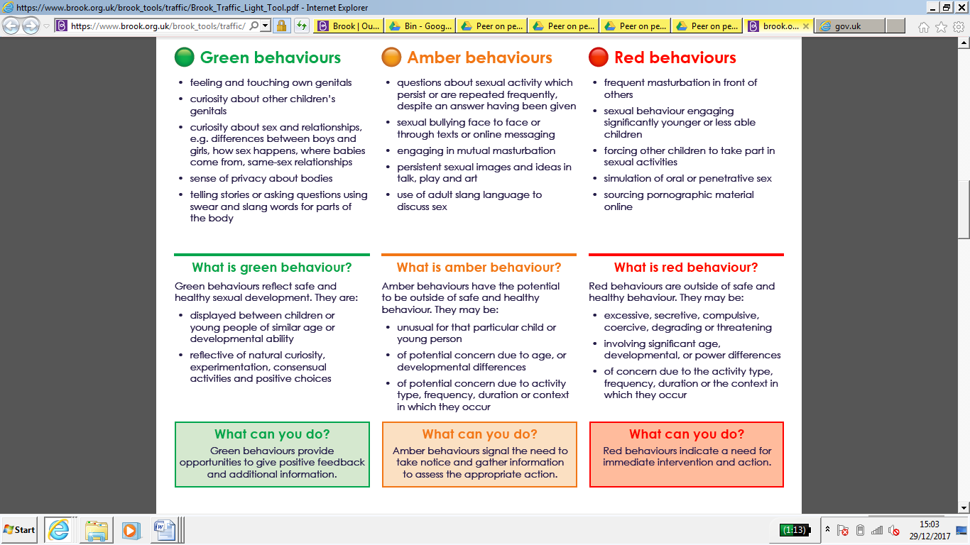

Student name: ___________________________________________________________________
Reason for selection: Chronological age / Developmental stage
Completed by: ______________________________________ Date: _______________________

Student name: ___________________________________________________________________
Reason for selection: Chronological age / Developmental stage
Completed by: ______________________________________ Date: _______________________

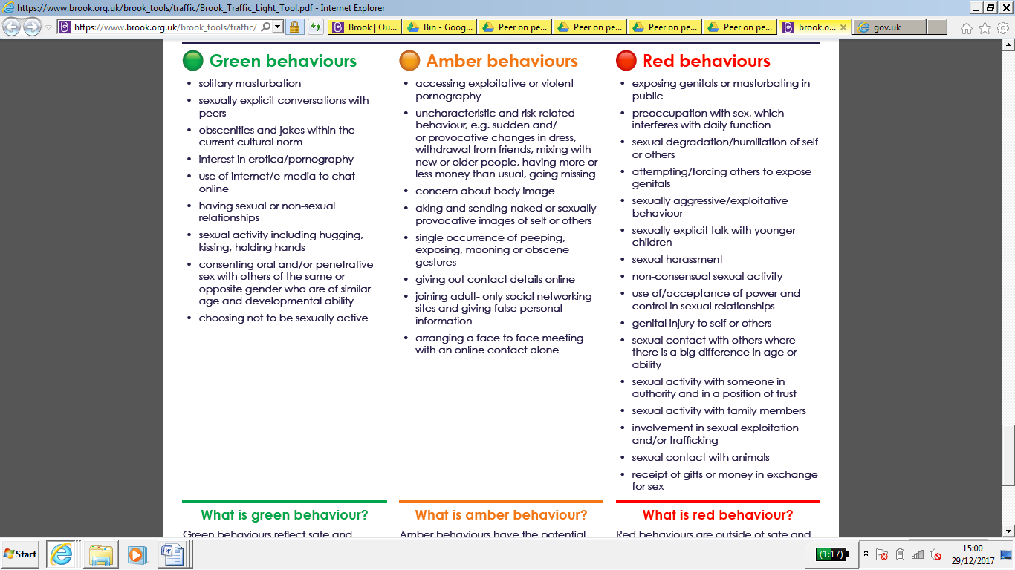
2.3
2.3
Individual student risk assessment – peer on peer abuse

Name(s) | Names of all students involved should be added here unless it is deemed appropriate to do a separate risk assessment for each student involved. | D.O.B.
Reason for risk assessment | Brief summary of allegation
Has violence been used or threatened? | Yes or no and with brief details
What kind of harm has been threatened or sustained previously? | Details of alleged incident triggering risk assessment
Is there a pattern of behaviour / risk? | Records (SIMs, confidential file) should be checked or any previous incidents which could indicate a pattern
Is there evidence to suggest it will be repeated or that there has been increase of risk? | Consideration should be given to the nature of the alleged incident and all students’ reactions to it. Increased risk could refer to risk of repeated or worsening incidents or to emotional risk through students involved being in contact with each other
Is there evidence to suggest premeditation? | Yes or no with brief details
Professionals / other adults involved and roles | Name, role and agency involved in the risk assessment – either directly or through their advice or opinions being taken into account - should be recorded here.
Intended outcome of risk assessment | This will include safe management of risk and should say whether the intention is for all parties to remain in school / classes or will be educated elsewhere.

Individual or group at risk | Nature of risk | Protective factors / controls normally in place | Risk rating ( severity x likelihood = risk) | Controls / actions needed | Modified risk rating ( severity x likelihood = risk)
Victim | Physical – risk of repeated assault or harassment  Physical – risk of retaliation by friends / family of perpetrator  Emotional – impact of assault or harassment  Emotional –aggravation of pre-existing physical or mental health concerns  Emotional – impact of ongoing investigation especially by outside agencies  Online – risk of harassment via social media | Staff and students adhering to Behaviour for Learning Policy  Staff and students adhering to Behaviour for Learning Policy  Support available from pastoral team  Support available from pastoral team and medical support  Support available from pastoral team  Support available from pastoral team | 4 x 3 = 12  4 x 3 = 12  4 x 5 = 20  4 x 5 = 20  4 x 4 = 16  4 x 3 = 12 | Consideration of isolation or exclusion of perpetrator  Action taken to ensure wider knowledge of incident is understood and students are clear about expectations. Ongoing need to consider isolation or exclusion for others  Named person for support, support plan agreed with victim and family. Consideration of support being sought from other agencies. Advice and guidance given to family  Named person for support, support plan agreed with victim and family. Consideration of support being sought from other agencies. Advice and guidance given to family  Named person for support, support plan agreed with victim and family. Consideration of support being sought from other agencies. Advice and guidance given to family  Named person for support, support plan agreed with victim and family. Consideration of support being sought from other agencies. Advice and guidance given to family  Action taken to ensure wider knowledge of incident is understood and students are clear about expectations. Ongoing need to consider isolation or exclusion for others | 4 x 1 = 4  4 x 2 = 8  3 x 4 = 12  3 x 4 = 12  3 x 4 = 12  4 x 2 = 8
Alleged perpetrator | Physical – risk of retaliation by friends / family of victim  Emotional – impact of alleged incident  Emotional –aggravation of pre-existing physical or mental health concerns  Emotional – impact of ongoing investigation especially by outside agencies  Online – risk of harassment via social media  Media –risk of incident being reported in the media | Staff and students adhering to Behaviour for Learning Policy  Support available from pastoral team  Support available from pastoral team and medical support  Support available from pastoral team  Support available from pastoral team  Support available from pastoral team | 4 x 3 = 12  4 x 5 = 20  4 x 4 = 16  4 x 3 = 12  4 x 2 = 8  4 x 2 = 8 | Action taken to ensure wider knowledge of incident is understood and students are clear about expectations. Ongoing need to consider isolation or exclusion for others  Named person for support, support plan agreed with perpetrator and family. Consideration of support being sought from other agencies. Advice and guidance given to family  Named person for support, support plan agreed with perpetrator and family. Consideration of support being sought from other agencies. Advice and guidance given to family  Named person for support, support plan agreed with victim and family. Consideration of support being sought from other agencies. Advice and guidance given to family  Action taken to ensure wider knowledge of incident is understood and students are clear about expectations. Ongoing need to consider isolation or exclusion  Action taken to ensure wider knowledge of incident is understood and students are clear about expectations. No comment made to press | 4 x 2 = 8  3 x 4 = 12  3 x 4 = 12  3 x 4 = 12  4 x 2 = 8  3 x 2 = 6
Other students | Physical – risk of assault or harassment  Emotional – impact of assault or harassment on friend / wider community  Emotional – impact of ongoing investigation especially by outside agencies  Online – risk of being a victim or perpetrator of harassment via social media | Staff and students adhering to Behaviour Policy  Support available from pastoral team  Support available from pastoral team  Support available from pastoral team and year teams | 4 x 3 = 12  4 x 3 = 12  4 x 5 = 20  4 x 4 = 16 | Consideration of isolation or exclusion of perpetrator  Action taken to ensure wider knowledge of incident is understood and students are clear about expectations. Ongoing need to consider isolation or exclusion for others  Action taken to ensure wider knowledge of incident is understood and students are clear about expectations. Watching brief of anyone affected  Action taken to ensure wider knowledge of incident is understood and students are clear about expectations. Watching brief of anyone affected. Ongoing need to consider isolation or exclusion for others | 4 x 1 = 4  4 x 2 = 8  3 x 4 = 12  3 x 4 = 12
Staff | Physical – risk of assault or harassment  Emotional – impact of receiving disclosure for staff involved including consideration of possible impact on pre-existing physical or mental health concerns  Emotional – impact of assault or harassment on wider community  Emotional – impact of ongoing investigation especially by outside agencies | Staff and students adhering to Behaviour for Learning Policy  Support available from DSL and SLT line manager  Support available from DSL and SLT line manager  Support available from DSL and SLT line manager | 4 x 3 = 12  4 x 3 = 12  4 x 3 = 12  4 x 3 = 12 | Consideration of isolation or exclusion of perpetrator  Regular support offered as required. Consideration of involvement of support from other agencies as necessary.  Regular support offered as required. Consideration of involvement of support from other agencies as necessary.  Regular support offered as required. Consideration of involvement of support from other agencies as necessary. | 4 x 1 = 4  3 x 2 = 6  3 x 2 = 6  3 x 2 = 6

 | Likelihood
Severity | Not likely (1) | Unlikely (2) | Possible (3) | Likely (4) | Highly likely (5)
Fatality (5) | 5 | 10 | 15 | 20 | 25
Major injury / harm (4) | 4 | 8 | 12 | 16 | 20
Moderate injury / harm (3) | 3 | 6 | 9 | 12 | 15
Minor injury / harm (2) | 2 | 4 | 6 | 8 | 10
No injury / harm (1) | 1 | 2 | 3 | 4 | 5

Overall risk rating
1 - 2 | 3 - 7 | 8 - 11 | 12 - 14 | 15 - 25
No risk | Minimal risk | Moderate risk | Serious risk | Major risk

Risk assessment completed by:

Signed: Name:

Role: Date:

Staff / other professionals consulted:

Proposed action, with controls as detailed above, can / cannot proceed.

Signed: Name:

Role: Date:

2.4
Serious Incident Chronology – peer on peer abuse

Date of incident
Location of incident
Brief summary of incident
Victim(s)
Alleged perpetrator(s)
Student witnesses
Staff witnesses
Lead member of staff investigating
Lead staff contact – victim(s)
Lead staff contact – perpetrator(s)
Other staff involved
Other professionals – victim(s)
Other professionals – alleged perpetrator(s)

This log must be stored securely along with any other documents and statements. A copy of the Peer on Peer Abuse Protocols, annotated to show actions taken, will also be included.

Date & time | Detail | Action | Resp. | Doc. ref. | Recorded by

2.5
Sexual violence or harassment between children
Ongoing support record – victim

Details of disclosure
Name of student
Assigned staff contact |  | Date of disclosure
Summary of disclosure

Student details
Vulnerability | Y / N? | Detail
S.E.N.D.
Medical
Emotional
Family
Peer group
Professionals involved
Professional / agency | Inv’d? | Contact name | Telephone / Email
D.S.L.
Headteacher
Police
Social Care
Health
CAMHS

Support plan
Area of need | Support plan | Lead professional | School contact (if applicable) | Date | Initials

2.6
Sexual violence or harassment between children
Ongoing support record – alleged perpetrator

Details of disclosure
Name of student
Assigned staff contact |  | Date of disclosure
Summary of disclosure

Student details
Vulnerability | Y / N? | Detail
S.E.N.D.
Medical
Emotional
Family
Peer group
Professionals involved
Professional / agency | Inv’d? | Contact name | Telephone / Email
D.S.L.
Headteacher
Police
Social Care
Health
CAMHS

Support plan
Area of need | Support plan | Lead professional | School contact (if applicable) | Date | Initials

