Advice for schools:

Transition and back to school during COVID 19

  - Ealing Educational Psychology Service
  - May 2020

Contents
Why is transition, and in particular ‘this transition’ important? 3
Key principles of a ‘good’ transition 4
What can we do to support children upon their return to school? 7
Psychosocial care 9
Psychological theories and principles underpinning guidance 9
Attachment 11
Nurture approach principles 13
Emotion Coaching 14
Resilience 15
Mindfulness 16
PACE Model 16
Identification of specific cohorts and groups to be considered 17
a) Transition to High School 17
b) Transition of Children from Nursery into School 17
c) Vulnerable Children 17
Identification of Vulnerable Individuals 18
Advice for Parents 18
For All Parents / Carers 19
Guidance for Schools 20
Table of provision 22
References 27
Appendixes 28
Appendix 1: Websites 28
Appendix 2: Additional Considerations 29
Appendix 3: Examples of whole school approaches to reintegration following community wide trauma 32
Appendix 4: The little elf and the flowers of hope and bravery 34
Appendix 5: The Little Elf who missed his birthday party 40
Appendix 6: ELSA wellbeing questionnaire- back to school 45
Appendix 7: ELSA back to school after COVID story 48

Introduction
Research suggests that many children and young people can find transition unsettling and stressful. Following the current Public Health Crisis (Covid-19) it is likely that many children and young people will experience similar feelings when they return to school once social isolation ends. The purpose of this guidance is, therefore, to provide advice on how schools can support all their children and young people in managing this transition.
At the time of writing this document, advice and guidance from the government, as to when schools are likely to return and as to what this return may look like for pupils, staff and parents had recently become available and schools are working hard to ready themselves. This document therefore aims to outline the psychological approaches and key principles that can be flexibly applied by schools to their own timescales and the measures governing their returns.

Why is transition, and in particular ‘this transition’ important?
It is important that we support our children and young people to experience successful transitions back to school, recognising that transition is a process and not a single event. We know that an individual’s experiences during this time can have a powerful and long-lasting effect on academic outcomes, as well as impacting on their self-esteem and emotional wellbeing.
During a period of transition children and young people can experience:
- A loss of attachment to familiar people, friends, the environment and objects within that environment
- Role and identity uncertainty
- Entry into an environment that is less predictable
- A perceived loss of control
- A feeling of being de-skilled and less valued
- Uncertainty about the future

In addition, we must acknowledge the ongoing thoughts and worries about safety and health at this unprecedented time.

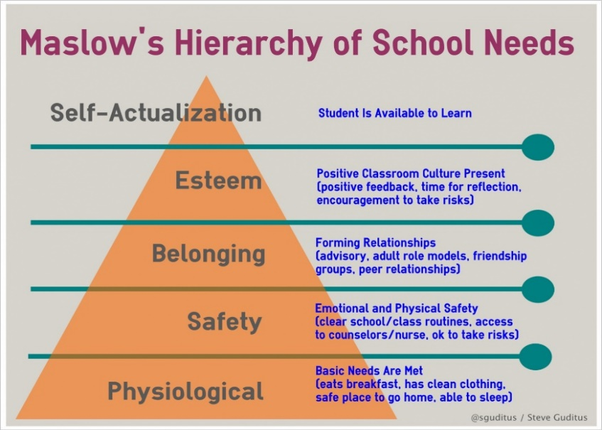
If we consider this in light of Maslow’s hierarchy of needs, and how they apply to a school, then we need to acknowledge that availability for learning and achieving potential can only happen if other foundation layers are in place. Preoccupation with safety will potentially have an adverse effect on learning and achievement.
Image from: http://sguditus.blogspot.com/2013/02/maslows-hierarchy-of-school-needs-steve.html

We also need to acknowledge that the common thread that runs through the current lived experiences of our children, is loss – loss of structure, loss of certain freedoms and opportunities, loss of friendships and social interactions and for some, loss of family members or loved ones.
These losses can trigger the emergence of anxiety, trauma and bereavement in any child. The overall impact cannot be underestimated. It may cause an erosion of the mental health of our children. As such it would be naive of anyone to think that the child will pick up the curriculum at exactly the same point at which they left it on the day their school closed. Too much has happened. Compassion, empathy and listening at this time will therefore be crucial.
(Carpenter B & Carpenter M. 2020).

Key principles of a ‘good’ transition

Whilst the current circumstances are unprecedented, schools are skilled in planning and preparing for transitions on a regular basis. The key principles of successful transitions still apply to the present situations (whether children are returning to the same class / setting before the end of the academic year or entering a new class / setting) although the means of executing transition processes may need to look different. It is worth noting therefore, that as well as the children and young people who are transitioning to a new environment, schools should also consider every pupil as a new pupil due to the amount of time that they have been absent.
Effective transitions are supported by:
- Advance planning and preparation
- Clear processes for communication
- Consideration of relationships

In these unprecedented times, it is useful to also consider the following principles:

- Everything is uncertain at this moment – that’s ok. It is okay not to have all the answers, or a concrete plan.
- Everything is NOT normal. Expectations (and wishes) of returning to normality are likely to be high (for pupils, staff and parents) – this will need to be managed.
- Relationships are key.
- Many are operating with diminished resources/staffing. Everyone is doing the best they can.
- Children and staff need to feel safe. Feeling safe is a prerequisite to being able to learn (see e.g. Maslow’s Hierarchy of Need).
- Everyone will have their own experiences / stories from lockdown. All experiences and feelings are valid and will need space and time to be processed and shared.
- Some people will be more affected than others. These may not be the people you expect.
- The same principles can be applied to all pupils.
- Make written information as accessible as possible. Families may not have access to usual sources of support such as family workers or extended family members to help with reading letters and filling informs. The same also applies to families with English as an additional language – access to translators may be more complicated
The practices to support these principles are further detailed in the Ealing transition guidance documents available at:
www.egfl.org.uk/transition-high-schools
www.egfl.org.uk/transition-early-years
Examples of good transition practices could be:
- Communication between staff and settings to find out about the pupils. This should not solely be for the purpose of sharing academic attainment but also involve personal information that is needed – such as good at sports, lost a parent, particular interest in dinosaurs etc.
- Communication about specific experiences linked to the COVID-19 outbreak, such as the loss or serious illness of close family members or friends, time in hospital, etc
- Children and young people to be involved as much as possible so they too can share their likes and dislikes. Examples could include completion of an ‘All about me’ activity.
- Communication with parents/carers, not only to find out additional information but to allow parents/carers to raise any concerns about recent events or ask questions.
- Schools to think how they can use technology to aid transition if it is not possible for children and young people to directly access settings. This could be in the form of virtual tours, question and answer sessions etc.
- Visual resources to be produced that can be accessed online, such as examples of lunch menus, what the uniform looks like, typical timetable etc.
*With thanks to guidance from Cornwall Council and Wakefield EPS which this section has been adapted from*

What can we do to support children upon their return to school?
It is important to recognise that for many children, going back to school will be a welcome return. However, for some children, this will be a time of anxiety. It is important to remember that each child will have had their own experience. Whilst there has been discussion in educational and psychological circles about the need for ‘trauma informed practices,’ it is essential to highlight that trauma is a response not an event. All staff, children and families have experienced the impact of COVID 19 on our lives; but not everyone will present with trauma. Therefore, a wide spectrum of emotional needs and responses should be expected. It seems likely though that although there will be range of responses, the unprecedented disruption to normal life will have had psychological consequences, not too dissimilar from community trauma. Although there is no direct material regarding the experience of pandemics yet publicly available and it is unclear what the extent of the emotional impact of the pandemic will be, early anecdotal reports suggest it is likely to be significant.
In view of all this, it is therefore important to recognize that it will take time for children to re-establish and re-learn routines and expectations in schools. It will be important to respond to what children have learnt, not what we expect them to have learnt, and what they may have forgotten. It could well be over-whelming and frightening to be amongst groups of children and adults, especially given the concentrated time spent in the home environment because of ‘lock down’. Children will have become used to being with their parents and immediate family for an extended period. Leaving parents and immediate family to return to school could therefore be a potential source of anxiety for some children.
As mentioned, we know that transition is a process and not an event. Recent research from The Sutton Trust (April 2020) reports that only 45% of students had communicated with the teachers in the past week. Further research from Oxford University (The Guardian, April 2020) states that a fifth of primary aged school children are afraid to leave the house, where older children are more concerned with their health and that of their families, reporting that two fifths of young people are worried that their friends or family will catch the virus and one fifth worried about catching it themselves.
Teachers and other adults who listen with empathy perform an important therapeutic function, without being therapists. Teaching is, after all, a relationship-based profession. Some children may be carrying a large emotional burden and school might be their only place to talk about this.
Therefore, a number of key psychological principles can be applied when thinking about how to support all pupils upon their return to school.
*With thanks to guidance from Wakefield EPS and a City & Hackney Alliance MHST document which this section has been adapted from*

Psychosocial care

Research has identified five key principles that support recovery following a disaster or serious incident. These principles will be important to consider when supporting members of staff, children and young people upon their return to school ((Hobfoll, S. et al 2007).
The five principles are:
- A sense of safety: It is important that adults, children and young people feel safe upon their return to school.
- A sense of calm: Children and young people are likely to experience a range of emotions including both pleasant and unpleasant emotions. It is important that these are normalised and they are given support to help them manage their emotions and return to a state of calm.
- A sense of self- and collective- efficacy: Children need to feel they have some control over what is happening to them, and a belief that their actions are likely to lead to generally positive outcomes. They need to feel they belong to a group that is likely to experience positive outcomes. This is known as collective efficacy.
- Social connectedness: It is important that adults, children and young people feel they belong and have a social network who can support them within the educational setting.
- Promoting hope: Whilst things may feel difficult at the moment, it is important that adults, children and young people feel things will get better and work out in future. They need to be provided with reassurance and understand that in the long term they will feel positive again.

*With thanks to guidance from Wakefield EPS, Northamptonshire EPS and the Microsoft Teams national working party of Educational Psychologists/Education Professionals which this section has been adapted from*

Psychological theories and principles underpinning guidance

This information is included, in order to explain the psychological theories that you could draw upon when welcoming children and young people back into schools/settings. It is included to share the theoretical frameworks underpinning recommendations, for your reference. As stated, teaching is a relationship-based profession, and in keeping with this we have therefore drawn on relational theories where appropriate.

Attachment
The principles of attachment (relationships with others) are key in thinking about and supporting transition. For some children and young people, they have healthy and secure attachments with their parents/caregivers, meaning that they might have no/little issue separating from parents to return to school, despite being in their care for an extended period of time. We know that transition can prove to be difficult, even when children have secure and stable ‘backgrounds’, reinforcing the need to use attachment informed principles, universally, for all students. Additionally, the uncertainly of the coronavirus and the impact that this has had, such as routines being disrupted and/or family members being ill, may cause anxiety for children upon their return to school. An attachment (emotional/relational) informed approach will also ensure that provision is appropriate for those children whose attachments may have been ‘disrupted’, so are not secure.
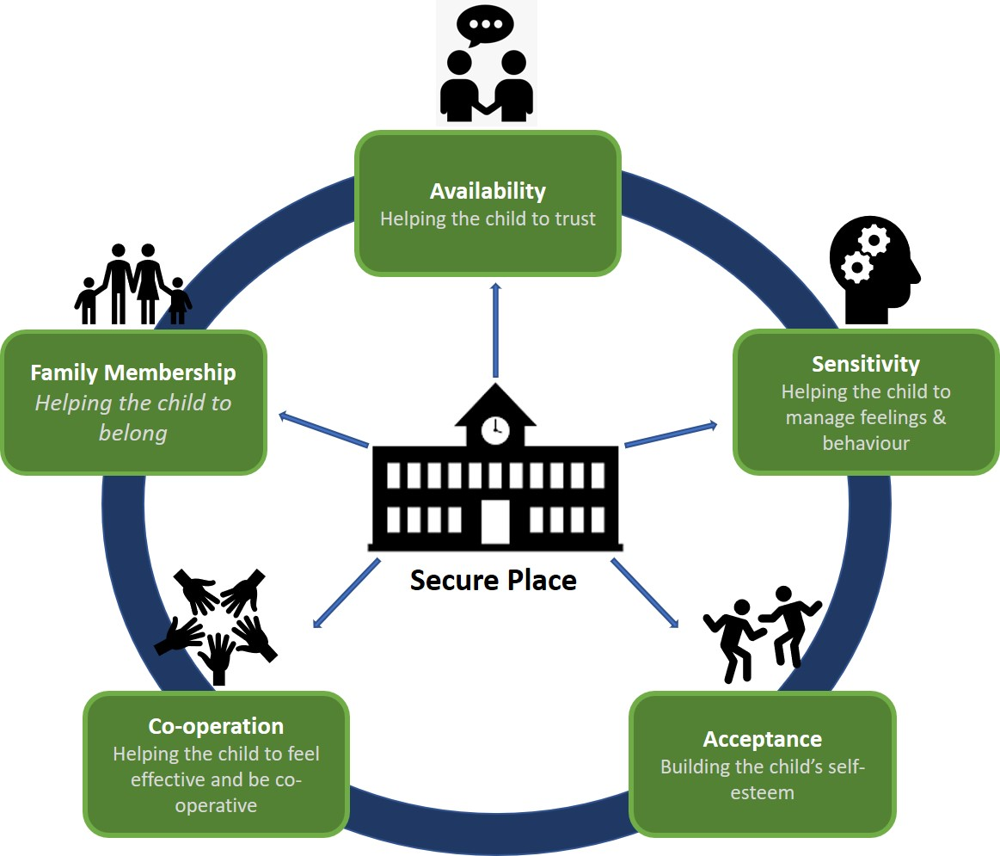
It is important that relationships with staff are also re-established for all children. The school setting, as well as the adults that care for children and young people, need to be safe and secure bases, in order for them to be emotionally able and ready to learn. The following diagram demonstrates the importance of schools being a safe base and how this can be achieved:
Children need experiences of being and feeling calm; belief that they are lovable and are loved; that others want to connect and interact with them; that others are interested in them and their thoughts/ideas; that they can be curious and make mistakes; that they are safe and that they can trust others to meet their needs.
Key principles from attachment literature, which promote positive attachments (relationships) include (but are not limited to);
- Staff to welcome and reassure children to ensure and sustain connections with them.
- Tuning in to them and their feelings; acknowledging behaviours, as a form of communication and ‘wondering aloud’ to translate behaviours to understand their emotional need.
- Communicate empathy with them and acknowledge that for some children, the impact of the coronavirus has been difficult (as it likely has been for staff).
- Differentiating the way in which we interact with them – be explicit about what they need to do, in order to carefully re-assert and remind them of boundaries and expectations.
- Ensure that they know what is happening and how the environments that they knew and were familiar with have changed (depending on the social distancing measures being stipulated)
(Bomber, M.L; 2007)
For children, where there are known social care needs or for whom staff have particular concerns about relationships with family members or staff, specific planning may appropriate with regards to provision, such as identification of a key adult to provide wrap around care to aid the transition.
The PACE Model is also an effective approach in promoting attachments (see below).

Nurture approach principles
Nurture Approach principles derive from Marjorie Boxall’s (1969) work on Nurture Groups which are defined as an, “in-school, teacher-led psychosocial intervention of groups of less than 12 students that effectively replace missing or distorted early nurturing experiences for both children and young adults. They achieve this by immersing students in an accepting and warm environment which helps develop positive relationships with both teachers and peers” (Nurture Group Network, 2017). The underlying features of Nurture Groups are derived from 6 core principles:
(Colley, 2009)
Nurture
principles
1
Learning is understood developmentally

5
All behaviour is communication

4
Language is a vital means of communication

2
The classroom offers a safe base

3
The importance of nurture for the development of wellbeing

6
The importance of transition in the lives of children and young people
These principles of adopting a nurturing approach can be implemented within a classroom. This may include; providing children and young people with a feeling of being safe and secure, as well as remembering that the transition back to school may be a difficult move for some children and so a range of activities to meet their emotional and social interaction needs should be foremost to ensure that they are ready to learn when the focus moves to a more formal curriculum.
However, first and foremost, nurturing principles focus on having the child or young person form attachments to loving and caring adults at school who can provide support giving clear structures and boundaries, responding to their need. A whole school approach is more likely to have a positive impact on both staff and pupils.

Emotion Coaching
Emotion Coaching is an evidence-based relational strategy based upon the work of John Gottman. Emotion Coaching uses moments of heightened emotion and resulting behaviour to guide and teach the child and young person about more effective responses. Through empathetic engagement, the child’s emotional state is verbally acknowledged and validated, promoting a sense of security and feeling ‘felt’. This activates changes in the child’s neurological system and allows the child to calm down, physiologically and psychologically. Challenging behavioural responses are not condoned in Emotion Coaching. When the child is calmer, incidents are discussed in a more rational and productive manner. Moves are made to problem-solve and engage in solution-focused strategies. As a result, Emotion Coached children are better able to:
- control their impulses
- delay gratification
- self soothe when upset
- pay attention

(Gottman, J; 1997)
The Ealing Educational Psychology Service can provide further training for staff. This training covers the psychology and psychobiology underpinning the Emotion Coaching approach, outlining the principles, sharing the four key stages and providing opportunity to develop useful scripts. Please contact your school-based EP if you would like to arrange this training.

Resilience
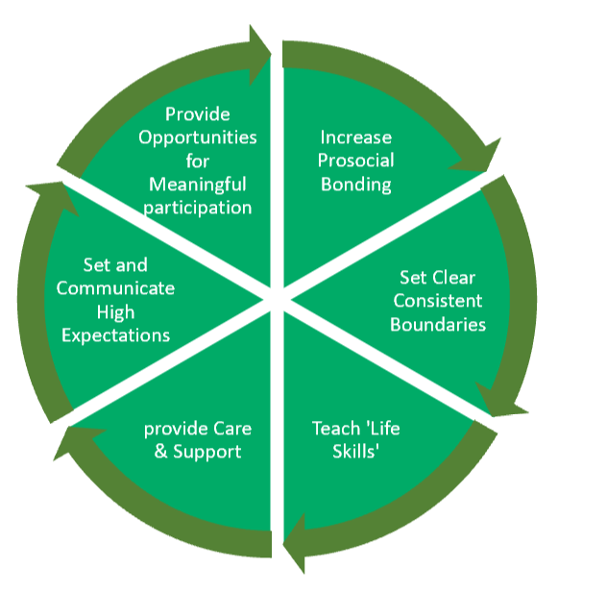
‘When children experience stress and adversity in their homes and communities, schools become a critically important setting in which to intervene and foster resilience’ (Herrenkohl et al., 2019)
Resiliency can be described as “a person’s capacity to handle environmental difficulties, demands and high pressure without experiencing negative effects” (Kinman and Grant, 2011).
Resilience is not a trait. Resilience is a capacity that involves behaviours, thoughts, and actions that can be learned by and developed in anyone.
Adapted from the book Resiliency in Schools: Making It Happen for Students and Educators by Nan Henderson and Mike Milestein, Published by Corvin Press, Thoussand Oaks, CA (1996)

Being resilient involves tapping into your resources, such as personal strengths and the support of others. Luthar & Cicchetti (2000) argue that resilience should be seen as a dynamic process that involves interactions between individuals and their environment and not as something that represents a personal characteristic. Therefore, resilience is learnable and teachable. As we learn we increase the range of strategies available to us during hard times.
One way of promoting resilience in school is to use the Resiliency Wheel which identifies six major approaches to promoting resilience along with specific strategies. Research shows that these six factors are critical factors in fostering resiliency. The Resiliency wheel can be used in building resiliency in individuals, groups or within a whole school approach.
Again, the wheel shows the importance of establishing positive relationships to feel safe and connected. One could argue that the ‘provide caring and support’ part of the wheel is the most critical element to developing resilience and that it is impossible to overcome adversity without the presence of a caring person. This does not have to be family. Having a caring person in your life is critical for support and consequently academic success.

Mindfulness
Mindfulness is not an abstract body of knowledge. Instead it is more of a practical skill, like being able to ride a bike or play the piano. Mindfulness is the human ability to be fully present, aware of where we are and what we’re doing, and not overly reactive or overwhelmed by what’s going on around us. This can be difficult when other thoughts come into our mind, especially if we are worried about something.
Mindfulness can help children and young people to regulate their emotions and focus their attention as well as developing their resilience. Furthermore, it can open a channel of discussion with adults on discussing any thoughts worries and concerns.
http://www.shambhala.com/media/wysiwyg/Sitting-Still.png

PACE Model
PACE can be used by an adult to validate, explore and understand children’s and young people’s feelings. It is again, a relational approach, which limits shame, promotes compassion and brings a sense of mutual support, strength and resilience. When an adult spends time with a child and demonstrates an interest in their inner life, they contain and regulate the child’s/young person’s emotions so that they can learn to do this themselves.

PACE stands for Playfulness, Acceptance, Curiosity, Empathy.
Playfulness
An open, ready, calm, relaxed and engaged attitude

Empathy
A sense of compassion for the child and their feelings

Curiosity
Without judgement children become aware of their inner life

Acceptance
Unconditionally accepting a child makes them feel secure, safe and loved

Identification of specific cohorts and groups to be considered
In addition to considering the processes in place to support all children and young people returning to school, there are some specific groups that may require additional planning. These children and young people include (but are not limited to) those who will be transitioning to a new school, those with an identified SEND (with or without an EHCP), children in care and other vulnerable children and young people.
The information below is intended to be a guide to some of strategies that may support groups where specific plans for transition are required.

Transition to High School
Please refer to Ealing guidance document for further information:
www.egfl.org.uk/transition-high-schools

Transition of Children from Nursery into School
Please refer to the Ealing guidance document for further information: www.egfl.org.uk/transition-early-years

Vulnerable Children
There are specific groups of pupils that settings must be thinking about when planning the return to school. These include pupils who are likely to have the found the changes in routines or disruption to relationships extremely challenging, such as those with social communication needs and /or social emotional and mental health needs.
These groups of students may need to have specific plans in place that consider the support and teaching approaches that have proved effective in the past.
School are advised to seek additional advice and guidance from the Ealing EPS in relation to those pupils with identified social communication and social emotional mental health needs if it is required.
For children who have (or continue to experience) disruptions in their home life and events which have impacted well-being, such as those in the care system or who have Child in Need and Child Protection plans, they are likely require an enhanced level of planned emotional support and nurture through caring relationships to enable a successful return to school. Settings should consider developing plans jointly in liaison with the Ealing services known to the young person / family and ensuring regular and effective planning to enable a holistic and family centred approach to working.

Identification of Vulnerable Individuals
Identifying and supporting vulnerable children will be important, and settings may need to recognise that these cannot be assumed to just be the children with previously identified needs, but also some children who previously were considered to typically manage well.
A simple emotional well-being rating could be completed by all pupils. Based on previously identified needs, and through information shared with the setting in communication with parents (this may take into account any recent events within the family/community, experiences of loss, identified worries about returning to school), settings may consider ‘RAG (Red, Amber, Green) rating’ pupils to identify the level of support that may be needed to facilitate a successful return to school.
The emotional needs of some children may become more apparent once they are back in the school setting. It is therefore important that staff continue to monitor pupils, showing sensitivity to the signs that they need to be supported in a different or enhanced way. It may be helpful to continue to use a RAG rating system over the period of a term following the return to school, adjusting the level of emotional and social support in place as required.
It is also important that settings take into consideration children/young people who may not be returning into school at this time. It is possible that on-going shielding and social distancing measures, may prevent some pupils returning at this time. There will also be families who choose not to send their children back to school at this time,
*With thanks to guidance from Wakefield EPS which this section has been adapted from*

Advice for Parents

The return to school will also be a time of significant change for many parents and carers. For most, they have been at home with their children for an extended period, and parents/carers themselves may have worries about the return to school.
They may have concerns about:
- Their son or daughter settling into a new class, or for some, a new classroom and/or routine
- Any enduring emotional impact of recent events, including experiences of loss and bereavement
- Any lasting impact of the disruption to their son or daughter’s learning and progress
- Their son or daughter being able to re-establish friendships and relationships in the class / school
- Their son or daughter’s safety, particularly if they have any existing health concerns
It is important that schools and professionals appreciate the thoughts and worries of parents and carers and pro-actively seek to reduce anxieties where possible, which may transfer to the individual child. We should reassure parents that any feelings of worry are understandable and normal in the current circumstances.

For All Parents / Carers
- Ensure that there is effective and enhanced communication in place in the lead up to any return to school. This should include contact from the pupil’s new class teacher (if this has changed) and key workers (if relevant). This will enable the sharing of information on both sides, and offer parents an opportunity to share information that may impact on the pupil’s return to school (for example, have they experienced bereavement and loss as a result of Covid 19, have there been any changes within the family, are parents key workers etc.).
- Keep parents informed of all plans that are being implemented for transitions and the enhanced arrangements on offer. Explain what is different about the process of transition this year.
- As some aspects of social distancing and safety measures will remain in place as school’s return make sure that parents know how these are being implemented in school.
- Parents may appreciate information being shared with them about changes that they can prepare their son or daughter for: new staff, classroom, routines, any changes that have occurred in school.
- Offer a key point of contact for questions and concerns. Parents may have more queries than would typically be expected at a transition point.
- Once children return to school, parents may continue to need an enhanced level of contact, and the space and opportunity to talk to staff about the settling in process more frequently than might typically be planned.
- Share information with parents about the emotional support and provisions that will be in place for all children in the weeks ahead (and months if necessary).
- Make parents aware of how any impact on learning will be addressed over the coming months.
- Let parents know what information has been shared with the new school, so that they feel assured that information has been effectively shared.

*With thanks to guidance from Wakefield EPS which this section has been adapted from*

Guidance for Schools

The following guidance is provided as a means of supporting settings to aid the transition of all children and young people back to school. As discussed, this advice is underpinned by the psychological approaches previously presented, most of which have the common theme of ‘relationships’.
The guidance takes the form of a hierarchical diagram, which outlines what can be done universally, for all pupils and gradually works towards targeted and bespoke planning, where necessary. This diagram is accompanied by a table highlighting relevant provision that we feel is important, at each stage. Additionally, further considerations and practical advice can be found in the table included within the appendices (Appendix 2).
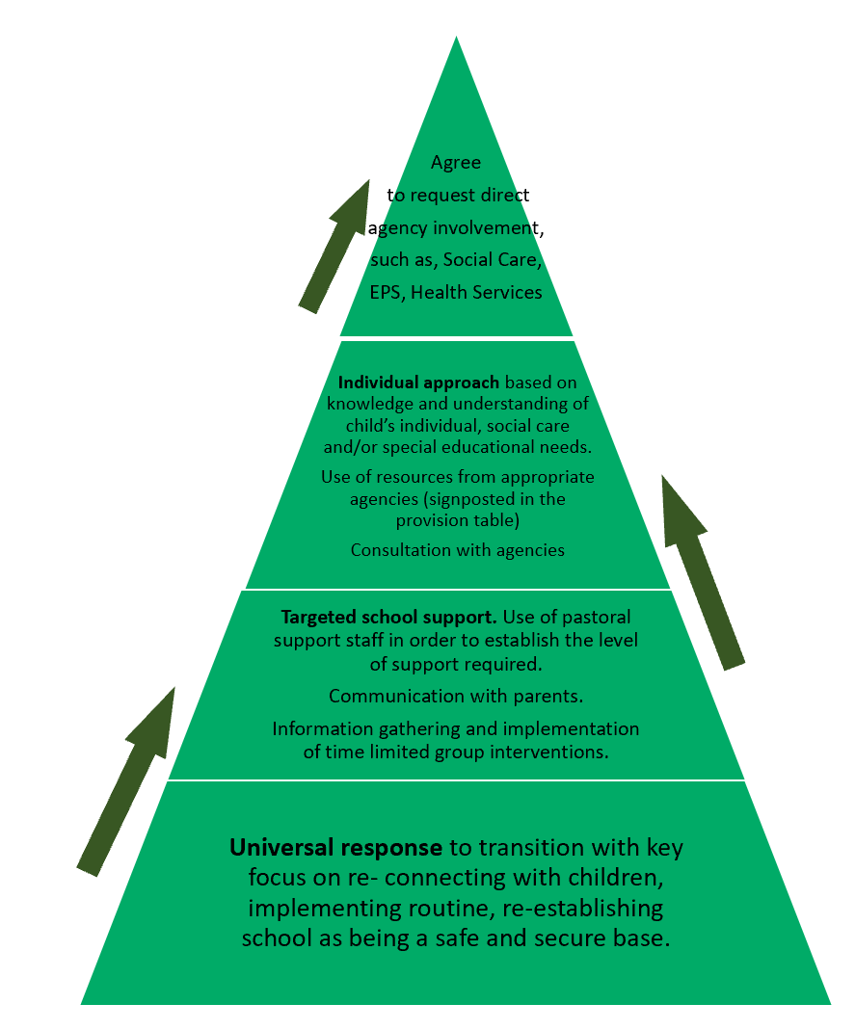
Waves of responses

Table of provision
Level of Response | Teaching and Learning Strategies | Provision | Support
Universal Response | Building Relationships  Resilience  Nurturing Principles  Mindfulness  Emotion Coaching  Trauma Informed approaches  PACE model | - Acknowledge that for some children and young people, they will be frustrated by the situation and want to be back in school.  - Acknowledgement that some children and young people will have experienced safeguarding issues at home.  - Priority to be given to the re-affirming of relationships between both staff and children/young people. Although there will be some learning lost, not to get straight into formal assessment.  - Flexibility – a way of demonstrating that wellbeing is the first priority.  - Awareness of any Key Worker children, if they have remained in school and their feelings towards others who have not been attending school.  - Consideration of the day especially in the first instance to think about activities that build on relationships, feeling safe, repetition of routines and structures. This can involve Circle Time, games, welcome back assembly (re-establishing school community) to celebrate any missed birthdays, show appreciation for key workers, reinforce everyone safe and back together.  - Time within the curriculum to acknowledge that everything has not just ‘returned to normal’  - Thought around displays in school to reflect the situation, for example things that we are sad about and things we should be happy about.  - Adults to model appropriate behaviours and talk about experiences when needed  - The use of visual resources to explain and reinforce routines and structures of the day. This could be via visual timetables, checklists etc…  - Clear and consistent rules and routines expressed – re-teach these.  - Use of social stories.  - Repetition and reminders that are supportive rather than assertive.  - The use of positive praise at all levels.  - Staff to be careful if questioning children on what work they may or may not have completed at home. It may be better not to do this directly.  - Children who have completed home working to be praised privately.  - Parents to be included in plans of the school with opportunities for parents to share if their child has experienced any difficulties during the lockdown (e.g. emotional, bereavement, illness).  - Safe spaces for children to talk about experiences.  - Ensure pastoral support is available throughout the day if possible and is not by timetable/appointment only.  - Clear communication regarding the whereabouts of members of the school community.  - Opportunities to celebrate members of the school community who have died, if appropriate. This could be in the form of a remembrance assembly where names could be read of family members of children, as well as celebrating the work of the NHS and key workers (in line with parental / family wishes and only when consent from bereaved families has been sought to do this).  - Opportunities to talk about feelings/emotions embedded throughout the curriculum.  - Careful balance of prioritising wellbeing and ensuring boundaries are in place, as these are safe, i.e. (it’s OK to feel scared about being at school but it’s not OK to hit staff).  - Expect ‘behaviour’ – plans in place for these.  - Gradual approach to reintroducing academic demands. Children and young people must be emotionally ready before they can learn.  - Staff wellbeing also a priority – “need to feel nurtured to nurture”.  - New rules and restrictions articulated as ‘do’ statements rather than ‘don’t’ – such as ‘do wash your hands’.  - Use of therapeutic stories for the whole class.  - The use of transitional objects to be used with younger children.  - DSL to be in contact with Virtual School if support needed. | Websites  www.boingboing.org.uk  www.nurtureuk.org  www.emotioncoachinguk.com  https://www.annafreud.org/  https://www.camhs-resources.co.uk/coronavirus  https://www.place2be.org.uk/our-services/services-for-schools/mental-health-resources-for-schools/return-to-school-resources  Books  Attachment in the Classroom – Louise Bomber  Inside I’m Hurting – Louise Bomber  Activities  Therapeutic Stories – The Little Elf – see Appendixes 4 & 5  Hope Cloud Activity (from Young Minds website)  All About Me Activities  Well-being rating scales/Daily emotion ‘check ins’ (i.e. placing name on chart to show how children are feeling).  Other  Advice and guidance from services such as Ealing EPS,
Targeted School Response | Building Relationships  Resilience  Nurturing Principles  Mindfulness  Emotion Coaching | All of the above and;  - A number of adults being ‘available’ to support children if and when needed.  - Ensure that key members of staff such as SENCo and DSL have additional time to attend to any matters that have arisen.  - Small group work, specifically targeting area of need, such as specific work around emotions, emotional regulation, bereavement…  - Examples of support: Zones of Regulation, FRIENDS, Lego Therapy, Talking Partners. | Websites  www.elsanetwork.org  https://www.elsa-support.co.uk/  Books  The Zones of Regulation: A curriculum designed to foster self-regulation and emotional control.  Activities  Advice and guidance from other services.
Individual Targeted Response | Building Relationships  Resilience  Nurturing Principles  Mindfulness  Emotion Coaching  Anxiety  CBT approaches  Loss and Bereavement work | All of the above and;  - Provide a consistent adult that a child can develop a positive and trusting relationship with.  - Specific targeted work with a familiar adult trained in delivering the programme.  - Information gathering and action plan set out to meet needs.  - Personalised timetable in the short term  - Allocated a member of staff/key worker, in the short term to help re-adjust.  - The use of both social and therapeutic stories with individuals if needed.  - Some specific children may experience separation anxiety from parents/carers – individual support may be needed to offer reassurance.  - Some children may experience specific anxiety. Looking at individual ways that they can be supported to offer reassurance, such as the use of CBT approaches.  - Some children may have experienced loss and bereavement and will need some additional adult support from a suitably trained adult. | Websites  http://www.em-edsupport.org.uk/coronavirus-eps  https://www.winstonswish.org  https://www.cruse.org.uk  https://www.samaritans.org  https://youngminds.org.uk  Books  The Invisible String – Patrice Karst  Think Good, Feel Good – Paul Stellard  Therapeutic Stories – Margot Sunderland  Starving the Anxiety Gremlin – Kate Collins-Donnelly (primary and secondary editions).  Huge Bag of Worries – Virginia Ironside  Conversations that Matter – Margot Sunderland  What to Do When You Worry Too Much? A Kid’s Guide to Anxiety - Dawn Huebner  The Mindfulness Journal for Teens – Jennie Marie Battistin.  Activities  The use of Therapeutic Stories – The little Elf (See Appendix 5&6)  Creation of a five-point scale, for any emotion, including anxiety (Dunn Baron and Curtis).  Other  Loss and Bereavement Guidance - please speak to Ealing EPS if you require this.
Outside Agency Support | Contacting as relevant:  EPS  CAMHS  Place2Be  Counselling Service  CLiPS  EPC  BIS  SAFE  MHST  BMF  SALT  OT  Other relevant health services | To have tried all the above strategies:  - This should be done following the graduated response with the Plan, Do and Review Cycle.  - In the majority of circumstances children and young people should be raised at the SEN plan meeting with the relevant supporting documentation.  - Education Health and Care Plan (EHCP)

*With thanks to guidance from Wakefield EPS which this section has been adapted from*

References
Bomber, L. M. (2007). Inside I’m Hurting. Croydon: Worth Publishing.
Carpenter B & Carpenter M. 2020. A Recovery Curriculum: Loss and Life for our children and schools post pandemic.
Colley, D (2009) Nurture groups in secondary schools. Emotional and Behavioural Difficulties, 14 (4) 291-300
Correspondent, S. W. E. (2020, April 10). Fifth of primary children afraid to leave house over Covid-19, survey finds. The Guardian. https://www.theguardian.com/world/2020/apr/10/fifth-of primary-children-afraid-to-leave-house-because-of-covid-19-survey-finds
Dweck, C. S. (2006). Mindset; How Can You Fulfil Your Potential. New York: The Random House Publishing Group.
Gottman, J. (1997) Raising an Emotionally Intelligent Child. Prentice Hall & IBD
Kinman, G. & Grant, L. (2011) Exploring stress resiliency in trainee social workers: The role of emotional and social competencies. British Journal of Social Work, 41, 261-275.
Luthar, S. & Cicchetti, D. (2000) The construct of resilience: Implications for interventions and social policies. Development and Psychopathology 12, (4), 857-885.
Lonne, B., Higgins, D., Herrenkohl, T. I., & Scott, D. (2019). Reconstructing the workforce within public health protective systems: Improving resilience, retention, service responsiveness and outcomes. Child Abuse & Neglect, 104191. https://doi.org/10.1016/j.chiabu.2019.104191
Reconstructing the workforce within public health protective systems: Improving resilience, retention, service responsiveness and outcomes
Nurture Groups. (n.d.). https://www.nurtureuk.org/sites/default/files/ngn_-_nurture_groups-201705web.pdf
Psychiatry Interpersonal & Biological Processes 70(4):283-315; discussion 316-69 · February 2007 with 6,742 Reads

A 'read' is counted each time someone views a publication summary (such as the title, abstract, and list of authors), clicks on a figure, or views or downloads the full-text.
DOI: 10.1521/psyc.2007.70.4.283 · Source: PubMed

Appendixes

Appendix 1: Websites

Below is a list of websites that may offer further advice and guidance. If you would like to discuss any of the content in this information pack, then please speak to your named Educational Psychologist (EP) who will be able to help.
https://youngminds.org.uk/resources/school-resources/transition-tips-for-pupils-with-send/
https://www.seainclusion.co.uk/post/the-many-problems-of-returning-to-school
https://www.education.ie/en/Schools-Colleges/Services/National-Educational-Psychological-Service-NEPS-/NEPS-Guides/Transfer-from-Primary-to-Post-primary/
https://www.mentalhealth.org.uk/learning-disabilities/our-work/employment-education/moving-on-to-secondary-school/
https://www.bbc.co.uk/teach/transitioning-to-secondary-school/zkc9pg8
https://childrensmentalhealthcampaign.org/resources/covid-19-resources
https://www.early-education.org.uk/attachment-and-trauma-awar

Appendix 2: Additional Considerations
Issues to be aware of | Possible impact | Practical activities
Everything is NOT normal | Expectations of normality amongst pupils, staff and parents will be high | - Schools to manage expectations and uncertainty in their communication to all stakeholders. Time must be available to do this.  - The ways in which school is likely to be different is considered and communicated to all prior to the return to school.  - There may need to be activities and displays in school which reflect upon this time. Things that we are sad about / things that we are glad about.  - Time provided within the curriculum to consider this.
Ongoing Social Distancing / Hygiene Considerations | Impact on attendance and distribution of classes within the school, as well as routines and practices. Understanding how social distancing measures might affect emotional wellbeing. | - Part time attendance, spacing in the classroom, time for hygiene  - Plan, communicate in advance, reinforce expectations consistently  - Communicate with families what measures are in place before children return so they know what to expect.  - Film the classrooms and make available online so children and young people can see the environmental changes before they return.  - Reinforce and explain that the measures are in place to keep everyone safe.
Routines have Changed | Not just for children but for whole families. There may need to be some sympathy and understanding around this. | - Plan clear routines, share these in advance, including any phased returns.  - Consider the impact of these new routines on attendance. How can families be supported/encouraged to prepare themselves for going back to school?  - Communicate with them to proactively plan for those who might need additional support.
Relationships | These need to be re-established and this may be an opportunity for renewal | - PRIORTISE Staff to focus on creating relationships with children and young people, such as, greetings, individual conversations, ‘checking in’, modelling and expressing calmness and warmth, emotion coaching approaches and PACE approaches. Treat all children as having attachment needs.
Gaps in Learning | Huge variation in the experiences and opportunities available to young people. | - Do not begin with formal assessment, assess knowledge more informally. Start curriculum with what children know … not what you think has been taught.  - Topics may be revision for some…this will not harm them. Plan additional tasks / topics for those who have covered more to enable those who must catch up. Give children the opportunity to share what they have learned (even if it is having watched films or played Minecraft).  - Catch up intervention for those who need it.
Some Children have Remained on Site. | Possible stigmatization, potential feelings that safe space is being intruded upon when all children return. | - Preparation of those children who have remained on site for the arrival of others. Perhaps plan a welcome back event or ask them to help with the planning and decision making about how they can welcome other children back to school.
Trauma and Bereavement | Many children / staff may have experienced trauma and bereavement | - Provide opportunities and encourage communication from parents / carers around child experiences. Plan information sharing.  - Staff to be vigilant (update awareness training prior to schools opening).  - Provide safe spaces for children to talk about experiences.  - Clear communication regarding the whereabouts of members of the school community.  - Opportunities to celebrate members of the school community who have died.
Safeguarding | There may be an increase in safeguarding issues including those related to poverty, Domestic Violence, parental mental health, substance abuse etc. | - Ensure that training is refreshed and up to date so that staff are aware  - Provide opportunity for young people to share experiences if needed.  - Extra time and support for DSL upon re-opening to work with relevant agencies to safeguard children.
Ongoing Illness Anxiety | Concerns about illness are heightened and are likely to be continually reinforced. | - Balance between acknowledging the issue and managing anxiety.  - Use of Social Stories.  - Opportunity to teach coping skills.  - Implementation of nurture and attachment principles to reassure and re-establish trusting and safe relationships.
Separation Anxiety | Children (and staff) are used to being home with their families. This is particularly comforting when the world feels so unsafe. This may particularly impact where there are key workers or vulnerable people in the family. | - Clarify communication lines so that children and young people are confident that contact could be made with them at school, in case of emergency (phones as transitional objects).  - Again, acknowledge feelings (emotion coaching / PACE) and teach coping skills.
Additional needs, especially children with ASD | Any time of change can be challenging … | - Additional preparation will be required, such as videos of any changes to the school; new routines and expectations shared in advance; additional adult support available to check in, explain, answer questions and reassure, as well as use of social stories/comic strip conversations to prepare for going back to school.
Sensory Needs | Potentially overwhelming environment for staff and Children and young people.  A development of fear of being around people – unused to people in their personal space. | - Consider a phased return or part time timetables.  - Availability of calm spaces, ear defenders, ability to protect personal space and choose who accesses it.  - Use of markers on the floor may be necessary.
Placement Transitions | Loss of ‘ending’ activities  Loss of transition activities during the previous term. | - Online transition activities, such as virtual school tours, sharing of videos the school has (sports / concerts) photos of classrooms and teachers. Virtual meeting with class teacher if possible.  - Phased starts.  - Real opportunities to meet the class teacher in home environment in September.  - Walks past the school.  - Acquisition of uniform when this is possible.
Uniform Issues | Outgrown, not replaceable at current time, financial issues | - Not the time for strict adherence. Show flexibility and aim to return to uniform at a later date. Consider how to organise uniform swops (may need to consider washing and handling of clothes at this time).
Staff Issues | Burnout, lack of downtime, bereavement, illness, stress and anxiety, childcare issues, financial issues | - Consider how staff wellbeing has been monitored. What have their experiences been and have they been bereaved of family members/friends?  - What are their current circumstances and family pressures? Are their children back at school? How can they be supported to balance work and home life?  - What information do you know to help create flexibility and support for them upon their return?  - Have staff had sufficient time and information to prepare for their return to work? Are expectations and plans to transition children back in to school clear?  - Initially, limit demands made of them, such as reducing pressures outside of the classroom (paperwork, unnecessary meetings and observations). The focus should be on relationships and supporting one another to re-adjust, rather than performance.  - Ensure that they have space and time to talk not only to each other but the children and young people.
Frustration for some students | Some students may feel frustrated that they want school to just get back to normal and feeling they have coped well with the crisis and schools being shut. Some students will have developed resilience through various coping strategies and approaches. | - Acknowledgement that students will respond to the situation in lots of different ways, some better than others and that this is fine. There is no shame in not coping.  - Celebration of the ways in which students coped and managed to keep going and feeling positive or hopeful.  - Recognise and celebrate the resilience and coping seen amongst our schools, settings and families and in so doing, consider ways to connect people to share how they have coped with these times, what sources of strength and even joy they have discovered, what reserves within themselves and their communities have taken them by surprise.

*With thanks to the Wakefield EPS and Microsoft Teams national working party of Educational Psychologists/Education Professionals. This document has been adapted from these sources..*

Appendix 3: Examples of whole school approaches to reintegration following community wide trauma

 | Hofsoll et al.’ s guidance | Specific examples and ideas from the literature
Promote sense of safety. | - Establish relative safety and confidence in protections available.  - Limit amount of time talking about the trauma if this makes people more anxious.  - Leadership provide reassuring, balanced voice to increase perception of safety. Provide balanced information.  - Manage media exposure. | - Assemblies to share information  - Newsletters/website providing information  - PSHE about managing media exposure and managing anxiety
Promote calming. | - Provide opportunities for grounding and relaxation such as breathing retraining, mindfulness, progressive muscle relaxation.  - Provide psychoeducation about the stress response, sleep hygiene, behavioural activation, emotion regulation and problem-solving skills. | - Activities at start of the day and after transition times to aid relaxation  - Preserve an appropriate room in school where students can drop in (without an appointment) for support through access to a quiet space or therapy focused / supportive conversation.
Promote sense of self– and collective efficacy. | - Increase sense of ability to cope and of being in control through increasing skills in emotion regulation and problem solving using cognitive-behavioural approaches.  - Remind of self-efficacy and build on it using a strengths-based approach.  - Community activities to enable children to see appropriate coping and to be involved in planning and implementing activities. | - Psychoeducation workshops for parents, young people and staff  - Safe spaces to share in e.g. Circle time  - PSHE (e.g. SEAL on Self-awareness, Self-management, Social awareness, Relationship skills, Responsible decision making)  - Community events such as plays, music concerts, fetes, sports days  - Signpost to local services.  - Provide written resources / handouts / information booklets/Newsletters/website
Promote connectedness. | - Empower natural support networks.  - Help people to tap into existing supports. Increase opportunities for social support activities, bringing together community groups for problem solving, sharing emotional understanding, acceptance and sharing of experiences discussion about coping.  - Psychoeducation about social supports and increase identification and recruitment of social supports.  - Identify and help those who are more socially isolated. | - Psychoeducation workshops  - Coffee mornings  - Assemblies  - Classroom displays about the value of social support  - Encourage telling of stories through artwork and sharing events  - Increasing opportunities for young people and staff to build relationships with specialist staff who can help raise awareness of mental health, provide consultation, identification of students & trainings.
Promote hope. | - Be mindful of western notions of hope, based on predictability, and explore where hope is garnered from e.g. religious and spiritual beliefs, or other resources.  - Join with and support through any barriers to gaining resources – not doing for.  - Identify and amplify strengths. Ensure those in need of treatment receive it.  - De-catastrophise.  - Help telling of stories. | - Presence of faith leaders, mental health professionals  - Provide range of different supports.  - Assemblies  - Encourage telling of stories through artwork and sharing events

*With thanks to City & Hackney Alliance MHST for a document which this section has been adapted from*

Appendix 4: The little elf and the flowers of hope and bravery
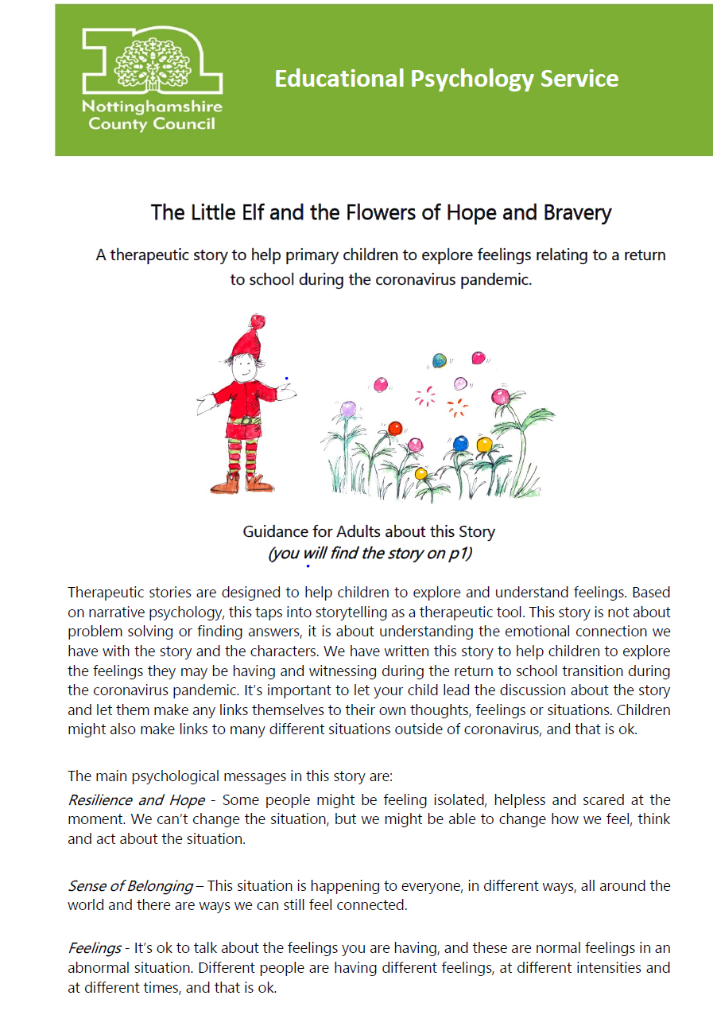
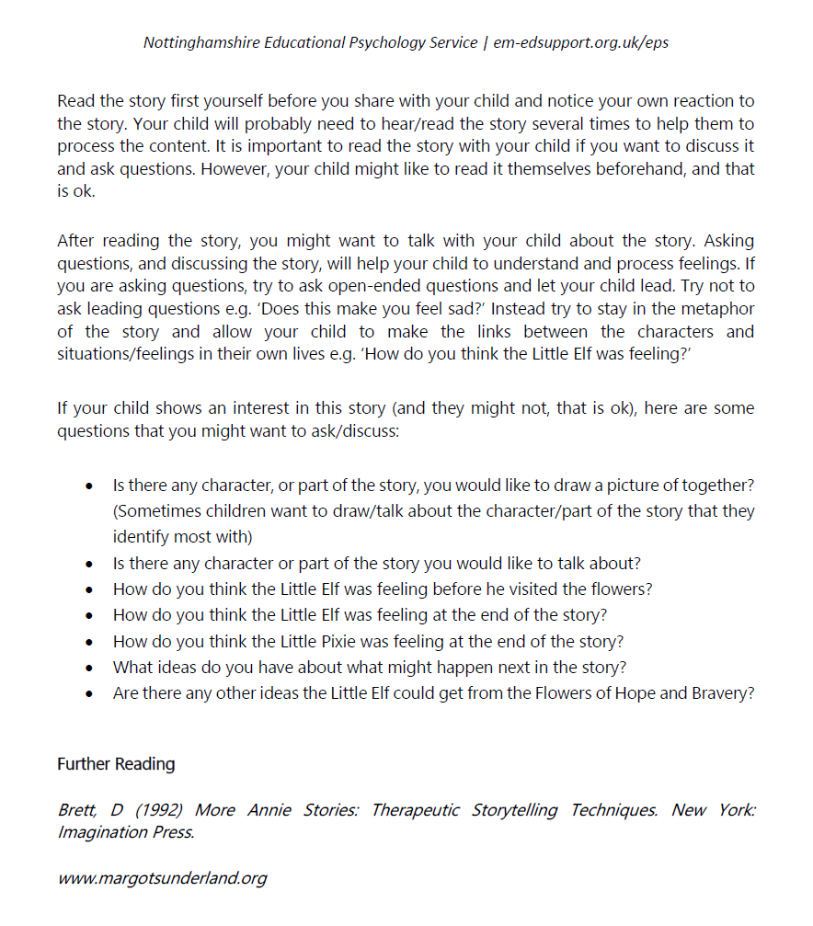
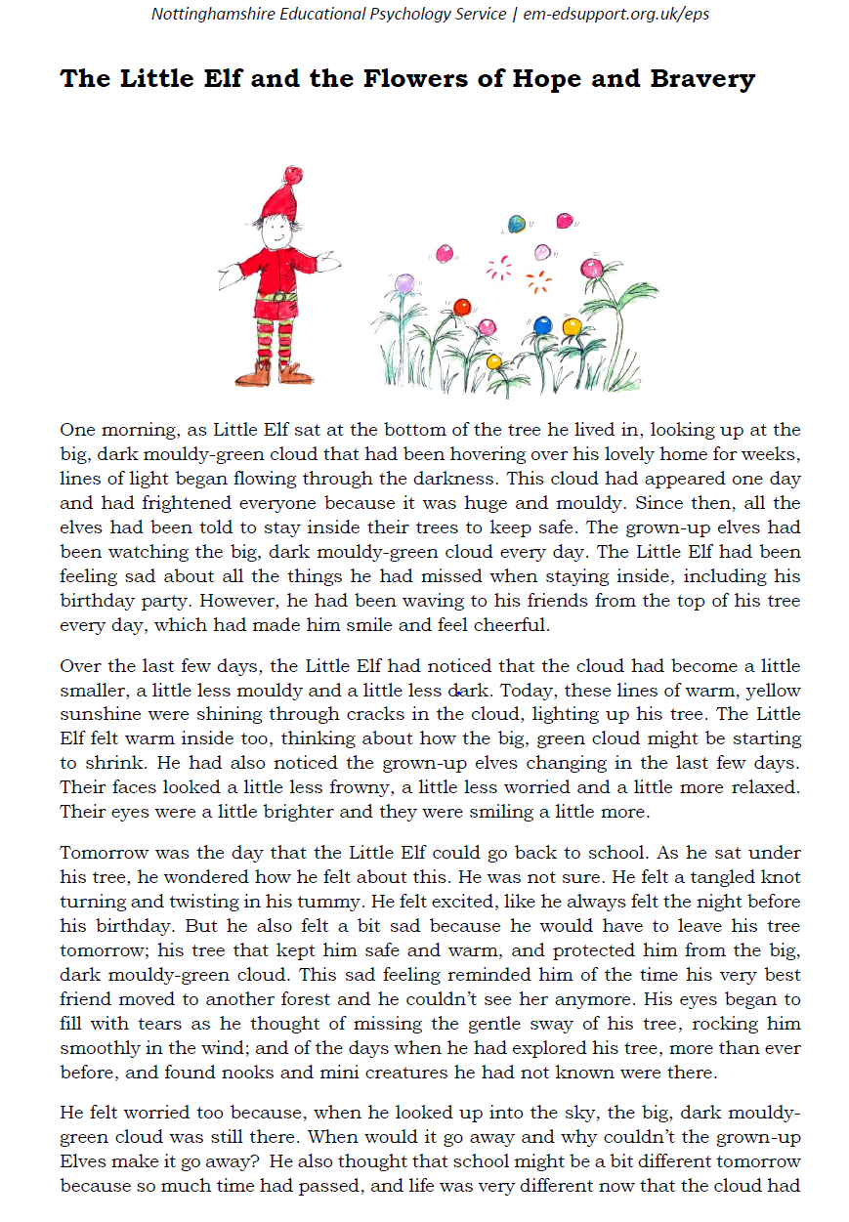

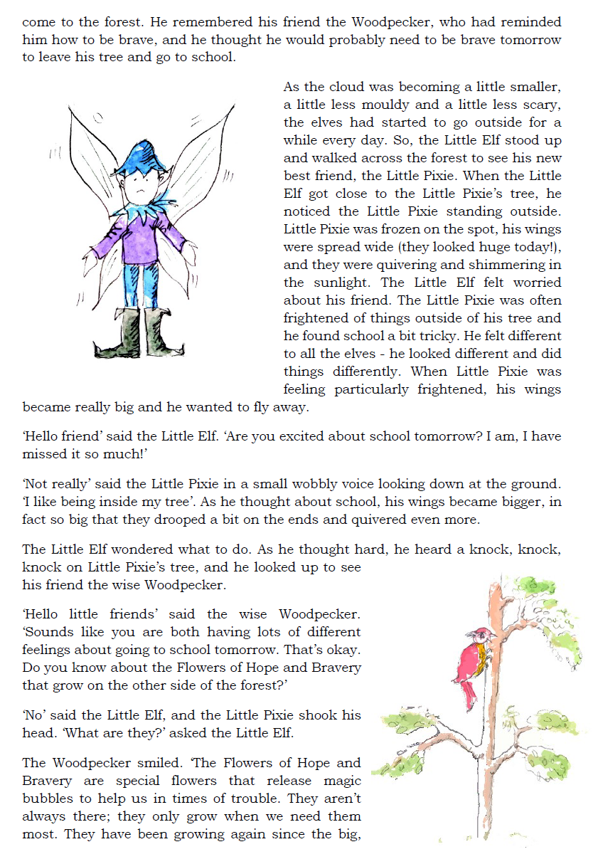

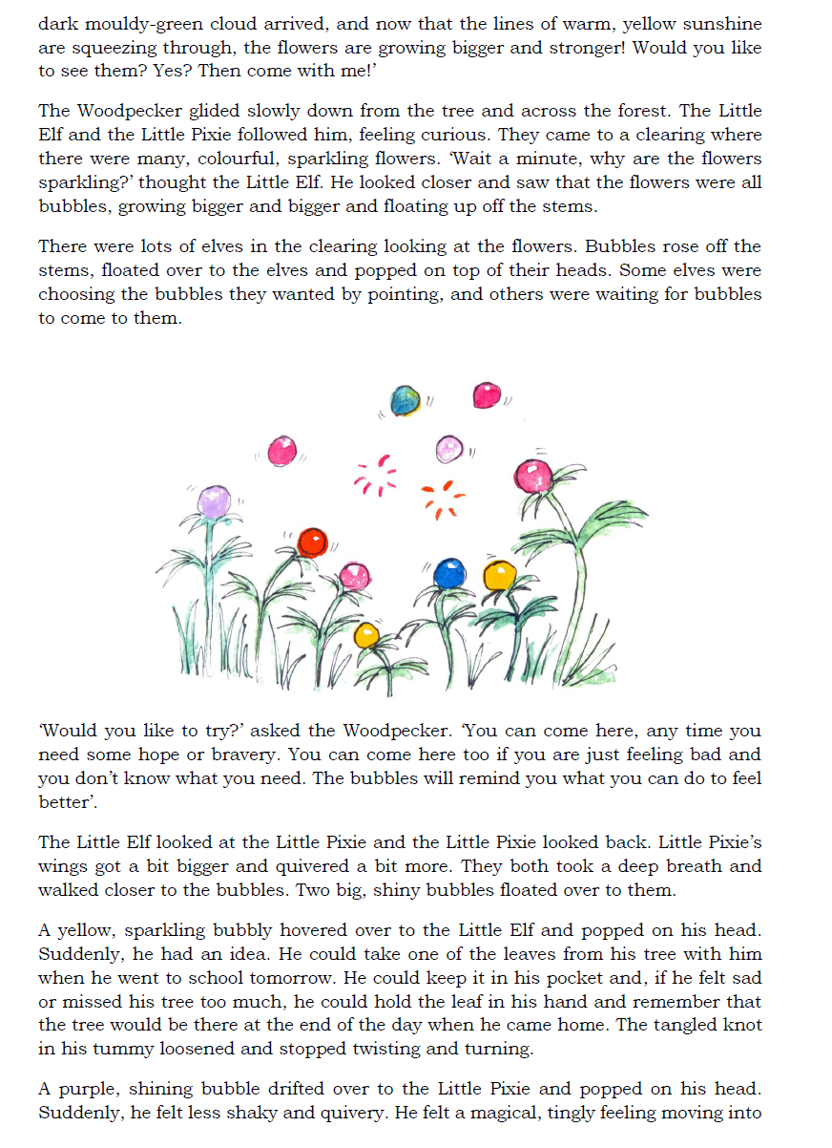
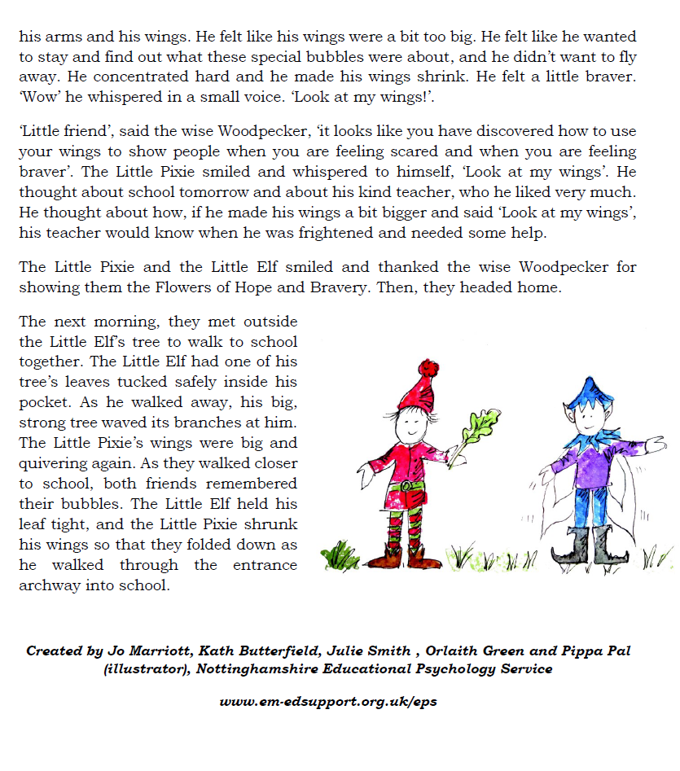

Appendix 5: The Little Elf who missed his birthday party
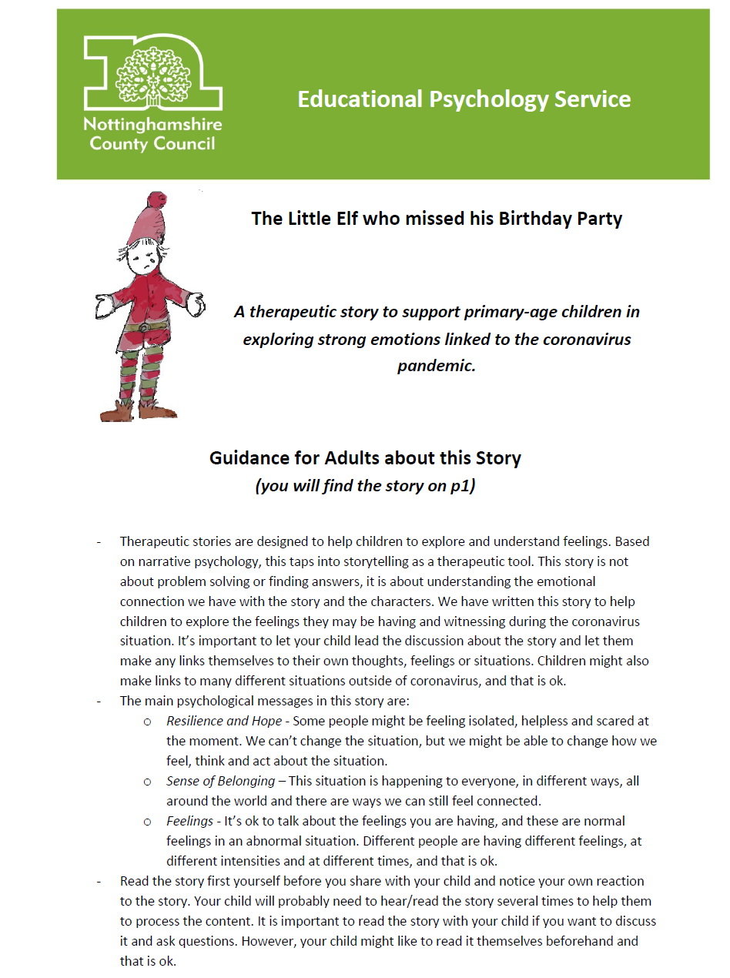

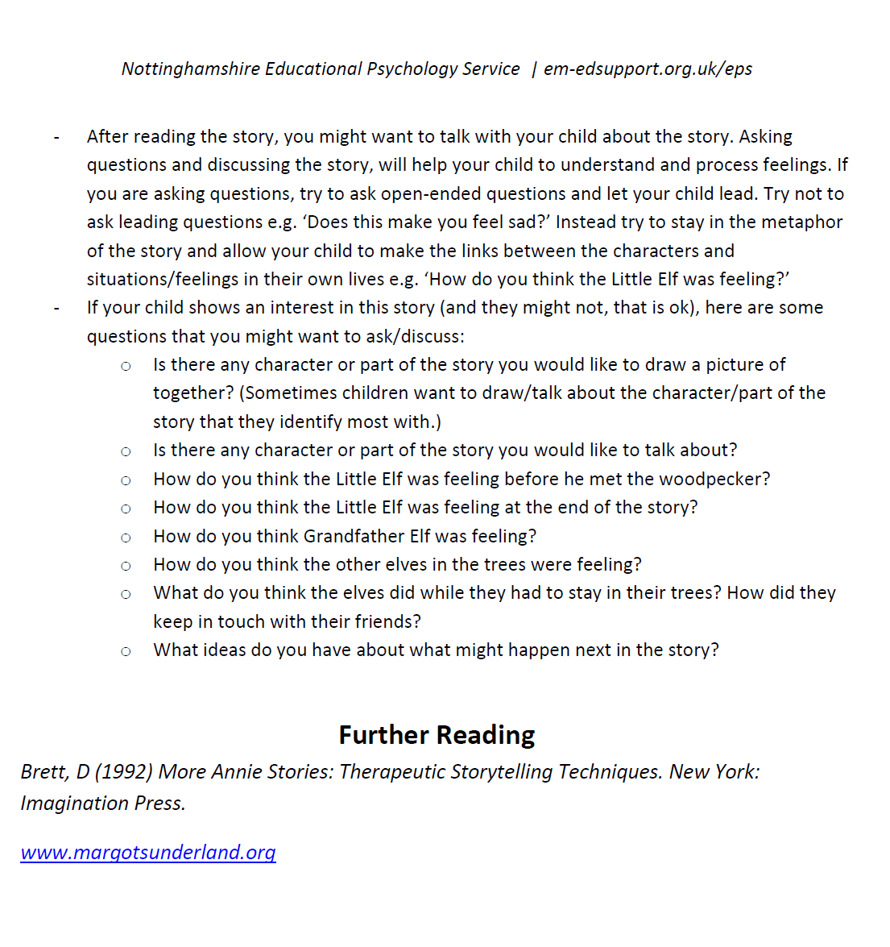

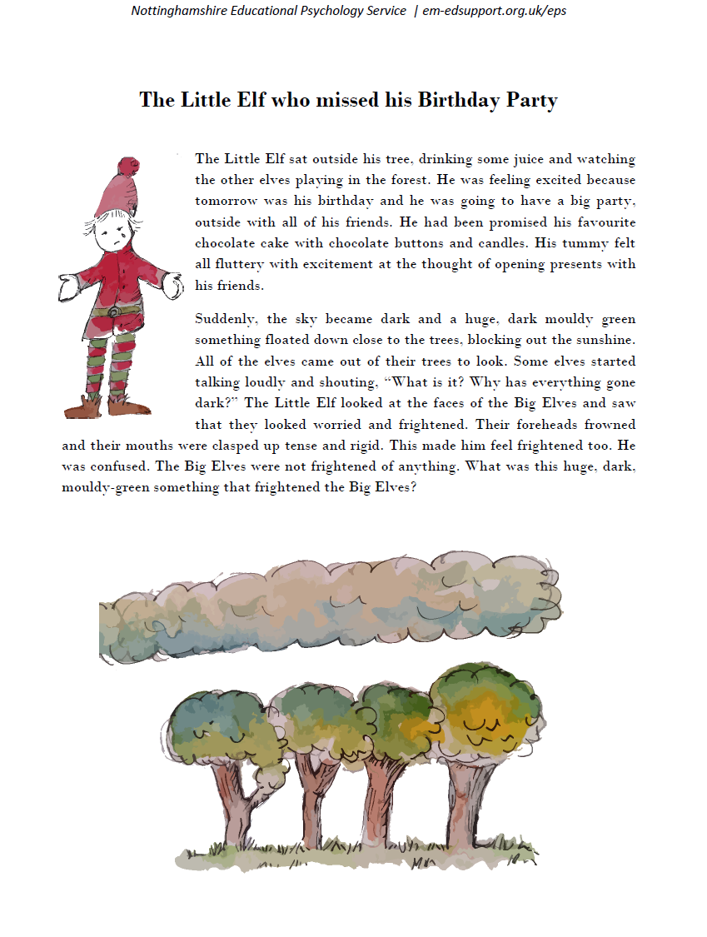
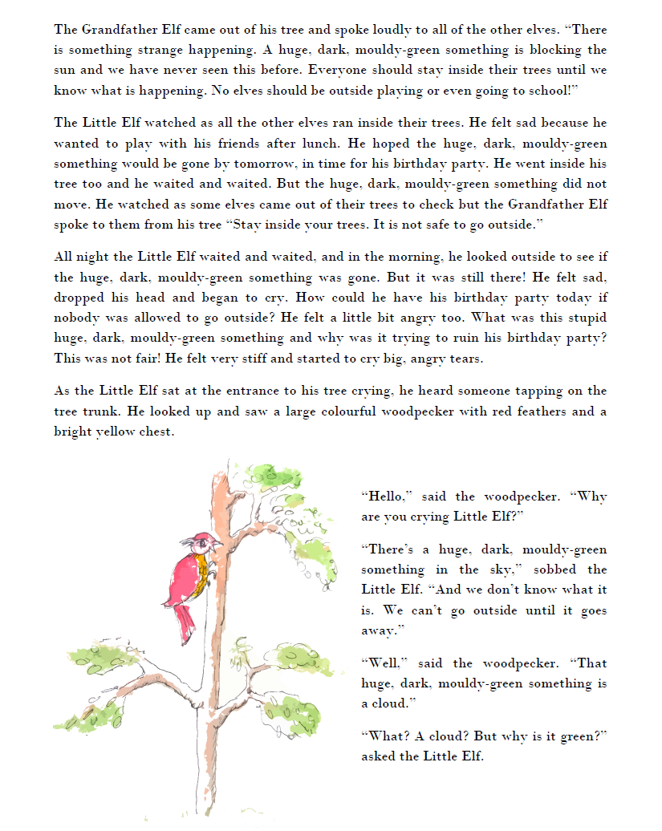
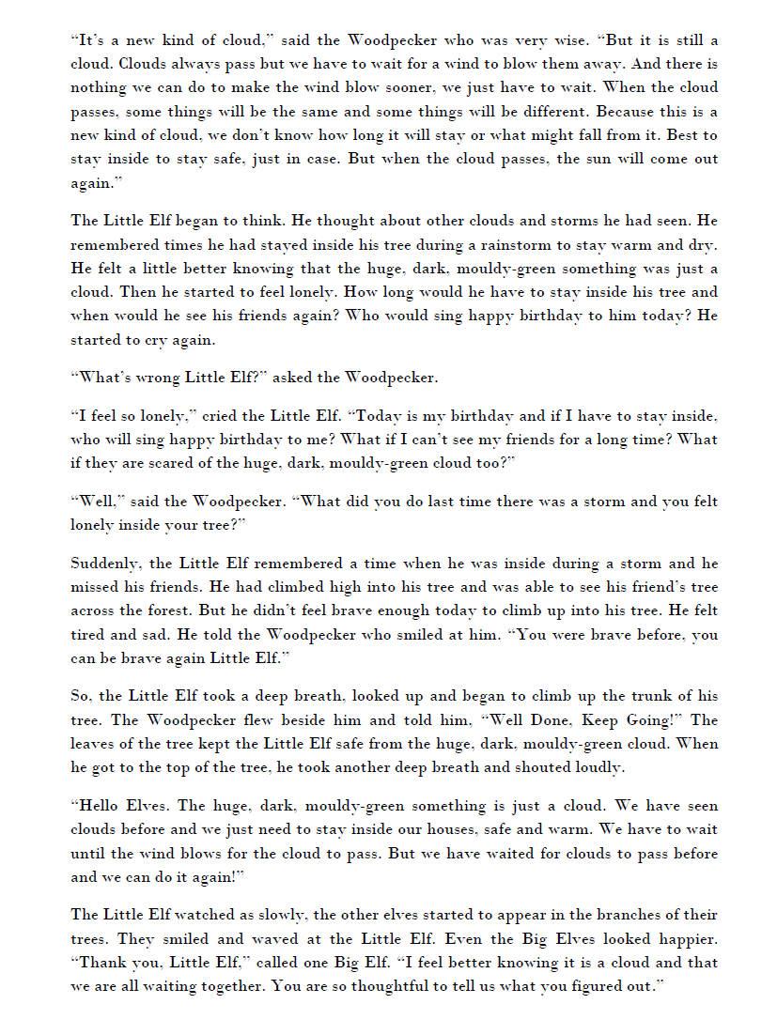

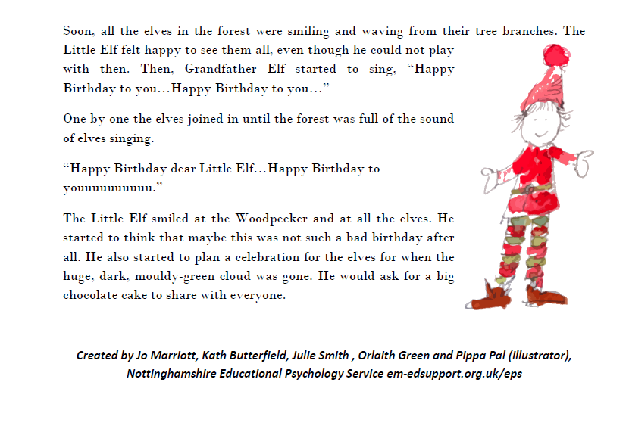

Appendix 6: ELSA wellbeing questionnaire- back to school
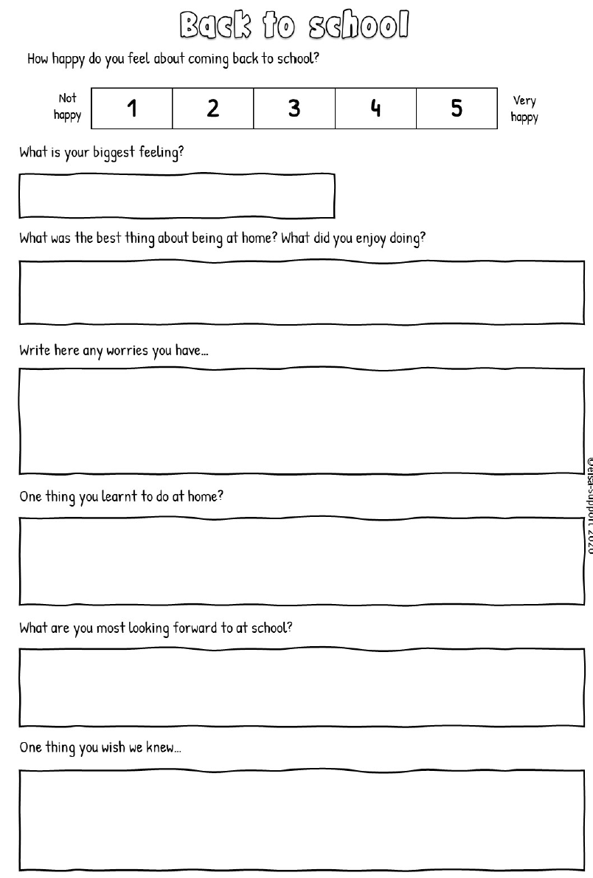

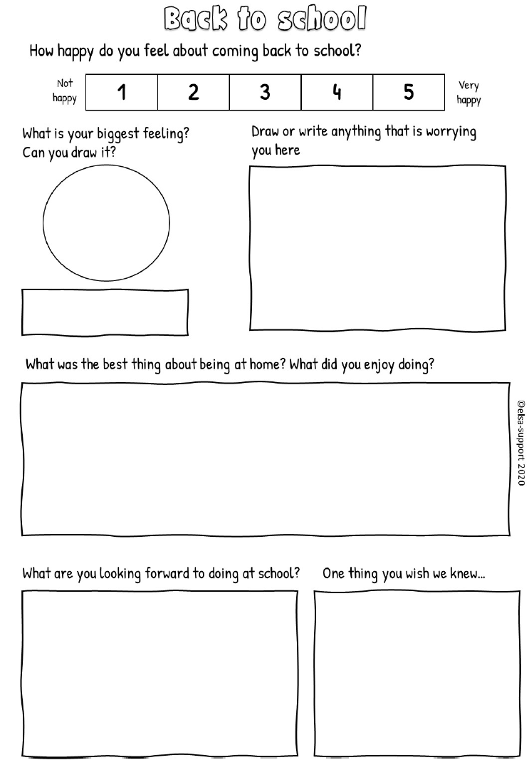

Appendix 7: ELSA back to school after COVID story

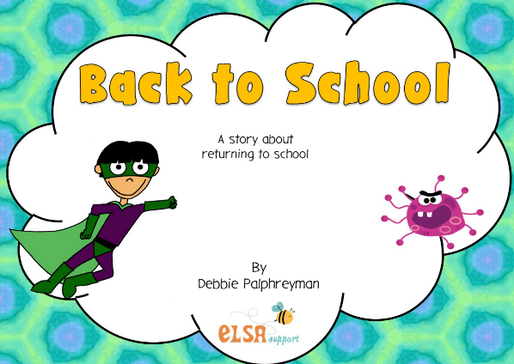 | 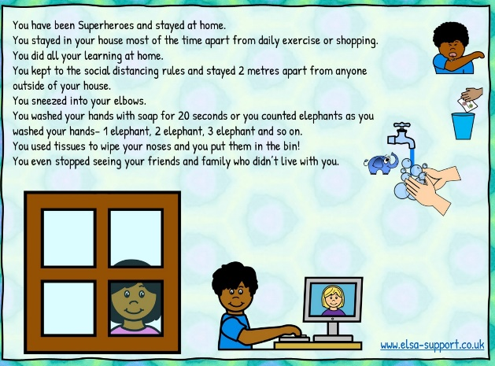
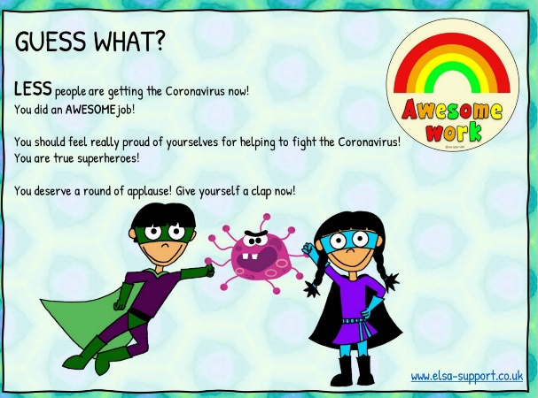 | 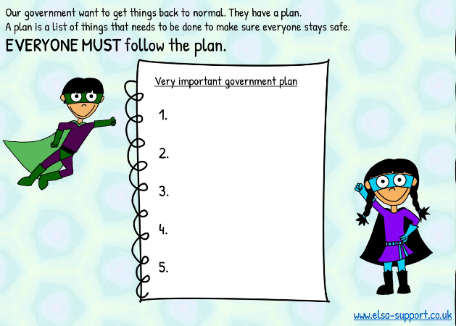
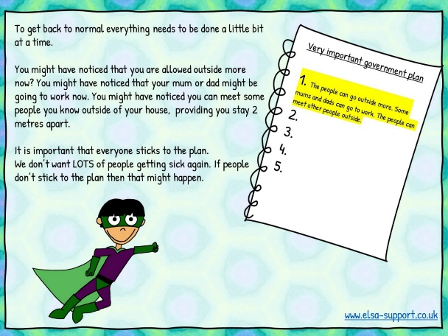 | 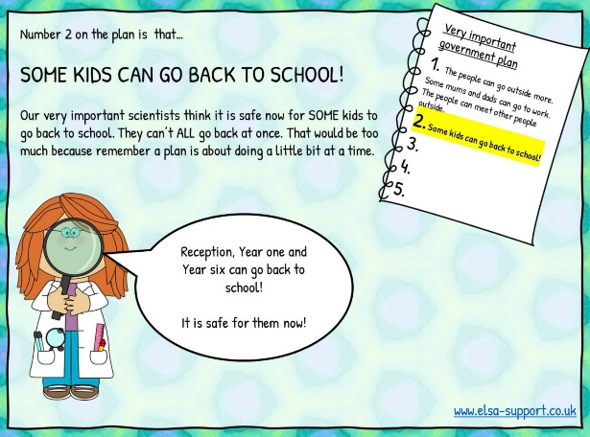

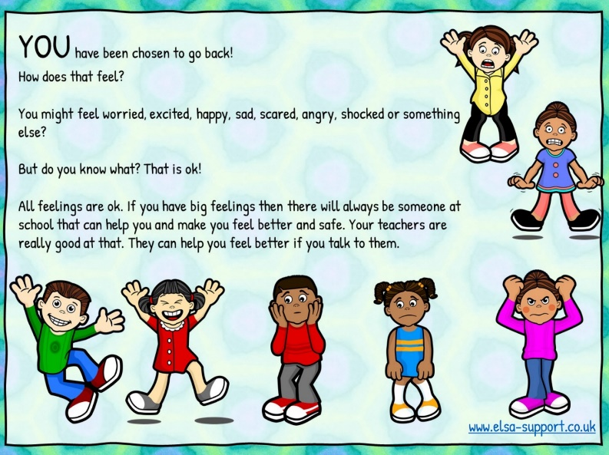 | 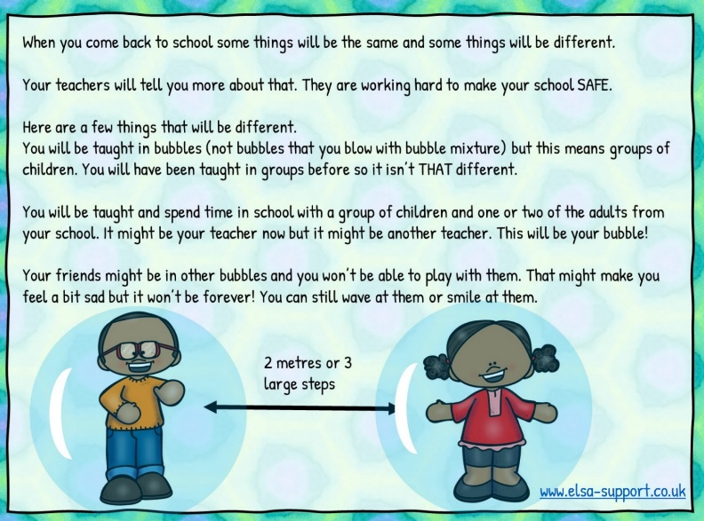
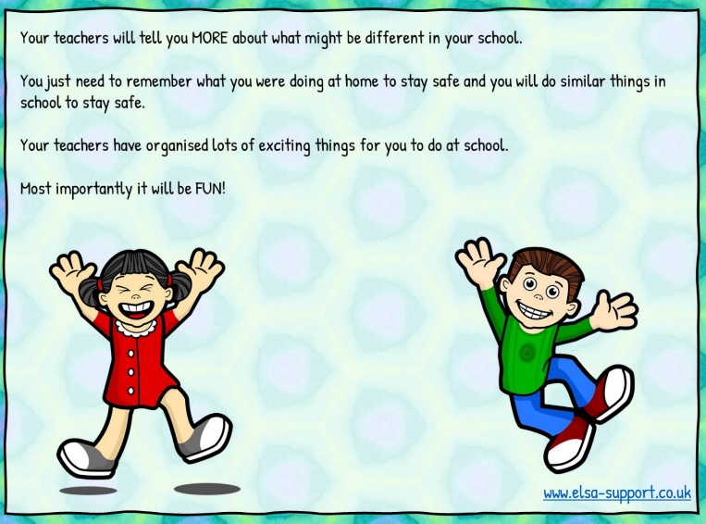 | 