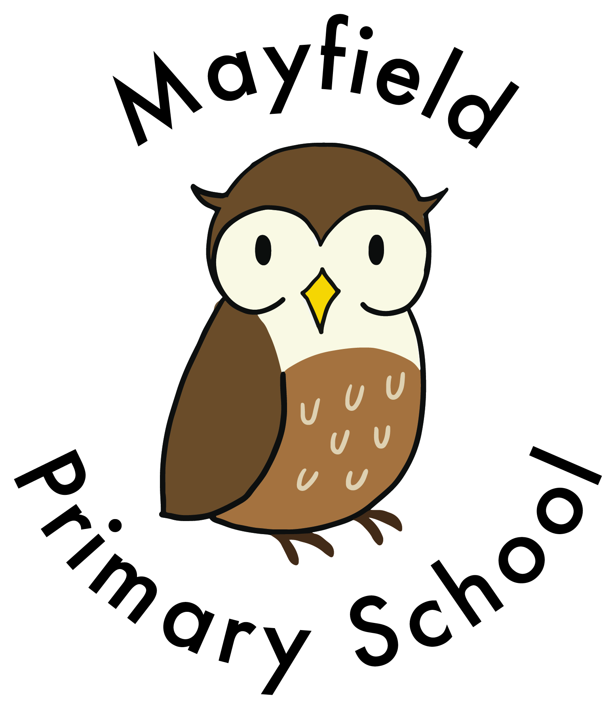
GENERIC RISK ASSESSMENT FOR: PREGNANT WORKERS (courtesy of Mayfield, Beaconsfield and Horsenden Primary Schools supported by Schools HR, Ealing’s Public Health Team and Schools Health and Safety)
COVID: with reference to: Coronavirus (COVID-19): advice for pregnant employees - GOV.UK (www.gov.uk)
This link gives current advice to pregnant workers about the care they will receive and if they have pregnancy related questions: Coronavirus infection and pregnancy (rcog.org.uk)

Name of Pregnant Worker:

Due date:

Date Risk Assessment completed/reviewed:

 | detail specifics | additional action the school will take to control these risks where it is practicable | Risk rating
Are there underlying health risks that would require adjustments be made to this risk assessment?

Are there any special recommendations from the mid-wife or health team that need to be considered?

Effects of pregnancy that may occur: Morning sickness / nausea, Backache, Varicose veins, Haemorrhoids, Frequent visits To the toilet, Balance, Comfort, Increasing body size, tiredness,.miscarriage, high blood pressure hypertensionPregnancy is not a static condition and the nature and degree of risk will change as the pregnancy develops, Pregnant worker should inform the Head immediately of any changes in their condition that may be relevant to their pregnancy and their safety at work.

ASSESSMENT UNDERTAKEN BY: LAST UPDATED 06.09.21
LIST HAZARDS HERE | LIST EXISTING CONTROLS HERE OR NOTE WHERE THE INFORMATION IS KEPT | NOTE ANY ACTION YOU WILL TAKE TO CONTROL ADDITIONAL RISKS, WHERE IT IS PRACTICABLE | ACTUAL RISK RATING
Physical / verbal assault, Communicable disease infection, Miscarriage, Stress, Vulnerability | FIRST, SECOND AND THIRD TRIMESTER:  Contact with known or potentially violent pupils or parents should be prevented wherever possible for duration of pregnancy. |  | 3x3=9 medium
tiredness | Mental / Physical fatigue and working hours: is pregnant worker able to cope with her workload and working hours – pregnant worker to inform Head if there is a change to this.  Avoid standing for long periods of time and ensure that rest breaks are taken when needed during teaching. |  | 3x3=9 medium
Slips, trips or falls on steps, bring on early labour | In school pregnant staff to use handrails when going up and down the steps, if the staff member prefers they can access upper floors using the lift. Please request a lift key from the Head.  Outside, use handrails when going up and down the playground steps, alternatively use the ramp access at the side of the building and access the lower playground through the Creative arts garden.  All staff responsible to report ALL seen spillages for immediate clean-up. Monitor corridors and exit routes daily to ensure no obstructions/ hazards impede exits. Condition of premises regularly checked  Prompt reporting and maintenance of defects. Immediate cleaning up of spillages. Good housekeeping maintained.  Ensure that the classroom is not cluttered. Bags and equipment should be removed from the floor so as not to create a tip hazard.  Train children to hang up coats and bags properly.  Take care when moving around the classroom. Be sure there is room for you to pass safely between desks and chairs. | Lift available for use. Request lift key from Head. | 3x3=9 medium
Potential for additional tiredness as the pregnancy progresses. High levels of stress and tension can lead to rise in blood pressure | Other class staff to take responsibility for leading front and back of pupil line in the event of fire evacuation or site evacuation allowing pregnant staff member to leave room at own safe speed.  Pregnant staff member may not be able to undertake “travel training” type activities as pregnancy progresses | Hygiene facilities: There are sufficient toilets and associated hygiene facilities available.  Adequate onsite arrangements for nutrition and liquid refreshments. Also that she is able to take breaks as and when required | 3x3=9 medium
 | Ensure that rest breaks are taken during the day and to keep line manager and senior staff informed of any periods of tiredness or fatigue. Attempt to minimise the number of times when it is necessary to walk up and down the stairs of the building or between buildings. |  | 3x3=9 medium
Pull a muscle, bring on early labour, back-ache  Knocks, trips | No significant manual handling of loads to be undertaken for duration of pregnancy. Member of staff to request assistance / support available. If need to take books home, pregnant worker to seek help from another member of staff to carry sets of books especially if moving up/down stairs.  Avoid lifting heavy objects. Ask other staff for help including the caretaker. Children could also help carry smaller loads in pairs.  Safe lifting technique – bending legs to lift  Avoid sitting for long periods to prevent back-ache. | Adult size seating always available in the classroom and close access to toilet facilities and staff rest area | 3x3=9 medium
 | Display Screen Equipment (DSE): if a DSE user ensure that the screen is not too low when working for longer periods. Inform Head if this is the case.  Typing such as for PPA and planning sessions can be done in staffroom where stand-alone PCs are available to be used.. |  | 3x2=6 medium
early labour or accident and no one around | Working Alone: ensure colleagues know you are working in the building. Arrange check-in calls with people from home/school | Follow working alone policy. | 3x3=9 medium
Excessive tiredness  Dehydration, Potential to become ‘overheated’ inside the building when heating system is operating. Breast feeding may be impaired by heat dehydration | Ensure you have ready access to water. Take water to the classroom to drink.  Ask colleagues or support staff to supervise the class if a toilet break is required. Go to the toilet when it is necessary; don’t wait for prolonged periods of time.  Consider need to open class windows to increase ventilation if feeling overheated or faint. | Facilities:  Adequate Resting facilities are available  (requirement under the regulations for employers to provide a quiet rest area to put feet up or lie down if required in the future.) | 3x2=6 medium
Knocks, injury, fall | At playtimes and lunch times, and especially during duty, be aware of children and balls and other playground equipment that may be outside and do not place yourself in a compromising position where you are in the line of a game or activity. When on playground duty, ensure situated on perimeter looking into playground rather than walking through so as to avoid children running into you or being hit by footballs or other equipment. Option to swop outdoor duty for indoor. Negotiate indoor duty and swop outdoor duty with colleagues.  Also be aware of the equipment in use during PE and outside games activities.  Ask the caretaker or support staff to help you set out the equipment, especially, heavy or awkward pieces. Safe lifting practice.  No staff are expected to work at height. | Reduce outside duties such as playground cover and swop with a colleague to do indoor duties.  Sit down to teach and rest when you feel tired and follow the advice from the doctor or midwife.  Take regular rest breaks. | 3x3=9 medium
Exposure to Communicable Diseases: Hepatitis B, TB, HIV, Chickenpox etc. For a more comprehensive list refer to the Pregnant Workers and Nursing Mothers guidance in the County Safety Manual  Listeria:  In pregnant women it may terminate the pregnancy or damage the foetus. | Pregnant staff NOT to undertake additional classroom COVID cleaning steps to minimise interactions with cleaning chemicals. | Biological Agents eg Hepatitis B, HIV, herpes, tuberculosis, chicken pox, typhoid  If infected during pregnancy, the unborn child can be affected. For most workers, the risk of infection is not higher whilst at school than in the community although the exposure may be higher in a school environment. | 3x2=6 medium
 | Awareness of HPA guidance on infection control in schools  Good hygiene practice followed (universal infection control procedures) |  | 3x2=6 medium
 | Consider hygiene measures or vaccinations. If there is a high risk of exposure to a highly infectious agent, the worker should avoid exposure completely. Follow NHS/medical advice.  Pregnant staff in direct contact with someone with a potentially infectious rash (e.g. chicken pox, measles, rubella etc.) to seek advice from their GP / midwife. Office staff to inform SLT of any reported cases of chicken pox or rubella so that additional measures can be put in place to minimise potential exposure.  All staff should be up to date with MMR but especially staff of child-bearing age. The guidance for all staff and pregnant staff can be found here under section 7 – staff health  Health protection in schools and other childcare facilities - GOV.UK (www.gov.uk)  For pregnant staff the guidance states: All female staff of child-bearing age working with young children, should have evidence of 2 doses of MMR vaccine. |  | 3x2=6 medium
tiredness.  Birth-ready! | Risk Assessment review for THIRD TRIMESTER: (OR EARLIER IF REQUIRED)  Reduce outside duties such as playground cover and swop with a colleague to do indoor duties.  Sit down to teach and rest when you feel tired and follow the advice from the doctor or midwife, including any adjustments required for third trimester.  Take regular rest breaks.  Ensure your pregnancy bag is packed and kept in the car when travelling to and from school.  Consider the emergency plan if you go into labour at school, who to call, home arrangements etc  The following recommendations apply for pregnant women who are 28 weeks pregnant and beyond or with underlying health conditions that place them at a greater risk of severe illness from coronavirus  If you are 28 weeks pregnant and beyond, or if you are pregnant and have an underlying health condition that puts you at a greater risk of severe illness from COVID-19 at any gestation, you must inform the Head asap. A more precautionary approach to the pandemic may be required.  This is because although you are at no more risk of contracting the virus than any other non-pregnant person who is in similar health, you have an increased risk of becoming severely ill and of pre-term birth if you contract COVID-19. |  | 3x3=9 medium  This may be increased if medical advice suggests a higher level of risk
COVID Cleaning:  Some cleaning agents/ substances can cause dizziness or nausea in pregnant staff | COVID: with reference to: Coronavirus (COVID-19): advice for pregnant employees - GOV.UK (www.gov.uk)  This link gives current advice to pregnant workers about the care they will receive and if they have pregnancy related questions: Coronavirus infection and pregnancy (rcog.org.uk)  Adhere to any active national guidance on social distancing.  If necessary to wear a mask or face shield: School can provide a face shield which can be worn while teaching or when speaking face-to-face with parents to protect from potential infection. Will wear a mask if required to meet in a larger group. |  | 3x3=9 medium

LIKELIHOOD | RISK RATING (S X L )
1 = very remote  2 = improbable  3 = possible  4 = probable  5 = likely  6 = certainty | High 14+  Medium 5 – 13  Low 1- 4

Signed……………………………………………………………………………………………Pregnant worker

Signed…………………………………………………………………………………………………..
Date………………………………………………………………………………………………….

