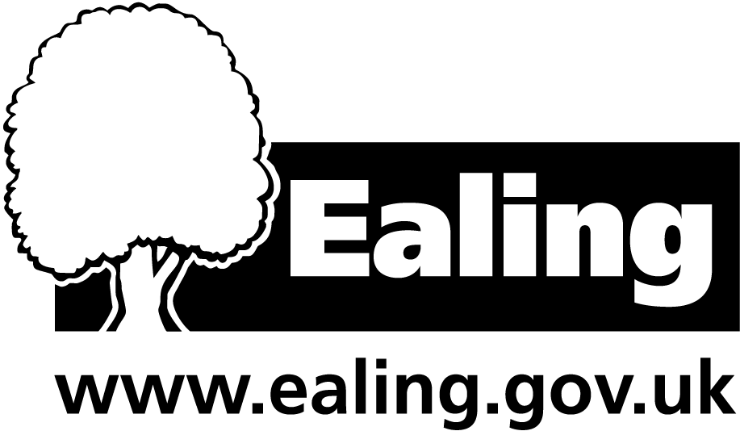**Purchase of National Governance Association (NGA) Membership**

## School Governance Development Service

**For one year 1st April 2019 – 31st March 2020**

I would like to confirm our school wishes to purchase NGA membership (please tick relevant package/s)

|  |  |  |  |
| --- | --- | --- | --- |
| **Standard membership: £90** |  | **+ Learning Link £79** |  |
| **Gold membership: £240** |  | **+ Learning Link £79** |  |
| **No NGA membership** |  | **Learning Link only** | **£159** |

*

This is for a one-year subscription running from 1st April 2019 – 31st March 2020

|  |  |
| --- | --- |
| **School name** |  |
| **Contact details for invoice:** |  |
| Name: |  |
| Position: |  |
| Email: |  |
| Telephone: |  |
| **Contact details for membership if not above:** |  |
| Name: |  |
| Position: |  |
| Email: |  |
| Telephone: |  |

I understand that Ealing Council will invoice the school for the total amount in the summer term 2019 School Governance will provide details of the contact person (above) to the NGA who will in turn contact that person to set up access with the governing board. If this is not the correct person please provide alternative name and contact details.

**Please complete and return by Friday 15th March 2019 School Governance Development** [governors@ealing.gov.uk](mailto:governors@ealing.gov.uk)