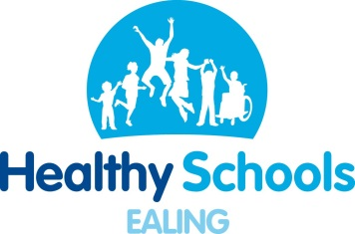
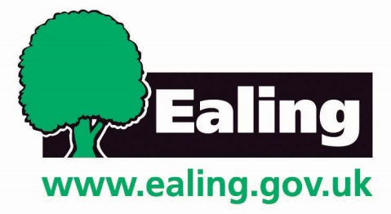
Resource List

2020/21
Health Improvement
Health Improvement Team
Resource List

The Ealing health improvement team are a trusted and qualified team of experts, providing support and training in safeguarding prevention, mental health and emotional wellbeing, nutrition and exercise, Relationships and Sex Education (RSE) and PSHE to help improve your pupils’ health and achievement.

About our Services
All Ealing schools get a free health in school visit. Most schools also buy back the Awards & Training package, 4 Day Bespoke Package or one of our specialist packages. Schools that buy back any of our packages get our conferences, networks (PSHE & mental health) and specialist workshops for free.
Specialist packages:
RSE, Mental health, & Reducing obesity.
Awards & Training Package

Includes six practical workshops to help you achieve the HSL awards, access to the Ealing Healthy Schools partnership, a celebration event, plus a choice from over 30 training workshops.

Awards & Training Package

- Awards & Training Package
Universal

Provides four days of comprehensive bespoke work, pre- and post-surveys to measure impact, an impact report and continuous phone and email support.

4 Day bespoke package

- Universal Service

Includes pre and post surveys to measure impact, pupil assembly, parent workshop, staff INSET, policy review, central trainings in the health area, and up to four targeted activities in the health area.

About this resource list
The Health Improvement resource list provides schools with the all the tools needed to develop and deliver health and wellbeing activities in their school. In this resource list we have included the useful resources on each our five health areas. To access the hyperlinked resources, download the electronic version from www.egfl.org.uk/healthy-schools.

Karen Gibson  Safeguarding prevention  Health improvement manager | Nicole McGregor  Nutrition & exercise  Senior health improvement officer | Emily Rayfield  Mental health and emotional wellbeing  Health improvement officer

Contents

NUTRITION
Curriculum 4
School lunch 4
Cooking at school 4
Breakfast 5
Parents’ awareness 5
Obesity and diet 5
Dining room 6

ORAL HEALTH AND HYGIENE
Personal hygiene 6
Oral health 7

PHYSICAL ACTICITY
Physical activity 7

SAFEGUARDING PREVENTION
Preventing extremism 8
FGM 8
Safeguarding 9

PSHE EDUCATION
PSHE 10
Drugs Education 11
Anti-bullying 11

RELATIONSHIPS AND SEX
EDUCATION
Relationships and sex education 12

E-SAFETY
E-safety 13

MENTAL HEALTH AND
EMOTIONAL WELLBEING
Mental health 14
Cooling down 14
Bereavement 15
Body Image 15
Gender stereotyping 16
Healthy relationships 16
Awareness and stigma 17
Mindfulness 17
Resilience 17
Stress and anxiety 18
Curriculum
Nutrition | Food a fact of life  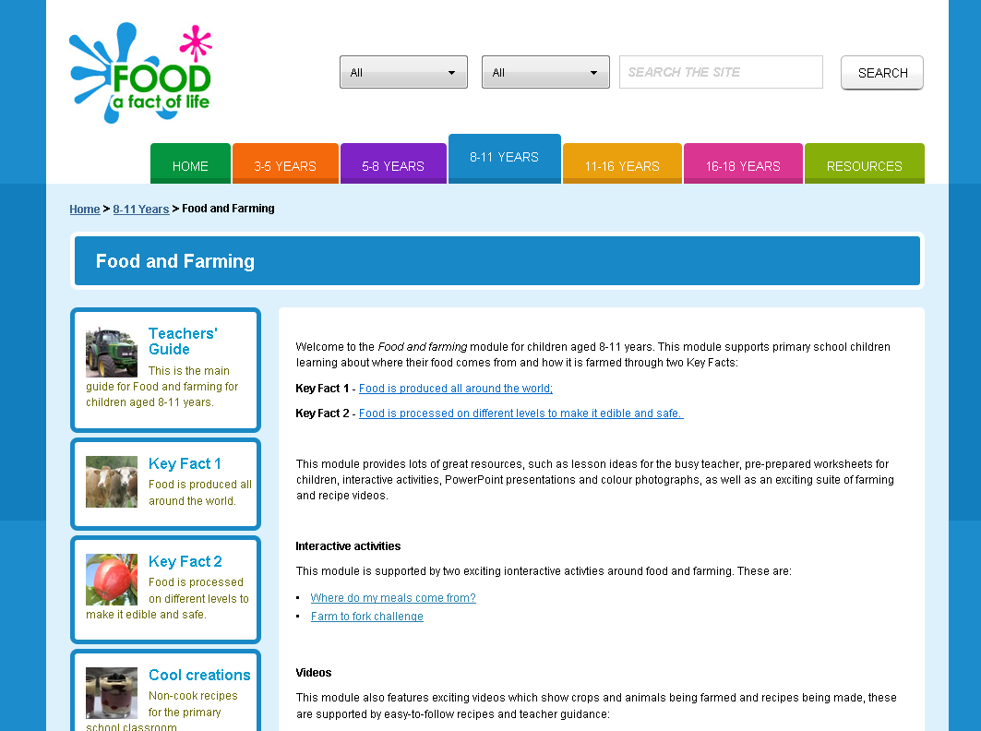 |  |  | Change4Life school zone |  |  |  |  |  |  | The great grub club  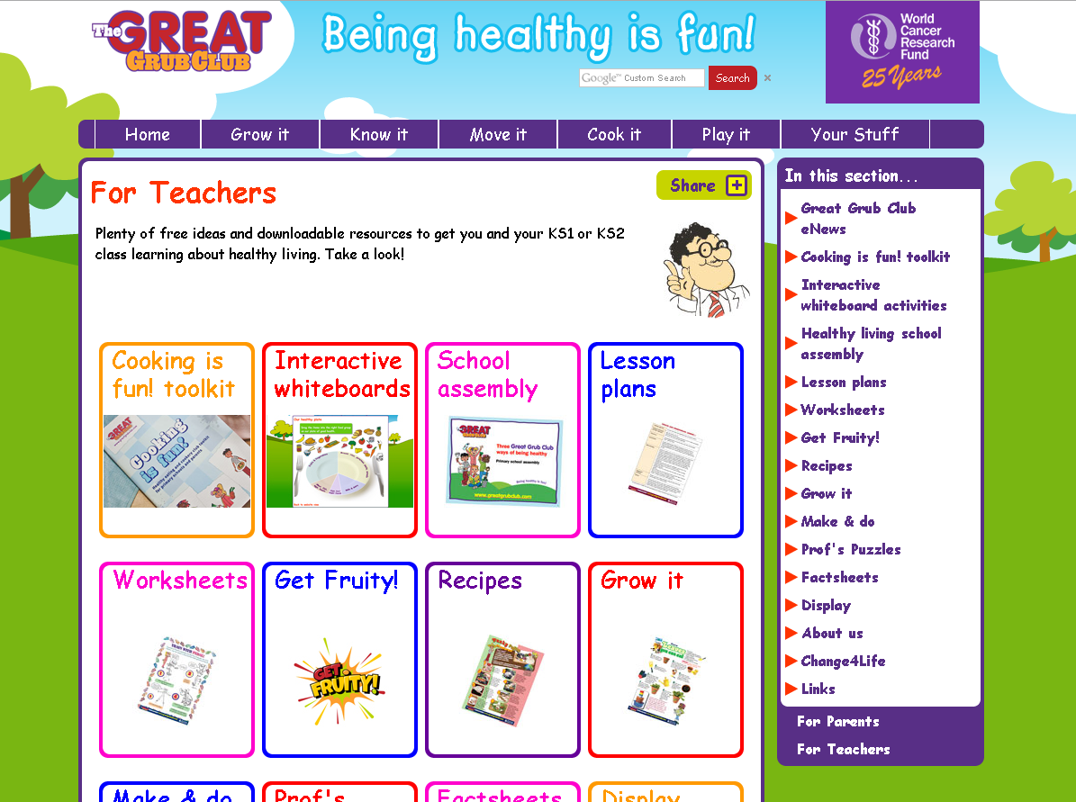
 | Food a fact of life lessons teach children about food and nutrition. The activities and resources provided are in line with the PSHE curriculum. Here you will also find the DT cooking and nutrition scheme of work. |  |  | Change4Life’s School Zone provides curriculum-linked materials about healthy eating and being active. Find here lesson ideas for KS1 and KS2 pupils. |  |  |  |  |  |  | The Great grub Club website includes lesson plans on healthy eating for primary pupils, assemblies, recipes and interactive whiteboards.
School lunch
Nutrition | Healthy Lunchtime Toolkit  The Healthy Lunchtime Toolkit explains how schools can successfully introduce a packed lunch policy and reward system in school. The toolkit includes policies, posters, letters, assemblies and surveys that you can adapt. Download a copy from EGFL under the ‘Toolkits’ tab. |  |  |  |  |  |  | Lunchbox recipes and tips  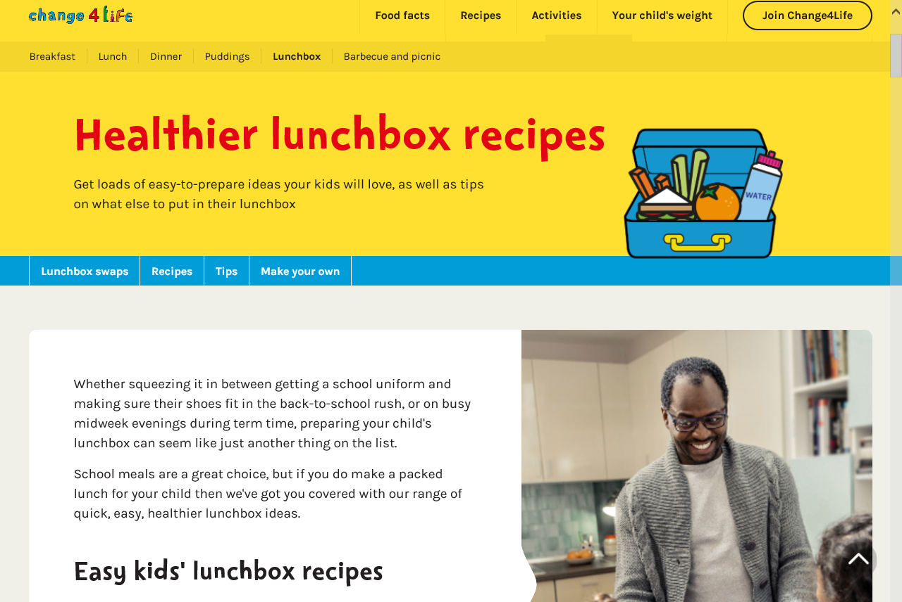  Change4Life has produced a website listing lunchbox recipes and tips for putting together a healthy packed lunch, quickly and inexpensively. See the Change4Life website for more information.
Cooking at school
Healthy eating | Food a fact of life  The Food a fact of life’s cooking and food skills module for KS1 and KS2 pupils supports pupils to learn about food preparation and cooking. Find here lesson plans and recipes for cooking in the DT curriculum. |  |  |  | Change4Life  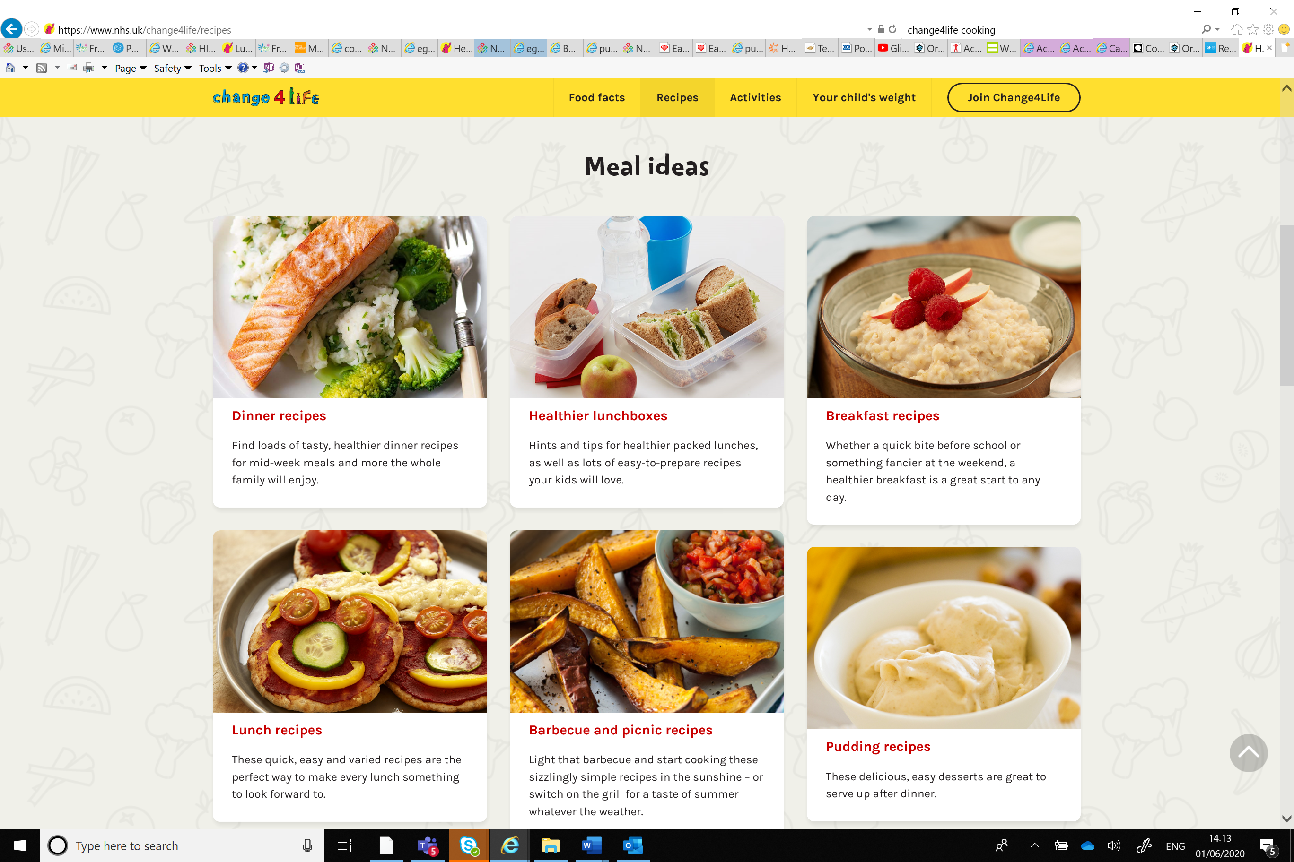  Change4Life has a wide range of breakfast, lunch, dinner snack and dessert recipes that are easy, quick and cheap to make. Change4Life also has resources to support  with cooking at school such as the Classroom Cooking Toolkit.
Breakfast
Nutrition | Magic Breakfast  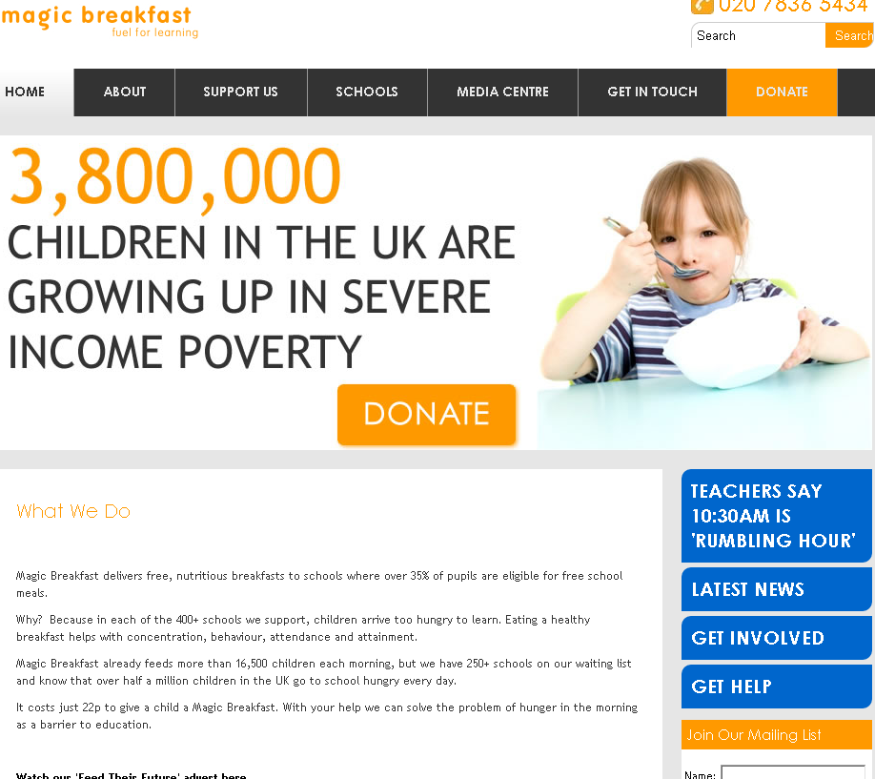  Magic breakfast provide ideas about how to set up a breakfast club, how to fundraise, where to get free food for your club and resources to help set up your breakfast club. |  |  |  |  | Breakfast Club Toolkit  Breakfast Clubs, more of a head start is a very comprehensive booklet to help schools set up a breakfast club with sample letters, checklists, questionnaires and more.
Parents awareness
Nutrition | Health Fair Toolkit  The Health Fair Toolkit includes all the tools and information you need to plan a successful health fair in your school. Download a copy of the toolkit and health fair contact list from EGFL. |  | Are You Sugar Savvy?  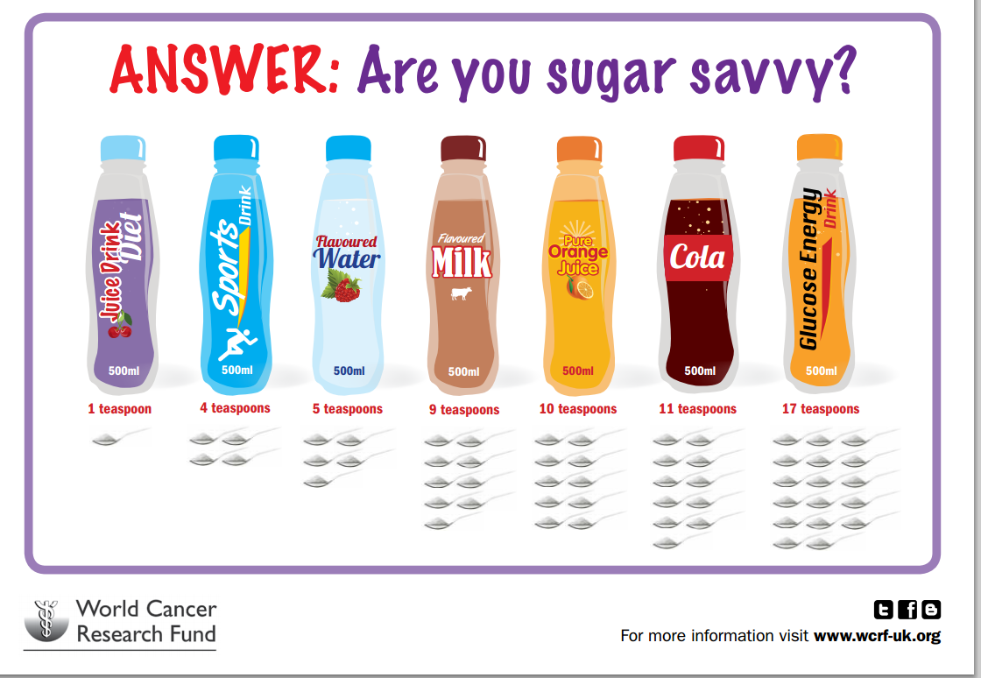  Play Are You Sugar Savvy with parents and children at health fairs. Players may be surprised to learn how much sugar some drinks contain. |  |  |  |  |  |  | Newsletter snippets  Fifty newsletter snippets on healthy eating for your parent newsletter. Download from EGFL under health improvement, resources, nutrition tab on EGFL
Obesity and diet
Nutrition | BNF healthy eating week  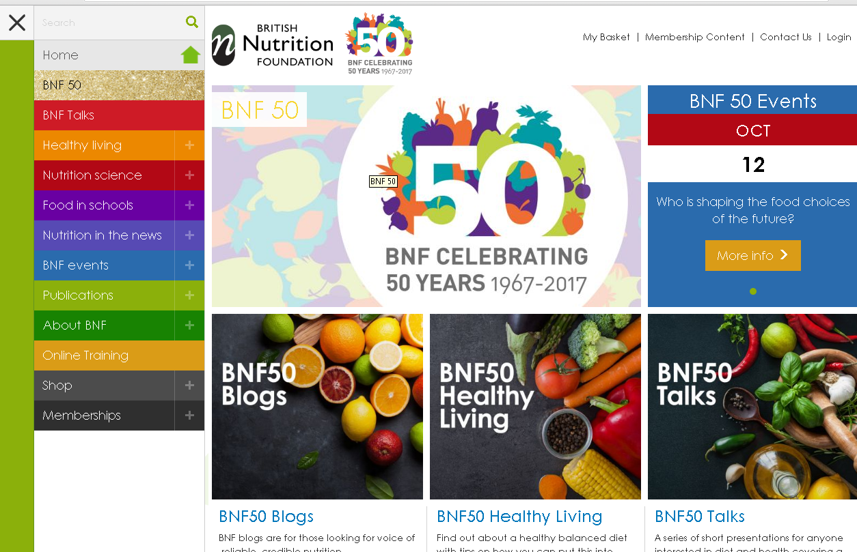  Register for Healthy Eating week 2021 online to receive a free healthy eating week pack full of resources, ideas and activities. To register your school, click here. |  |  | Whole school food policy  This toolkit outlines the steps needed to develop a whole school food policy and includes a range of helpful resources. Use our model policy on EGFL. |  |  |  |  | Eat Like A Champ  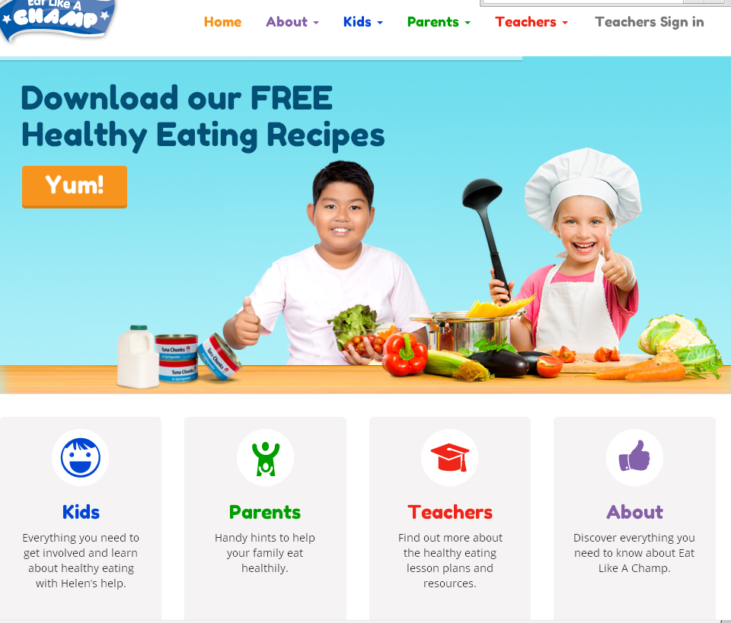  Eat Like A Champ is a free six-week healthy eating programme for year 5 pupils. Year 5 teachers can sign up to receive their free resource pack here.
Dining room
Nutrition | Dining room toolkit  Improving the dining experience in schools guidance booklet brings together ideas and suggestions for your school to help improve the experience pupils have at lunch time. |  |  |  |  |  | How to create calm dining halls  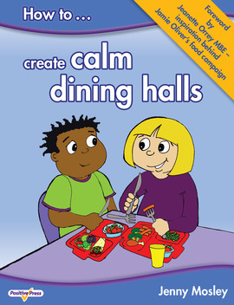  Jenny Mosley’s book on How to create calm dining halls provides ideas and case studies to improve the lunchtime experience. It retails at £19.95.
Personal hygiene
Oral health & hygiene | Wash your hands poster  Wash your hands poster shows the eight-step hand washing technique in pictures. | Glow germ  Teach pupils how to wash their hands properly with the Glow germ activity. Buy a kit on amazon or demonstrate this activity using glitter. |  |  |  |  |  |  |  |  | e-Bug  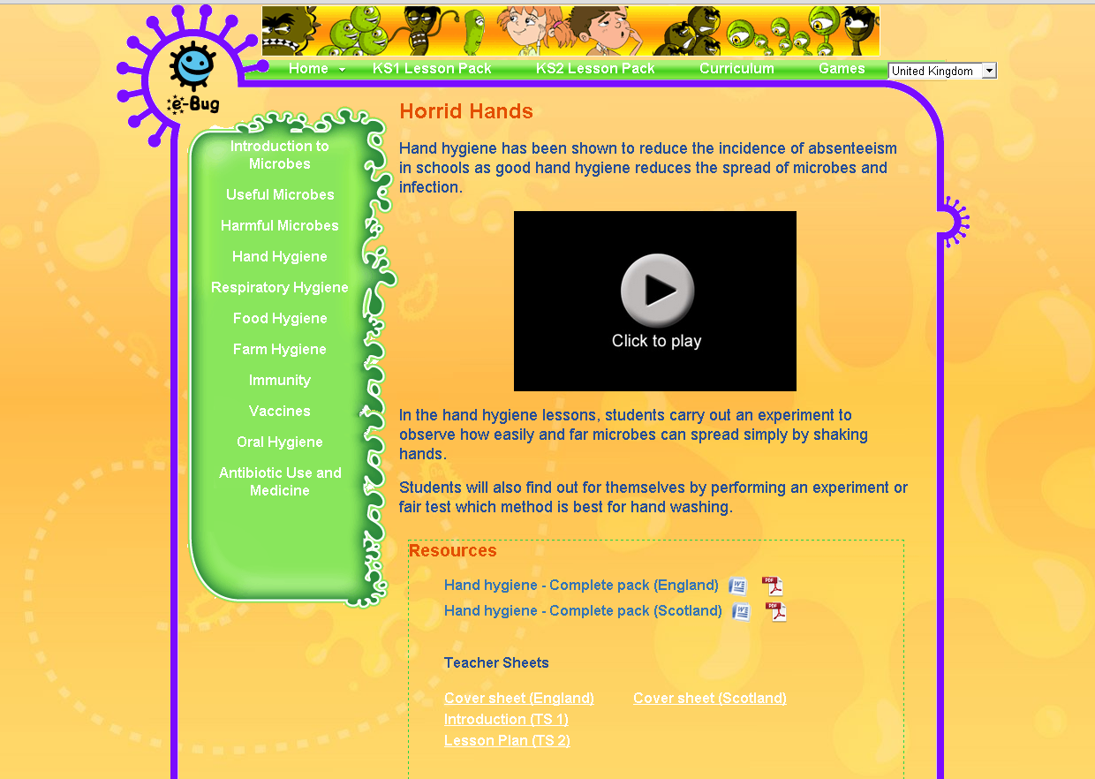  The e-Bug website includes lesson plans, activities, videos and posters on hand washing and personal hygiene.

Oral health
Oral health & hygiene | Dental buddy  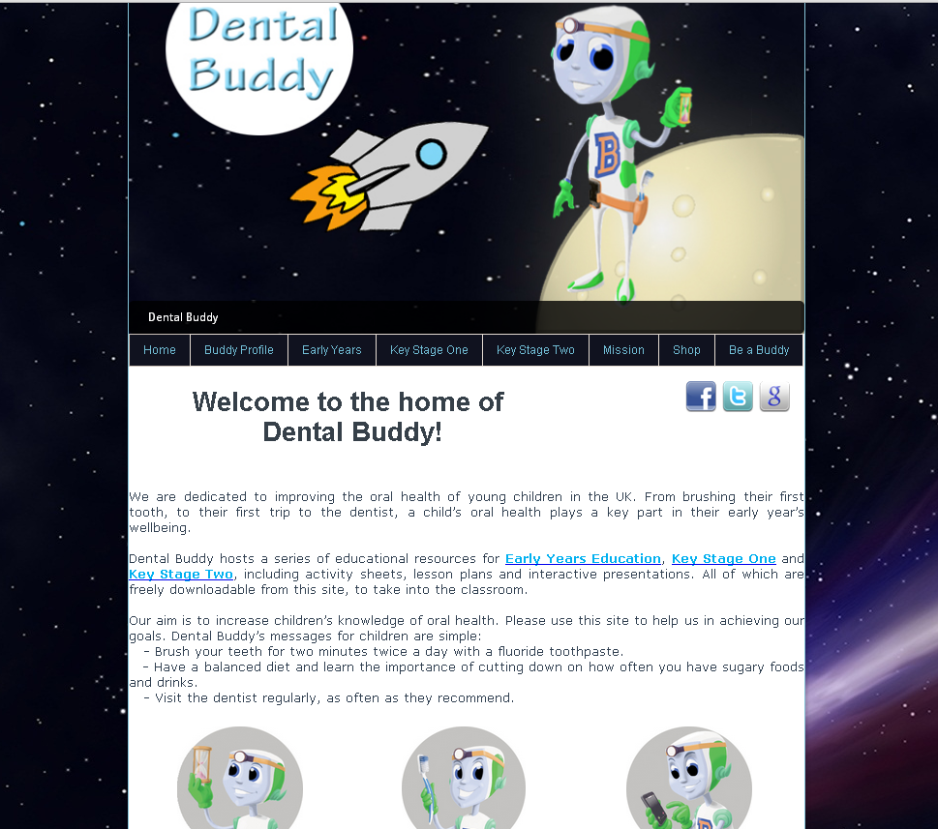  Dental buddy includes free lesson plans on oral health for KS1 and KS2. Order a range of resources including leaflets, goodie bags, sand timers, teeth models and sugar in foods kit. |  | The Comic Company  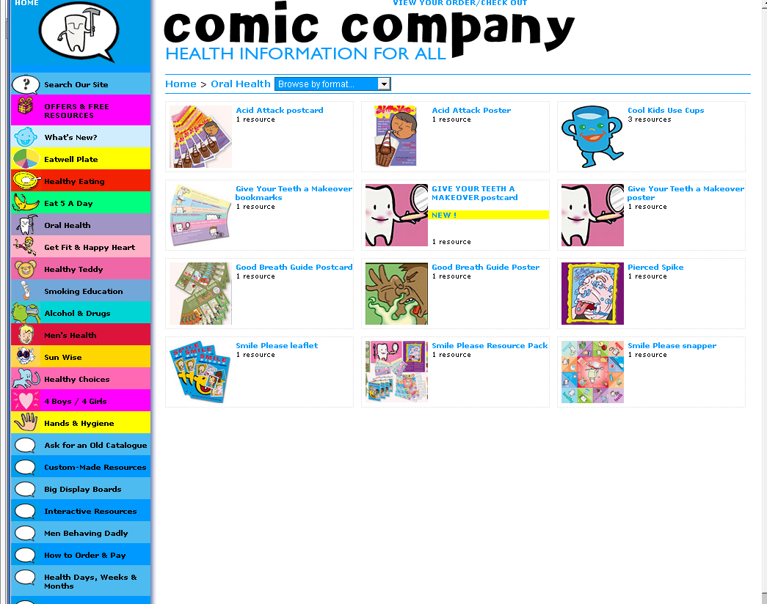  Purchase leaflets, posters, games, bookmarks and postcards on oral health for your school from The Comic Company. |  | e-Bug 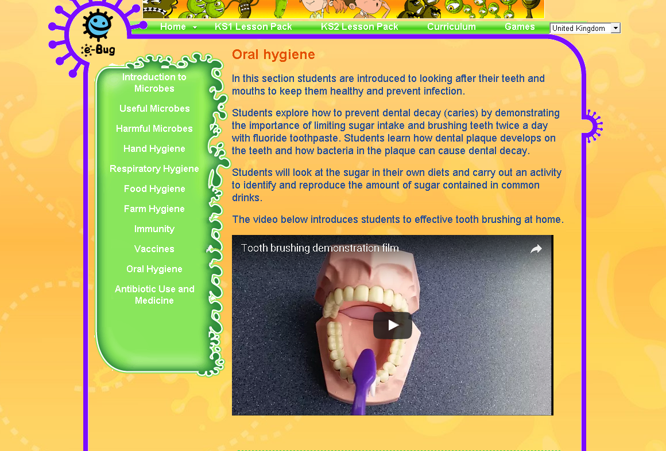  The e-Bug website includes videos and activities on how to prevent dental decay. All lesson plans are linked to the school curriculum.
Physical activity
Physical activity | Active Ealing  The Active Ealing website lists the activities available to children in Ealing after school. | Youth Sports Trust |  | Change4Life Sports Clubs
 |  | 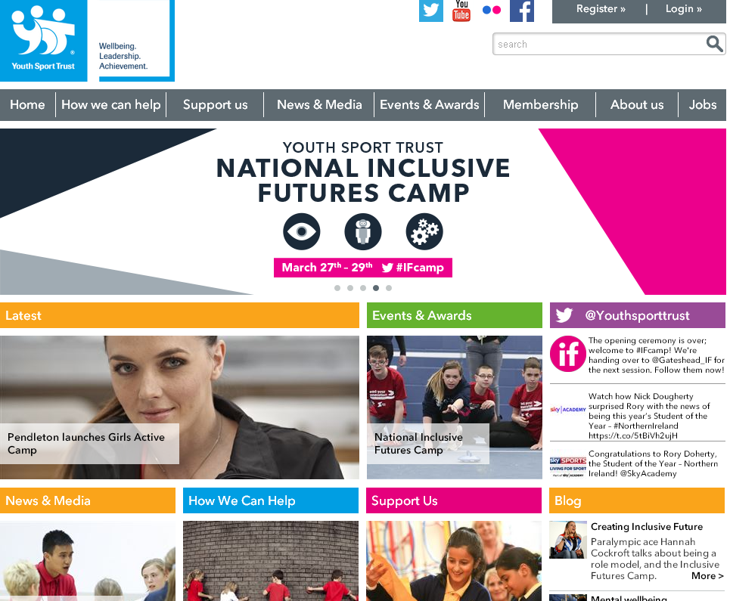  The Youth sports trust website lists a range of sport programmes available to schools, including some free programmes. |  | 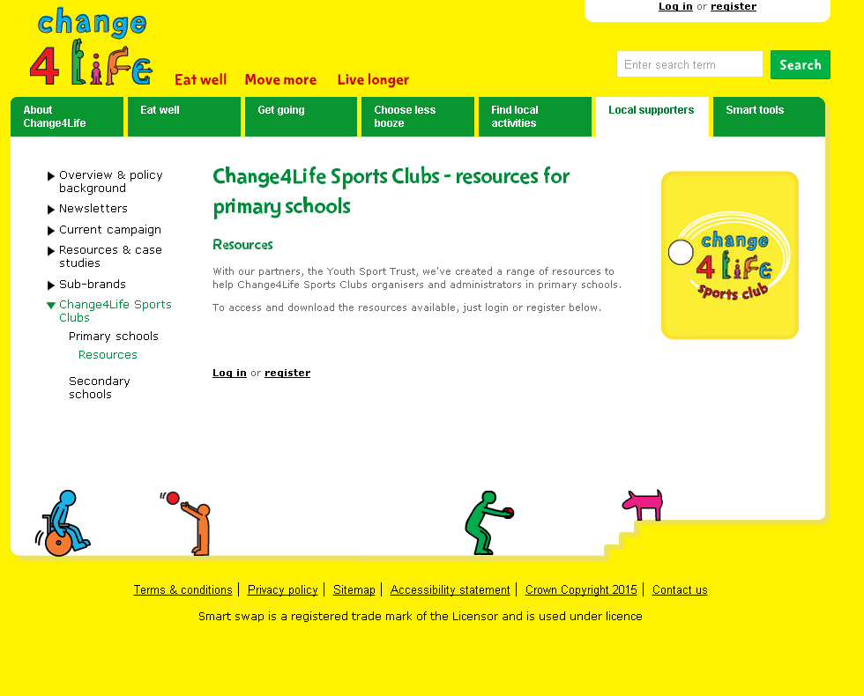  Change4Life Sports Clubs aim to engage less-active children in physical activity and school sport. Schools can use their sport funding for this.
 | The Daily Mile  The Daily Mile toolkit includes letter templates, flyers, surveys and assemblies to help you set up the Daily Mile. Download a copy from EGFL. | Fit4Sport  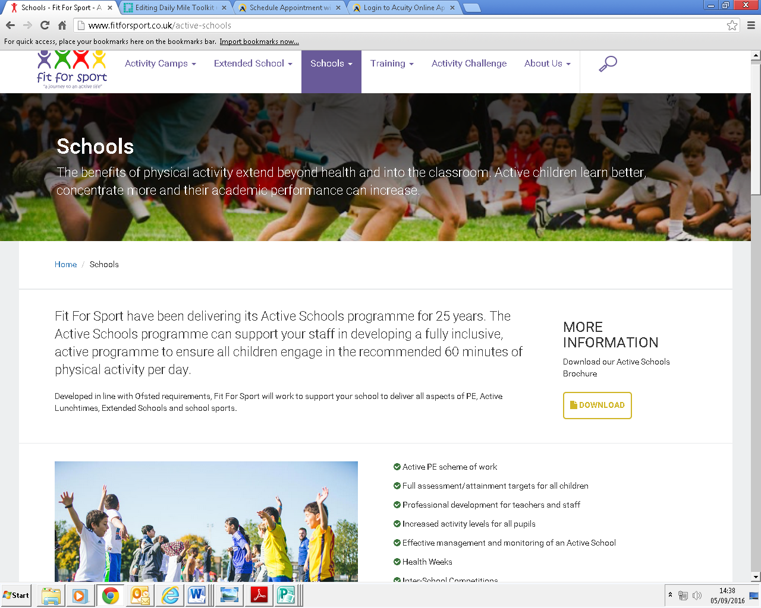  The Fit4Sport team upskills school staff through training courses and resources. They deliver fully inclusive PE and offer structured and fun activities during play times. |  | Walk to school week  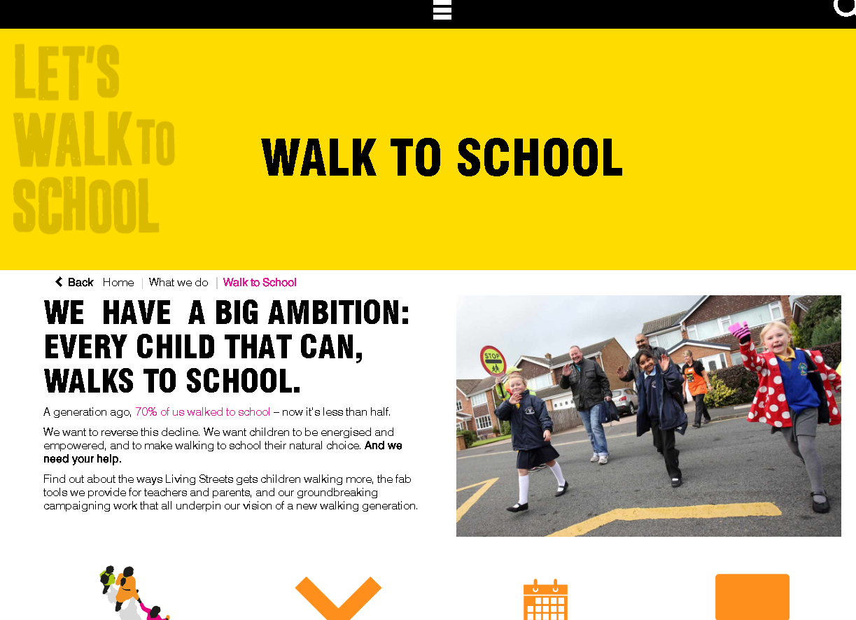  The living streets website includes resource packs and materials for schools interesting in getting involved in ‘Walk to school week’.
Preventing extremism
Safeguarding prevention | Discussing a terrorist attack with children in the primary phases  This guidance, which was developed by the PSHE Association, gives practical suggestions for ways that you can structure questioning, discussion or further learning about such events. It is not intended as a script or lesson plan, but to help teachers answer questions, structure discussion and, if appropriate, extend children’s learning and understanding. | Supporting children worried about terrorism  The NSPCC have developed a series of support tools for teachers and parents to support discussions about terrorism. These resources include top tips for parents, a video to support discussion and signposting to further support tools. | Ealing Prevent Toolkit
 |  |  | Ealing Prevent Toolkit for Schools includes ideas, resources and practical approaches to support primary and secondary school practitioners to understand the principles of the Prevent strategy and implement the Prevent duty as part of a whole school approach.
FGM
Safeguarding prevention-FGM | Ealing PSHE SOW for teaching FGM lessons  The Ealing primary PSHE scheme of work has lessons focused on raising children’s awareness of FGM. These lessons are taught in the summer term for years 3 – 6. | DfE statutory guidance  Working Together to Safeguard Children is a framework for all local safeguarding partners to make arrangements to work together to safeguard and promote the welfare of local children | Lesson plan
 |  |  | This FGM Lesson is for use in KS3 but can be adapted to be used in year 6. It is to raise awareness of the practice of FGM and to inform young people of the facts and issues, and how and where to get help if they need to.

Safeguarding
Safeguarding | DfE statutory guidance  Statutory guidance for schools and colleges on safeguarding children and safer recruitment. The NEW version is now available. | ESCB/ HIT Safeguarding series  The ESCB runs series of briefings for schools on safeguarding issues such as FGM, RSE and child protection. For further information, please look on CPD online or contact Karen Gibson.
 | Run, Hide, Tell  The Run, Hide, Tell resource pack has been produced by the National Counter Terrorism Security Office, as part of their ACT for YOUTH campaign to inform 11-16 year olds of how best to react to a gun or knife terror attack. | #knifefree  The free-to-download lessons – one for key stage 3 and one for key stage 4 – will inform young people of the consequences of carrying a knife and inspire them to pursue positive alternatives, using real life stories of young people’s experiences as a basis.
 | EGFL Safeguarding and Child Protection  The EGFL Safeguarding pages provide information and resources for headteachers, governors and designated safeguarding leads in schools. | ESCB Multi-Agency  Vulnerabilities Screening Tool  A vulnerabilities screening tool to complete if concerned about the safety of a child where the primary risk is outside of the family home.

PSHE Education
PSHE Education | PSHE Association  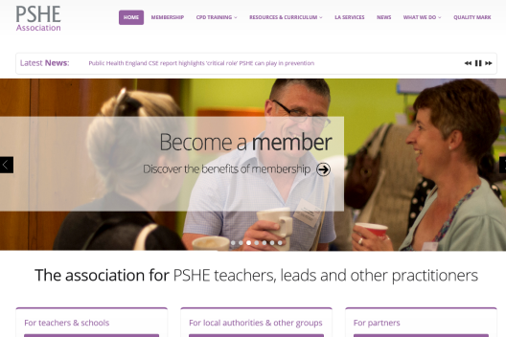  The PSHE Association have lots of up to date guidance, policies and resources to help you deliver high quality PSHE at your school. | Ealing PSHE scheme of work  The Ealing HI team have re-developed the PSHE scheme of work for Primary Schools. This scheme of fully compliant with the DfE statutory guidance for Relationships and Health education. Contact Claire on meadec@ealing.gov.uk for more information.
 | Premier League Primary Stars  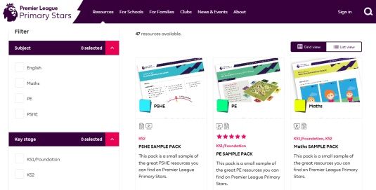  Premier League Primary Stars uses the appeal of the Premier League and professional football clubs to inspire children to learn, be active and develop important life skills. | Homelessness  Cumbria County Council’s Youth Homelessness and Housing team have produced two lessons KS4 with accompanying PowerPoint slides to support teachers in reducing the risk of homelessness.
 | econoME  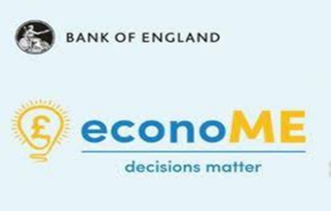  The Bank of England has launched econoME, a free PSHE education resource for students aged 11 to 16 for teaching about economic wellbeing and the economy. The lessons aim to give young people greater economic awareness and the analytical skills to make informed decisions, using real-world examples. | First Aid  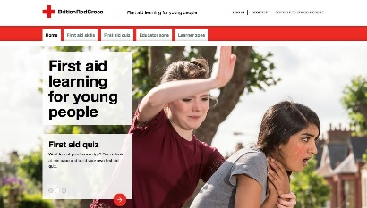  First Aid for Learning for Young People, by the British Red Cross, has been designed for KS3-KS5 pupils and aims to give students the confidence, skills and knowledge to help someone in a first aid emergency. The free resource features 16 first aid skills, which are explored using realistic scenarios relevant to young people.
 | Drugs, alcohol and tobacco education
PSHE – Drugs, alcohol and tobacco education |  | Drink Aware  Drinkaware education resources are aimed at pupils in key stages 2 and 3. These free resources are designed for 9-11- and 11-14-year olds and are flexible, allowing teachers to mix and match activities. | Christopher Winter Project  The Christopher Winter Project is a comprehensive scheme of work for primary and secondary drugs. Contact Claire on meadec@ealing.gov.uk for a copy of lesson plans and resources.
 |  | Action on Smoking Health  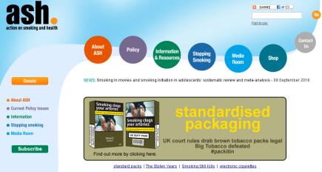  ASH provides lots of resources and information to help teach about the dangers of smoking. | Stop Smoking  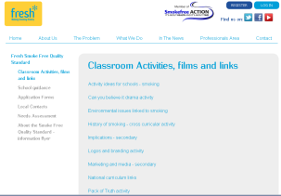  Fresh has resources to help teach about the effects of smoking. They also have great ideas for making this theme cross curricular.
Anti-bullying
PSHE Anti-bullying | Anti-bullying Alliance  The Anti-bullying Alliance provides information on anti-bullying initiatives and leads on anti-bullying week. They also have activities and resources to teach about homophobic bullying, racist bullying and gender-based bullying. | Kidscape  Kidscape has a range of advice and information on bullying available to young people, parents and professionals who work with children. They also have classroom resources to support schools in tackling a range of anti-bullying topics.
 | Show Racism the Red card has a range  of resources and materials to help tackle racism in schools. | Diversity Role Models offer workshops and teacher training on homophobic bullying.

Relationships and Sex Education
Relationships and Sex Education | Ealing schemes of work  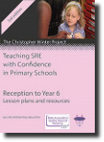  The Ealing HI team have written a series of Relationships lessons for primary schools and RSE lessons for high schools. These lessons are freely available to all Ealing schools. schools can access these resources via EGFL. | PANTS Rule  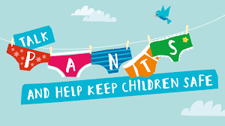  The NSPCC Pants rule is a simple set of rules for parents and professionals to help children keep themselves safe from abuse. | Image in action  Image in action - nationally recognised charity that supports schools with delivering RSE for pupils with special educational needs.
 | Woman’s Aid  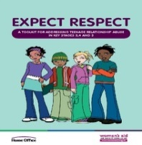  The Expect respect- toolkit for both primary and secondary schools has lesson plans and activity ideas to help plan and deliver lessons on healthy relationships and domestic abuse. | Media Smart  Media Smart has a range of resources for High School pupils based on healthy relationships and critical thinking skills online. They also have a range of resources based on pornography. | Crossing the line  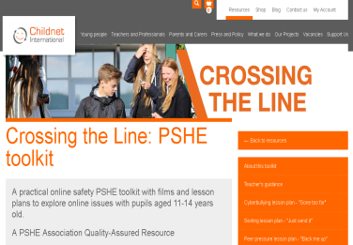  Crossing the Line is a series of PSHE lessons for High School pupils. This toolkit contains lessons on sexting, healthy relationships, peer pressure.
 | Rise Above  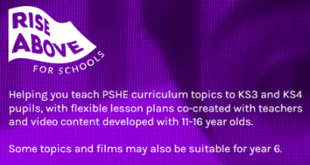  Rise Above, has a range of support materials for high schools. These include videos, lesson plans, activity ideas and guidance for teachers on topics such as bullying and cyberbullying, alcohol, positive relationships, smoking, exam stress, online stress, social media and body image in a digital world. | Making sense of relationships  These free resources include; three lessons to support transition and changing friendships at key stage 2 and six lessons exploring healthy and unhealthy relationships at key stage 3. The lessons at key stage 4 address abusive behaviour in relationships and pornography. | SRE covered  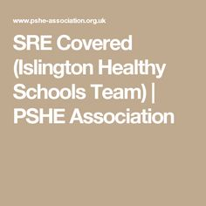  This resource pack contains a wide range of activities and resources to address the breadth of RSE topics. Lesson plans are provided for KS3 and KS4 and include a range of resources.

 | Online Safety
Online Safety |  | Online-safety toolkit  The Online-safety toolkit on EGFL has information and advice for schools, parents and pupils. | Safer Internet Day  Safer internet day will take place on the 9th February 2021. Visit the Safer Internet Day website for resources for teacher, pupils and parents. | ABA – Online resources  The Anti Bullying Alliance have many resources, lesson plans, guidance and activities to teach pupils about online safety.
 |  | Share Aware  The NSPCC online safety campaign Share Aware aims to empower parents and provide support in navigating the online world. | Leaflet for children  Childnet have produced an online safety leaflet for parents in 11 different languages. | CEOP  The CEOP Think u know website has lots of resources to teach the skills of online safety to all ages.

Mental Health and emotional wellbeing
Mental Health in Schools | Mental Health Toolkit  The mental health toolkit is a step-by-step guide for implementing and embedding a whole school approach to mental health at your school. Download it on EGFL here. | PSHE Association  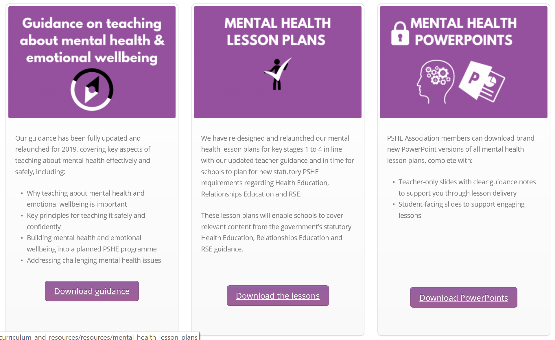  The PSHE Association offer lesson plans and guidance for teaching about mental health at each key stage.
Anger management and cooling down
Anger management | Printable behaviour charts  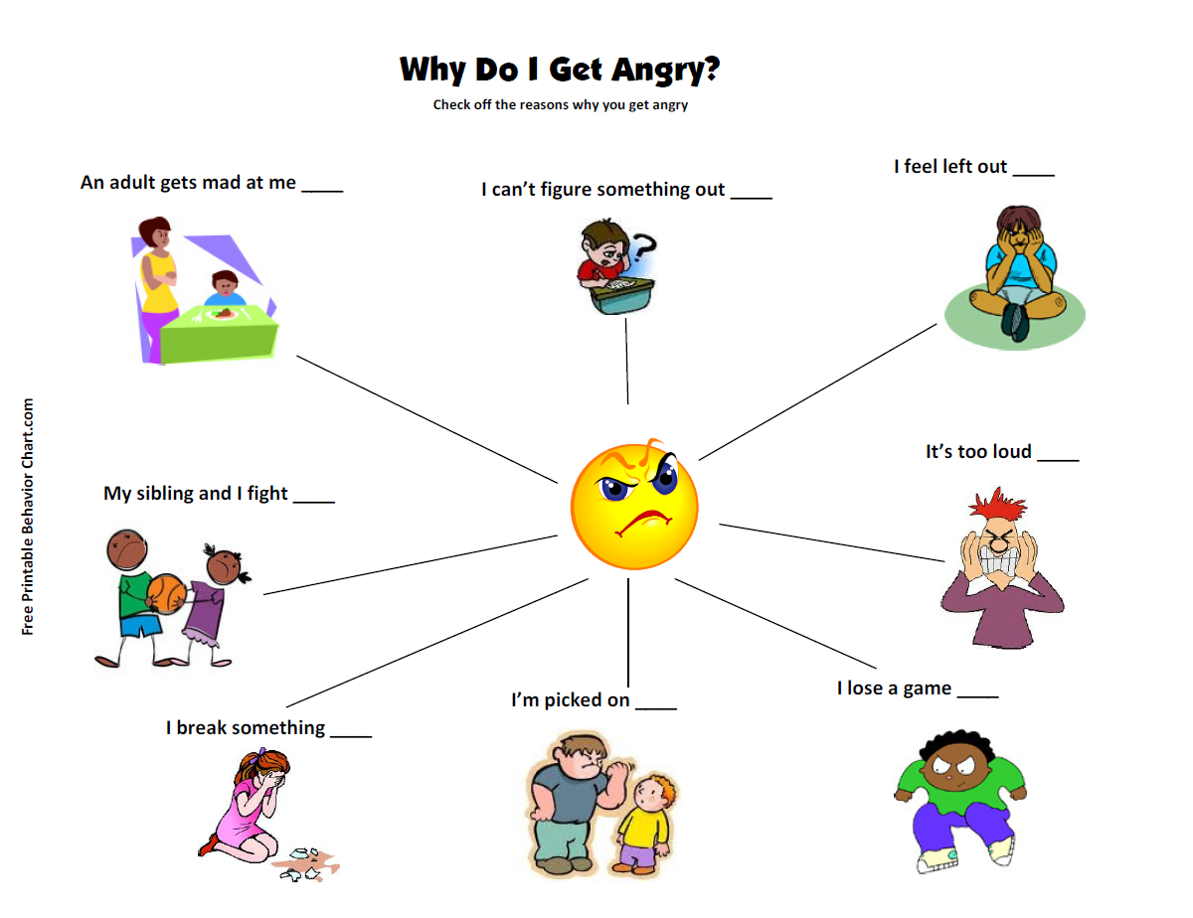  Free, printable posters and behaviour charts with calm down strategies for children. | Tucker the Turtle  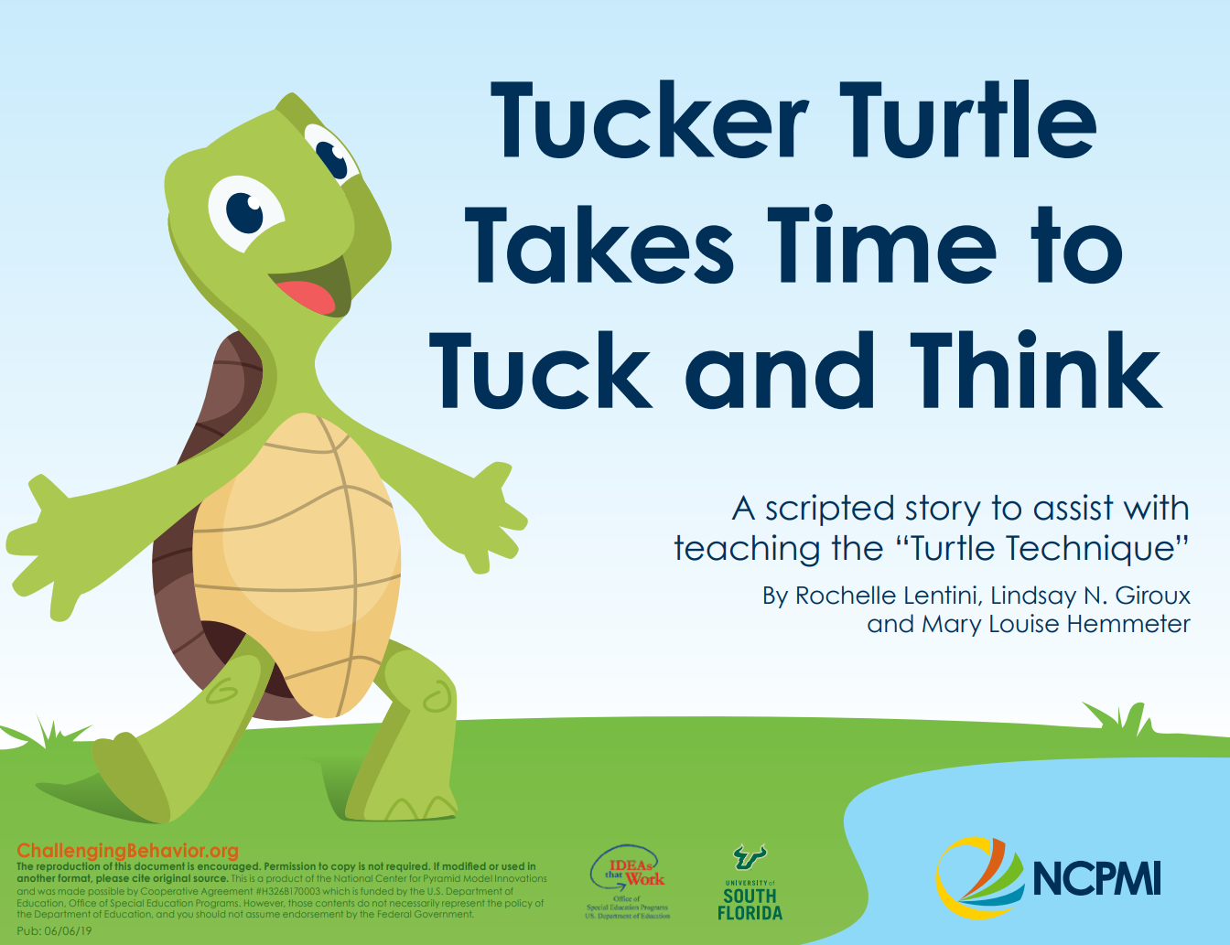  A free online story for children with strategies for anger management and cooling down.

Bereavement and loss
Bereavement and loss | Hope Again  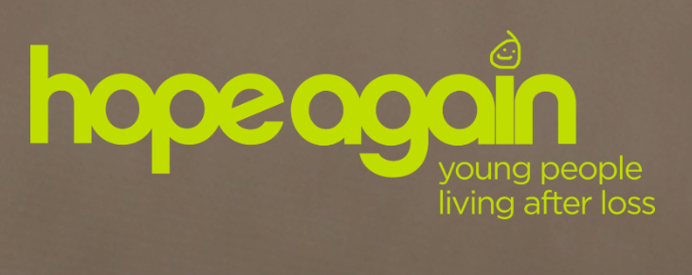  Support, advice and resources for young people, including blogs, videos, information and guidance. Cruse Bereavement Care’s website for young people. | Information for Secondary Schools  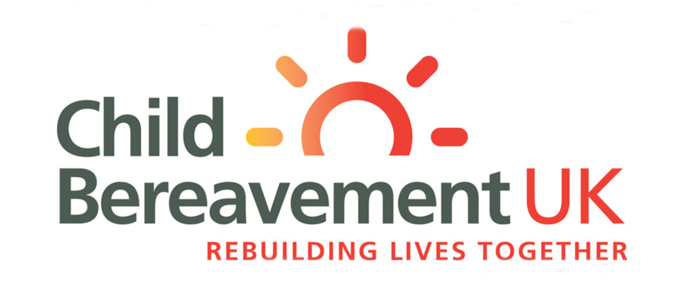  Comprehensive guidance for secondary schools on supporting a bereaved student, supporting a family or yourself, developing a bereavement policy, and managing bereavement at your school.
 | Managing a Sudden Death in the School Community  LGFL guidance for schools, in particular senior managers, with videos, support packs and assemblies. | The Elephant’s Tea Party  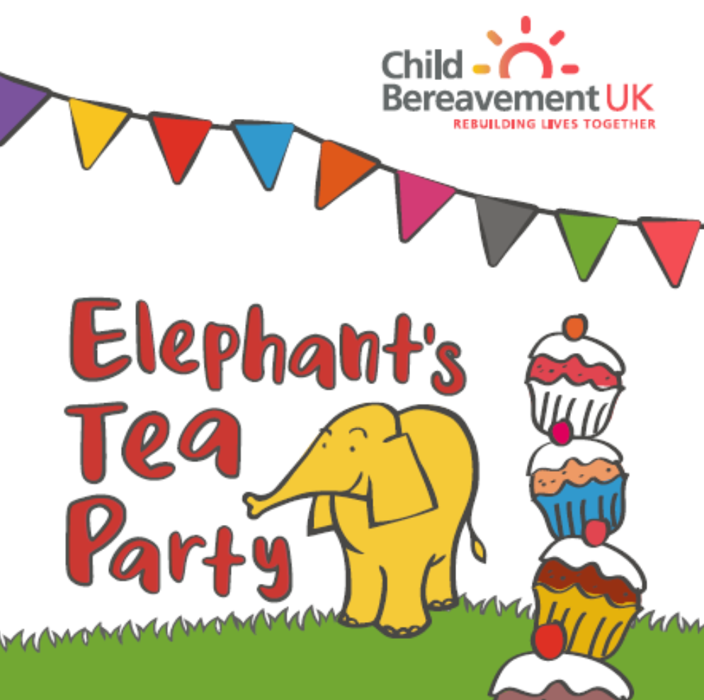  The Elephant’s Tea party is a resource pack for primary schools, exploring death and grief in a fun and age-appropriate way.
Body image
Body image | Confident Me workshops  Five workshops for cultivating health body image, and addressing appearance ideals, social media, celebrity culture and advertising, body activism and positive behaviour change. | Ofsted good practice  A detailed whole school action plan for promoting positive body image at Oak Cottage Primary School.
Gender stereotyping
Gender stereotyping | Let Toys Be Toys  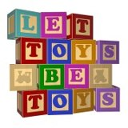  How to challenge gender stereotypes, lesson plans, help for parents and much more. |  | Lifting Limits  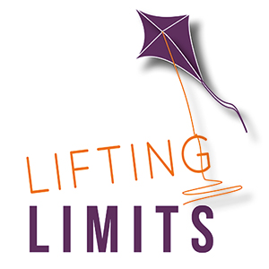  Information for education providers, resources for families, gender detective activities and book lists.
Healthy relationships
Healthy relationships | Saying ‘No’ Poster  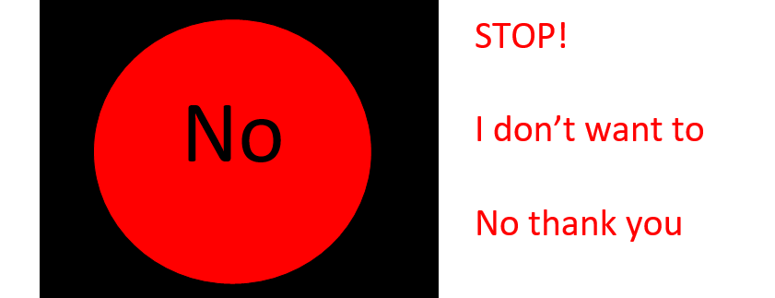  An easy traffic light system for children to remember how to say ‘no’. | The Expect Respect Educational Toolkit 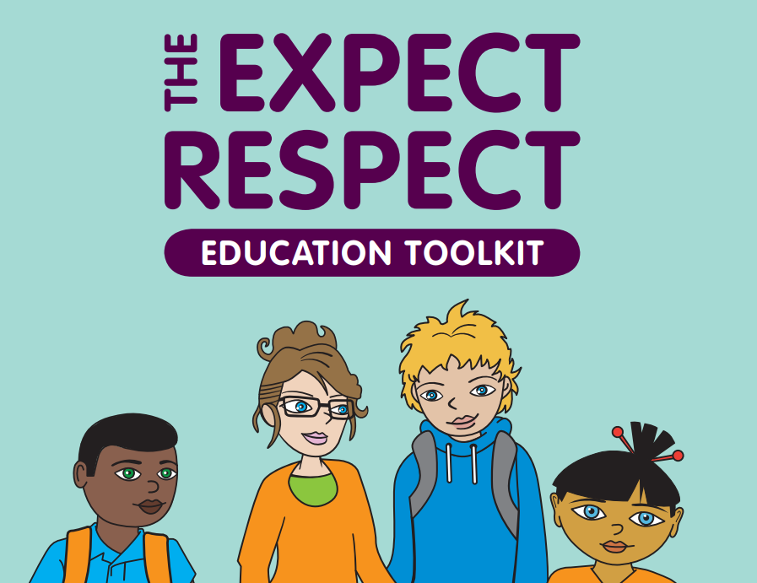  Included in the toolkit are core lessons + resources for year groups reception-year 13, based on effective themes for tackling domestic abuse.

Mental health awareness and anti-stigma
Mental health awareness and anti-stigma | Time to change  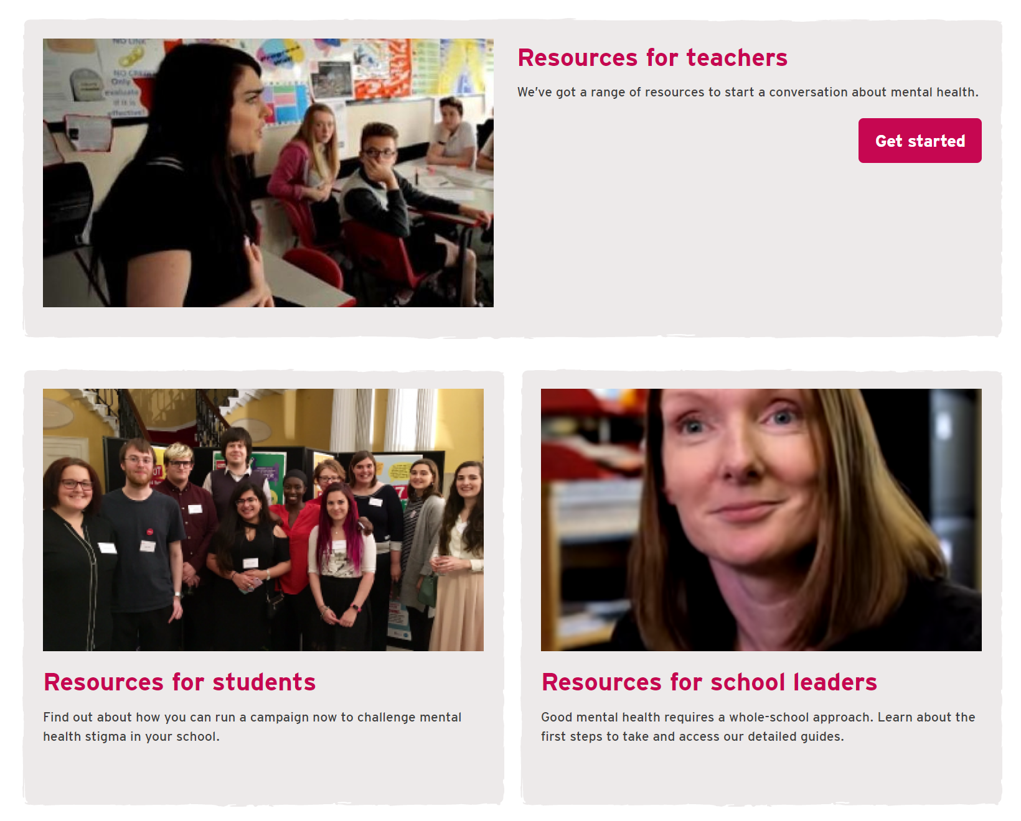  An anti-stigma campaign with resources for schools (assemblies, activities and posters) young people, and parents.
Mindfulness
Mindfulness | Mindfulness in Schools Project  Offers an 8-week mindfulness course for school staff and the Paws b mindfulness curriculum. Visit their website for free taster session. | Mindful Schools  Mindful Schools offers a wide range of training and a free online mindfulness class for kids.
Resilience
Resilience | The Resilience Framework  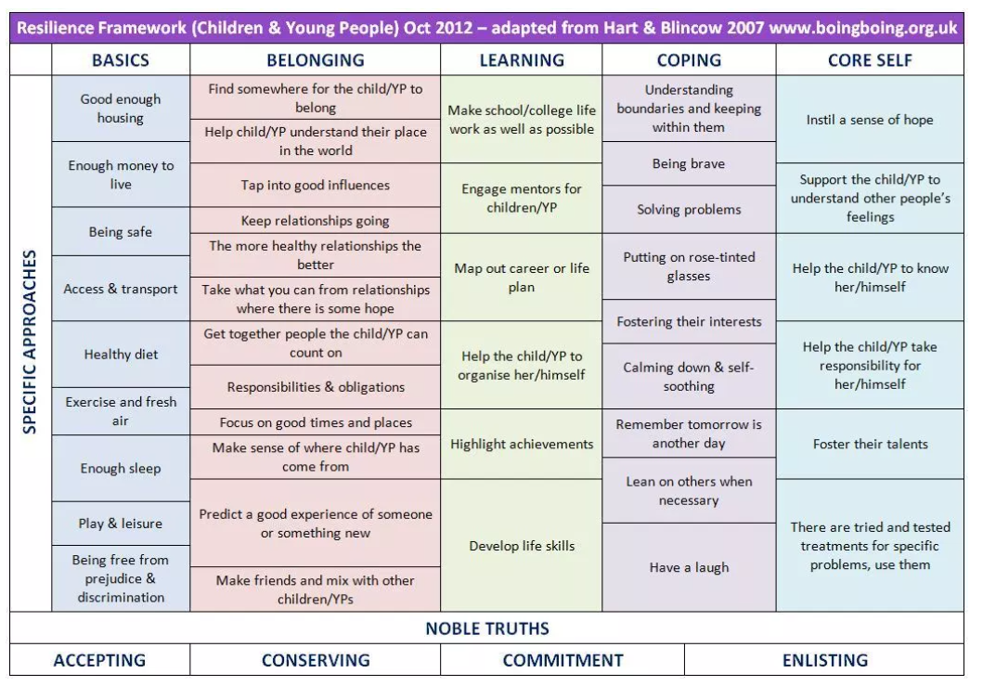  A handy table of specific approaches for building resilience in children and young people. | The Resilient Classroom  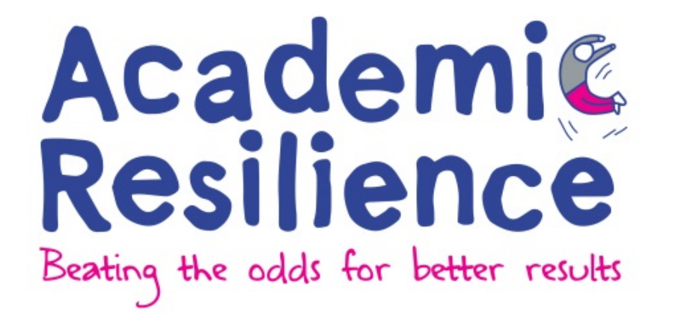  A resource pack for tutor groups and pastoral school staff, practical activities for pupils to develop resilience.

Stress and Anxiety
Stress and anxiety | Caring for the wellbeing of teachers and school staff  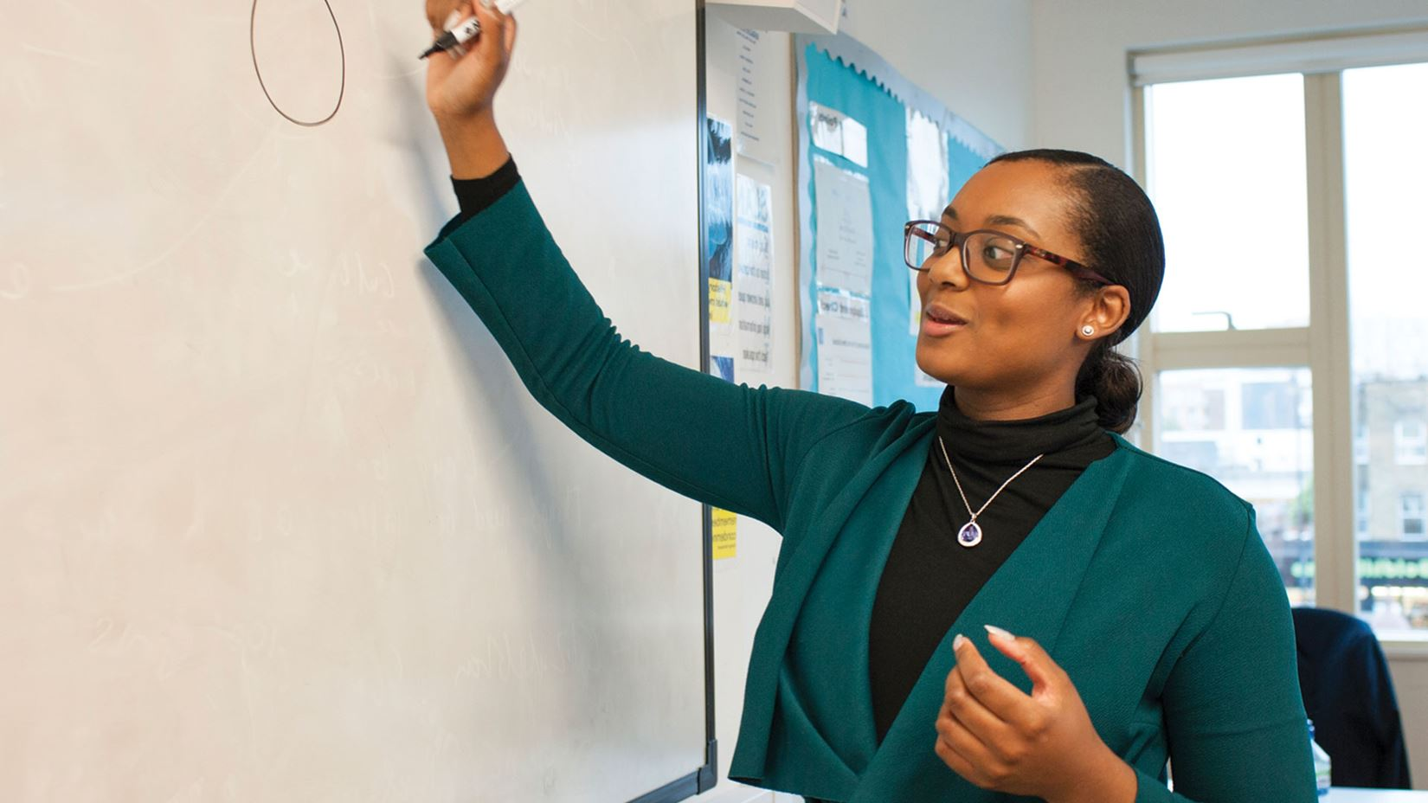  Guidance from Young Minds on the causes of stress for teachers, and what you can do in school to support their wellbeing. | Helping children and young people to manage anxiety  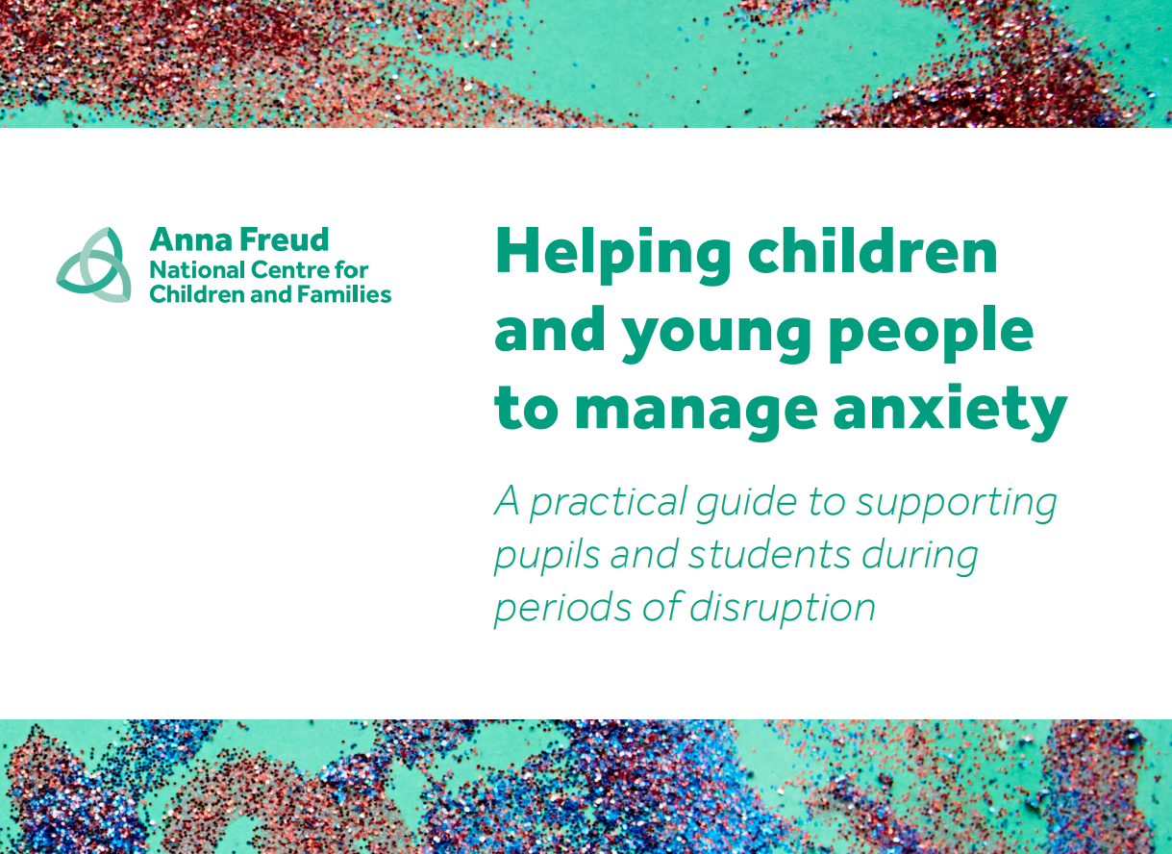  A practical guide for schools from the Anna Freud Centre.

For more information about any of the services, please contact Nicole
mcgregorn@ealing.gov.uk
020 8825 5484
www.egfl.org.uk/healthy-schools

