You see someone upset at playtime. They are feeling lonely and are finding it hard to make friends. What randon act of kindness could you do?

Random act of kindness scenario cards

One of your class mates has had some sad news. What random act of kindness could you do?
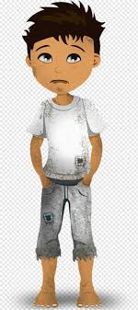

Someone in your class is worrying about their school work and feeling like they aren’t good enough. What random act of kindness could you do?

Some in your home is working hard to ensure that all the household jobs are done. What randon act of kindness could you do?

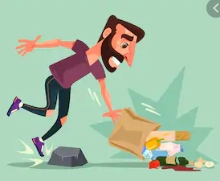
You are in the supermarket with your family and you notice that someone has dropped their shopping. What randon act of kindness could you do?

Your friend has been really kind to you. What random act of kindness could you do?
