Emotions: The Game

**How to play**

* Roll the dice to see who starts (highest roll goes first).
* Take turns to roll and use the key to find out what you need to do with the emotion you land on.
* First to the finish wins!
* If you land on the same square as another player, jump ahead one space.

Decide before you begin whether players need the exact number of squares to win.



**Tell** us about a time you felt this emotion

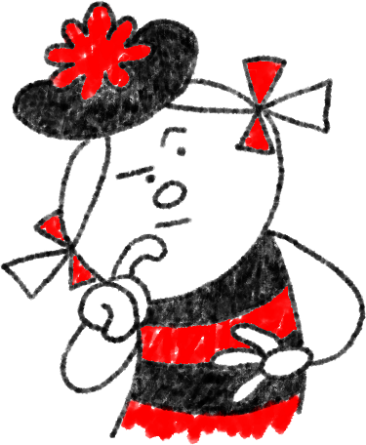

**Act** it out



**Draw** an emoji which expresses this emotion



scared

tired

nervous

joyful

shocked

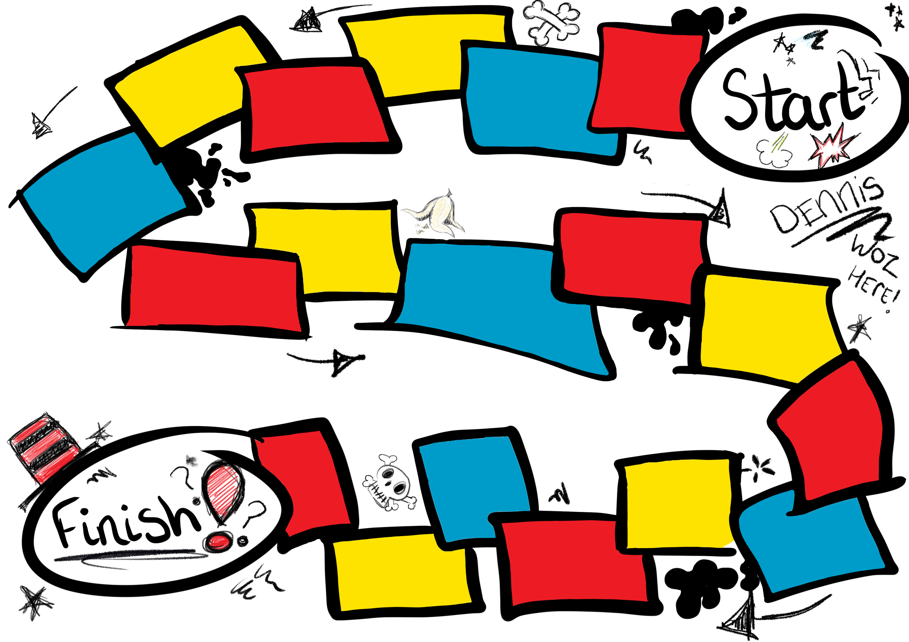

18

17

16

15

14

13

12

11

10

9

8

7

6

5

4

3

2

1

cross

guilty

proud

hurt

furious

upset

confident

angry

sad

afraid

happy

sorry

excited