**Changes In My Life**

Name:

1. Think about a change to your life that has recently happened or is about to happen – a change in your class, school year or school perhaps?

…………………………………………………………………….

2. Think of the day-to-day challenges that change may bring (for example, how much homework you might get, learning new names, getting to know a new timetable and teacher). Dealing with each of these smaller steps can be less daunting than worrying about the change as a whole.

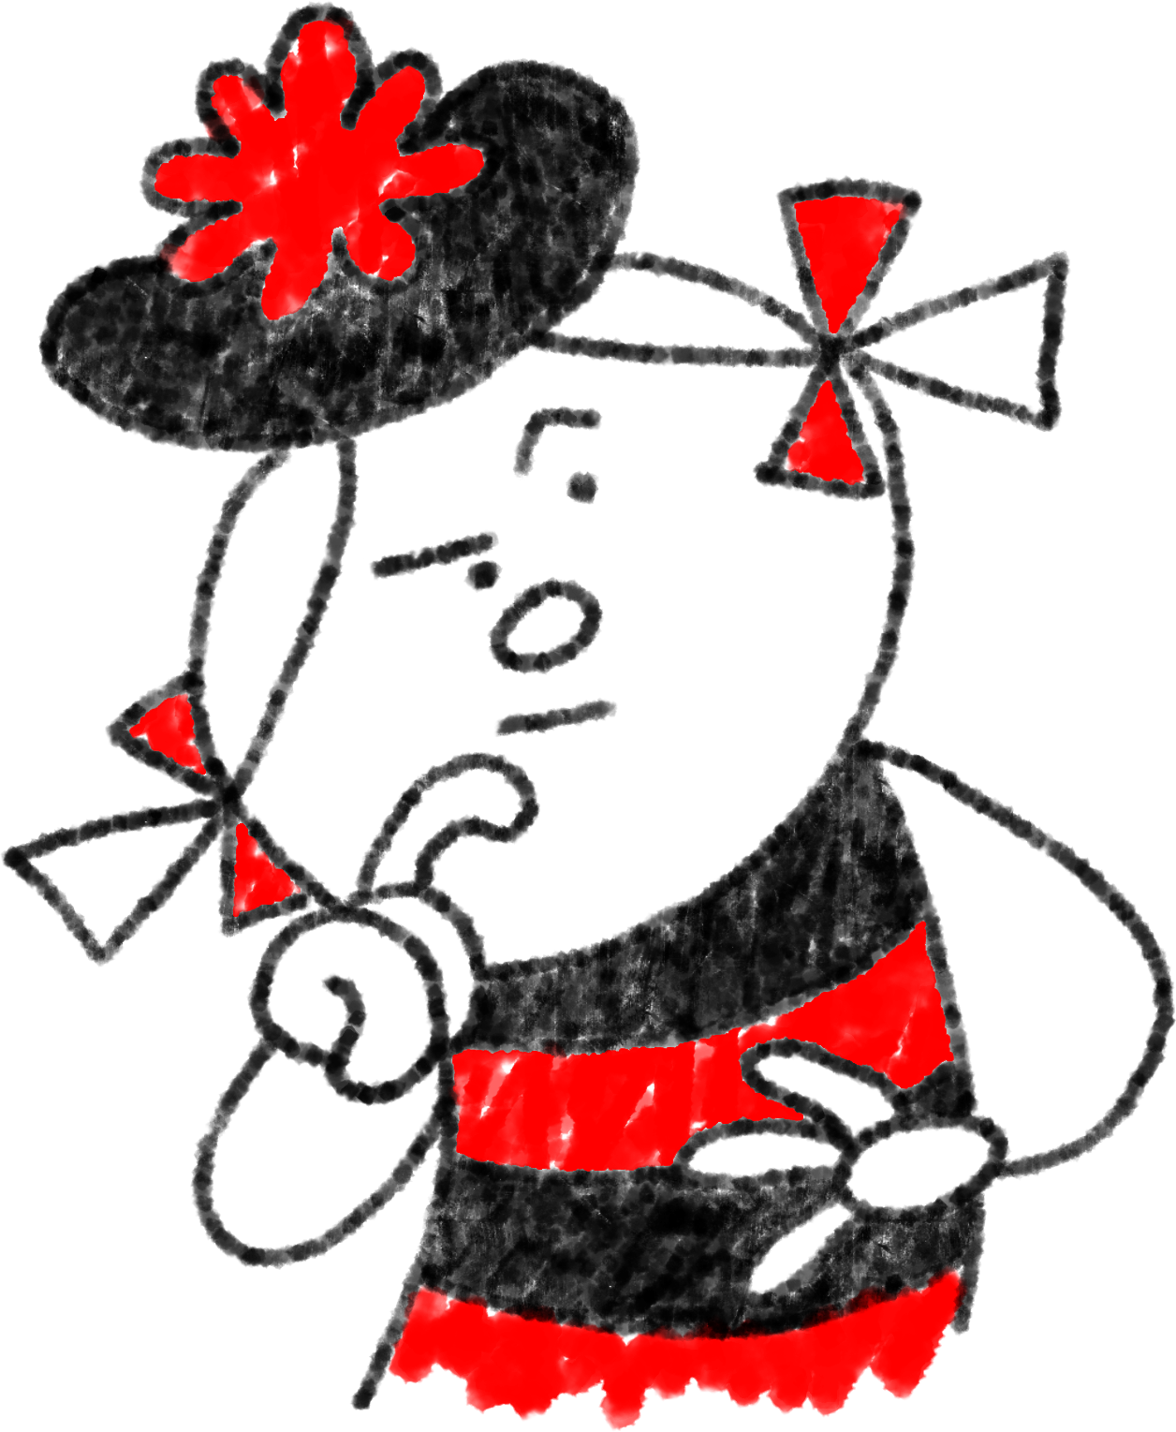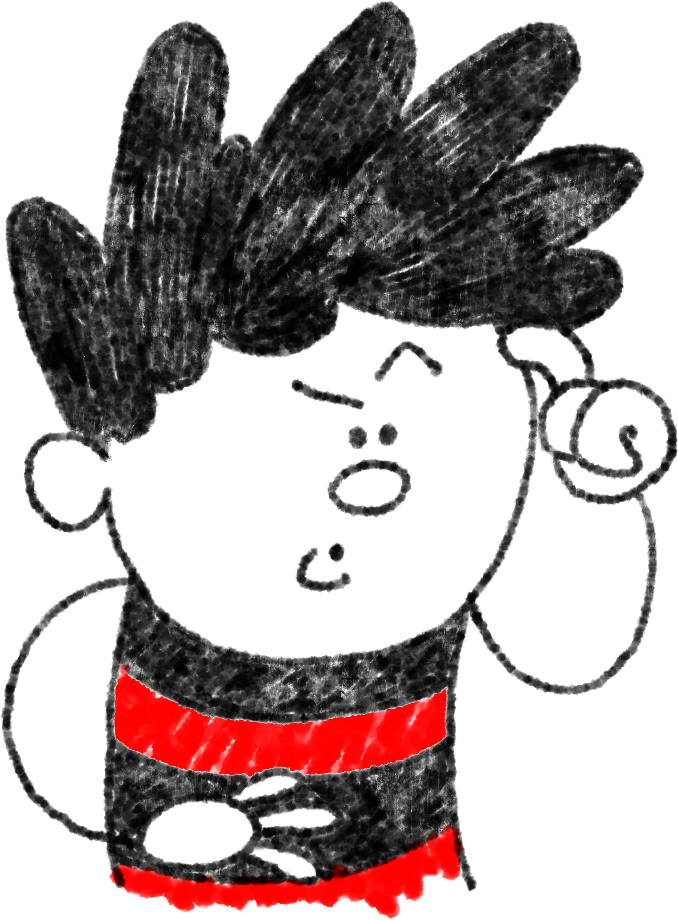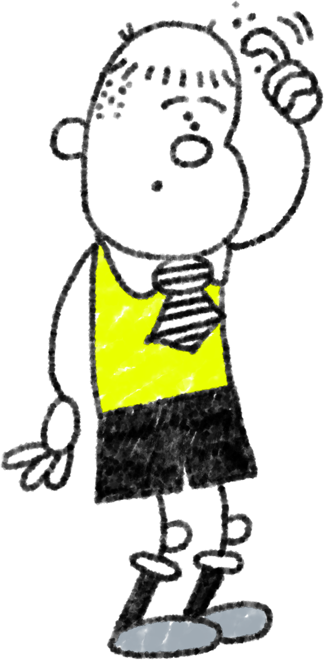Decide whether each challenge should go on the outer circle or the inner circle and write them below:

Can you think of an action you could take to make some of these challenges less stressful?

**What I can’t control**

How does it feel to have little or no control over a situation?

Who could help us feel better about these challenges?

**What I can control**