Recovery curriculum planning template
Year group:  Lower Key Stage 2 | Key skills of activity:  - Children to share what they did at home and why they enjoyed at home  - Children to share what they are looking forward to doing at school  - Children to share what they are excited/nervous about  - Children to identify positive and difficult emotions about being at home and coming back to school  Key vocabulary:  Reflecting, memories, difficult emotions, positive emotions, managing emotions, feelings, transition
Theme:  Community | - Chn to share what they did at home and why they enjoyed at home - memory jar  - During lockdown some chn felt their favourite things were taken away but what positive things have we learnt? What skills have they mastered? talents? Qualities? - Baking? Ball touches? Dancing? Times tables? Gardening?... Who have they spent it with? What was their favourite moment? Watching a movie? Funniest moment?  - Children will write a memory jar to share all the things/qualities they have learnt and improved.  - Jar can be divided into 4 boxes: best memory, funniest moment, thing that I’ve learnt.  - Share all memories and things they have learnt with their peers.  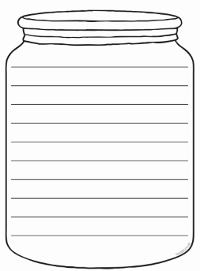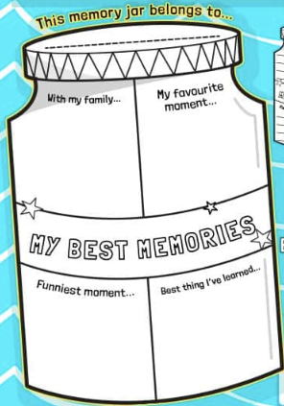  - Chn to share what they are looking forward to doing at school - email/letter/post it notes to your teacher  - Children might feel they have wasted time at home. Remind them all the skills they’ve worked on during lockdown and the hard work they did with the remote schooling.  - Now is time for chn to express all the things they missed or the goals they consider they haven’t achieved. What are you looking forward to doing at school? What did you miss the most from school? The least?  - Chn to write on post it notes/letter/email what they want to do at school.  - Children to share what they are excited/nervous about - worry tree  - It is important for children to express what they are worried/excited about. What is going to happen next? How is school going to be? How am i Going to have fun with my friends?  - Ask children to draw a tree that represents themselves and their family (or give the twinkl tree from the link below)  - On post it notes write the worries excitements you have. Stick them into your tree. https://content.twinkl.co.uk/resource/09/ef/t-p-314-back-to-school-worry-tree-_ver_3.pdf?__token__=exp=1591181915~acl=%2Fresource%2F09%2Fef%2Ft-p-314-back-to-school-worry-tree-_ver_3.pdf%2A~hmac=2c52b3eb5f4d9d41df19cb4a2a1f4135e094517ed88d00f21044dcf9f99cd409  - Children to identify positive and difficult emotions about being at home and coming back to school  - Share with chn emotions chard https://www.twinkl.co.uk/resource/feelings-pictures-printable-t-t-292  - How did they feel while being at home? How do they feel now? Which emotions have disappeared/ appeared/ changed?  - Make chn understand the importance of having negative/difficult emotions. Share strategies will help us change the perspective of difficult emotions.  - Identify all the thoughts and emotions that as a class or individually we consider negative and transform them into positive. Activity sheet.  - https://content.twinkl.co.uk/resource/01/75/t-c-255094-making-negative-thoughts-into-positive-thoughts-activity-sheet-english.pdf?__token__=exp=1591280565~acl=%2Fresource%2F01%2F75%2Ft-c-255094-making-negative-thoughts-into-positive-thoughts-activity-sheet-english.pdf%2A~hmac=d770f4fd24285c08fdc936c67824ff4b6ed182ed3646da7d3e6e8dd5d3a273d2  - Reflecting on time at home  - Ask children to think about the kinds of activities they did for home learning, what they did together with their family and what they did when they had time on their own.  - Ask what they enjoyed about the kinds of things they did. Did they enjoy their time at home?  - Together build a time line of the week’s children spent at home.  - Children create their own time lines of the kinds of activities they did.  Week 1 week2 week3 week 4 week 5  - Looking forward  - What are you most looking forward to, now that you are able to be back at school?  - Is there anything that is worrying you about returning to school? This could be that they are worried that they have forgotten things that they learnt since the school closed. Tell them that this is a natural type of feeling that many of them will think.  - Discuss as a circle time event. Remember social distancing.  - Children to draw pictures and annotate about what they are nervous and excited about coming back to school. These can be displayed on working wall so that they can come back to them at a later date to talk about again  - Identifying emotions  - Start with creating a vocabulary bank or cut up and complete the feelings match-up  - Look at the booklet or poster Lesson 3 resources. Read together, stopping at appropriate places. (photocopy A5 booklets for each child for them to keep as a reminder)  - Discuss the information in the booklet as a class. Record the children’s responses.  - Discuss why the safety measures have been put in place.  - Children may ask why they are not together as a whole class. This can create another discussion ask them for their ideas about this.  - Talk through how the situation has changed from what they remember. Children could annotate their booklets if that helps them to see that things are going to be ok and that they are safe at school.  - Reassure them that it is ok the feel nervous about the changes, but they can embrace them and it will be ok.  - Time capsule  - Classes to make a time capsule of their time during lockdown and then bury it within the school site.  - Create a show box/letter box which will allow children to write letters to a pen pal/other student in a different school in their community about their time during lockdown and give 3 things they did that were positive during lockdown.  - Story books  - Each day focus on a different book from ‘Book Beyond Words’. Look at the pictures as you go through the book and create/make up a story. Could be done as a whole class or in groups.  - Circle time games  - Find someone who game – where the statements can be related to what children might have done during lockdown and children to go around the class and find someone who meets the statement.  - Kindness origami  - Make an origami kindness jar either in class or at front of the school– Children to write kind statements and notes and fold it into a start using origami. When a child needs a little pick-me up, they can pick a star, open it and keep the kindness statement.  - Visits  - Keeping in mind and following Government Guidelines/When safe to do so – Visit the Elderly at a nearby home and share their experiences with them. | Next steps/evaluation of activities:  Chn share the things they have been doing during lockdown with their/family community with their friends and teachers. Challenge themselves to continue learning/practicing those skills when coming back to normal.  Express that all the time spent at home is a different way of learning and that they have developed other skills they don’t use at school. Encourage children to keep expressing what they are expecting from school.  It is okay to have different feelings. This is a new situation for everyone. Encourage children to keep expressing their feelings.  Changes in our lives make us feel different things. Sometimes negative emotions can weigh more in the balance. Chn to propose the strategies they will use when this is the case
Week: 2 of 5 | Guidance for teacher:  We must recognise that curriculum will have been based in the community for a long period of time. We need to listen to what has happened in this time, understand the needs of our community and engage them in the transitioning of learning back into school. | Additional support needed:  If you notice any pupils may need extra support with transition back to school, please make note here and speak to your Designated Safeguarding Lead/Pastoral Lead.

