Name:
Managing Difficult Emotions

The feeling |  |  |  | The way this feeling might makes us behave
Anger |  | 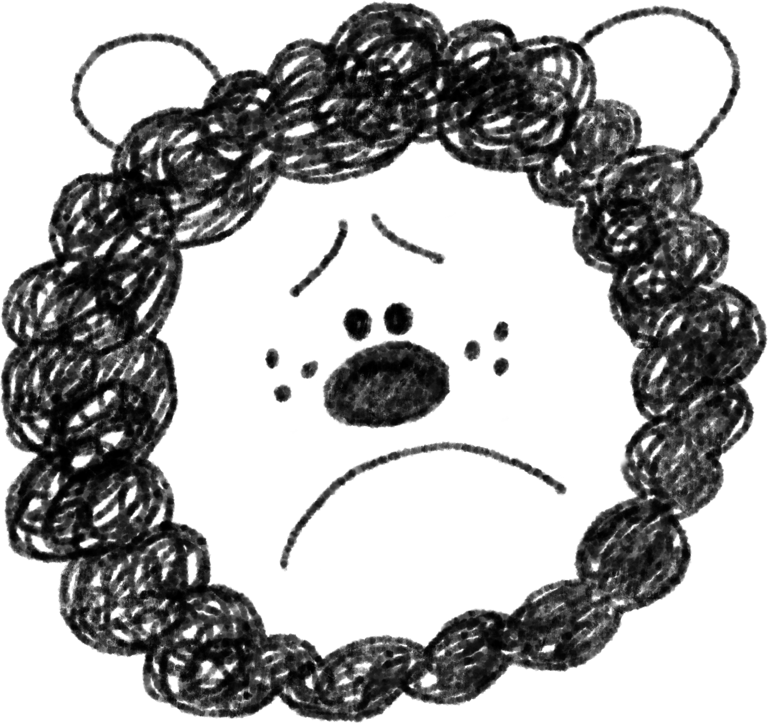 |  | I might want to cry. I might want to run away from everyone and be quiet and alone.
Sadness |  | 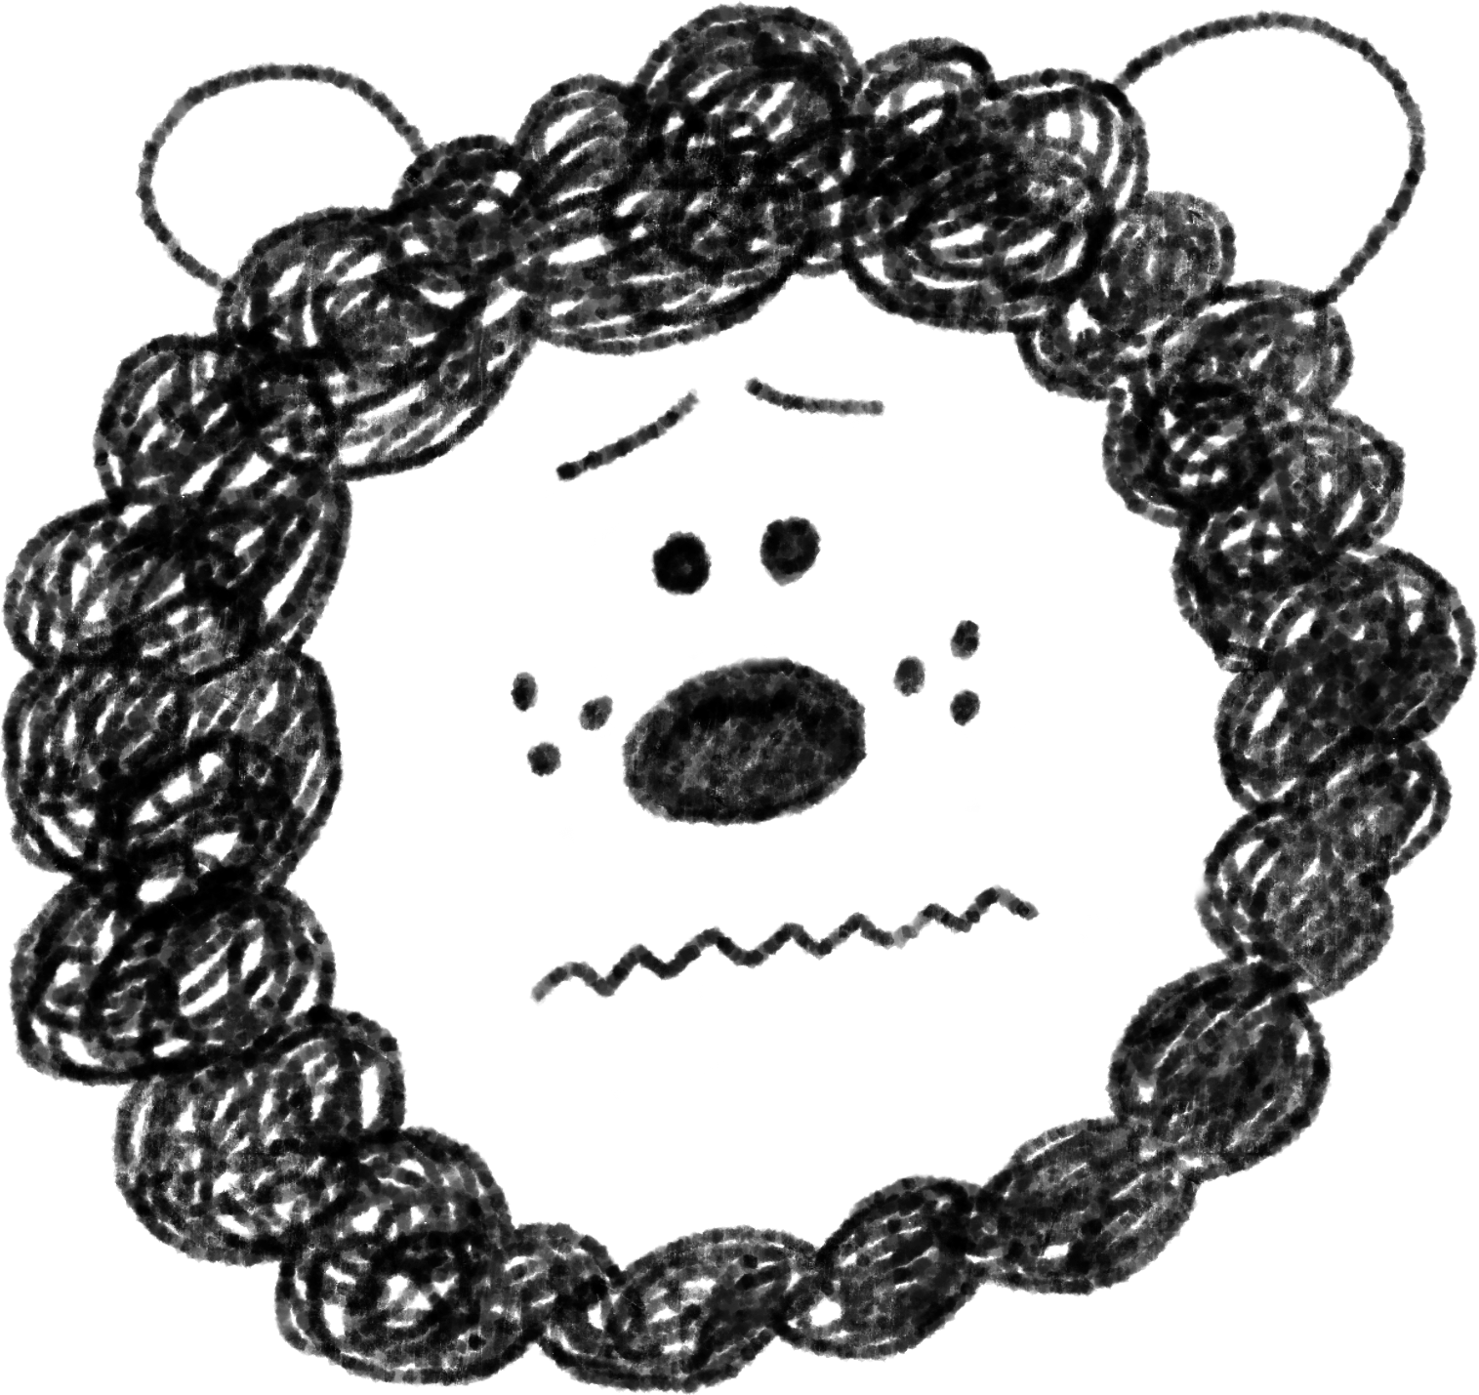 |  | I might feel annoyed and my face might redden and feel hot. I might want to shout, scream or even hit something. Others might feel a little scared around me and I might say upsetting things that I don’t really mean. It might feel like I could explode.
Worry |  |  |  | I might feel a little hot and sweaty and my tummy might feel funny. I find it hard to stay still and my may heart race. I want to hide and might feel tearful.
Draw lines to match the face with the feeling it is showing, and with the behaviour this might lead to.

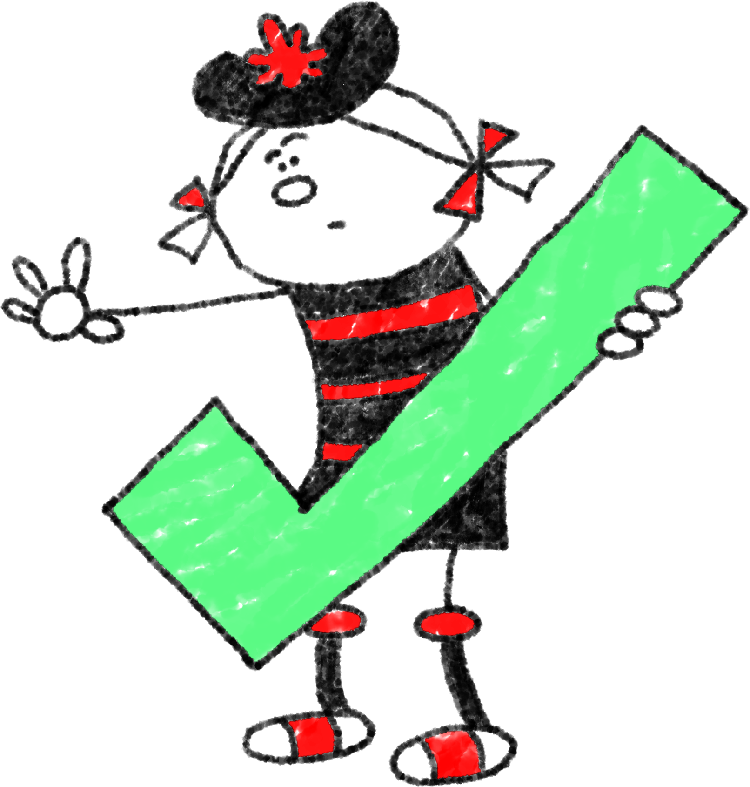
We all feel difficult emotions sometimes – it is impossible not to. But there are things we can do to stop our feelings from running out of control.

Run around as fast as you can to release your angry energy.
Take a deep breath and count to 10.

Listen to music.

Draw a picture of how you feel.

Get or give a hug.

Talk to a friend.
Sit and think about good things, like school holidays or playing with your friends.

Here we have some things we can do if we feel angry.

Tick which ones you think might work for you.

Go for a walk.
Watch TV or read a book to take your mind off it.

Ask for time out.

