Name:

Dealing with My Worries

We all worry about things – schoolwork, friendships, what we look like, things at home etc. – it’s normal. We can worry about almost anything.

What things do you sometimes worry about?

Colour in the emotions below that you feel when you get worried about something
(or add some of your own):

tearful
worn out

frustrated
lonely
hot
I get a tummy ache
unhappy
sick

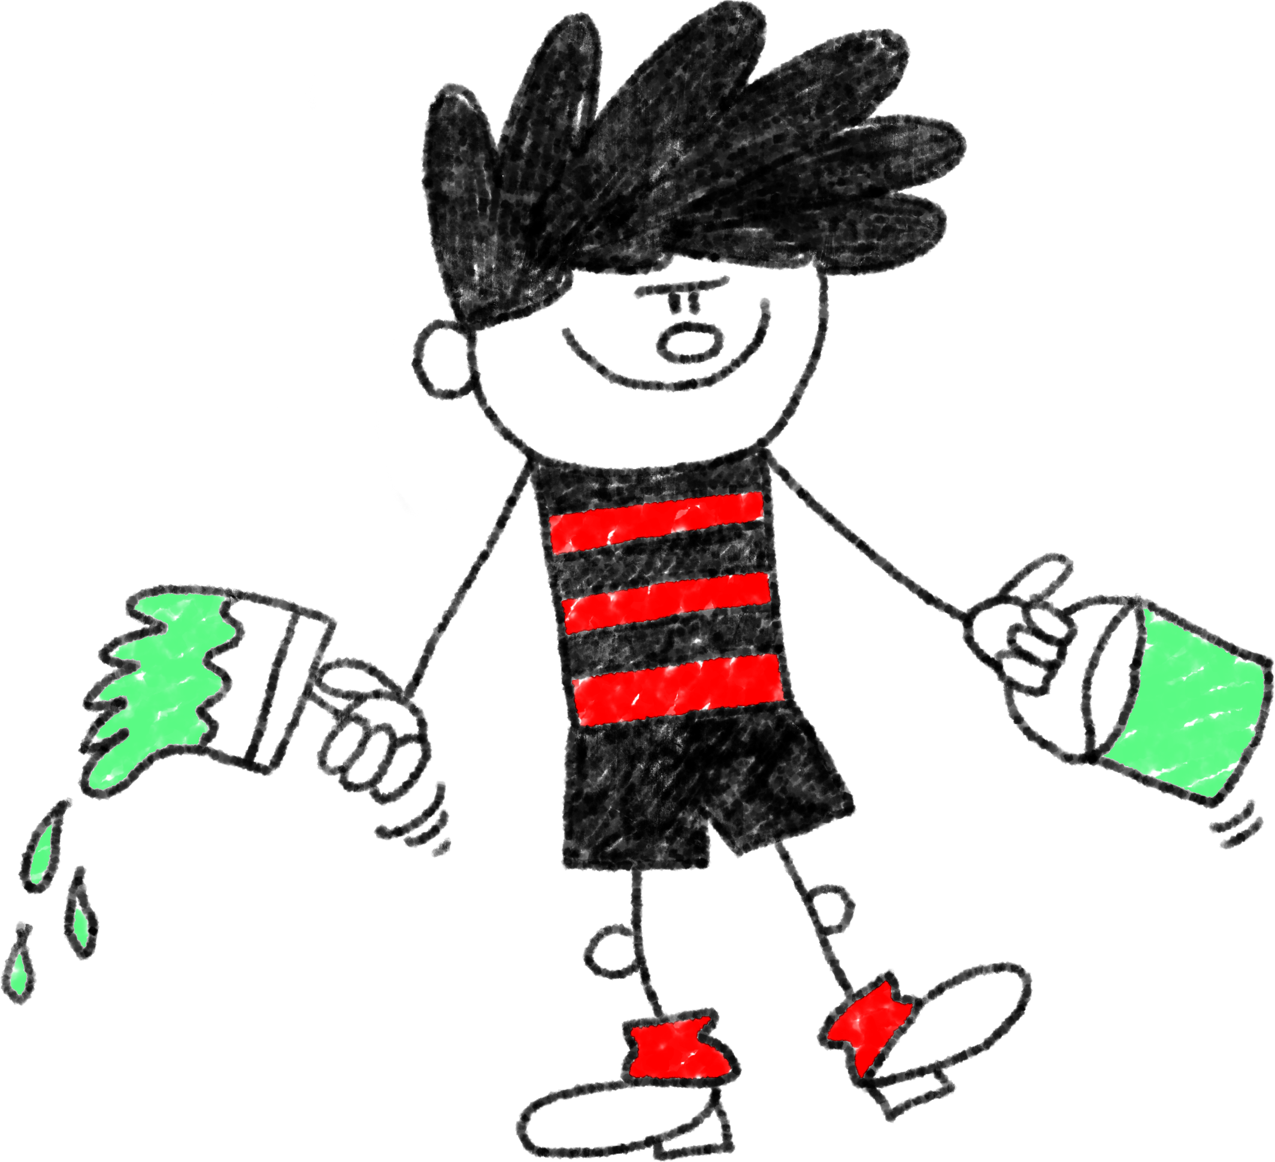
sweaty
angry

confused
I lose my temper
tired

It is important that we try and manage our feelings and think of ways to feel better.
What Helps?
Try to draw a picture to go with each of the things we can do to help when we have worries and feel stressed.

Doing exercise (for example playing football, dancing or riding our bikes).
Talking to a grown who cares about us (like our parents or teacher).

Taking time to relax
Going for a walk.

