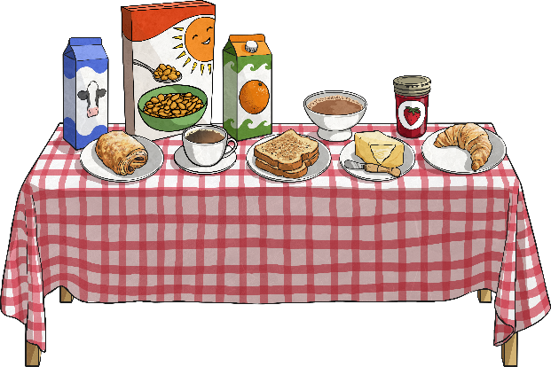
Tommy Part 1

Tommy is having his breakfast with his family.
What if Jack isn’t in school today because he felt ill yesterday? I won’t be able to play cards with him… I’ll be on my own. What will I do? That last time Jack was ill, I was alone all day and I didn’t like it!

Discuss in groups or pairs how Tommy is feeling.

Part 2
We can see that Tommy is worrying about the future - a future that might not even happen.
Tommy is also overthinking what had happened in the past and is picking all the worst parts of his memories out which is making the whole thing worse.
He has forgotten that on that day, Emma and Tai asked if he wanted to play their card game but he said no.
Tommy is not enjoying himself at all with his family or thinking about what he is doing, he is not living in the present moment and enjoying himself. He is living in the past and the future…not the present.

Discussion time

So, Jack was at school after all! Tommy was worrying about something in the future that didn’t even happen!
Discuss
In pairs, what do you think Tommy could have done that morning instead of worrying about whether his friend would be at school or not?

