Year group:  Lower Key Stage 2 | Key skills of activity:  - Children to identify what is special about themselves and share this with others  - Children to identify what is special about other people in the class  - Identify similarities and differences between themselves and others  - Children to identify what they enjoy about being part of a class/being in school  Key vocabulary:  Special, recognise, different, similar, important, unique, celebrate
Theme:  Space | Sample activities:  - Children to identify what is special about themselves and share this with others  Explain that we all have differences and similarities. Find one similarity and difference with the person in front of them.  Talk about identity and how our characteristics contribute to it. Why am I different? Why is my identity different from others'?  Activity- write what makes each chn special in the centre of the paper. Write things that contribute around. Ex: I am kind to people in need (in the centre). I help at my local charity, ask my friends when they are upset, try to help my parents with the chores… (are things that help you build your most special characteristic).  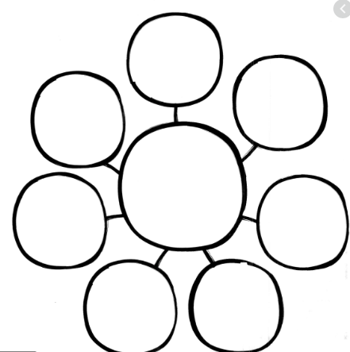  - Children to identify what is special about other people in the class  Talk about identity and why we are all different. Recap on characteristic, differences, similarities, and identity.  Chn to think about their idol, family member… they admire. Why is that person special? Share what makes that person special.  Give each chn the name of another classmate. How is this person similar to me? How is he/she different?  Activity: write a letter to that person saying why he or she is special. Make sure all chn receive a letter. Give them time to write it neat and decorate to hand it to their friend.  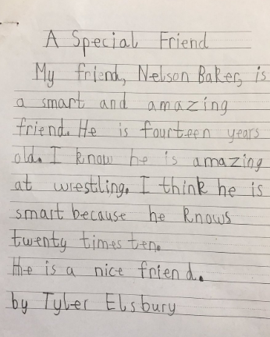  - Children to identify what they enjoy about being part of a class/being in school  Lots of people say school days are the best days of your life, but what do you like about school? Do you like seeing your mates and learning new things?  Create a common list of the things chn enjoy about being part of school. Emphasize all the support that students get from children and adults.  Chn to draw a timeline of their day at school. Entering the building, lessons, playtime, lunchtime, home time… Write and reason their favourite moments from a day at school.  - Being special  Start by saying I am Special because… teacher to give a reason.  Then ask children to think of a reason they are special, go round the class, each person to have a go. If they are reluctant to say, let a volunteer say why they think the person in special.  Collect vocabulary as a class that describe what makes someone special.  affectionate, attentive, brave, caring, cheerful, considerate, funny, generous, gentle, honest, humorous, kind, loving, loyal, nice, responsible  sensitive, strong, sincere, sociable, sweet, sympathetic, tactful, thoughtful, trustworthy, warm-hearted, and wonderful.  In pairs, write down things that make you a special person. Try and think of words that best describe you as a special person. In pairs, think of words to describe your partner. Complete the stars with pictures and words and display in the classroom.  - Making others feel special  If possible sit in a circle, or go round the class. Ask the children to think about someone in the class and suggest what is special about them.  If they chose the same child as another person they must think of a different reason that makes them special.  Use the balloon resource sheet to write down the reasons and display them in the classroom.  Share as a class. Ask children to give the reasons why they thought this about their special classmate  - Being part of a class  Ask: Remember back to when we all at school early this year. What was school/class like then? Elicit that we were all together, sitting in groups, able to touch our friends.  Ask: what was it they/you liked about school/class?  Record answers to come back to later.  Ask: Is it different being in school now, how? Elicit that now we need to be more careful about how we gather together in school/class.  Ask: How do you feel about school/class now  Record answers and compare them to what was recorded earlier.  Ask: Are they aspects that are the same? We are the same. The building is the same. The class looks the same.  Remind the children that we do not have to think about how school/class is different, we just need to be careful about how we going about our day at school now.  Task: Children to record similarities and differences about school before it closed and now it has re-opened. Write a conclusion comparing school about whether it really is so different, including a positive thought about school now.  - Being special – looking in a mirror  Children to look at themselves in the mirror and think about 3 things what makes them special. Then share this with the person on their right, left, in front of them and then behind them.  - I am special – creative activity  Create lolly sticks/paper with the children’s names on. Go around the class and get a child to pick a lolly stick/paper. They are to write 2 things that are similar and two things that are different about them and the person on their lolly stick.  - I am special – photographs  Take individual pictures of the children’s faces. Print these off on A3 paper and cut their face in half. Using catalogue, magazines, look book pictures and other materials children are to create the other half of their face using different materials.  - Brainstorm  Brainstorm some idea of what you enjoy about being part of a class/being in school at this time. | Next steps/evaluation of activities:  Children could identify more than things about themselves that make them special. Encourage people to find things that are enriching and avoid comments, such as, I am good at video games.  Some chn can struggle identifying good things about others. Give them examples of positive characteristics tht they could tell their friends/classmates. They could also write another letter to a family member.  Chn could break out a moment of the day and specify different things they enjoy.  Write a final paragraph summarizing why school is a special place they enjoy being at.
Week: 5 of 5 | Guidance for teacher:  It is only natural that we all work at an incredible pace to make sure this group of learners are not disadvantaged against their peers, providing opportunity and exploration alongside the intensity of our expectations. | Additional support needed:  If you notice any pupils may need extra support with transition back to school, please make note here and speak to your Designated Safeguarding Lead/Pastoral Lead.

