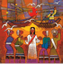 | Ealing Agreed Syllabus: guidance for teachers
 | Year 7: New life and followers

Learning objectives | Suggested activities | Suggested resources
To reflect and encourage a sense of awe and wonder in observation.  To observe and identify the ways in which the natural environment changes.  To develop an understanding of attitudes to the natural world in Islam.  To develop an understanding of the concept of follower in Christianity and how it aims to reflect Jesus’ teaching.  To provide students with an understanding of related Bible stories and characters  To encourage students to reflect on personal achievement and progress | - Intro: sign (‘new life’) and look for signs of spring in and around the school environment / make comparisons with previous term.  - Reinforce by accessing video clips online (e.g. BBC Springwatch etc).  - Awareness of environments: treasure trail (find previously objects and / or symbols around school)  - Awareness of environments: use of big book (The World of Dottie and Buzz) to emphasise aspects of the natural environment and make comparisons.  - View and review related section from Dottie and Buzz video related to the natural world / new life.  - Approach to new life: use of big book (Seven New Kittens) with attached activities and puzzles etc.  - Respect for other life: use of big book (The Tiny Ants) with attached activities and puzzles etc  - Review of further changes in the natural world in and around school / make comparisons and access video clips etc  - Followers: intro to the sign, symbol and word follow / following and reinforce with music games and Simon Says (staff and student led)  - Followers: following signs / use of big book (Christianity: Followers) / follow signs to Food Technology (or other location) room for a snack.  - Followers: use of big book / extract from Sermon on the Mount and miracle of the five loaves and two fish / support with video (Animated Bible Stories etc)  - Followers: What Jesus taught His followers / further extracts from the Sermon on the Mount / use of big book My Christina Faith to address key Christian beliefs / followers of Jesus focus (e.g. Bible stories re: lives of disciples)  - Undertake RE evaluation / cover sheet / complete RoA work | http://www.bbc.co.uk/nature/animals/springwatch/

Key words | New life, followers, following

Outcomes

At the end of this unit, pupils at foundation level will:

- be able to respond to a range of sensory stimuli in relation to given themes, through the use of artefacts, auditory, experiential and visual opportunities and presentations used to explore new life and followers

At the end of this unit, pupils at intermediate level will:

- be able to highlight features and respond to detail in the natural world
- be able to display and communicate interest
- be able to respond to simple detail via artefacts, books, posters, dvds and internet
- be able to attempt key signs where appropriate, such as aspects of the natural world and Jesus

At the end of this unit, pupils at advanced level will:

- be able to make comparisons and recognise changes in the immediate natural world
- be able to use key signs / words consistently
- will be able to recall key information in Bible stories
- will be able to complete given worksheets and review tasks independently

Background information
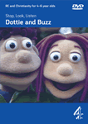  Dottie and Buzz DVD available from:  http://www.4learningshop.co.uk | Child-size puppets Dottie and Buzz experience a rich spectrum of experiences and respond with emotions ranging from fear, loss and loneliness to love, happy reflection and wonder at the created world. Throughout the series themes and ideas are revisited and developed.  Part of a series presenting RE and Christianity in a positive and child-friendly way, produced in association with Culham College Institute. Can be used on computers with DVD-Rom drives and ideal for use on interactive whiteboards.  Embedded teachers’ guide and activity book and weblink subject areas (1. Belonging 2. Creation 3. Baptism 4. Wide World 5. Forgiving)  Dottie and Buzz website: http://www.dottieandbuzz.co.uk/
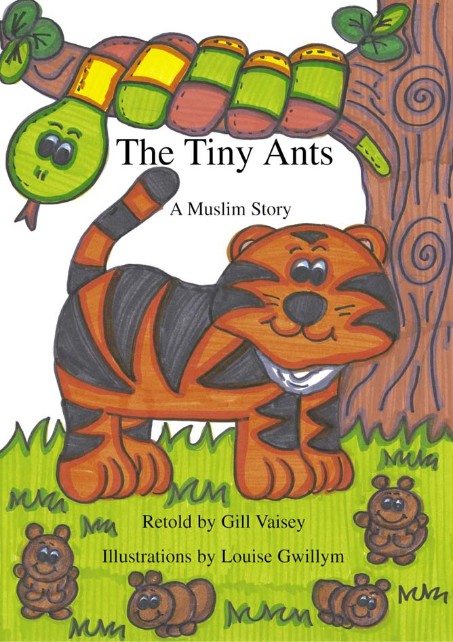  The Tiny Ants  www.booksatpress.co.uk | Seven New Kittens is a traditional Muslim story that encourages children to reflect on the beauty and wonder of new life and the natural world. Children will delight in anticipating and counting the arrival of the seven kittens as they appear on the pages as the story unfolds.  The resource pack includes:  - Seven New Kittens big book  - 21 piece number and storyboard pieces  - ‘Match and Count the Kittens’ game  - 32 cats and kittens  - Large ‘Collect the Kittens’ game board  Available from Books@Press:  http://www.booksatpress.co.uk/index.htm | The Tiny Ants is a delightful retelling of a traditional Muslim story with a message that encourages children to think about the importance of caring for the natural world.  The cross-curricular resource pack includes:  - The Tiny Ants big book  - 6 storyboard cards for sequencing and re-telling  - ‘Match the Mini-beasts’ game  - 60 assorted mini-beasts  - Large ‘Care and Beware’ game  - Mini-beast Pictogram.

