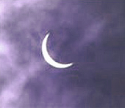 | Ealing Agreed Syllabus: guidance for teachers
 | Unit title: Festivals of light

Learning objectives | Suggested activities | Suggested resources

Festivals
AT1  To understand the word festival. | Starter: Brainstorm the word ‘festival’. What does it mean? Write suggestions on flowchart/ spidergraph.  Development:  - Teacher to tell a story from their childhood about a festival they remember and the feelings/smell etc it provokes; perhaps show a picture.  - What memories of festivals do pupils have? Discuss in pairs. Put festivals and emotions on flowchart/spidergraph.  - Ask pupils to record their memories, including their feelings, of their favourite festival. The teacher should provide a writing frame and key words for lower-attaining pupils to help them.  Conclusion: Introduce the concept of religious festivals, including the ones that will be studied during the unit. | http://www.bbc.co.uk/schools/religion/  Pictures of festival celebrations.

Eid-ul-Fitr 1
AT1  To understand the practices of Eid-ul-Fitr for Muslims. | Starter: Discuss with pupils the festival of Eid-ul-Fitr, often known simply as Eid or Id, including how it is celebrated by Muslims. If appropriate, draw on the pupils’ own experiences.  Development:  - Read the big book Watching for the Moon. Explain a bit about religious festivals that are calculated according to a lunar calendar, as compared to those that occur at the same time each year (e.g. Christmas).  - Point out that fasting (sawm) during Ramadan is one of the five pillars of Islam.  Conclusion: Pupils record the key events during the festival of Eid-ul-Fitr. | Big book Watching for the Moon. Lynne Broadbent and John Logan, Religious and Moral Education Press  ISBN 1 85175 206 4  Sheet for SEN

Eid-ul-Fitr 2
AT1  To understand the importance of Eid-ul-Fitr for Muslims.  AT2  Pupils reflect on how they could best help others. | Starter: Watch video on Eid-ul-Fitr. (See background information.)  Development:  - Consider the feelings of believers by asking key questions, e.g. what do Muslims feel when they fast? Stress the benefits, e.g. thinking about others less fortunate than themselves, health benefits, obeying the Qur’an. Are there any hardships?  - Tell students about Zakat-ul-Fitr, the donation made to the needy during the month of Ramadan.  Conclusion: Pupils make an Eid card. | Islam/Aspects of Islam video (see background information)  Card.  Coloured pencils/pens

Diwali 1
AT1  To understand the importance of Diwali for Hindus.  AT2  Pupils reflect on how they come over as young people. | Starter: Read the big book A Row of Lights, which tells the story of Rama and Sita.  Development:  - After reading the story, discuss the characters. Who are the pupils’ favourites? Why? What are their good/bad points?  - Have pictures of three main characters and build a profile, brainstorming words to describe them.  Conclusion: In pairs, pupils reflect on words that best describe themselves. Then they write down a profile of themselves. Lower-attaining pupils write in sentences using a writing frame. Higher-attaining pupils write an account. | Big book A Row of Lights, Lynne Broadbent and John Logan, Religious and Moral Education Press, ISBN 1 85175 179 3

Diwali 2
AT1  To understand the feelings of Rama and Sita.  AT2  To act out a story using their profiles from the previous lesson about how they come over as young citizens. | - Pupils make divas and puppets of Rama and Sita  - Pupils then act out the story of Rama and Sita.  - Using the descriptions of themselves from the previous lesson, role-play how they might act in an imaginary situation. | Clay, nightlights, card, colouring pens, sticky tape.
Christmas
AT1  To understand the importance of Christmas for Christians.  AT2  Pupils consider how they can give something to others. | Starter: Listen to Christmas carols. Do children recognise any of them? What do they signify?  Development:  - Ask pupils to discuss in pairs what is the meaning of Christmas? Focus on the religious aspects during this lesson.  - Read the big book The Tallest Candle and discuss what the story is about. Talk about the symbolism of Advent Sunday and the lighting of the candles in the advent wreath.  - How do Christians celebrate Christmas? What is the significance of presents?  Conclusion: In pairs, pupils reflect on the idea of giving, not presents, but of themselves to help others. Pupils are asked to write about how they could help others. A suitable writing frame should be provided for lower-attaining pupils. | Music tape (Christmas carols).  Big book The Tallest Candle, Lynne Broadbent and John Logan, Religious and Moral Education Press, ISBN 1 85175 180 7

Hanukah 1
AT1  To understand the importance of Hanukah for Jews. | Starter: Read the story of Hanukah.  Development:  - Discuss the importance of the menorah.  - Ask pupils how the Jewish people might have felt when the soldiers were behaving badly in their temple?  - What sort of disrespectful behaviour happens in school? What could we do about it?  Conclusions: Pupils draw a menorah and write about its significance during the festival of Hanukah. | www.education-world.com/a_lesson/lesson040.shtml

Hanukah 2
AT1  Pupils experience aspects of Hanukah for themselves | Pupils make potato latkes (see background information) or play a dreidel game on internet. | http://www.torahtots.com/holidays/chanuka/dreidel.htm

Key words | Eid/Id,Eid-ul-fitr, Muslim, fasting, Qur’an, Diwali, Hindu, Rama, Sita, diva/diya, Christmas, Christian, Advent, Hanukah, Jewish, Menorah, dreidel.
Points to note | The Arabic word ‘Eid’ (occasionally spelled Id) means ‘day of celebration. Eid-ul-Fitr refers to the festival at the end of the month of Ramadan and means ‘the celebration of breaking the fast’.

Outcomes

At the end of this unit, most pupils will:

- Understand that different religions celebrate a festival of light.
- Identify some of the stories connected to the festivals.
- Name some of the artefacts associated with the festivals.

Some pupils will have made less progress and will:

- Name some of the stories and artefacts associated with festivals of light.

Some pupils will have made more progress and will:

- Understand that different religions celebrate a festival of light.
- Identify the religions for each festival.
- Understand that some of the stories have a moral issue, such as the conflict between good and evil.

Background information
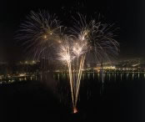  Eid-ul-Fitr fireworks  Sharjah, UAE  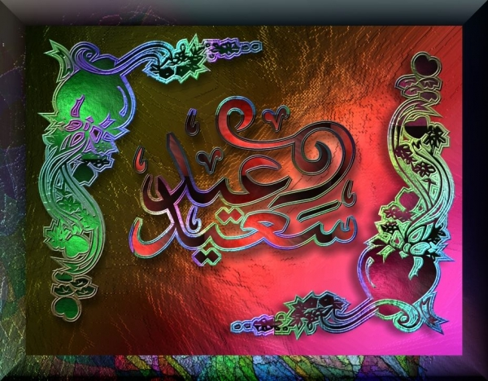  Eid Mubarak | Eid is an Arabic word meaning a recurring event, and in Islam it denotes the religious festivals. Fitr means “to break” and this particular festival marks the breaking of the fasting period of Ramadan. This Eid is known as the ‘small’ festival, al-Eid al Saghir, as it lasts only three days compared with the four days of Eid-ul-Adha, the festival of sacrifice.  For a Muslim, Eid-ul-Fitr is a day of thanksgiving. Fasting is forbidden and in the morning, Muslims are encouraged to enjoy a sweet snack such as dates. Other practices include bathing and wearing one’s best or new clothes. Thanks to Allah are expressed by distributing alms among the poor and needy and offering special prayers. On this day, gifts are also given to children and loved ones, but it is also a time of forgiveness, and for making amends.  The first Eid was celebrated in 624 CE by the Prophet and his friends and relatives after the victory of the battle of Jang-e-Badar. Therefore it can be said that Muslims are not only celebrating the end of fasting, but also thanking Allah for the help and strength they received throughout the previous month.  The festival begins with the first sighting of the new moon, although Muslims in most countries rely on news of an official sighting. There are special services out of doors and in Mosques, processions through the streets, fireworks and a special celebratory meal—the first daytime meal Muslims will have had in a month. The traditional greeting at this time is Eid Mubarak, i.e. “a happy and blessed Eid”.  The word Zakah means ‘purification’ and as an annual contribution of 2.5% of one’s wealth to public welfare it is one of the five pillars of Islam. There is a Zakah specifically linked to Ramadan called Zakat-ul-Fitr, a smaller sum that amounts to approximately £3 that is to be paid before the Eid prayers. The Zakat-ul-Fitr is distributed to those most in need, so that all can participate in the Eid celebrations with good food and new clothes.

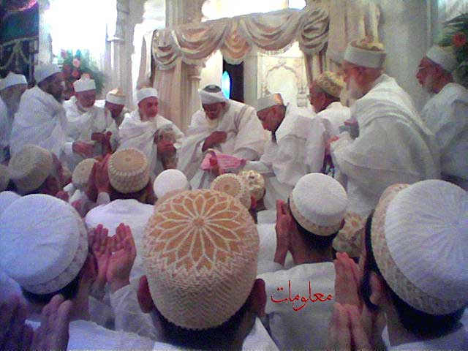  Eid-ul-Fitr prayers | Aspects of Islam (Video)  Featuring a birth ceremony, worship at home, worship in the mosque, Ramadan and Eid-ul-Fitr and a wedding ceremony. Designed by teachers to integrate with classroom activities. There is no ‘voice over’ commentary. Produced by: Videotext  Video price £29.83 ISBN: 0080345417 Available from: http://www.scm-canterburypress.co.uk/  Islam (Video/DVD)  Two 29-minute programmes (“A Guide to the Mosque”; “Eid-ul-Fitr”) aimed at KS2-KS3 that look at Muslim life. Made with the support and co-operation of the Muslim community in London. Produced by: Educational Media Film and Video. DVD/Video Price: £29.50 Available from: http://www.viewtech.co.uk/detail.html?pgcode=11571
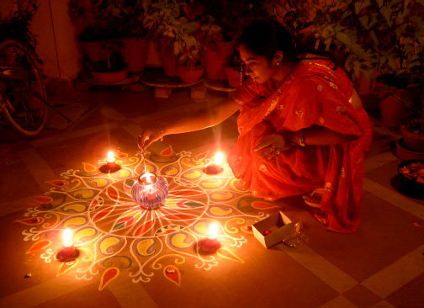  Diwali rangoli  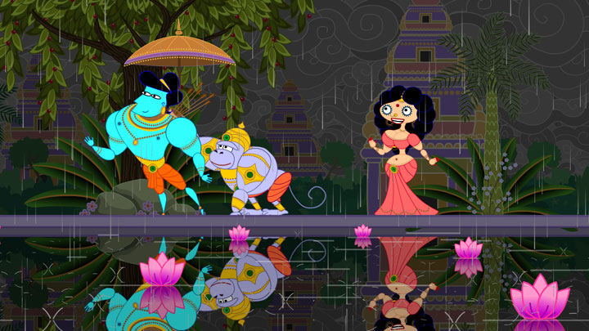  Rama and Sita return  Still from film “Sita sings the blues” | Diwali, the Hindu festival of lights, is the most popular of all the festivals from South Asia, and is also the occasion for celebrations by Jains and Sikhs. Extending over five days, it celebrates the victory of good over evil and knowledge over ignorance, although the legends that are used as symbolic manifestations of this victory vary in different regions.  The name of the festival comes from the Sanskrit word dipavali, meaning “row of lights”. Small earthenware lamps called diyas (divas), traditionally fueled by mustard oil, are placed in windows, doors and outside buildings—although nowadays these are often replaced by strings of electric lights, particularly in larger towns.  For many Indians the festival honours Lakshmi, the goddess of wealth. The new business year starts at Diwali, and some Hindus will say prayers to Lakshmi for a successful year. Windows and doors are left open to make it easy for her to enter, and special patterns, rangoli, are drawn on the floor, the most popular being the lotus flower. There is much feasting and celebration, and the lamps are meant to make it easy for Lakshmi to find her way into the house.  Another legend that speaks of the origin of this festival regards the killing of the demon Ravana, who had kidnapped Sita, the wife of Rama. Rama had been in exile for 14 years because of a disagreement regarding whether he or his brother should be the next king. He journeyed to Ravana’s kingdom to recover Sita, and after a great battle the demon was defeated. It was a dark moonless night when Rama and Sita returned home, and people put little lamps outside their houses so that the two could find their way. Thus began the tradition of the festival of lights, during which, in many places, Rama’s coronation as king is also celebrated.

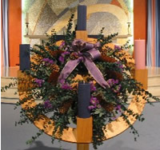  Advent wreath | The Sunday closest to 30 November is known as the first day of Advent, a four-week period during which Christians prepare for the celebration of Christmas. In Latin “advent” means “coming towards”, and in this context, it refers to the anticipated coming of the Christ child on Christmas Day. Two traditions particularly associated with this period are the advent wreath and the advent calendar.  The advent wreath is a custom that originated in Eastern Germany. Four candles—three purple or violet ones representing penance, sorrow, and longing, and one rose or pink candle representing the hope and coming joy—are placed in the wreath, one to be lit on each of the Sundays of advent. A final, white candle is lit on Christmas day, signifying the transition from darkness to light.  In many countries, people use special calendars to keep track of the twenty-four days prior to Christmas. Advent calendars were first used in the nineteenth century and originated from the protestant area of Germany. Families made a chalk line for every day in December until the arrival of Christmas Eve, and before long, commercial entrepreneurs began to produce special calendars to cover this period. The first known printed version dates from 1851; nowadays advent calendars tend to have 24 little windows which can be opened to reveal some image or portion of a story, one door for each day starting at the beginning of December and leading up to Christmas.
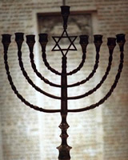  Hanukkiah | Hanukah (or Chanukah) is the Jewish festival of lights. The word means ‘dedication’ and commemorates the struggle of the Jews for religious freedom.  Historically the festival marks the victory of the Jewish people—led by the Maccabee brothers—over the Syrians after a three year war in 165 BCE. When the war was over, the Jews decided to repair the temple and have a dedication ceremony. As part of the celebrations a menorah (a candelabra with seven sconces) was lit. Although there was considered to be only enough oil to keep the menorah lit for a single day, it somehow lasted for a total of eight.  It is in remembrance of this miracle that Hanukah is celebrated. The central ritual focuses on a special menorah, sometimes known as a hanukkiah, which has eight sconces instead of the usual seven. Each night of the festival, an extra candle is lit: in other words, on the first night, one candle is lit, on the second two, and so on up until the eighth night, when all eight candles are set alight. It is also traditional at this time to eat foods cooked with oil, e.g. donuts or potato cakes.  To find out more about the story of Hanukah, visit the Ealing Synagogue website.

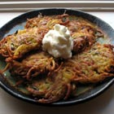  Potato latkes | Recipe for Potato Latkes  - 4 large potatoes, peeled  - vinegar or lemon juice  - 3 tbsp. matzah meal  - 3 eggs, beaten  - 1 tsp. salt  - ¼ tsp. pepper  - 1 tsp. onion powder  - oil  - Grate potatoes into a bowl or pan of cold water with a few drops of vinegar or lemon juice (to prevent them from darkening), and then drain them. Using your hands, squeeze out as much water from the grated potatoes as possible.  - Mix the grated potatoes, matzah meal, eggs, salt, pepper, and onion powder in a bowl until all is well blended.  - Pour enough oil in the skillet so that it is ¼” deep. Heat the oil and then add a tablespoon or two of batter. When the batter starts to bubble and sizzle, add four more pancakes to the hot oil until it just begins to smoke. Flatten each slightly with the back of a spoon or a pancake turner. Fry on one side until brown, then flip over and brown the other side.  - Remove the latkes from the skillet and drain them on paper towels.  - Cook any remaining latke batter in the same manner, adding more oil to the skillet as needed and allowing it to get hot before adding more latkes.

Scheme prepared by: Elaine Levy, Little Ealing Primary School, London Borough of Ealing

