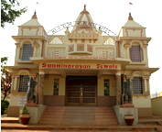 | Ealing Agreed Syllabus: guidance for teachers
 | Unit title: Religious buildings

Learning objectives | Suggested activities | Suggested resources

Introduction
AT1  Pupils understand that there are often special rules about acceptable behaviour and dress when visiting a religious building.  AT2  Pupils think about places that are ‘special’ or ‘sacred’ to them, and how they feel differently in these places. They  begin to think about the specific features of buildings that both please and displease them. | Starter: Show class an assortment of pictures of buildings, familiar and not. Ask pupils to think of a favourite building. In pairs talk about their favourite buildings, how it makes them feel and why. Repeat process for buildings pupils do not like. Ask pupils to imagine taking someone to a place that is special to them. How would they want their friend to behave? Would they like it if their friend made fun of their special place?  Development:  - Talk about the various ways spaces are defined, e.g. large versus small spaces, sound in spaces (echoing spaces), familiar versus strange spaces, open spaces (e.g. courtyards). Introduce the concept of ‘special’ versus ‘everyday’ space.  - Ask class to volunteer some of their impressions of visiting a place of worship, e.g. sounds, smells, feelings.  - Point out that different religions have different rules concerning how people should dress and behave in their sacred buildings, e.g. removing shoes before entering a mosque, gurdwara or mandir, but not before entering a church or synagogue.  - Prepare students for the place (s) of worship they are to visit, including the behaviour/dress that will be expected of them (see background information).  Conclusion: Discuss the concept of ‘respect’ and how it applies to visiting a place with rules that are different from what they are used to. | Note: It is hoped that the class will visit at least one place of worship during the course of this unit. There are lessons in this scheme for places of worship for each of the major religions, and teachers should choose at least three to teach in addition to the introductory and revision lessons, and the lesson on the church. The lessons should be adapted accordingly if they refer to a place of worship that is to be the subject of a class visit: this could involve the class researching in the library or internet. Ensure that the class is thoroughly briefed before any visit, so that they behave appropriately and are able to ask relevant questions.  Google for pictures of buildings, alternatively ask pupils to bring in photos or postcards of their favourite buildings.

Christian church
AT1  Pupils understand that for Christians, the word ‘church’ refers to both the building and the community of believers. They can identify important features found in churches. | Introduction: Discuss the meaning of the word ‘church’: what does this word mean to pupils? Point out that, for Christians, the word also refers to the body of believers, and therefore that the Christian church can be defined as a worldwide community of people who subscribe to a common set of beliefs.  Development:  - Ask class to name a notable external feature of a church: e.g. steeple or bell tower, cross. Show pictures of some examples.  - Draw a rough diagram of the typical internal layout of a church (see background information) highlighting the important features, e.g. nave, sanctuary or chancel, baptismal font or baptistery for immersion baptism, altar, cross/crucifix, pulpit, lectern. Point out that in some traditions (e.g. Roman Catholic, Orthodox and Church of England) the actual plan of the building (i.e. cross-shape) has symbolic significance.  - Show pictures and discuss some of the symbolic features to be found in a church: candles, icons, candlelight (e.g. votive candles in a Catholic church), stations of the cross, stained glass windows or statuary illustrating figures or stories from the Bible.  - Talk about some of the ways the senses are engaged in a church, e.g. light coming through stained glass windows, the smell of incense, the sound of bells and the church organ, and the communal singing of hymns.  - Point out that, like many places of worship in other faiths, churches serve as centres of various activities for the community.  Conclusion: Using the IWB, show one or more of the videos that highlight several of the features discussed in the lesson. | The LGfL espresso for schools site has many short videos on various aspects of worship that can be shown to the class via an interactive white board. In order to access this material, you will be required to log on using your LGfL password (if you don’t have one, you can get one from your school’s ICT co-ordinator).  For three short videos about worship in a church:  http://content.lgfl.org.uk/secure/faiths/t2_faiths/christianity/index.html  Virtual tours of various churches and cathedrals:  http://www.request.org.uk/main/churches/buildings/buildings.htm  REonline’s “Places of Worship” website contains a video about worship and artefacts in an Anglican church: http://pow.reonline.org.uk/videos.htm

Muslim mosque
AT1  Pupils understand that the mosque is the focus of community life for Muslims. They understand that the symbolic centre of the worldwide Muslim community is Mecca, and that the mihrab or niche in every mosque indicates the direction of Mecca, which believers should face when praying. | Introduction: Discuss the meaning of the word ‘mosque’. Ask pupils to name some recognizable external features of purpose-built mosques (as compared to mosques in ordinary houses). Using the IWB, you might show pictures of minarets, domes, or the crescent and star symbol from a variety of mosques.  Development:  - Discuss the role of the muezzin, the person responsible for calling the faithful to prayer. Point out that although in Muslim countries the call to worship would usually be delivered from the roof or minaret of the mosque, in Britain it is often delivered inside the mosque so as not to disturb the neighbours. (For an animated version of the call to worship that can be shown on the IWB: http://www.islam4schools.com/adhaan.htm).  - List some of the important internal features of a mosque, e.g. wudu room, prayer hall, mihrab, minbar, women’s area.  - Mention that in Islam, it is forbidden to have representations of humans or animals, and that this is why many mosques have been decorated with geometric designs or passages from the Qur’an. Point out that the development of beautiful forms of writing (calligraphy) has been an important way for Muslims to glorify the word of Allah.  - Using the IWB, show the video of the wudu (wuzu) ritual from the CLEO website: http://www.cleo.net.uk/resources/index.php?cur=15&ks=2 (Note: be sure and allow time for the video to download.) Point out that mosques always provide running water for wudu, either a special room or a fountain in an external courtyard, and that this provision shows the importance of cleansing before prayer.  Conclusion: Discuss the fact that in every place of worship the holy text of that religion is treated with special reverence and respect. Show class an example of a Qur’an stand, and point out that it is forbidden to place the Qur’an on the floor. As there are no chairs in the prayer hall of a mosque, individuals studying the Qur’an use a special stand known as a rihal, rehal or tawla. | REonline’s “Places of Worship” website video about Birmingham mosque: http://pow.reonline.org.uk/videos.htm  For two short videos about Muslim worship in a mosque: http://content.lgfl.org.uk/secure/faiths/t2_faiths/islam/video_worship_1.html  Virtual tour of a mosque: http://www.hitchams.suffolk.sch.uk/mosque/default.htm  Tour of Preston mosque: http://www.lancashiremosques.com/discovery_mosque_tour.asp  Qur’an stand: www.starbeck.com/islam.html  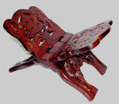

Jewish synagogue
AT1  Pupils know the main external and internal features of a synagogue. They understand that the synagogue serves as a place of assembly, study and prayer. | Starter: Introduce the three ways Jewish people refer to their place of worship: 1) house of assembly (Hebrew beit k’nesset) 2) school or house of study (Hebrew beit midrash, or shul in Yiddish) and 3) ‘house of prayer’ (Hebrew beit tefilah). Point out that these names reflect the different activities that take place in a synagogue, and that these activities are also common in most places of worship.  Development:  - If possible, arrange to take the class on a tour of one of Ealing’s synagogues; if not, show class the features of a synagogue on the IWB using a virtual tour, or by watching the videos about synagogues on the LGfL Espresso site or the REonline “Places of Worship” website.  - Show pictures of the outside of various synagogues, discussing what symbols would mark them as such (e.g. magen David—shield or ‘star’ of David—or the seven-branched candelabrum, the menorah).  - Get pupils to work in pairs to draw a schematic of the main internal features of a typical synagogue, e.g. Ark, Bimah, Ner Tamid. Point out that the Ner Tamid is always lit as a symbol of the constant presence of God.  - Show pictures/discuss some of the symbolic articles of dress worn in a synagogue, e.g. prayer shawl (tallit) and headgear (kippah, Yiddish yarmulke). Point out that in orthodox or conservative synagogues men and women sit separately, but that this is not the case for reform or liberal synagogues.  Conclusion: Class discusses what they have learned. How does a synagogue differ from other religious buildings? |  | For a short video about synagogues:  http://content.lgfl.org.uk/secure/faiths/t2_faiths/judaism/video_synagogue.html#  Virtual tour of an Orthodox synagogue in Wales:  http://www.ngfl-cymru.org.uk/vtc/ngfl/re/m_parry_carmarthenshire/  addoldai/synagog/synagogtwo.html  Alternatively see http://scheinerman.net/judaism/synagogue/tour/image-map.html for a ‘click-me’ tour of a synagogue.  REonline’s “Places of Worship” website contains a video about worship and artefacts in Exeter synagogue: http://pow.reonline.org.uk/videos.htm  Ealing Synagogue  15 Grange Road, London W5 5QB. For tours contact Rabbi Vogel, 020 8579 4894.  Ealing Liberal Synagogue  Lynton Avenue, Ealing, W13 0EB  Tel: 020 8997 0528

Hindu mandir
AT1  Pupils know the main external and internal features of a mandir. Pupils begin to understand that the many different images of the gods (murti) in a mandir are different manifestations of one divine being. | Starter: If possible, arrange to take the class on a tour of one of the local Hindu temples (see background information); otherwise, using an IWB, show class the short videos about the Neasden mandir, the virtual tour of the Shree Swaminarayan mandir in Cardiff and/or the video of “waking the deities” in the Preston Gujarati mandir (see links right).  Development:  - Discuss some of the external features of a mandir, e.g. domes and pinnacles, which symbolise thoughts of higher things. Other symbols that might be found on the outside of a temple are the Aum symbol and the swastika, which is an ancient Aryan symbol.  - Sketch the typical layout of a mandir, including such features as: a) the mandap or main hall, b) the inner shrine containing the images (murtis) of the gods, c) the antarala, or area where worshippers can approach the murtis and/or walk in a circle round the shrine.  - Get pupils to suggest different identities they might have, e.g. son/daughter, brother/sister, student, friend. Point out that in a similar way, the many deities in Hinduism are seen as different aspects of one divine being, Brahman. This is why a temple might hold so many different statues. Point out that, for believers, the deity is actually present in the image and can be offered food and prayer. (See video of “waking the deities”)  - Discuss the way the senses become involved in a mandir, e.g. smell of incense and flowers, the sight of candles (particularly the five-branched lamp used in the aarti ritual), sounds of bells (and occasionally conches) and singing and clapping.  - Discuss the special rules of respect to be observed in a mandir: a) shoes are removed, b) some mandirs require women to cover their hair, arms and legs, c) if you sit on the floor you must tuck your feet behind so that they aren’t pointing at the deities, d) traditionally, men and women sit separately during communal worship.  Conclusion: The class brainstorms about the differences and similarities found in the places of worship they have studied so far. | Two short videos about the Shree Swaminarayan mandir in Neasden that could be shown on the IWB (you will need to log on); http://content.lgfl.org.uk/secure/faiths/t2_faiths/hinduism/video_mandir_1.html  A virtual tour of the Shree Swaminarayan mandir in Cardiff can be downloaded from: http://www.ngfl-cymru.org.uk/vtc/ngfl/re/cardiff_hindu_virtual_tour/e_index.htm  Video of “waking the deities” in the Preston mandir: http://www.cleo.net.uk/resources/index.php?cur=15&ks=2  Information about mandirs can be found on the Neasden Mandir website: http://www.mandir.org/mandir/index.htm

Sikh gurdwara
AT1  Pupils know the main external and internal features of a gurdwara, including the importance of langar. | Starter: Point out that temples in India are often indicated by an orange flag, and that this tradition was carried over into the Sikh faith, where the Nishan Sahib (‘respected emblem’) often bears the Sikh symbol of the khanda (see background information). The flag indicates that the building is a place of worship and hospitality, and the flag itself is given great respect: the flagpole is washed and the flag replaced every year during the festival of Baisakhi.  Development:  - Discuss the fact that many features of a gurdwara symbolise the importance of the Sikh holy book, the Guru Granth Sahib, and that it is treated like royalty (see background information).  - Point out that the langar hall is as important as the prayer hall, thus emphasising the Sikh belief that the needs of the body are no less important than the needs of the soul. The word langar refers to both the kitchen and the communal meal. This free mid-day meal is vegetarian so that everyone, including non-Sikhs, can partake; it is a way that Sikhs can live out the principles of equality and service (sewa).  - If there are Sikh children in the class, ask them for examples of other things that might be seen or heard in a gurdwara, e.g. reading from the scriptures, music and the singing of devotional prayers (kirtan), chanting of Wahe Guru (“Wonderful Lord”).  - Show examples of pictures of the ten Sikh Gurus, explaining that although such images might be displayed on the walls in a gurdwara, Sikhs do not worship the human Gurus as God, but rather revere them as teachers and leaders. Also show a decorative example of the phrase Ik Onkar (“there is only one God”, the first words of Guru Nanak’s prayer, the Mool Mantar), which might also be on display in a gurdwara.  Conclusion: Discuss proper behaviour when visiting a gurdwara, i.e. both boys and girls to cover their heads, remove shoes, dress modestly, sit with legs crossed or feet tucked behind so that the feet are not pointing towards the holy book, and avoid turning their back to the holy book. Explain again the importance of hospitality to the Sikhs, and point out that if offered karah parshad or langar it should be accepted or declined in a respectful manner. | Two short videos about Sikh worship in a gurdwara: http://content.lgfl.org.uk/secure/faiths/t2_faiths/sikhism/video_worship_1.html  The CLEO website has an excellent set of video interviews about the Singh Sabha Gurdwara in Southall: http://www.cleo.net.uk/resources/index.php?cur=15&ks=2  REonline’s “Places of Worship” website contains a video about activities in a gurdwara, including information about the 5 Ks: http://pow.reonline.org.uk/videos.htm    Ik Onkar computer wallpaper  www.sikhnet.com

Buddhist vihara
AT1  Pupils understand that a Buddhist vihara can be a monastery and/or place for Buddhists to meditate and study.  AT2  Pupils can identify what it is about certain places that make them feel peaceful. | Starter: Ask class to name various emotional states: e.g. excitement, sorrow, happiness, peace. Show class a picture or statue of a meditating Buddha and ask them to suggest what emotional state the image evokes. Point out that one of the goals of Buddhism is the search for inner peace and ask them for examples of places that make them feel particularly peaceful.  Development:  - Discuss the belief that one of the roads to inner peace is through meditation, which often involves sitting quietly and trying to still the mind. Point out that meditation of one sort or another (e.g. in the form of silent, individual prayer) is part of the practice of many religions, but that it is particularly important in Buddhism.  - If possible arrange for class to visit a Buddhist temple or vihara; alternatively show the film on the “Places of Worship” website. Tell the class a bit about traditional Buddhist places of worship, mentioning that in Britain some are simple meditation halls.  - Discuss the importance of the shrine room. Show examples of figures of the Buddha (the Buddharupa), pointing out that different representations symbolise different qualities of the Buddhist path, e.g. meditation, teaching the dharma.  - Look at other common features of a shrine room, e.g. lotus (symbolises everyone’s ability to grow as a human being), incense (symbolises that the teachings of the Buddha can reach everywhere and can ‘perfume’ human existence), candles (symbolise the light that Buddhist teaching can shine on ignorance), and flowers (symbolise both beauty and impermanence of all living things).  - Talk about/demonstrate some of the sensations one might experience in a Buddhist shrine or vihara, e.g. the sounding of a bell or gong to signify the beginning and end of meditation, chanting, the sight of worshippers bowing before the image of the Buddha to indicate humility.  Conclusion: Pupils talk about the way they might decorate a room to evoke a sense of peace, and the rules they might need to maintain a peaceful atmosphere. | Two short videos about worship in the Buddhist temple in Wimbledon that could be shown on the IWB (you will need to log on); http://content.lgfl.org.uk/secure/faiths/t2_faiths/buddhism/video_worship_1.html  REonline’s “Places of Worship” website contains a video about worship and artefacts in Birmingham Buddhist centre, which describes the symbolism of various objects found in a typical Buddhist shrine room: http://pow.reonline.org.uk/videos.htm  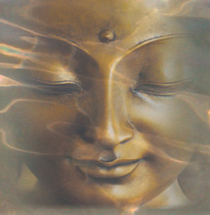  Meditating Buddha  www.madhyamaka.org

Places of worship: revision
AT1  Pupils know some features common to several places of worship. They are also able to recount some rules of behaviour expected when visiting these places. | Starter: Using the interactive white board, download the short video “What happens next?” from the CLEO website. Before playing the video, ask the class to suggest ideas about what the room is used for. You might get class to brainstorm the following: “If this was to become a place of worship, what would need to be done to it?” Finally, play the video, and then discuss how an ordinary everyday space can be transformed into a special place.  Development:  - Summarise some of the features of buildings used by various religions for places of worship. What are common features and what are special to only one religion.  - Talk about the place (s) of worship the class visited, showing any photographs taken. Get class to recount the mood of the visit and any sensations of sight, smell and sound that they remember.  - Divide the class into groups. Give each group a large sheet of paper and ask them to sketch a place that could be used by members of a particular religion, or alternatively anyone—of any or no religion—for worship, meditation or quiet reflection. What rules of behaviour would they expect from visitors to the room. What kinds of sights, sounds and smells would visitors find there. (You could print out pictures of various religious artefacts for the groups to cut up and paste on their sketches.)  - The groups share their sketches. Make sure that the sketches reflect the rules/artefacts of the particular religion chosen (e.g. a place to be used for Muslim worship should not contain any representations of the human form, and should have a mihrab showing the direction of Mecca and facilities for washing).  Conclusion: Summarise some of the common uses of religious buildings, e.g. worship, study, focus of the community, shared meals. | Photographs and notes taken during visits to place (s) of worship and/or downloads from internet.  “What happens next?” video: http://www.cleo.net.uk/resources/index.php?cur=15&ks=3  There are teachers’ notes and a simple recording sheet available for download with a screen shot of the completed room. This sheet can be used by pupils to record discussion points or draft an answer to the question: “What is a place of worship?”  Large sheets of paper, coloured pens, pictures of religious artefacts, paste.

Key words | Respect, courtesy, church, font, nave, sanctuary, chancel, mosque, masjid, minaret, dome, wudu, mihrab, qiblah, minbar, synagogue, shul, menorah, magen David, ner tamid, ark, bimah, tallit, kippah, mandir, mandap, antarala, murti, gurdwara, Nishan Sahib, khanda, langar, sewa, vihara, Buddharupa, lotus, meditation
Points to note | Before visiting any place of worship, pupils and teachers should be aware that the visit is for educational purposes only, and that they will not be required to participate in worship or to affirm any of the beliefs of the relevant religion. The school must all be aware of any special dress requirements for entering the place of worship, and children should be prepared to be polite about any food they may be offered during the visit.

Outcomes

At the end of this unit, most pupils will:

- be able to identify the internal and external features of several places of worship and relate them to the appropriate religion.
- be able to identify some of the uses of religious buildings.
- know how to behave appropriately in a place of worship.
- consider some of their own special places and why these are important to them.

Some pupils will have made less progress and will:

- be able to identify some external and internal features of some places of worship.
- be able to name some religious artefacts found in religious buildings.
- reflect on their own special places.

Some pupils will have made more progress and will be able to do all of the above. In addition they will:

- be able to explain some beliefs related to different places of worship.
- understand the importance of special places to people’s lives.

Background information
The church

- The communion table is most often called the altar.
- The chancel railing, also known as the communion railing, has provisions for kneeling.
- Clergy use the pulpit for gospel readings and sermons.
- Lay readers use the lectern for scripture readings.
- The sanctuary/chancel is often on a higher level than the nave. This boundary is occasionally marked by a gate. In Orthodox churches, the boundary may be in a slightly different location and may consist of a screen covered with icons.
- Western churches have pews in the nave but in most Orthodox churches the congregation stands.
- In the Roman Catholic, Orthodox and Church of England traditions, the church is often built in the shape of a cross, with the font for baptism at the entrance and the altar for communion at the far end. Symbolically, this suggests the entry, passage and goal of the Christian life journey.
- In Protestant Churches, the shape, furniture and decorations are not usually regarded as aids to worship. These buildings are kept simple to reflect the belief that the place where God is worshipped should have as few distractions as possible. In such churches the pulpit is often prominent, reflecting the fact that preaching God’s word is the most important feature of worship.
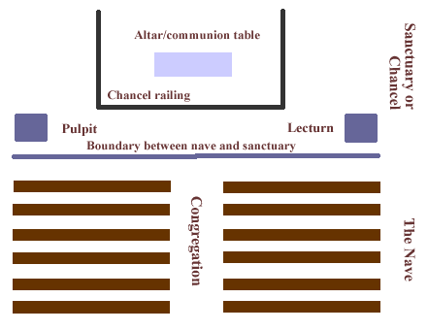

If the class is visiting a church: make sure they understand that 1) most churches will expect visitors to behave respectfully, 2) in some churches there are parts that only clergy can enter (e.g. the sanctuary), 3) men and boys do not wear hats or caps in the church and 4) in some churches women and girls are expected to cover their heads.

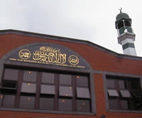  Central Jamia Masjid, Southall    Interior of dome  “Glimpses of a Holy City” website | The mosque (masjid)  The Arabic word masjid means place of worship and is derived from the verb sajada (root s-j-d, meaning ‘to bow’ or ‘to kneel’) in reference to the prostrations performed during Islamic prayers. The modern-day English word mosque comes from Spanish mezquita.  The mosque is the centre of the Muslim community. It is here that the five daily prayers and other forms of religious and social activities are performed in accordance with the teachings and practices of the prophet Muhammad. The mosque serves as an information and education centre (madressah), and in most mosques Qur’anic studies are regularly provided for both young and old.  Muslims entering the mosque carry out a strict sequence of ablutions in the designated washing area (wudu). Shoes are removed and the head, nostrils and ears, the hands and arms (up to the elbows) and the feet (up to the ankles) are washed in running water.  Although mosques do not contain religious pictures or statues—which are proscribed in the Qur’an—there is usually a board marking the times of the five daily prayers, and the niche (mihrab) which indicates the direction (qiblah) of Mecca, towards which all Muslims face when they pray.  To the right of the mihrab can be found a minbar, a set of steps leading to the platform used by the imam when he gives the jumu’ah, the sermon during the important midday Friday prayer. Boxes outside the prayer hall are for zakah, the duty to provide alms which is one of the five pillars of the faith.  If the class is visiting a mosque: all should dress modestly, with both boys and girls wearing loose-fitting clothes that cover their arms and legs. Women/girls should cover their head with a scarf; men/boys may wear a cap. All will be required to remove their shoes on entering. Pupils should be told that they should not walk in front of people who are praying, or sit with their feet pointing towards the qiblah. Although it is usually permissible, always ask before taking photographs. |  |  | 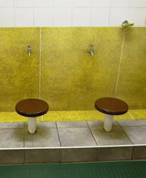  Wudu room  Central Jamia Masjid, Southall  “Glimpses of a Holy City” website  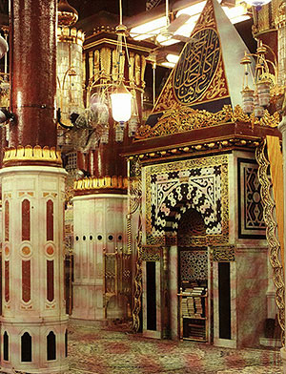  Qiblah, Prophet’s mosque, Madinah  www.mideasti.org
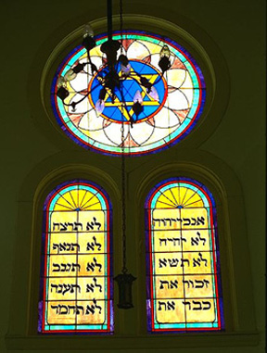  Stained glass window  Beth-El synagogue, Corsicana, Texas  www.geocities.com | The synagogue  The portion of the synagogue where prayer services are performed is commonly called the sanctuary. Synagogues are often designed so that the front of the sanctuary face Jerusalem, which is the direction Jews are supposed to face when reciting certain prayers.  Probably the most important feature of the sanctuary is the Ark. This word is an acrostic of the Hebrew words Aron Kodesh, ‘holy cabinet.’ The Ark is a cabinet or recession in the wall, which holds the Torah scrolls; in addition to doors, there is a curtain (parokhet) on the cabinet in memory of the curtain in the sanctuary of the historic Temple in Jerusalem.  In front of and slightly above the Ark is the ner tamid, or eternal lamp, symbolising the commandment to keep a light burning in the Tabernacle (Exodus 27:20-21). In the centre of the room or in the front there a pedestal called the bimah, on which the Torah scrolls will be placed for reading. The bimah is also sometimes used as a podium by the person leading the service; in some synagogues there is an additional lectern called an amud.  In Orthodox synagogues, women and men sit in different places separated by a wall or curtain called a mechitzah. This is because they are supposed to keep their minds on their prayers, rather than allowing themselves to be distracted by members of the opposite sex.  Most synagogues function as a place where matters of importance to the Jewish community can be discussed, and as such they often have a social hall for non-religious activities.  If the class is visiting a synagogue: All men/boys are required to cover their heads. Because of kosher food rules, make sure none of the students bring food with them. Always ask before taking photographs. | 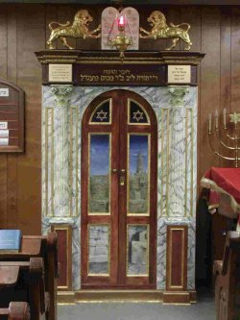  Ark and Ner Tamid  Ner Tamid Greenspring Valley Synagogue, Baltimore, Maryland  http://www.mynertamid.com/
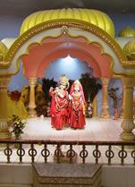  Murtis of Krishna and Radha (Vishwa Hindu Mandir)  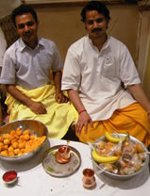  Distributing parshad  “Glimpses of a Holy City” website | The mandir  The word mandir is derived from an ancient Sanskrit name for the house of the deity, man signifying the inner self, while dir means ‘dwelling place’. The standard Hindu temple has remained fundamentally the same from the 6th century to the present. Visitors enter through an ornate gateway into an open courtyard that leads into the heart of the temple—a small dark chamber, called garbhagriha that contains the chief deity. Devotees visit the shrine and make an offering to the murtis or images of the gods. The chamber is surrounded by a circumambulatory, vestibule or antechamber, called antarala.  Since Hindu worship is not fundamentally of a congregational nature, the only essential part of a temple is the shrine proper with its symbol-laden threshold and doorway, normally facing east. However, in all but the most basic temples, other elements are present, at least a porch, and often an antechamber or antarala, a hall or mandap, and a dwajasthamba or flag-mast. These are all set in a rectangular courtyard, which sometimes contains additional smaller shrines.  Temple architecture is remarkably uniform throughout India, however two main styles can be distinguished: the northern or Nagara style and the southern or Dravida style. Temples in Britain, unlike those in India, often double up as community centres where Hindus can meet for social, cultural, and charitable events.  Vishwa Hindu Mandir, 2 Lady Margaret Road, Southall UB1 2RA, (020) 8574 3870  http://www.vishwahindumandir.co.uk/  Bhagwan Valmik Mandir, 16/18 Featherstone Road, Southall UB2 5AA, (020) 8571 6318  Shri Swaminarayan Mandir, 115-119 Brentfield Road, Neasden, London NW10 8IP, (020) 8965 2651. For information about school visits see: http://www.mandir.org/booking/index.htm  Kanaga Thurkkai Amman Temple, 5 Chapel Road, London. W13 9AE. (020) 8810 0835  If the class is visiting a mandir: shoes must be removed; some places require women to cover their hair, arms and legs; if you sit on the floor you must tuck your feet behind so that they aren’t pointing at the deities, if offered parshad it should be accepted or declined respectfully. |  |   Mandap  Inner shrine  Antarala  Porch  The plan of a typical North Indian temple. South Indian temples are more complex, and are usually surrounded by a number of concentric walls each with a number of elaborate gateways (gopurams).  The sanctuary or inner shrine contains the deities, and often includes preparation room. It is usually enclosed behind doors or curtains, which are opened every day.  The antarala is the space between the inner shrine and the main hall, allowing worshippers to walk round the shrine.  The mandap or main hall is often marked by pillars, and may be sunken in the floor.  For more information:  hinduism.iskcon.com
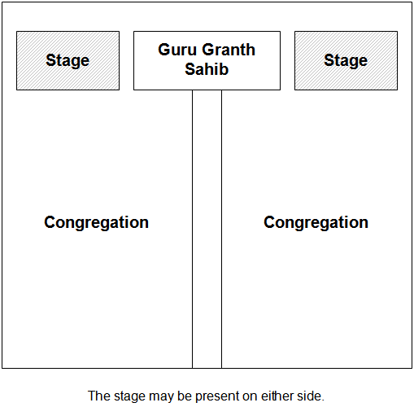  Schematic of a typical darbar hall  wikipedia  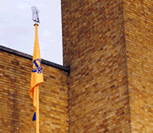  Nishan Sahib  Gurdwara Guru Nanak Darbar, Southall  All photos, apart from the schematic, from “Glimpses of a Holy City” website | Gurdwara means ‘the doorway to the Guru’, and a gurdwara is simply a place where the Sikh scriptures are present. Thus a family home may be considered a gurdwara, as long as it holds a copy of the Guru Granth Sahib. Purpose-built gurdwaras typically have a large prayer hall, known as the darbar, where the Guru Granth Sahib is placed on a throne (akhat) under a canopy (palki). Darbar means ‘court’, and many features of the gurdwara reflect the fact that the Guru Granth Sahib is treated like royalty. For example:  - It is positioned on a raised dais on a throne.  - When it is not being read it is covered in beautifully embroidered cloths (ramalla).  - It is offered donations of food, flowers and money (for the upkeep of the gurdwara).  - The Granthi (the person who reads and officiates at ceremonies) will wave a fan (chauri) made of yaks hair over the scriptures to symbolise their regal status.  - Worshippers do not sit with their feet pointing in the direction of the holy book, and they walk in such a way as to avoid turning their back on it.  Another feature common to all gurdwaras is the Sikh flag, the Nishan Sahib. It contains the image of the khanda comprised of a central double-edged sword symbolic of the teaching that Sikhs must fight for truth, two scimitar swords—the kirpans—represent the spiritual and earthly worlds, and the chakra or circle reminding believers that God is one.  The main purpose of the Gurdwara is to be a place where Sikhs can study the Guru Granth Sahib and to praise God. Secondary uses include serving as a community and education centre, where local Sikhs can learn about their faith and language. Travellers are welcome to a free meal at the Gurdwara and can find temporary accommodation there.  Shri Guru Amardas Gurdwara, 1A Clifton Road, Southall, Middlesex UB2 5QP, 020 8570 1210  Gurdwara Guru Nanak Darbar, AFG-EKTA Cultural, Religious/Community Centre UK, 67–73 King Street, Southall UB2 4DQ, 020 8571 3265/020 8574 4651  Sri Guru Singh Sabha, Havelock Rd, Southall, Middx UB2 4NP, 020 8574 8901  If the class is visiting a gurdwara: both boys and girls will be expected to cover their heads, remove shoes, dress modestly, sit with legs crossed or feet tucked behind so that the feet are not pointing towards the holy book, and avoid turning their back on the holy book. The teacher should explain again the importance of hospitality to the Sikhs, and point out that if offered karah parshad or langar it should be accepted or declined in a respectful manner. |  | 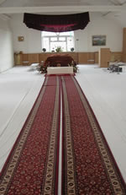  Darbar hall, Shri Guru Amardas Gurdwara, Southall  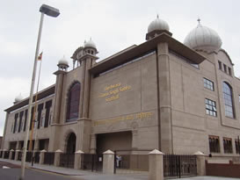  Guru Singh Sabha  Havelock Rd, Southall  (below, palki)  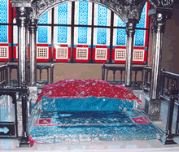
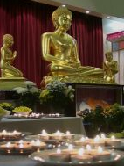  Shrine room  London Buddhist Vihara  reonline.org.uk  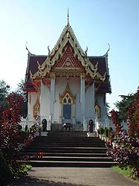  Wat Buddhapadipa  Wimbledon  www.untoldlondon.org.uk | The vihara  Two types of structures are associated with Buddhism in south Asia: stupas and viharas. The initial function of a stupa was the veneration and safe-guarding of relics, and the earliest still-existing example is in Sanchi (Madhya Pradesh). As religious practice changed, stupas were gradually incorporated into chaitya-grihas (stupa halls). These reached their highpoint in the first century BCE, exemplified by the cave complexes of Ajanta and Ellora (Maharashtra).  The Buddhist stupa or pagoda consists of three parts: square foundation, with dome on top, surmounted by a pinnacle. These can be taken to symbolise the 3 parts of the Noble Eightfold Path: sila—ethical conduct—is the foundation, samadhi (‘mental development’) is built on this foundation leading to panna (‘wisdom’), which is the goal of the practice.  Vihara is a word that originally meant ‘dwelling’ or ‘refuge’, such as those used by wandering monks during the rainy season. In the early decades of the religion the wandering monks had no fixed abode, however they often sheltered in temporary accommodation during the rainy season. These dwellings were typically simple wooden constructions or thatched bamboo huts. Over time, as it was considered an act of merit not only to feed the monks but also to shelter them, monasteries were built by rich lay devotees near populated settlements, close enough for the monks to beg alms but with enough seclusion to ensure undisturbed meditation.  Buddhanet has information about the symbolism of the temple: http://www.buddhanet.net/stupa.htm as does the Stupa Project for World Peace: http://www.stupa.org.  The London Buddhist Vihara in Chiswick, a Sri Lankan Theravada Monastery with five resident monks and a support staff of lay Buddhists, is a good place to start if you are looking for a speaker to come to the school. They also welcome visits. Contact Ven. B. Seelawimala or Richard Jones on 020 8995 9493, email: london.vihara@virgin.net  (Address: London Buddhist Vihara, Dharmapala Building, The Avenue, Chiswick, London W4 1UD. Website: www.londonbuddhistvihara.org )  Although it is a bit further to travel, the Thai Buddhapadipa Temple in Wimbledon also welcomes school visits. Contact: Santong Dhammacaro, 020 8946 1357, dhammacaro@yahoo.co.uk (Address: The Buddhapadipa Temple, 14 Calonne Road, Wimbledon Parkside, London SW19 5HJ. Website: http://www.buddhapadipa.org/index.html )  If the class is visiting a Buddhist temple or vihara: they will be expected to remove their shoes before entering, dress modestly, behave in a respectful manner, and refrain from physical contact with monks or nuns (e.g. shaking hands).
Scheme prepared by Nora Leonard, SACRE consultant, London Borough of Ealing

