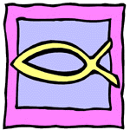 | Ealing Agreed Syllabus: guidance for teachers
 | Unit title: Signs and symbols

Learning objectives | Suggested activities | Suggested resources

Signs and symbols
AT2  Pupils begin to understand the difference between a sign and a symbol. | Starter: Explore the difference between signs (which usually have only one clear meaning, e.g. ‘H’ for hospital) and symbols (which can have many meanings). Point out that a red stop sign can mean ‘stop here’, but can also be used symbolically in other contexts.  Development:  - Discuss with children signs and symbols they might see around in the local community. What do they mean?  - Children walk around school and/or local community looking for signs and symbols, which they draw and write meaning underneath.  - Look at personal objects and discuss how they represent memories, i.e. they are symbolic of a time or place or person. Write about what the object symbolises to the individual to whom it belongs.  - Get children to design a postcard that they could send to a friend, with a picture of something that has symbolic significance for them, e.g. a place, person or event. | Assortment of signs and symbols.  Children bring in personal objects that have meaning to them, like souvenirs from trips to special places.  Paper and coloured pens or pictures that can be used as the basis of a postcard.

Sacred symbols
AT1  Pupils start to understand that religious symbols convey important ideas about that particular religion. | Starter: Ask children to name some of the religious symbols with which they are familiar.  Development:  - Show pupils examples of the symbols they have named, either in pictorial or artefact form.  - Look at an assortment of other sacred symbols, e.g. the Christian cross, the Buddhist wheel, the Sikh khanda, the Jewish Star of David, the Islamic star and crescent. Begin to discuss the religious ideas associated with these symbols.  - Children make a list of other symbols they are familiar with, e.g. a red rose for England, a dragon for Wales, the owl for Sheffield Wednesday supporters. Get them to say why these symbols are important to them—what do the symbols remind them of?  - Using pictures or cards as prompts, ask pupils to link symbolic objects to an idea, e.g. lion as a symbol of bravery. Point out that religious symbols also convey ideas. | http://altreligion.about.com/library/glossary/symbols/bidefsmagen.htm  Pictures or cards of various symbols

Symbols of identity
AT1  Pupils understand that people express religious affiliation through outward symbols.  AT2  They think about how they express and define their identity through symbols or symbolic dress. | Starter: Show children the 5 Ks or ideally ask a member of the Sikh community to come in and talk about them to the children. Explain their significance for Sikhs.  Development:  - Discuss the way people dress. What does it tell you about them?  - If the school has a school uniform, ask children to think about how this identifies them as a member of that particular school. Are there any symbolic elements in the uniform? School crests, etc?  - Children use magazines or the internet to collect pictures of people in religious and non-religious uniform. Make a class display putting key words that describe the people around them.  - Ask pupils to design a symbolic badge that expresses an aspect of their identity. Get children to share their badges. | Materials for making simple badges.

Symbolic acts of remembrance
AT1  Pupils understand how the rituals and symbols of Passover help Jews to remember their past and reinforce their identity.  AT2  They understand how symbolic food can be used to remember important events. | Starter: Returning to the first lesson, think about those personal souvenirs or objects that remind pupils of a past time or place. Ask them to consider how these objects are personal to them, and how they shape their sense of who they are.  Development:  - Ask the class to imagine they are living away from home or have moved to another country. Imagine that they are preparing a special meal, and get them to plan a menu that would remind them of home. What foods would they choose and why?  - Tell the story of Passover. Discuss, e.g. how eating matzoh remembers the story of the flight from Egypt. Make a seder plate using paper plates and different materials and/or cut-outs to represent the symbolic foods.  - Ask pupils to think of a family event, e.g. birthday, religious festival or national day from their country of origin. Get them to write a comparison between the symbols for that occasion (e.g. candles on a birthday cake, turkey and corn for Thanksgiving) and the symbols used in the celebration of Passover. | LGfL Espresso site, on-line Passover storybook (you will need to log in with your LGfL login and password): http://content.lgfl.org.uk/secure/faiths/t2_faiths/judaism/story_passover.html  Belief.net has an interactive seder plate that could be displayed on the IWB: http://www.beliefnet.com/religion/judaism/passover/introshell.htm  Passover artefacts including a seder plate and either pictures or fresh symbolic foods.  Other artefacts are available from Articles of Faith: http://www.articlesoffaith.co.uk/

Symbolic gestures
AT1  Pupils understand the use of symbolic gestures in Buddhism.  AT2  They begin to understand how important a shared knowledge of gesture is to communication. | Starter: Ask class to demonstrate some gestures that they might share with friends—obviously the less controversial ones! Talk about some universally understood gestures, e.g. a salute, a bow, shaking a person’s hand, a wave, shaking a fist.  Development:  - On the IWB, show the class a short video clip of a person performing sign language, for example the information videos on the Leeds County Council website. Discuss how sign language evolved to help deaf people communicate. Point out that modern sign language is a complex language, with signs that are both specific for certain words and also symbolic.  - Consider some signs and gestures that are more specifically religious, e.g.:  - Making the sign of the cross  - Namaste (see background information)  - Tell the class a bit about the Buddha. Point out that certain symbolic hand gestures—known as mudras—were common among Indian religions, such as Hinduism, Buddhism and Yoga. Talk about how several of these mudras became associated with the story of the Buddha, and that images of the Buddha showing one of these mudras represent particular facets of his story and of the Buddhist life. Demonstrate the five major Buddhist mudras, explaining what they symbolise.  - In groups, children plan a short sketch to perform for the rest of the class using only facial expressions, hand signals, body language etc. The class must try and understand the message of each presentation. | An image or statue of the Buddha demonstrating one of the classic mudras.  Illustrations of classic Buddhist mudras: http://www.exoticindiaart.com/mudras.htm  Information videos in British Sign Language (BSL) on Leeds County Council website; http://www.leeds.gov.uk/page.aspx?egmsIdentifier=99cd70c6-192e-4966-9d30-ca69bdcff7d1  BuddhaNet’s description of the five major mudras: http://www.buddhanet.net/e-learning/history/mudras.htm

Symbolic language
AT1  Pupils understand that metaphor helps to convey meaning in religion.  AT2  They understand that metaphor helps us to describe feelings and ideas that are difficult to put into more straightforward language. | Starter: Make a list of some familiar metaphoric sayings, e.g. “You’re driving me up the wall!” and “It’s raining cats and dogs.” Ask class to picture them literally, and then to suggest what the saying actually means in its metaphoric sense. With the class, come up for a definition of ‘metaphor’.  Development:  - Choose a feeling, e.g. jealousy, anger, fear, love, and explore in terms of simile and metaphor, asking class to suggest their own examples. For example, “I was so angry I felt like a volcano about to explode.”  - Look at some metaphoric references to God and Jesus in the Bible (e.g. the book of Psalms, where God is described as a rock, a shield, a tower, a fortress, a strong hold, and the New Testament, where Jesus is described as a shepherd and a corner stone.) Discuss why these images might have been chosen. As a class compile a dictionary of religious terms to help people understand religious metaphors.  - Look at the use of familiar metaphors to describe the nature of God, e.g. God or Goddess as a father or mother, God as all-merciful. Tell the class the story of Yashoda looking into Krishna’s mouth (see background information) as an example of metaphor used to point out that side of God that is difficult to comprehend.  - Show a picture that depicts many different Hindu gods, and talk about how in Hinduism all the gods and goddesses are considered to be manifestations of one supreme being: i.e. each different god or goddess and their story can be seen as symbolic of a greater whole that is hard to comprehend.  - In Islam it is believed that Allah is ‘beyond image’, therefore Allah is never pictured in human form. Instead the glory of Allah is portrayed in symbolic form in architecture and calligraphy. Look at some examples of this. | http://www.strath.ac.uk/Departments/SocialStudies/RE/Database/Graphics/Artefacts/HinduDeities.html
Review lesson
Recap on all aspects of symbolism studied. Children can then choose to either:

- Design a meal with food that is symbolic to them.
- Pick a person who is familiar to them and draw a picture of that person, putting in the signs and symbols that represent them.

Key words | Signs, symbols, cross, khanda, Star of David, star and crescent, kangha, kesh, kirpan, kara, kacheras, Passover, charoset, matzoh, roasted egg, salt water, lamb bone, parsley, bitter herbs, freedom, slavery.

Outcomes

At the end of this unit, most pupils will:

          - understand the difference between a symbol and a sign.
          - understand that some people use signs and symbols to express their religious identity through outward means, e.g. the way they dress and through the use of food.
          - be able to relate the use of signs and symbols to their own lives.

Some pupils will have made less progress and will:

- be able to identify some of the signs and symbols used in religion to express identity.
- begin to relate the use of signs and symbols to their own lives.

Some pupils will have made more progress and will be able to do all of the above. In addition they will be able to:

- state some ideas associated with religious symbols.
- understand the use of metaphoric language to describe God and give some examples.

Background information
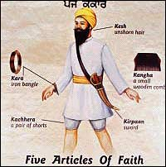  The panj kakke | Signs of belonging  Amrit Sanskar: Young Sikhs may be formally initiated into the khalsa ages 14-16. A special solution of sugar and water, known as Amrit, is prepared in an iron bowl while the five Banis (special prayers) are recited by five Sikhs in the presence of the Guru Granth Sahib (a reminder of the historical founding the khalsa and the role played by the five companions of Guru Gobind Singh, the panj piare). During the ceremony the Amrit is blessed and sprinkled on the hair and eyes of the initiate, a prayer is said and a meal is eaten together. For boys, the amrit sanskar may be combined with Dastar Bandi (wearing of the first turban). Alternatively it may be performed separately: the boy is taken to a Gurudwara and there—in the presence of the Guru Granth Sahib—his first turban is ceremonially tied on by the Granthi or by a Sikh elder. This ceremony designates the respect with which the turban is regarded and is usually attended by many family members and friends.  The panj kakke, five Ks: uncut hair (kesh), comb (kangha), bracelet (kara), sword (kirpan) short trousers (kachera).  The bbc schools website has a worksheet for learning the 5Ks: http://www.bbc.co.uk/schools/religion/worksheets/sikhism_baisakhi_5ks.shtml  For information about Vaisakhi, see the Days of Observance Calendar (April) on the Ealing Grid for Learning: www.religion.ealing.lgfl.net
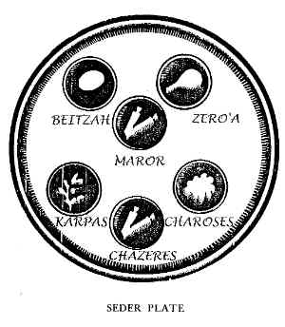 | Passover  Sweet mixture: a mixture of apples, nuts, wine and spices. Symbolic of the mortar the Jewish slaves made in their building for the Egyptians.  Roast bone: a shankbone or neck of poultry, roasted. Symbolic of the Paschal lamb offered as the Passover sacrifice in Temple days.  Roast egg: hard-boiled egg. An egg is used because it is a traditional food for mourners, reminding Jews of the destruction of the Temple in Jerusalem.  Spring vegetable: a vegetable such as parsley, representing spring and growth. Dipped in salt water to represent the tears of the slaves.  Maror (bitter herbs): herbs such as horseradish. Represents the bitter life of the Israelites during the time of their enslavement in Egypt.  Bitter vegetable/salt water: a bitter vegetable such as celery or lettuce. Those who do not put such a vegetable on their Seder Plate sometimes put a dish of salt water in its place.
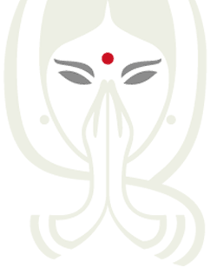  http://www.namaste-media.de | Namasté is a South Asian greeting which is used when both hello and goodbye would be used in English. The meaning is quite different, however, translating literally ‘reverential salutation to your inner (being).’ It is commonly accompanied by a slight bow made with the hands pressed together, palms touching, in front of the chest. In a religious context namaste be taken to mean:  The Spirit in me meets the same Spirit in you.  I greet that place where you and I are one.  I salute the Light of God in you.  I bow to the divine in you.  I recognize that within each of us is a place where Divinity dwells, and when we are in that place, we are One.  My higher energy salutes your higher energy.  the God in me sees and honors the god in you.  May the God within you, bless you  In other words, it recognizes the equality of all, and pays honour to the sacredness and interconnection of all, as well as to the source of that interconnection. Namaskar is the term for such greetings, and is also used as a greeting itself.
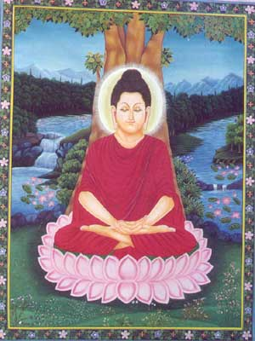  Dhyana mudra  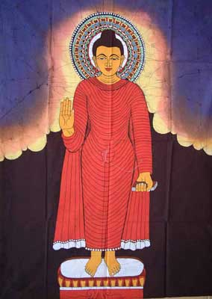  Abhaya mudra  www.buddhapia.com  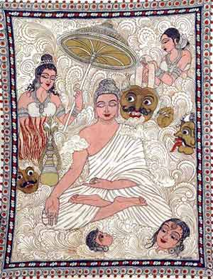  Bhumisparsha mudra  www.exoticindiaart.com | A mudra (Sanskrit, literally ‘seal’) is a symbolic gesture usually made with the hand or fingers. Along with asanas (seated postures), they are employed in the yoga meditation practice of Hinduism, where each mudra is said to impart a specific quality to the practitioner. Many mudras were absorbed into Buddhist culture, and common hand gestures can be seen in both Hindu and Buddhist iconography. An example of a mudra done with the hands would be the outward-facing open palm known as Abhaya (without fear) mudrā, a gesture meant to dispel the fear of the devotee.  Examples of Buddhist mudras (images from http://www.buddhanet.net/e-learning/history/mudras.htm):
  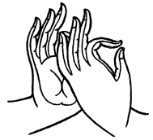 | Dharmachakra (Sanskrit, ‘wheel of Dharma’) The thumb and index finger of the right hand stand for wisdom and method combined; the other three raised fingers symbolize the teaching of the Buddhist doctrine. This mudra symbolizes one of the most important moments in the life of Buddha, the occasion when he preached the first sermon after his enlightenment to his companions in the Deer Park at Sarnath. It thus denotes the setting into motion of the Wheel of the teaching of the Dharma.
   | The Dhyana mudra is the mudra of meditation. According to tradition, this mudra derives from the one assumed by the Buddha as he meditated under the pipal tree before his Enlightenment. It indicates the perfect balance of thought, rest of the senses, and tranquillity and is a gesture that was also adopted from time immemorial by yogis during their meditation and concentration exercises.
  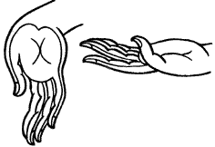 | Varada mudra, or gesture of bestowal of accomplishments. This mudra symbolizes charity, compassion and the granting of boons. It is nearly always made with the right hand, and can be made with the arm hanging naturally at the side of the body, the palm of the open hand facing forward, and the fingers extended. The gesture of the right hand symbolizes bestowal of supreme accomplishment; that of the left symbolizes meditation. Together, they stand for the Buddha’s power to grant boons to his disciples, which he bestows while he meditates.
  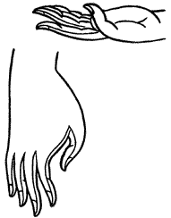 | Bhumisparsha mudra (literally ‘touching the earth’). This mudra, formed with all five fingers of the right hand extended to touch the ground, symbolizes the Buddha’s enlightenment under the bodhi tree, when he summoned the earth goddess, Sthavara, to bear witness to his attainment of enlightenment. Again, as in the varada mudra, the left hand assumes the position of meditation.
  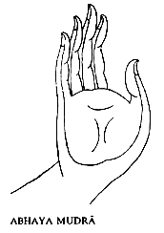 | Abhaya means ‘fearless in Sanskrit. Thus the Abhaya Mudra symbolizes protection, peace, and the dispelling of fear. In Thailand, and especially in Laos, it is associated with the movement of the walking Buddha also known as ‘the Buddha placing his footprint’. It is nearly always used in images showing the Buddha upright, either immobile with the feet joined, or walking.
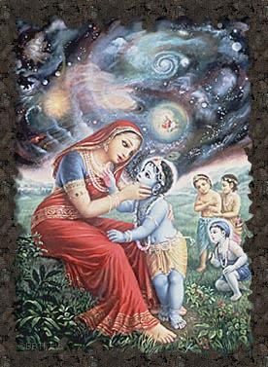  Yashoda seeing the universe in Krishna’s mouth  www.dalsabzi.com | Symbolic language and images used to describe God: the story of Yashoda and the child Krishna  As a child Lord Krishna was naughty, full of mischief and pranks. Sometimes his foster mother Yashoda must have despaired of teaching him anything, but she would not have changed him for the world. He was the most adorable child possible. Still, obedient he was not.  Yashoda came into her house one day to see Krishna taking dirt from the ground and eating it. She was appalled, and she cornered him immediately, demanding to know whether he had indeed just eaten dirt.  He looked up at her, his eyes large and innocent. “Would I do such a thing?” he asked.  “Answer the question!” she replied.  “No, mother,” he told her, his voice sweetly sincere. “I didn’t eat any dirt.”  She knew better than to believe him, of course. “Open your mouth,” she ordered, “and show me what is in it.”  So little Krishna opened his mouth wide, and Yashoda peered into it.  She saw, then, what was truly inside her son. For an instant all veils were swept aside, and, no longer protected by the illusion that keeps from us what we cannot handle, Yashoda saw the Universe in its entirety. She saw the stars, pinpoints in the void. As she saw them she was aware of the vast cold distances between them, and of their mortality, their brief flash of life so much longer than her own. She saw herself, an insignificant speck standing on a tiny planet staring into her son’s mouth, and inside his mouth she saw the Universe again, with its stars no less lonely and its distances no smaller. She saw Krishna again in that image, the Universe in him repeating itself into infinity.  And then Krishna gently restored the illusion, because he knew she could not cope with the truth.  Source: http://www.icsi.berkeley.edu/~shweta/stories/mythology.html

