Ealing Agreed Syllabus: guidance for teachers
Unit title: Detailed study (Buddhism)

Learning objectives | Suggested activities | Suggested resources

Who was Gotama?
AT1  Pupils to know the key events in the life of the Buddha  AT2  Pupils to apply aspects of the life of the Buddha to their own lives | Starter: Examine a statue or image of the Buddha, asking what aspect of the Buddha’s life the image reflects?  Development:  - Discuss the story of the Buddha’s life as a framework for whole unit.  - Ask pupils to discuss and record the key events in the life of the Buddha.  Homework:  Ask pupils to write about which part of the Buddha’s life story seems most relevant to them, clearly explaining why and drawing out any similarities to their own feelings.  Note: the “Laughing Buddha” figure (see background information) is not considered to be a proper image of the Buddha by many Buddhists.  Additional suggested resources:  Video: “Little Buddha” (1994, director B Bertolucci)  Aspects of Religion CD Rom, available from:  http://www.onestopeducation.co.uk/icat/18412497  Buddhist artefacts, prayer wheels, bells etc.  Website of London Buddhist Vihara: www.londonbuddhistvihara.org | What the Buddha Taught by Walpola Rahula.  ISBN 1851681426.  Another excellent introduction that includes more on the life of the Buddha: The Buddha and His Teachings by Narada Thera. ISBN 9552400252.  The Dhammapada Translated by Narada Thera ISBN: 0877739668 (Also available online: http://www.ohbliss.org/en/tipitaka/khuddaka/dhammapada_narada.html )  Buddhism by Peggy Morgan (aimed at GCSE students) ISBN 0 7134 5203X  What do we know about Buddhism? by Anita Ganeri ISBN 0 7500 2240X  Buddhist Vihara by Anita Ganeri. ISBN 0 7136 4833 3 (Includes photos taken inside the London Buddhist Vihara).

Learning objectives | Suggested activities | Suggested resources

Renunciation
AT1  Pupils to know about the renunciation.  AT2  Pupils to apply the principles of renunciation to their own lives. | Starter: Re-examine the story of the Four Sights.  Development:  Role-play: divide class into small groups and ask them to re-enact the situations when Gotama experienced each of the Four Sights.  Homework:  Ask pupils to write about whether there are things in life we should renounce, explaining the reasons for their conclusion.

Enlightenment
AT1  Pupils to learn about the enlightenment.  AT2  Pupils to draw lessons from the enlightenment for their own lives. | Starter: Discuss what the Buddha was doing when he discovered the four Noble Truths.  Development:  - Discuss each of the Noble Truths.  - Give pupils the choice of two tasks:  - Write a paragraph describing the expression on the Buddha’s face and illustrate the points you make. (Note: it is important to keep in mind that the facial expression is a product of the artist’s imagination.)  - Do you share the Buddha’s view that the impermanence of everything in life leads to suffering? Why? Why not? Do you think we all need to be enlightened at some time in our life? Relate an experience that you would describe as ‘enlightening’. How does this experience differ from what a Buddhist would call ‘enlightenment’?  - Get pupils to suggest their own four Noble Truths. | Interactive website explaining 4 noble truths and eightfold path:  http://www.4truths.com/

Learning objectives | Suggested activities | Suggested resources

Eightfold Path
AT1  Pupils to learn about the eight-fold path. | Starter: Display a large poster/whiteboard image of a wheel with eight spokes, giving some insight into the symbolism of the wheel in the Buddhist religion.  Development:  - In a sorting exercise, read sixteen statements, half of them from the eightfold path, half invented.  - Get pupils to decide which are the genuine statements.  - Transfer the correct elements of the path onto the spokes of the wheel.

Meditation
AT1  Pupils to learn what it is like to meditate. | Starter: Ask pupils about any previous experience of meditation.  Development:  - Take pupils through a relaxation exercise asking them to tense and relax different parts of the body until finally concentrating on the inhalation and exhalation of the breath and the sensations which arise as the breath flows in and out past the nostrils. (This exercise has the merit of being ‘religion-neutral’, so pupils of any or no religion can take part without compromising their integrity.)  - Ask pupils to write down how they felt during the exercise. | Guided imagery and/or background music.  See background section for information about meditation in Buddhism.

Learning objectives | Suggested activities | Suggested resources

Practising Buddhism
AT1  Pupils to experience some of the thinking and practices from a practising Buddhist | Starter: Ask students to write down a few questions they would like to ask a Buddhist about their way of life.  Development:  - The visiting Buddhist gives a short talk on the aspects of their religion that are most important to them.  - Pupils put questions to the visitor. | Visiting Buddhist (see background information for possible contacts)

Buddhist temples
AT1  Pupils are to learn about the different types of Buddhist temple and their symbolism. | Show images of a variety of different Buddhist Temples and examine the different shapes that make them up and what these shapes symbolise.  Homework: Revise all they have learnt of Buddhism to date in anticipation of the end of unit task. | REOnline has links to several resources for teaching Buddhist symbols:  http://www.reonline.org.uk/allre/tt_links.php?69

The Buddha’s legacy
AT2  Pupils are to link what they have learnt to life today. | How important is the Buddha today?  Extended writing task (250 + words). Include also an evaluation of the unit. What have I learnt in this unit? What have I most/least enjoyed? How could it be adapted to make it even better for next year?

Key words | Alms, Anatta, Anicca, Awareness, Bhavana, Bodhi tree, Buddha, Dhamma, Dukkha, Enlightenment, Four Noble Truths, Kamma, Mandalas, Mantra, Materialism, Meditation, Merit, Nibbana, Noble Eightfold Path, Pali, Samsara, Sangha, Stupa, Tipitaka, Zen
Points to note | - The pragmatism of Buddhism, in particular that there were questions so uselessly speculative that the Buddha refused to answer them  - Its philosophical, non-theistic nature.  - Spellings: There is a whole range of different spellings of persons and places. For instance, the Pali spelling of our central character is Siddhattha or Siddattha Gotama; but this is also frequently spelt Siddhartha Gautama. The latter is not wrong—it is simply the Sanskrit version. Different Indian languages have different spellings of the same names, so it is important teachers don’t impose their own standards of orthographic correctness. GCSE tends to prefer the Pali version, so you can recommend this but the fact remains several other variants are perfectly acceptable to Asian Buddhists—in fact Mahayana Buddhists frequently prefer the Sanskrit spelling.  - Doctrinal variety: The multiplicity of Buddhist schools should also be remembered in terms of doctrine as well as spelling.  - Meditation: No teacher would dream of forcing his/her class to pray in any particular form; similarly certain pupils (or more probably parents) may see the exercise in meditation as something “religious” and object to (their child) taking part in it on those grounds. It is important to be honest about this and ensure that the form of meditation you choose to do with the class does not involve assent to any dogma or concept of the divine. Pupils should be made aware of their right not to participate in the exercise at any stage. (Note: The Pali word bhavana means mental training or mental development; the practice of sitting quietly and observing one’s breath should not be offensive to anyone, no matter what their religious or philosophical views may be.)

Outcomes

At the end of this unit, most pupils will:

- know the story of the Buddha’s life in some detail.
- understand that he did not find happiness in the material things he was surrounded with during his youth.
- understand that it is important to question purely materialistic routes to happiness offered by contemporary society.
- understand and have experience of at least one form of meditation as distinct from prayer.
- have explored the concept of “enlightenment” and applied it to their own experience of knowledge gained thus far in life.

Some pupils will have made less progress and will:

- know the Buddha’s life story, without necessarily understanding its relevance to their own contemporary situation.
- understand the basics of meditation and how it differs from prayer.
- have been introduced to the idea of enlightenment and a moral life-style.

Some pupils will have made more progress and will:

- have learnt and understood all the above.
- recognise in their own lives to date a journey of progressive spiritual and moral development.
- understand that this journey may be marked by moments of intense spiritual awareness when new spiritual lessons are learnt.
- recognise unsatisfactory aspects of life and understand the Buddha’s way of explaining and remedying these.

Background information
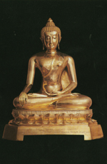 | The very first representations of the Buddha were not in human form, but rather symbolic representations, e.g. the Dharma Wheel, footprint (buddhapada), Bodhi tree or lotus (symbolic of the pure Buddha mind). Anthropomorphic representations of the Buddha started to emerge from the 1st century CE in northern India in two centres which have been identified as Gandhara in today’s Punjab in Pakistan, and the region of Mathura, in central northern India.  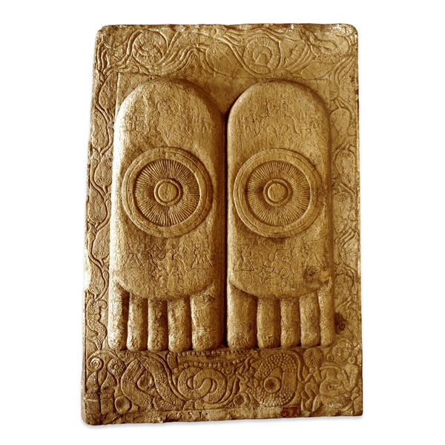  Gandharan Buddhist sculpture displays Greek artistic influence from centuries of interaction with Greek culture since the conquests of Alexander the Great in 332 BCE. In contrast, the art of Mathura reflects a strong Indian tradition.The Mathuran school contributed clothes of thin muslin covering the left shoulder, the wheel on the palm or soles of the feet, the lotus seat, etc. For more on the evolution of Buddhist art visit the Wikipedia encyclopaedia: http://en.wikipedia.org/wiki/Buddhist_art  Article on the life of the Buddha: http://buddhism.about.com/library/blbudlifebirth1.htm  Another informative website on the nature of Buddha images, which includes traditional rules for the making of an image and the proper way to handle them: http://seasiancrafts.com/spiritworld/buddha.htm
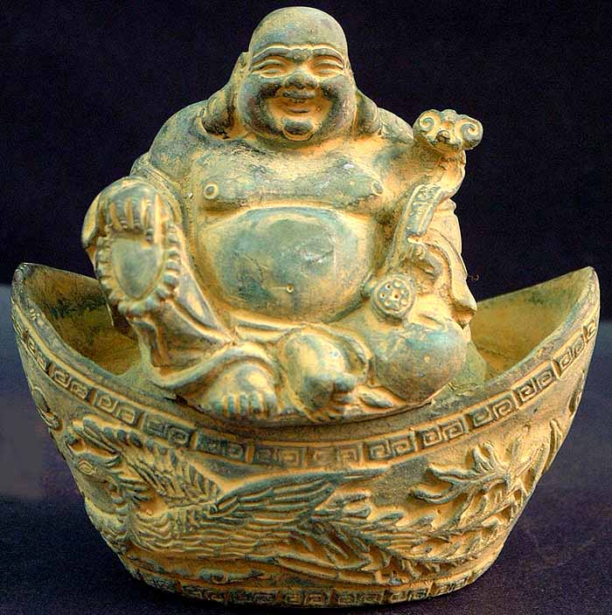  Laughing Buddha  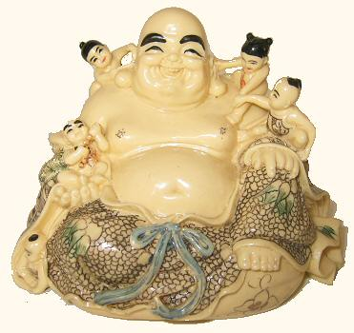  Hotei, god of good luck | The laughing Buddha  One story about the origin of the figure of the laughing Buddha refers to a monk named Angida who is supposed to have lived at the time of the historical Buddha. According to legend Angida was a talented snake catcher, who would catch venomous snakes and remove their poison before releasing them again. It is said that because of this kindness—both to the snakes and to those who otherwise might have been bitten—Angida was able to attain bodhi (enlightenment). Like the familiar image of the Laughing Buddha, Angida is often portrayed as a large jolly man with a sack—only in Angida’s case the sack is for the snakes.  When Buddhism spread to China, Buddhist notions of bliss based on self-mastery and enlightened insight became fused over the centuries with the popular Chinese ideal of happiness through material prosperity. It is said that the image of the fat Buddha clutching his prayer beads in one hand and with a bag of riches in the other—and often surrounded by children—reflects a more typically Chinese value system.  It is also possible that the Laughing Buddha was modelled on an historical figure, a 10th century Chinese monk who became known as Pu-tai Hoshang (‘hemp bag’ monk) for the bag he always carried. Early sources say that portraits of him were worshipped by people in the belief that Pu-tai was in fact an incarnation of the Buddha Maitreya (i.e. the Buddha to come). Imported into Japan along with other elements of Chinese Buddhism, Putai became Hotei, one of the seven gods of good luck in the Shinto religion.  Statues of the so-called laughing Buddha depict a stout, smiling or laughing bald man in robes; his large potbelly is meant to be symbolic of happiness, good luck, and plenitude. Some depict him surrounded by small children. He is usually portrayed with an alms bowl, his sack bearing food and gifts—ready to be filled with the sadness he has come to take away. But it is important to note that many Buddhists would take issue with the image of the laughing Buddha. Although the Buddha taught that piti (joy) is an important mental quality, he also taught that enlightenment is not to be found in material prosperity. If any reference is made to a ‘laughing’ Buddha, it is perhaps important to make sure that students understand that this is a popular Chinese development, but not part of Buddhism proper.
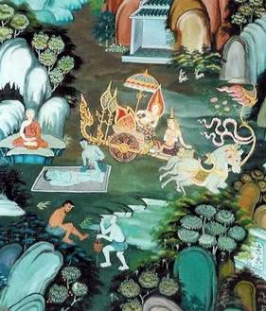  The four signs | The four sights or signs  Because of the prophecies that had attended Prince Siddhattha’s birth—i.e. that he would either become a world ruler or a great holy man—his father wanted to shield him from the more distressing features of the world. Consequently the prince spent his life within the confines of the palace and its grounds, absorbed in his own pleasure.  Eventually, however, he grew dissatisfied and asked his charioteer to take him on an excursion outside the palace. On the first trip into the ‘real world’ he encountered an old man; during the next he saw a man devastated with disease, and on his third excursion he saw a corpse being carried to cremation. These sights impressed upon him the prevalence of suffering in the world: that he too was subject to old age, sickness and death, vicissitudes of life that no-one—not even a king’s son—could escape.  On the verge of losing all hope he made one final trip, during which he encountered an ascetic, apparently content and at peace with the world. This fourth sign was the one that inspired him; convinced that this was the way to ease his mental agitation, Gautama resolved to follow the ascetic’s example.
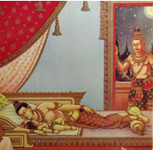  The prince’s farewell look | 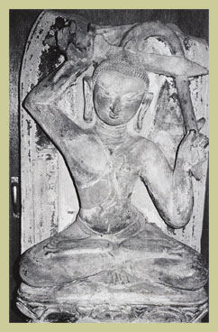  Burmese sandstone relief of Siddhattha cutting off his hair  The great renunciation  Gotama’s only son was born on the day that he saw the final sign. Nevertheless, such was Siddhattha’s desire to attain something which would be of benefit not only to his family but all humankind that he was still determined to renounce his privileged life to go out and seek enlightenment.  After ordering his charioteer to prepare his horse, the prince took one final look at his sleeping wife and their newborn son and then left the royal household: it was midnight on the full moon day of the month of Vesakha and he was 29 years old.  He crossed the river, shaved his hair and sent his charioteer and horse back to the palace; thus he began the life of a wandering ascetic, possessing nothing but a begging bowl and a simple robe.
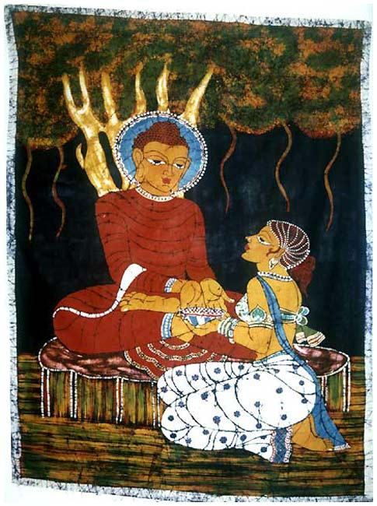  Gautauma ends his 6-years  of rigorous asceticism by accepting a bowl of sweet rice | The four noble truths  “Monks, it is through not realizing, through not penetrating the Four Noble Truths that this long course of birth and death has been passed through and undergone by me as well as by you. What are these four? They are the noble truth of dukkha (suffering); the noble truth of the origin of dukkha; the noble truth of the cessation of dukkha; and the noble truth of the way to the cessation of dukkha. But now that these have been realized and penetrated, cut off is the craving for existence, destroyed is that which leads to renewed becoming, and there is no fresh becoming.” (From the Maha-parinibbana Sutta)  See Wikipedia entry: http://en.wikipedia.org/wiki/Four_Noble_Truths
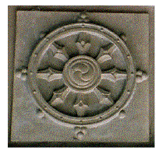 | The noble eightfold path:  For a lovely exposition of the eightfold path from a Zen perspective see: http://www.hsuyun.org/Dharma/zbohy/Literature/essays/czs/eightfoldpath2.html  Wikipedia also has useful information: http://en.wikipedia.org/wiki/Noble_Eightfold_Path
  Wisdom  (pañña) | 1. Right view
  Wisdom  (pañña) | 2. Right intention
  Ethical conduct  (sila) | 3. Right speech
  Ethical conduct  (sila) | 4. Right action
  Ethical conduct  (sila) | 5. Right livelihood
  Mental development  (Samadhi) | 6. Right effort
  Mental development  (Samadhi) | 7. Right mindfulness
  Mental development  (Samadhi) | 8. Right concentration
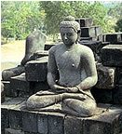  Meditating Buddha  Borobudur Temple, Java | For most schools of Buddhism, some kind of meditation practice is essential for the realization of Nibbana, and two quite distinct methods of meditation are commonly described. The first is samatha (literally ‘tranquillity’ or ‘calm’). The initial stage of this type of meditation involves focussing the mind by concentrating on an object. One of the more widely practised techniques is mindfulness of breathing (anapanasati). When the mind is totally focused and the five hindrances (ill-will, sensual desire, anxiety, sloth and doubt) have been eradicated, the meditator may gain access to states of rapture (jhana) that nonetheless fall short of nibbana because they are impermanent.  Vipassana or ‘insight’ meditation offers a different approach. The emphasis here is on seeing things as they really are, unclouded by attraction or aversion or other preconceptions. The basic practice is to note everything you are doing as you are doing it; thus the first stage of vipassana meditation is heightened awareness. At the same time insight into the factors that underlie all phenomena is obtained, i.e. impermanence (anicca), suffering (dukkha), and not-self (anatta).  In both methods the practice may begin with developing awareness of the breath as it enters the nostrils. By continuing this as a samatha practice, mental and physical processes become calmed. In vipassana practice, awareness is developed that the breathing process, like everything else, has the characteristics of impermanence, suffering, and not-self. Unlike samatha, vipassana is a meditation method that can take one to Nibbana.
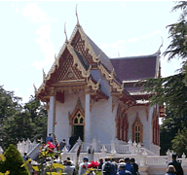  Wat Buddhapadipa  Wimbledon | Practising Buddhists  The London Buddhist Vihara in Chiswick, a Sri Lankan Theravada Monastery with five resident monks and a support staff of lay Buddhists, is a good place to start if you are looking for a speaker to come to the school. They also welcome visits. Contact Ven. B. Seelawimala or Richard Jones on 020 8995 9493, email: london.vihara@virgin.net  (Address: London Buddhist Vihara, Dharmapala Building, The Avenue, Chiswick, London W4 1UD. Website: www.londonbuddhistvihara.org )  Kathy Tomlinson is a practising Buddhist who lives in Ealing and would be willing to come in to schools and answers questions about what it means to her to be a Buddhist. (020 8579 5282)  Although it is a bit further to travel, the Thai Buddhapadipa Temple in Wimbledon also welcomes school visits. Contact: Santong Dhammacaro, 020 8946 1357, dhammacaro@yahoo.co.uk (Address: The Buddhapadipa Temple, 14 Calonne Road, Wimbledon Parkside, London SW19 5HJ. Website: http://www.buddhapadipa.org/index.html )
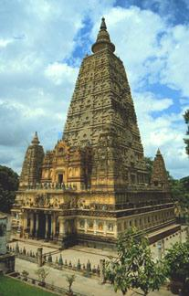  Mahabodhi temple  Bodh Gaya, Bihar | Buddhist temples  Two types of structures are associated with early Buddhism in south Asia: stupas and viharas (literally ‘abode’, ‘house’ or ‘monastery’). The initial function of a stupa was the veneration and safe-guarding of relics, and the earliest still-existing example is in Sanchi (Madhya Pradesh). As religious practice changed, stupas were gradually incorporated into chaitya-grihas (stupa halls). These reached their highpoint in the first century BCE, exemplified by the cave complexes of Ajanta and Ellora (Maharashtra). Viharas were developed to accommodate the growing and increasingly formalised Buddhist monasticism.  The Buddhist stupa or pagoda consists of three parts: square foundation, with dome on top, surmounted by a pinnacle. These can be taken to symbolise the 3 parts of the Noble Eightfold Path: Sila—ethical conduct—is the foundation, Samadhi (‘mental development’) is built on this foundation, and leads to Panna (‘wisdom’), which is the goal of the practice.  The Buddhapadipa Temple (14 Calonne Road, Wimbledon, Parkside, SWl9 5JH. 020 8946 1357) is the London centre for the Thai Buddhist community. It is an impressive building with nine resident monks. Visit their website to see activities and information about group tours: www.buddhapadipa.org  Buddhanet has information about the symbolism of the temple: http://www.buddhanet.net/stupa.htm as does the Stupa Project for World Peace: http://www.stupa.org.
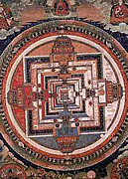  Tibetan mandala | Mandala is a Sanskrit word meaning ‘circle’. In the Tibetan tradition, all religious works of art are collectively referred to as sku gsun thugs rten. rTen literally means ‘support’, i.e. they are intended as supports to the process of enlightenment. ‘Body supports’ (sKu rten) are images of the Buddha, deities, or saints in the Buddhist pantheon. ‘Speech supports’ (gSun rten) are scriptures such as sutras and tantras, or commentaries on these. ‘Mind supports’(Thugs rten) include stupas and mandalas (dkyil khor). The word dkyil khor means ‘centre-circumference,’ and describes both the essential geometric structure and ritual significance of mandalas.  Tibetan Mandalas are often constructed of sand, somewhat in the manner of the Navajo sand-paintings used in healing rituals. They may also incorporate jewels, flowers, coloured stones, or dyed rice. As the mandala is constructed, each particle is charged with the blessings of the ritual purpose and process. Both the deity residing at the centre of the image and the mandala in its entirety are perceived as sacred expressions of the enlightened mind of the Buddha. Each person engaging in the construction ceremony is nourished through the process of visualizing and contemplating the image.
Other keyword definitions (When appropriate, the Sanskrit term can be found in parentheses)

Anatta (anatman): From an ‘not’ and atta ‘self, soul’. Non-self; Buddhist doctrine postulating that there is no unchanging, permanent self within a human being. This is in contrast to the Upanishad view that the atman or inner essence of a human being is identical with the Supreme principle (Brahman) that pervades and is the universe.

Anicca (anitya) The Buddhist doctrine of impermanence, in which suffering (dukkha) is seen as stemming from the fact that all sensory experience and objective reality are impermanent.

Dana (‘giving’) Giving—whether of material resources, time, care, love etc.—without any expectations of reward or other outcome.

Dhamma (dharma) The liberating law discovered and proclaimed by the Buddha, summed up in the Four Noble Truths.

Dukkha In Buddhism, the concept of the unsatisfactory nature of life. It includes much more than the English word “suffering”, e.g. frustration, disappointment, irritation. The Buddha said, “….not to get what one wants is dukkha.”

Kamma (karma) Intentional actions that affect one’s circumstances in this and future lives. The Buddha’s insistence that effect depends on volition marks the Buddhist treatment of kamma as different from the Hindu understanding of karma.

Karuna (‘compassion’) Karuna is the wish to do something to alleviate the suffering (dukkha) of others.

Mantra A word, syllable or phrase believed to embody some aspect of spiritual power; used as an object of concentration and repeated constantly while in a meditative state. Only some schools of Buddhism use mantras, e.g. Tibetan Buddhism (om mane padme hum) and the Nichiren School (yam myoho renge kyo).

Metta Unconditional and unselfish love for all beings without any exceptions or limitations; a feeling of pure goodwill, which is the best antidote to anger, hatred and ill-feeling in all its forms.

Nibbana (Nirvana) Blowing out of the fires of desire, anger and delusion, and the state of perfect peace that follows. The end of rebirth.

Pali Ancient language derived from Prakrit, a language that is also the precursor to Sanskrit. The scriptural and liturgical language of Theravada Buddhism.

Samsara Sanskrit word meaning ‘wheel’ or ‘cycle,’ and hence, the endless cycle of existence throughout birth, death and rebirth.

Sangha The Buddhist monastic community, considered one of the three jewels of Buddhism along with the Buddha and the Dhamma.

Sila The foundation of the Buddhist way of life; the part of the Noble Eightfold Path that deals with ethical conduct or morality. This ethical lifestyle is summarised by the observance of five Precepts or Rules of Training: to refrain from killing living beings, to refrain from taking that which is not freely given, to refrain from sexual misconduct, to refrain from using harsh or false speech, and to refrain from using alcohol or drugs which intoxicate the mind.

Tipitaka (Tripitaka, literally 'three baskets’) Collective name for the canonical scriptures of Buddhism, which fall into three main divisions: Vinaya-pitaka, Sutta (or Dhamma), and Abhidhamma.

Zen A Japanese sect of Mahayana Buddhism that aims at enlightenment by direct intuition through meditation.

Scheme prepared by George Wrigley, Ellen Wilkinson School for Girls, London Borough of Ealing
Thanks also to Richard Jones of the London Buddhist Vihara for his comments and additions.

