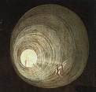 | Ealing Agreed Syllabus: guidance for teachers
 | Unit title: Life after death

Learning objectives | Suggested activities | Suggested resources

Day of the dead
AT1 (entire unit)  To be able to describe what believers feel about life after death.  To know some similarities and differences in religious beliefs about life after death.  To understand how people show what they believe through their words and actions. | Starter: Word definitions. Pupils write the definitions to the following words: altar, funeral, skeleton, prayer, soul.  Development:  - Read the information on ‘Day of the Dead’; discuss with the pupils if this type of attitude – open, ritualistic and annual – helps people to accept death more readily.  - Paired speaking activity. Pupils discuss and note down reasons why death is a taboo subject in the UK. Secondly, decide how it might affect their attitude towards death if they were brought up in a society where the ‘Day of the Dead’ was part of their experience.  - Pupils write down any sentences or phrases in the text that describe Mexican beliefs about life after death.  - Pupils complete a table showing the activity and the meaning from the ‘Day of the Dead’, e.g. Activity Meaning  Setting up an altar Remembering dead relatives  Plenary: Today I found out that…  SEN/EAL: Give pupils a photocopy of the text so they can highlight sentences and phrases.  Extension: If you were asked to plan a day of remembrance for the life of someone close to you what would you include? What objects, sounds, words, places or actions would you use?  Homework: target board (see background information). Pupils place the following ideas on a target board in order to prioritise them, the most important in the centre to the least important on the outer circle: to worship gods, to remember All Saints’ Day, a special time for thinking about death, celebrating the lives of deceased family members, to encourage a fun side to the sadness of death, to ensure death is not a taboo subject. | 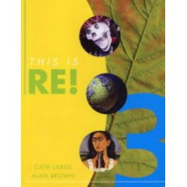  This is RE Book 3, Julia Ingham et. Al, Hoddard Murray Pub.  ISBN 0 7195 7523 0 P20  www.mexonline.com/daydead.htm  This is RE Teachers Resources Book 3, John Murray  ISBN 0 7195 7524 9  P45 worksheet 2.1 “Remembering the Dead”

Near death experiences
AT2 (entire unit)  Be able to consider whether it is important to believe in life after death.  Reflect on what life after death means to others and themselves.  Express why a belief in life after death is—or isn’t—important. | Starter: Read two examples of near death experiences. Pupils highlight the text, finding the things that are similar in both experiences.  Development:  - Read a scientific explanation of near death experiences.  - Pupils discuss their ideas with a partner. Choose which of the statements fit your points of view. Add bullet points to summarise your views.  - These stories prove to me that death is not the end because:  - These stories are just tricks of the mind because:  - I want to believe them because:  - I find it hard to believe them because:  - I should like to know the answers to these questions:  Plenary: Why are people interested in life after death? Pupils write down three words or phrases. E.g. ‘death is a mystery’  SEN/EAL: Simplify reading texts. Reduce number statements to include A, C, D  Extension: Give pupils two statements: A. These experiences are proof of an afterlife because…  B. These experiences are just the mind playing tricks on the patient because… Using the source material chose a statement and write reasons to support their point of view in sentences and paragraphs.  Homework: pupils to sort the statements five statements (A-E) into agree, disagree and not sure. Include a blank one so they can add their own comment. | This is RE Book 3  P22-23  This is RE Teachers Resource Book 3, p46, worksheet 2.2: “There was a bright light…”  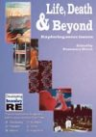  Developing Secondary RE: Life, Death and Beyond, RE Today Services, p10,  ISBN 1-904024-38-6  (Available from: http://www.rumple.co.uk/cem/acatalog/The_Online_Shop_RE_Today_Publishing_1.html)

Where do you think we go when we die?
 | Starter: Hand pupils a copy of “What do you think happens to a human being after death” Pupils to read through statements and shade the boxes they agree with.  Development:  - Paired work. Give pupils a series of statements that they can cut out and diamond rank starting with the one they most agree with down to the least.  - Snowball the groups so they are now working in 4s. Pupils decide which statements cause the most agreement and the most disagreement.  - Pupils write a group summary, which will be shared with the class. Give the groups starting sentences: Our group agreed most with statement (A-K) because…We disagreed most with statement (A-K) because…The statement we found most difficult to agree on was (A-K) because…  Plenary: pupils read statements to the class.  SEN/EAL: reduce the number of statements and then pupils can put them into 2 piles ‘agree’ or ‘disagree’.  Extension: enable pupils to write statements to add to the diamond ranking activity. Sort statements into categories under the headings: §Atheist §Theist §Agnostic  Homework: Using the statements from the lesson answer the question: “Where do you think we are going when we die?” | Developing Secondary RE: Life, Death and Beyond, RE Today Services, p 15  ISBN 1-904024-38-6  This is RE Book 3, p24

Life after death 1 & 2
 | Starter: Show pupils William Blake’s painting “The Last Judgement”. Ask them to examine it carefully and describe what is happening at various places in the painting; then ask them to describe the picture’s overall message.  Development:  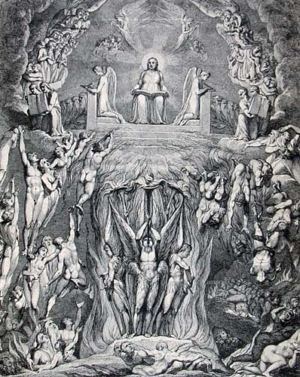  First lesson: Working in jigsaw groups, pupils are required to prepare a report on the beliefs about life after death for one particular religion: Christianity, Islam, Hinduism or Judaism. They will report their findings back to an expert group made up of pupils who have been gathering information on the other religions.  The home groups will be looking at the key ideas about life after death for a particular religion. They will spend one lesson in their home group gathering information before forming expert groups the following lesson where they will share the information. (There is a one-page framework appended to the background information that will help pupils prepare the required information.)  Second lesson: pupils will be reporting back to an expert group. They will need to make notes on the other pupils’ presentations. Give pupils a framework for this task.  SEN/EAL: Ensure home groups are mixed academically to provide support. Provide pupils with a more structured framework for collection of information and feeding back.  Extension: Encourage more able pupils to take a greater leadership role in the groupings.  Homework: Whilst pupils are gathering information, set a research homework on their given religion. | For a good picture of Blake’s “The Last Judgement”: http://www.virtualmuseum.ca/Exhibitions/Annodomini/THEME_02/EN/theme2-4-zoom.html  Jigsaw Grouping is useful for ensuring participation from all pupils, as well as for developing speaking and listening skills.  A topic is divided into sections. In home groups of four or five, allocate sections to each and then regroup into expert groups. I.e. the home group splits so that individual members go to different expert groups.  The expert groups work on their aspect and then rejoin their home group to report back. The home group is then set a task, drawing on the different areas of expertise.

An end or a beginning?
 | Starter: Listen to Allegri’s “Miserere Mei”.  - How does the piece make you feel?  - What feelings is the composer trying to create?  - What images come into your head when you listen to the music?  - Did you enjoy listening to the music? Say why.  Development:  - Read the description of ‘Threshold to the Kingdom’ by Mark Wallinger (1959-) a video installation showing an airport arrivals hall, which likens it to people arriving in the kingdom of heaven (see background information).  - Show images from video installation:  (see e.g. http://www.rusmuseum.ru/eng/exhibitions/?id=218&i=4&year=2003 ).  - Working in pairs, pupils imagine that they are the security guard deciding who shall pass through (into heaven) and who shall be turned away. Pupils need to decide on criteria listing these.  - Snowball this out into groups of 4 where the pupils need to decide on between 5-8 criteria for entry into heaven. These should be fed back to the rest of the class.  EAL/SEN: give pupils a list of criteria and they can choose which ones are appropriate.  Extension: To what extent might a Christian agree or disagree with this presentation? (Note: Mark Wallinger did not set out to reflect Christian teaching.)  Homework: Pupils draw their own image or write their own description on ‘For me death is like…’ | Allegri’s “Miserere Mei”  (Miserere—the imperative of Latin misereri, to have mercy or pity—is the name of one of the seven Penitential Psalms (i.e. Psalm 51), from its opening words, Miserere mei, Deus, “Have pity on me, God.” Allegri’s setting of this psalm is one of the most well known.)  Words of Psalm 51  Developing Secondary RE: Life, Death and Beyond, RE Today Services, p12  ISBN 1 904024 38 6  For information about Mark Wallinger: http://en.wikipedia.org/wiki/Mark_Wallinger

A personal response
Development:

- Read the poem ‘Know this now’ by Grace Smith from Traveller’s Tales:
All partings come
unexpected or expected
if in one or a hundred years;
but those unavowed links of love
are not broken
so true are the words we have spoken;
Eternity is ours, and unwelcome death,
know this now
For us you hold no fears.

- Pupils discuss in pairs or write down:
  - Why the author of the poem believes that death holds no fears?
  - Do they think that the poem is a religious poem?
  - Could the poem be used by non-religious people?
  - Do you agree with the poem’s message?

- Pupils to write their own poem expressing their thoughts, feelings, hopes and fears about life after death. They should include interesting ideas from previous work. Give pupils a frame work sheet to guide them.

Plenary: Read pupils’ work to class.

EAL/SEN: Illustrate a poem about life after death.

Extension: Work with pupils to extend their poetry work, encouraging them to use techniques connected to the rhythm or alliteration for example.

Homework: reflective questions, e.g.: During this unit I have thought about…Before I thought that…Now I think that…Religious views about life after death help us to…

Key words | Altar, funeral, skeleton, prayer, soul, mystery, atheist, theist, agnostic, hallucination, reincarnation, karma, atman, samsara, moksha, Brahman, Kaddish, Bet Chayim, soul, orthodox, resurrection, Reform, Orthodox, shiva, Akhira, Qur’an, Barzakh, Shari’ah.

Outcomes

At the end of this unit, most pupils will:

AT1 Level 5
- explain key religious and scientific beliefs and ideas about life after death.
- identify similarities and differences within and between religions in relation to life after death.
- explain the impact of beliefs about life after death on individuals and their communities.
- consider how religious sources are used to provide answers to ultimate questions.

AT2 Level 5
- ask, and suggest answers to questions about where we are going, relating them to their own and other’s lives.
- ask and suggest answers to questions of meaning and purpose relating them to their own and other’s lives.
- lead discussions relating to where are we going.

Some pupils will have made less progress and will:

AT1 Level 4
- describe and show understanding of religious and scientific ideas about “where are we going”.
- make comparisons between the beliefs and ideas of some religions in connection with “where are we going”.
- express beliefs and ideas about life after death.
- use a developing religious vocabulary, writing in simple sentences which are organised into paragraphs.

AT2 Level 4
- can ask questions about life after death and where we are going and suggest appropriate answers
- discuss in small groups issues relating to “where are we going”
- apply their ideas to their own and other people’s beliefs about “where are we going”

Some pupils will have made more progress and will:

AT1 Level 6
- interpret sources and arguments, explaining the reasons that are used in different ways to provide answers to ultimate questions.
- give informed accounts of religious and scientific beliefs and ideas about life after death and the reasons for the diversity amongst them.
- explain the impact of religious and scientific beliefs on individuals and communities.
- use religious and philosophical vocabulary in various sentence structures.

AT2 Level 6
- relate different religious perspectives on ultimate questions to their own and other’s lives.
- use reasoning and examples to express insights into their own and other’s views on “where are we going”.

Background information
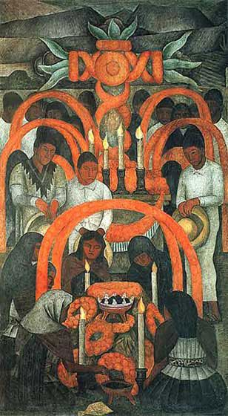  Día de los Muertos: La Ofrenda  Diego Rivera 1923-1924  encontrarte.aporrea.org | The Mexican Day of the Dead (Dia de los Muertos) is an ancient holiday with a complex history, and its observance varies by region and by degree of urbanization. Although a day of remembrance it is definitely not a morbid occasion.  The original celebration can be traced to many Mesoamerican native traditions, such as the summer festival dedicated to children and the dead, which was moved after the conquest by Spanish priests who wanted to link it to the Christian holiday of All Souls.  Families decorate graves with flowers— primarily large, bright flowers such as marigolds and chrysanthemums—and hold picnics in cemeteries, telling stories about the departed. The meals prepared for these picnics usually feature meat dishes in spicy sauces, chocolate beverages, cookies, sugary confections in a variety of animal or skull shapes, and a special egg-batter bread known as pan de muerto, ‘bread of the dead’.  In the home family altars are also decorated with flowers and decorated with items believed to be treasured by the souls of the departed, e.g. photographs, a diploma, or an article of clothing. This is done to encourage the dead to return to take part in the remembrance. In some native communities he path from the street to the altar is strewn with petals.  Traditionally children are remembered during the first day of the festival (the Day of the Little Angels, ‘Día de los Angelitos’), and adults on the second. Friends and family members give one another gifts consisting of sugar skeletons or other items with a death motif, and the gift is more prized if the skull or skeleton is embossed with the person’s name.  In general, the more urban the setting the less religious and cultural importance is retained. This is in contrast to rural Indian communities where the festival is of greater social importance.
 | Place the following ideas on a target board in order to prioritise them, the most important in the centre to the least important on the outer circle.  - To worship gods  - To remember All Saints’ Day  - A special time for thinking about death  - Celebrating the lives of deceased family member  - To encourage a fun side to the sadness of death  - To ensure death is not a taboo subject
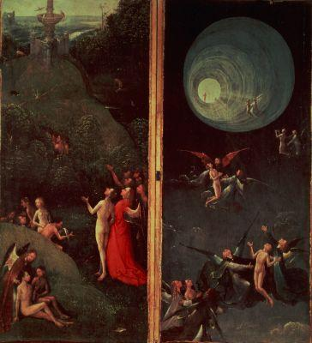  Ascent into the Empyrean  Hieronymus Bosch (c1450-1516)  www.museumsponsor.com  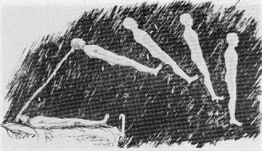  Projection of the astral body  www.crystalinks.com | Dr. Raymond Moody coined the term ‘near-death experience’ (NDE) in his 1975 book, Life After Life, however reports of such experiences have occurred throughout history. A near-death experience is the perception reported by a person who has nearly died or who was clinically dead and revived, perhaps a more common occurrence since the development of cardiac resuscitation techniques.  A ‘core’ near-death experience most often involves feelings of peace, joy and harmony, followed by insight and mystical or religious experiences . However a significant number of NDEs involve ‘hellish’ scenarios, e.g. encounter with a bardo dimension, limbo, or purgatory, or scenes of a startling and unexpected indifference: these types of NDE are usually experienced by those who seem to have deeply suppressed or repressed guilt, fears, and angers, and/or those who have an expectation of some kind of punishment or accountability after death.  A typical progression for the more pleasant NDE experience:  - A sense of being dead.  - An out-of-body experience. A sensation of floating above one's body and seeing the surrounding area.  - Pleasant feelings, calmness. A sense of overwhelming love and peace.  - A sensation of moving upwards through a tunnel or narrow passageway.  - Meeting deceased relatives or spiritual figures.  - Encountering a being of light, or a light (possibly a religious or divine figure).  - Being given a life review.  - Reaching a border or boundary.  - A feeling of being returned to the body, often accompanied by a reluctance to return.  The most intense NDEs involve an awareness of things occurring in a different place or time. Many individuals who experience an NDE see it as a verification of the existence of an afterlife, but others do not, seeing it as a natural phenomenon. According to this perspective the experience might be a result of neurobiological mechanisms related to such factors as anomalous temporal-lobe functioning, epilepsy, compression of the optic nerve (as a cause of the tunnel sensation), chemical changes in the brain related to serotonin and endorphins, and general changes in brain functioning.  Whatever the cause individuals who have had a near death experience often report changes in their worldview, such as increased interest in spirituality, greater appreciation for life, increased interest in the meaning of life, increased empathic understanding, decrease in fear of death, higher self-esteem, greater compassion for others, heightened sense of purpose and self-understanding, adesire to learn, greater ecological sensitivity and planetary concern, and feelings of being more intuitive or psychic.


In Mark Wallinger’s video installation “Threshold to the Kingdom” (2000) passengers walk through reflective double doors and into the arrivals lounge of an airport. The film is projected in slow motion and accompanied by the choral music of Allegri’s Miserere, which presents a plea for redemption through the words of Psalm 51. The moment of ‘arrival’ is instilled with spiritual resonance as if experienced by souls passing through the gates of heaven.

“[In] Threshold to the Kingdom…Wallinger simply took his camera to the arrivals gate at a London airport and filmed travellers at the moment they came home.

Filmed in slow motion, the video is silent except for Allegri’s Miserere, a setting of the 51st psalm (“Have mercy on me, God, in your kindness/In your compassion blot out my offence”), which for centuries was sung only in the Sistine Chapel. Threshold to the Kingdom is perhaps the most moving evocation of the afterlife created by an artist since Gustav Dore illustrated Dante’s Paradiso in the 19th century.

To see the look of transporting joy on the faces of those who, after a long journey, once again embrace their loved ones, is to realise that that the expectation of seeing again those we have loved is the foundation on which Christianity is based.”

Richard Dorment, Telegraph.co.uk

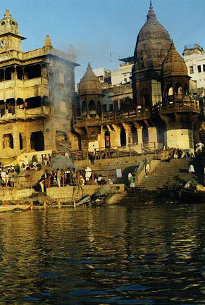  Hindu cremation ghat  Varanasi  www.edwebproject.org  Many Hindus believe that if you are lucky enough to be cremated at Varanasi, you break the cycle of reincarnation and may proceed directly to heaven. At any given moment, there may be as many as a dozen funeral pyres. Once the body has been cremated, the ashes are swept into the holy Ganges, to be taken away by its currents. | Hindus believe in the law of karma, which states that each individual passes through a series of lives until, depending on the actions of previous existences, the state of moksha—liberation from the cycle of birth and rebirth—is attained. Consequently, death is understood to be not the end of a process, but merely a stage in the long chain of transition. It is this continuity, extending beyond the limits of any single lifetime, which is enhanced and focused during the elaborate mortuary rituals performed by Hindus. The funeral ceremonies involve not only the immediate family members, but also those of the extended kin network. There are many regional and sub-cultural variations in the content and duration of mourning practices; the following is limited to describing the ceremonies in the broadest terms.  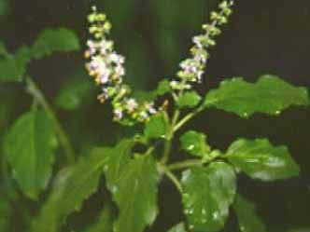  When death is imminent, the person is lifted from the bed to the floor so that the soul’s free passage into the next life is not obstructed. Water from the holy River Ganges is given to the dying person and a tulsi (basil) leaf is placed in the deceased person’s mouth. The tulsi leaf has a dual significance. Firstly, it is associated with Lord Vishnu, one of the three gods who are collectively known as the Hindu Trinity of gods; Vishnu is also known as the preserver of the universe. Secondly, the tulsi leaf is believed to have many medical properties.  - Hindus believe in reincarnation, and that at death the soul sheds its body and ‘puts on’ another body (not necessarily human) in a cycle of re-birth until it reaches God.  The sacred tulsi plant  - In India the body is usually cremated within 24 hours of death. It is wrapped in a cloth and placed in a coffin. The coffin is covered in flowers.  - By tradition the eldest son should set the funeral pyre alight, or press the button if a crematorium is used.  - The eldest son and other close male relatives have their heads shaved as a sign of bereavement and cleansing.  - Friends and relatives keep the bereaved company, share grief and offer support.  - On the eleventh or thirteenth day all will gather to offer a blessing to the deceased in order to show gratitude for acts of kindness that they received during his/her lifetime.  - After the thirteenth day, public mourning ends in a large feast. After this, only private personal grief remains.  Memory is preserved in the family’s daily prayers (puja).
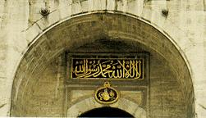  The Shahada  Ottoman Topkapi Palace, Istanbul  www2.hawaii.edu  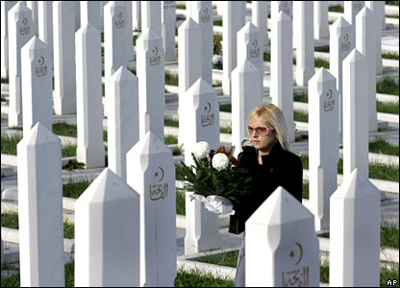  Visiting a Muslim cemetery  Bosnia  news.bbc.co.uk | The Islamic concept of death is quite simple, the idea being that “from God (Allah) we have emerged and to God we return.” Consequently, the official mourning period tends to be relatively short, usually not more than three days. Widows mourn for a year in the Middle East and North Africa. The next of kin mourn for forty days, however this does not include the deceased’s spouse or children.  When death is imminent, the person is asked to declare their faith by repeating the simple formula known as the Shahada: “God is One and Muhammad is His Prophet”.  The Imam (the prayer leader at the mosque) is informed as soon as possible after death and prayers from the Qur’an (Koran) are recited over the body. In addition to the specific rituals described above, the dead are commemorated in various ways. On Thursday evenings, prayers are offered to the dead after the magrib namaz, the prayers recited at sunset. Similarly, after Eid at the mosque, the family visits the cemetery and offers prayers for the dead. It is customary for Muslims to visit families that have been bereaved to offer condolences in the course of the year.  Other Islamic beliefs about death include:  - There is only one life to be lived. There will be a day of judgement when each soul is judged according to their deeds on earth.  - Extravagant expressions of grief are against the will of Allah.  - Mourning is demonstrated by readings from the Qur’an.  - The burial should take place before noon, and with the minimum of delay.  - The body is washed and wrapped in a simple white cotton sheet or shroud. All Muslims are dressed alike to symbolise their equality before God.  - The body is buried with the head towards Makkah (south east in the UK).  - On the first three days after the burial prayers are said at the home of the deceased.  - After the Eid celebrations visits are made to the cemetery to say prayers at the family grave. This is a reminder that even in the middle of happy celebrations, life is temporary and that it is important to live correctly to ensure eternal life with Allah.
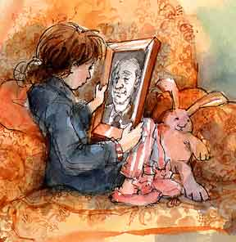  Illustration by Catherine Stock  From: Kaddish for Grandpa, in Jesus’ name, amen by James Howe  www.catherinestock.com  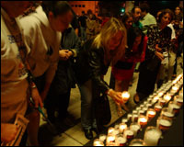  Saying Kaddish for the victims of 9/11  www.jewishjournal.com | Jewish beliefs about death and funeral customs  - Jews believe in one God and that there is only one life to be lived.  - After death the body is washed, dressed in a white shroud and placed in a coffin.  - Whenever possible, burial should take place within 24 hours.  - No flowers or music are provided, ensuring that there is no discrimination between rich and poor.  - Mourners ritually cut a slit in their outer clothes as a sign of grief.  - There are seven days of intensive mourning during which close relatives say prayers throughout the day, and neighbours and friends visit to offer condolences and help.  - For the following eleven months the Kaddish is said every day.  - Every year on the anniversary of the death, the family say the Kaddish and burn a candle for 24 hours.  Kaddish (Aramaic ‘holy’) refers to an important and central blessing in the Jewish prayer service. The opening words of this prayer are inspired by Ezekiel 38:23, a vision of God becoming great in the eyes of all the nations. The central line of the kaddish in Jewish tradition is the congregation’s response, “May His great name be blessed forever and to all eternity”, a public declaration of God’s greatness and eternality. In the liturgy, several variations of the Kaddish are used as separators between various sections of the service. However the term is often used to refer specifically to the version said as part of the mourning rituals in all prayer services as well as at funerals and memorials: when mention is made of ‘saying Kaddish’, this denotes the rituals of mourning.
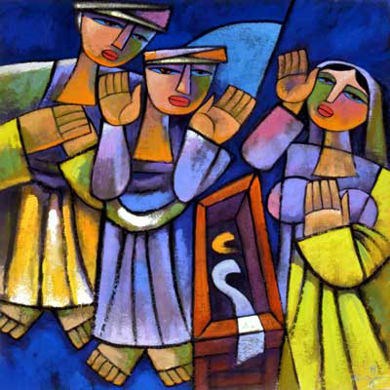  Empty Tomb by He Qi  www.heqiarts.com  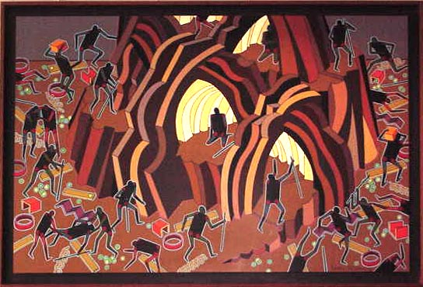  Purgatory by Glenn Berry  Humboldt State University Library | Christian beliefs about death and funeral customs  - Christian belief and practice is based on the mysteries of incarnation and resurrection.  - Personal identity is retained after death.  - Human beings are in continuing fellowship with God throughout life and death.  - Some Christians maintain a clear belief in heaven and hell.  - Roman Catholics believe in a state called purgatory—a place where a soul is purified in preparation for entry into heaven.  - A person lives only one physical life.  - The body is placed in a coffin by an undertaker and subsequently taken to a church or crematorium. Following a memorial service the body is buried or cremated.  - Flowers may be used in the form of wreaths. These are traditionally round to symbolise continuity and eternity.  - The colour used to express mourning is usually black.

Scheme prepared by: Suzy Cole, Dormers Wells High School, London Borough of Ealing

What do four religions believe about life after death?

Task: You are required to prepare a report on the beliefs about life after death for one particular religion, Christianity, Islam, Hinduism or Judaism. You will be required to report your findings back to an expert group made up of pupils who have been gathering information on the other religions.

Your Steps to preparing a report on beliefs about life after death

- Read all the information in the fact file for your religion.

Write down at least one key belief about what happens after death.

Find an example from a funeral practice that shows the belief.

Choose a quote from a sacred text that supports the belief.

Prepare a glossary of key words from the file.

- Remember you are going to present your report to the expert group.

