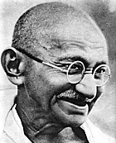 | Ealing Agreed Syllabus: guidance for teachers
 | Unit title: Modern day leaders

Learning objectives | Suggested activities | Suggested resources

Introduction
AT1 (whole unit)  Pupils understand that people’s faith influences their lives and can inspire them to fight against oppression. | Starter: Ask the class to think about those people—dead or alive—who have inspired them: these can include fictional characters in books, film or television. Ask for examples of people who were leaders: what were the qualities that they needed to inspire others to follow them.  Development:  - Point out that over the course of the unit they will learn about men and women whose convictions led them to take a stand against that which they perceived as morally wrong.  - Class reads pages 1-3 of Ghandi’s life (Gandhi Assembly Pack).  - Show photos on OHP. Discuss issues such as the use of non-violent protest, e.g. a willingness to go to jail for burning the identity papers one was forced to carry.  - Pupils discuss in pairs a time they were unfairly treated. Write up experience, answering: what happened, how they felt, how did they deal with it?  - Listen to Ghandi speaking about his beliefs; note: this is so students have the experience of hearing his voice. The title of this talk—recorded on the 17th of October 1931 in Kingsley Hall, London—was “My Spiritual Message”. (Note: all the media files for this unit can be downloaded from the EGfL: www.egfl.org.uk/religion. Choose “RE curriculum”, then “Media resources”. The audio clip is 6 minutes long.) | Gandhi Assembly Pack/  Gandhi Posters and Notes  Available from Minority Group Support Services, Coventry City Council, 024 7671 7800; also available from Lewisham PDC Centre, http://ecs.lewisham.gov.uk/pdc/  Comprehensive site on Ghandi, including speeches, letters, and sound and video files:  http://www.mkgandhi.org/  “My Spiritual Message” sound file: http://www.egfl.org.uk/categories/teaching/curriculum/subjects/re/re_curric/sound_pages/5E.html

Mahatma Ghandi: struggle for freedom
 | Starter: Using the IWB, watch video clips from the Salt March from the “Celebrating 75 years of the Saltmarch website” (www.saltmarch.org.in). (Note: these clips take some time to download, but be patient as they give a good feel for the times.)  Development:  - Using interactive whiteboard, read the BBC News report “The Life and Death of Mahatma Gandhi” (see link right). Then read the report on the re-enactment in 2005 of the Salt March (http://news.bbc.co.uk/1/hi/world/south_asia/4342745.stm).  - Discuss the events leading up to the salt march, and what it would be like to participate.  - Introduce the concepts of swaraj (‘self rule’) and satayagraha (‘firmness based on truth and love’).  - Pupils to write own newspaper report from point of view of journalist eyewitness to the salt march.  Conclusion: Students to suggest causes that they would be willing to protest against. What form would their non-violent protest take? | Documentary clips of the Salt March: http://www.saltmarch.org.in/video.html  BBC News report from web  (http://news.bbc.co.uk/1/hi/world/50664.stm , The Life and Death of Mahatma Gandhi)  Add pictures from Ghandi posters pack  Wikipedia on Ghandi:  http://en.wikipedia.org/wiki/Mahatma_Gandhi  Wikipedia on the salt march:  http://en.wikipedia.org/wiki/Salt_March

Qualities of a good leader
AT2  Pupils are able to describe important qualities of leadership. | Starter: Finish reading Gandhi’s life story (whole class activity).  Development:  - Discuss:  - What motivated Gandhi to do what he did?  - What qualities did he possess that caused others to follow him?  - Could he have done things differently?  - Referring back to the first lesson, make a list of qualities that are important in order to be a leader.  - Ask pupils to compare Gandhi with a leader they know—e.g. parent, teacher, football manager, prime minister—and record how effective they are as a leader compared with Gandhi.  - Discuss how living by strong beliefs or moral convictions helps a person lead.  - Discuss the difference between a tyrant—i.e. a person who rules through force and fear—compared to a true leader, i.e. a person who inspires others to follow their example.  Conclusion: Ask class to share their nominations for a “Most inspiring leader” award, giving the justification for their choice.

Everyday courage: the story of Rosa Parks
AT2  Understand that non-violent protest can be effective, i.e. can influence more people’s lives than violent protest. The importance of courage and conviction. | Starter: Read events of “Bus Story”, for instance in the account on the Henry Ford Museum website (see link).  Development:  - Role play these events in groups of 4, with one member acting as Rosa Parks, one as the bus driver, one as a white person and one as a policeman.  - Listen to Rosa Parks discussing these events in her own words in an interview in 1956 with Pacifica Radio. (The interview with Rosa Parks is imbedded in an hour-long radio programme. If you download the file—and you must download it from the website onto your computer before class, as otherwise it will take too long—you can find the interview by scrolling along the bottom bar of the Windows Media Player until you reach time index 12:39. Then push the play button. All the media files can be accessed via the EGfL: www.egfl.org.uk/religion. Choose “RE curriculum”, then “media resources”.)  - Point out that Rosa Parks is considered to be the ‘mother’ of the American civil rights movement. That although she was often described as a “quiet seamstress”, she in fact played an important part in the movement.  - Talk about how easy or hard it is to stand up for one’s rights and beliefs in difficult circumstances, and ask the class for other examples of ordinary people who found the courage to take a stand. Discuss what people need to take a stand: e.g. courage, self-esteem, moral conviction, strong religious beliefs. | Free at Last (Faith in Action series), Religious and Moral Education Press, ISBN: 1851751335 (Available from Amazon)  The events of ‘bus story’  http://www.thehenryford.org/exhibits/rosaparks/story.asp  Chronology of Rosa Parks and the civil rights movement: http://www.thehenryford.org/exhibits/rosaparks/chronology.asp  The life of Rosa Parks from the website of the Rosa Parks museum: http://montgomery.troy.edu/museum/parksbio.htm  Transcript of Rosa Parks 1956 interview: http://www.democracynow.org/

Martin Luther King
 | Starter: Ask students to volunteer what they know about Martin Luther King. Play or read parts of the “I have a dream speech.”  Development:  - Play the audio file of “I have a dream” speech, or the Flash video (http://www.americanrhetoric.com/speeches/mlkihaveadream.htm)  - Create a cartoon strip to illustrate the significant points of Martin Luther King’s life.  - Point out that although Martin Luther King was an inspirational leader, the American Civil Rights movement depended largely on the courage of ‘ordinary’ people. For example the many black men and woman who walked miles to their jobs as a protest against the unfair rules about segregation on buses; also those people—including school children—who risked their lives to be served in restaurants or to go to a good school.  - Using the IWB, play the “Civil Rights Memorial on the Southern Poverty Law Centre kids pages: http://www.tolerance.org/pt/index.html (This interactive site includes a timeline and the sound files, but if your browser is set to disable pop-ups, you will have to re-allow them for this site before you can see it.)  Conclusion: Ask the children to write about their own “inspirational dream”—after appropriate discussion to avoid ‘winning the lottery’, ‘being a famous footballer’ type dreams. | Martin Luther King Assembly/Lesson Pack & Poster Pack  Available from Minority Group Support Services, Coventry City Council, 024 7671 7800; also available from Lewisham PDC Centre, http://ecs.lewisham.gov.uk/pdc/  Full text of speech:  http://www.americanrhetoric.com/speeches/mlkihaveadream.htm

Aung San Suu Kyi: woman of peace and purpose
 | Starter: Tell class a bit about Aung San Suu Kyi and her struggle to bring democracy to her country. Highlight the fact that as a devote Buddhist, she was influenced by Mahatma Ghandi, whose philosophy of non-violence fit well with her own Buddhist beliefs.  Development:  - Talk about how she might have been inspired by her parents: her mother, Daw Khin Kyi, was a prominent Burmese diplomat, and her father, General Aung San negotiated Burmese independence from the British in 1947. (“I could not, as my father’s daughter remain indifferent to all that was going on.”)  - Discuss how Suu Kyi’s Buddhist faith has helped her during her many years of house arrest.  - Point out that when she won the Nobel Peace Prize in 1991—for her non-violent struggle against the repressive military regime in her country—she used the money ($1.3 million) to establish a health and education trust for the Burmese people. What quality of leadership does this demonstrate?  - Compare her house arrest in Myanmar with Nelson Mandela’s many years of imprisonment, pointing out that a strong moral leader can have an influence even when locked away.  Conclusion: Play Aung San Suu Kyi’s message on the occasion of the 50th Anniversary of the United Nations Declaration of Human Rights. Discuss her position on human rights.  (Note: all the media files can be accessed via the EGfL: www.egfl.org.uk/religion. Choose “RE curriculum”, then “media resources”.) | If you can get hold of a copy, play the single “Walk on” by the Irish band U2, which was written about and dedicated to Aung San Suu Kyi. (See background information for lyrics.)

Key words | Swaraj, Satayagraha, racism, apartheid, discrimination, equality, non-violent protest, tolerance, courage, human rights.
Points to note | Racism, children’s emotions (dealing with unfairness etc), children might poke fun at Gandhi’s speech.

Outcomes

At the end of this unit, most pupils will:

- Know key events in the lives of Gandhi, Martin Luther King, Rosa Parks and Aung San Suu Kyi.
- Understand that they were influenced by their faith.
- Understand the principle of non-violent protest.
- Be able to recognise some aspects of the lives of these people in other leaders known to them.
- Understand the qualities that make a good leader.

Some pupils will have made less progress and will:

- Know some events in the lives of Gandhi, Martin Luther King, Rosa Parks and Aung San Suu Kyi.
- Be able to recognise a few aspects of great leaders in other leaders known to them.

Some pupils will have made more progress and will understand all of the above. In addition they will:

- Reflect on how their beliefs might influence their lives.
- Reflect on difficult situations and consider a non-violent response.

Background information
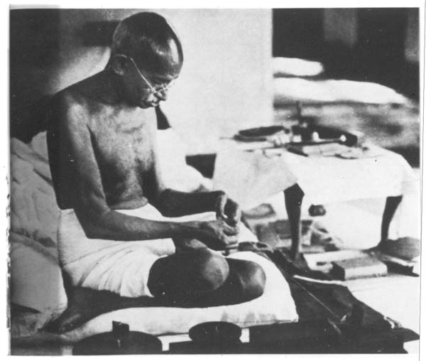  Ghandi spinning thread  Bombay 1945  courses.washington.edu  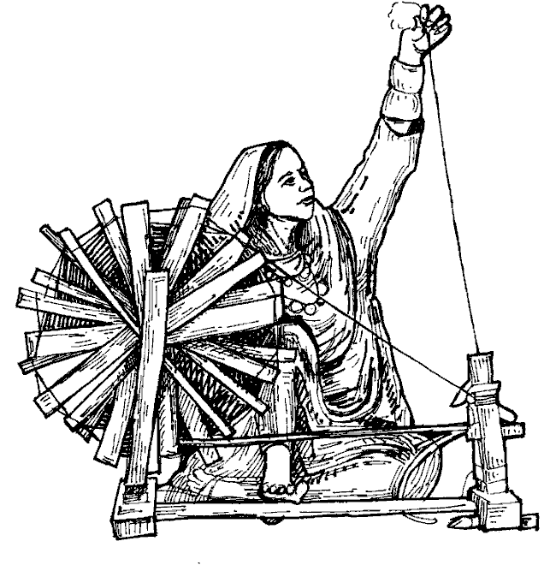  Charkha  www.4to40.com | Mohandas Karamchand Gandhi (2 October 1869 – 30 January 1948) was one of the most important leaders in the fight for freedom in India and its struggle for independence from the British Empire. He was the pioneer of satyagraha, a form of civil protest which led India to independence and has inspired movements for civil rights and freedom across the world. He is commonly known in India and across the world as Mahatma Gandhi (Sanskrit, Mahatma ‘great soul’).  Gandhi employed satyagraha to organise poor farmers in India to protest oppressive taxation and extensive discrimination; bringing it onto the national stage he used it as a means of campaigning against oppressive laws made by the ruling British government. When he became the leader of the Indian National Congress, he led a nationwide campaign for the alleviation of poverty, the liberation of Indian women, for dialogue amongst communities of differing religions and ethnicity, and for an end to untouchability and caste discrimination.  Above all else he championed swaraj, ‘self rule’—i.e. the independence of India from foreign domination. In 1930 he led thousands of his countrymen in a 400 kilometre protest march against the salt tax. He was imprisoned for many years on numerous occasions in South Africa and India.  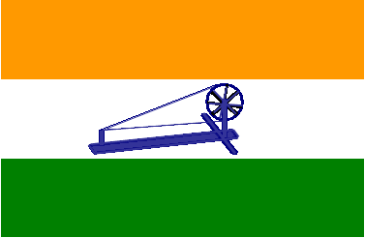  Throughout his life, he remained committed to non-violence and truth even in the most extreme situations. He was a student of Hindu philosophy and lived simply on a self-sufficient ashram (place of retreat). Rather than buying European-style garments manufactured in Britain from Indian raw materials, he made his own clothes—the traditional Indian dhoti and shawl—using a type of spinning wheel called a charkha that was both a tool and a symbol of the Indian independence movement. He used rigorous fasts for self-purification as well as a means for protest. Gandhi’s life and teachings inspired Martin Luther King, Steve Biko and Aung San Suu Kyi and respectively the American civil rights movement and the freedom struggles in South Africa and Myanmar. In India, Gandhi was recognized as the “Father of the Nation” by Subhas Bose, another prominent leader of the Indian independence movement. October 2, his birthday, is each year commemorated as Gandhi Jayanti, and is a national holiday.  Flag of the provisional government of India  wikipedia

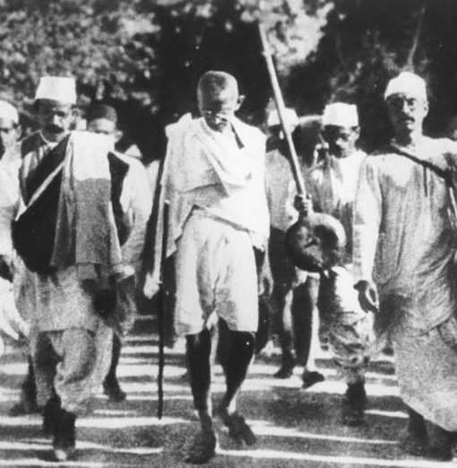  Ghandi on the Salt March  wikimedia | In the application of Satyagraha, I discovered, in the earliest stages, that pursuit of Truth did not admit of violence being inflicted on one’s opponent, but that he must be weaned from error by patience and sympathy. For, what appears to be truth to the one may appear to be error to the other. And patience means self-suffering. So the doctrine came to mean vindication of Truth, not by infliction of suffering on the opponent but one’s own self. (MK Gandhi, from All Men Are Brothers: Life and Thoughts of Mahatma Gandhi as Told in His Own Words, published by UNESCO, 1958.)  Satya is Sanskrit for ‘truth’, and graha (from the Sanskrit root grah cognate with English ‘grab’) can be rendered as ‘effort/endeavor’. Satyagraha, as defined by Gandhi, can mean “an effort to discover, discern, obtain or apply the truth”. The term was popularized during the Indian independence movement, and is used in many Indian languages including Hindi.  Gandhi’s definition of Satyagraha relied on three basic tenets: satya or truth, implying openness, honesty, and fairness; ahimsa, meaning physical and mental non-violence; and tapasya, literally penance, in this context self-sacrifice.  Satyagraha and its offshoots, non-cooperation and civil disobedience, are based on the law of suffering, a doctrine that the endurance of suffering is a means to an end. This end usually implies a moral upliftment or progress of an individual or society. Therefore, non-cooperation in Satyagraha is in fact a means to secure the cooperation of the opponent consistently with truth and justice. The essence of non-violent resistance is that it seeks to eliminate antagonisms without harming the antagonists themselves, as opposed to violent resistance, which is meant to cause harm to the antagonist. A Satyagrahi therefore does not seek to end or destroy the relationship with the antagonist, but instead seeks to transform or “purify” it to a higher level. A euphemism sometimes used for Satyagraha is that it is a “silent force” or a “soul force” (a term also used by Martin Luther King Jr. during his famous “I Have a Dream” speech). It arms the individual with moral power rather than physical power. Satyagraha is also termed a “universal force”, as it essentially “makes no distinction between kinsmen and strangers, young and old, man and woman, friend and foe”.  Civil disobedience is also seen as a social right in the concept of Satyagraha, however, civil disobedience cannot stem from irresponsibility. Therefore, a Satyagrahi (meaning the individual performing Satyagraha) obeys the laws of society intelligently and of their own free will, because they consider it their sacred duty to do so. According to Gandhi, only when a person has thus obeyed the laws of society scrupulously, do they have the right to make a judgment as to which laws are just, and must be respected, and which laws are unjust and must be disobeyed. (From Wikipedia)
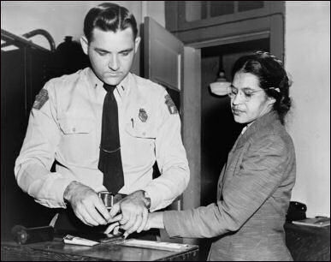  Rosa Parks being booked for refusing to give up her bus seat  wikipedia  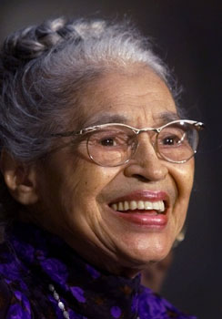  Parks being presented with the Congressional Gold Medal  15 June 1999  © AP/WWP | People always say that I didn’t give up my seat because I was tired, but that isn’t true. I was not tired physically, or no more tired than I usually was at the end of a working day. … No, the only tired I was, was tired of giving in.  Rosa Parks, 1995  Rosa Parks was an educated woman and a seamstress by profession. Shortly before her arrest in December 1955, she had completed a course in Race Relations at the Highlander Folk School in Tennessee. She was also secretary for the Montgomery chapter of the National Association for the Advancement of Coloured People (NAACP). On 1 December 1995 Rosa was arrested for refusing to yield her seat to a white patron on a Montgomery, Alabama city bus. The following Monday she was charged with violating racial segregation laws in Montgomery, Alabama.  In point of fact Rosa had been sitting in the fifth row of the bus—the first row that blacks were allowed to occupy—along with four other African Americans. It was after the front four rows had been filled that a white man boarded the bus and wanted all the blacks in the fifth row to move— blacks and whites were not allowed to occupy seats in the same row. The other four black passengers complied, but Rosa refused.  The day after her arrest, a citywide boycott of public transit was called at a church meeting with the new minister in the city— Martin Luther King, Jr— thus triggering the movement known as the Montgomery bus boycott. A political and social protest campaign intended to oppose the city’s policy of racial segregation on its public transit system, the boycott had actually been planned before Rosa’s arrest. Community leaders had been waiting for the right person to be arrested, a person who would anger the black community into action, who would agree to test the segregation laws in court, and who, most importantly, was ‘above reproach,’ and Rosa Parks fitted the bill.  The demands of the boycotters included courteous treatment by bus operators, first-come, first-served seating, and employment of African American bus drivers. The ensuing struggle lasted from 5 December 1955 to 21 December 1956, and led to a United States Supreme Court decision that declared the Alabama and Montgomery laws requiring segregated buses unconstitutional.  After the bus boycott, Rosa Parks lost her job and relocated to Detroit in 1957 with her husband and mother. In 1965 she joined the staff of US Representative John Conyers of Michigan and worked until her retirement in 1988. In 1999 she was awarded the Congressional Gold Medal of Honour, the highest honour a civilian can receive in the United States. She died 24 October 2005 aged 92.

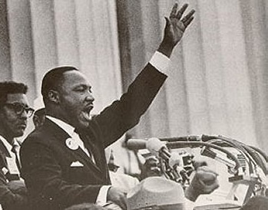  Giving the “I have a dream” speech at the Lincoln Memorial  www.drmartinlutherkingjr.com  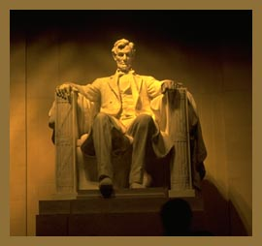  Lincoln Memorial  Washington, DC  www.transemantics.com | Martin Luther King, Jr was born 15 January 1929. King entered Morehouse College in Atlanta Georgia at the age of fifteen, as he skipped his ninth and twelfth high school grades without formally graduating. In 1948, he graduated from Morehouse with a Bachelor of Arts (BA) degree in sociology, and enrolled in Crozer Theological Seminary in Chester, Pennsylvania, graduating with a Bachelor of Divinity (BD) degree in 1951. In September of that year, he began his doctoral studies in systematic theology at Boston University, receiving a PhD in 1955.  In 1953, at the age of twenty-four, he became pastor of the a Baptist church in Montgomery, Alabama; it was two years later that Rosa Parks was arrested for refusing to comply with the Jim Crow laws that required her to give up her seat to a white man. The Montgomery bus boycott, led by King, lasted for 382 days, the situation becoming so tense that King’s house was bombed. King himself was arrested during this campaign, which ended with the United States Supreme Court decision outlawing racial segregation on all public transport.  King was instrumental in the founding of the Southern Christian Leadership Conference (SCLC) in 1957, a group created to harness the moral authority and organizing power of black churches for the purposes of staging non-violent protests. King was an adherent of the philosophy, often in dramatic stand-offs with segregationist authorities. He is perhaps most famous for his “I Have a Dream” speech, given in front of the Lincoln Memorial during the 1963 march on Washington for jobs and freedom: King was among the leaders of the so-called ‘big six’ civil rights organisations that were instrumental in the organisation of the march.  The march was originally conceived as an event to dramatise the desperate condition of blacks in the South and a very public opportunity to place organizers’ concerns and grievances squarely before the seat of power in the nation’s capital. However, the group acquiesced to pressure from President Kennedy, and the event ultimately took on a far less strident tone. Despite tensions, the march was a resounding success. More than a quarter of a million people of diverse ethnicities attended. King’s speech, which electrified the crowd, is regarded, along with Abraham Lincoln’s Gettysburg Address, as one of the finest speeches in the history of American oratory.  Throughout his career of service, King wrote and spoke frequently, drawing on his long experience as a preacher. On 14 October 1964 he became the youngest recipient of the Nobel Peace Prize, which was awarded to him for leading non-violent resistance to end racial prejudice in the United States. He was assassinated on 4 April 1968. In 1977, he was posthumously awarded the Presidential Medal of Freedom by Jimmy Carter. In 1986, Martin Luther King Day was established as a United States holiday (observed on the third Monday of January each year, around the time of Kings birthday), and in 2004, King was posthumously awarded the Congressional Gold Medal.
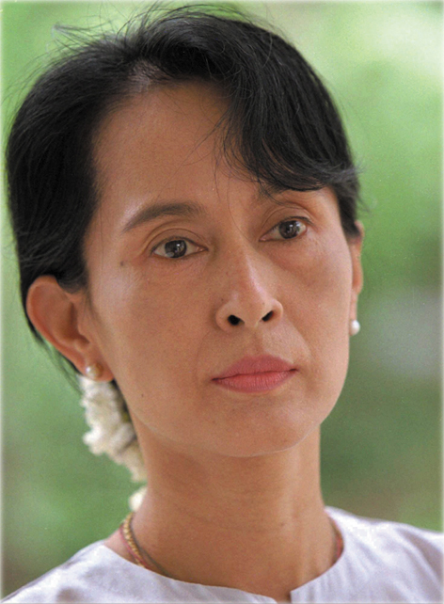  Aung San Suu Kyi  Institute for Democracy  and Electoral Assistance | Aung San Suu Kyi is the daughter of Daw Khin Kyi and General Aung San, the hero of Burma’s independence. She was born in Rangoon and was only two years old when her father was assassinated just six months before independence. Suu Kyi was educated in the city of Rangoon until she was 15 years old. In 1960, her mother was appointed the Burmese ambassador to India and Nepal, and she accompanied her to Delhi where she studied politics at Delhi University. She went on to study philosophy, politics and economics at Oxford University in the UK.  After living in Oxford for many years with her British husband and two sons, she returned to Burma in 1988 to nurse her sick mother. While in Burma she joined the pro-democracy movement, the National League for Democracy (NLD), which was pushing for political reform. Suu Kyi became leader of the NLD, her outspoken criticism of the military leaders of Myanmar and the memory of her father making her a symbol of popular desire for political freedom and a focus of opposition to the dictatorship.  She travelled extensively throughout the country, giving hundreds of speeches, often to crowds of thousands, in an attempt to unite the people and instil them with the courage necessary to achieve their long-sought goal of freedom. She was loved and revered by the Burmese people, who, in courageous defiance of the military edict forbidding gatherings of more than four, turned out in mass to listen to her speak. As she gained in popularity, military harassment of her campaign escalated, and in July 1989 she was placed under house arrest.  The military government called national elections in May 1990, and Aung San Suu Kyi’s NLD convincingly won the polls, despite the fact that she herself was under house arrest and disqualified from standing. She was compelled to refuse permission to travel to the UK to visit her dying husband in 1999 for fear she would not be allowed back into Burma. Even though her party had won the election, the military government has refused to give over control, and she has remained under house arrest for most of the time since then.  Aung San Suu Kyi has become an international symbol of heroic and peaceful resistance in the face of oppression. She has acknowledged the inspiration of the non-violent campaigns of Martin Luther King and Mahatma Gandhi. She was awarded the Nobel Peace Prize in 1991, which her sons Alexander and Kim accepted on her behalf. At the presentation, the Chairman of the Nobel Peace Prize Committee, Francis Sejested, called her “an outstanding example of the power of the powerless.”
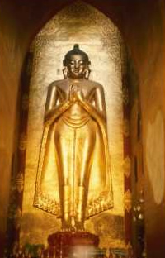  Golden Buddha,  Pagan, Burma  mijnposter.nl | Aung San Suu Kyi has repeatedly drawn on her Buddhist faith to sustain and inspire her, spending much of the time she has been under house arrest meditating and memorising Buddhist sutras. Her speeches and essays include frequent references to Buddhist principles. In her essay entitled “In Quest of Democracy” she counters the military government’s assertions that democracy and human rights are ‘un-Burmese’, stating that Buddhism has always taught that “the legitimacy of government is founded on the consent of the people.”  For Aung San Suu Kyi, Buddhism and dictatorship are in fundamental contradiction. Buddhism, she argues, places the highest value on the human being, who alone has the ability to attain the supreme state of Buddhahood. But under despotic rule, humanity is valued least, as a “faceless, mindless—and helpless—mass to be manipulated at will.”  The idea of law and order, she writes, is frequently misused as an excuse for oppression: an idea is officially expressed as nyein-wut-pi-pyar (“quiet–crouched–crushed–flattened”). Suu Kyi, on the other hand, equates law with justice, order with the discipline of a people satisfied that justice has been done. Drawing on Buddhist precepts, she affirms that the concept of law is based on dhamma, righteousness or virtue, not on the power to impose harsh and inflexible rules on a defenceless people.  She links the Buddhist principles of human freedom to Western socio-political ideas: “In their quest of democracy the people of Burma explore not only the political theories and practices of the world outside their country, but also the spiritual and intellectual values that have given shape to their own environment.”  Aung San Suu Kyi’s strength is derived from faith in a simple idea: that all men and women have the right to a life that is free from fear and oppression. Through her action and determination, she has demonstrated a heroic commitment to non-violence, her courage and wisdom inspiring millions of Burmese.
“[The children of prisoners] have known what it is like to be young birds fluttering helplessly outside the cages that shut their parents away from them. They know that there will be no security for their families as long as freedom of thought and freedom of political action are not guaranteed by the law of the land.” (Aung San Suu Kyi, 1997).  It is perhaps this quote that inspired the Irish band U2’s song “Walk On”, which is dedicated to Aung San Suu Kyi.    “Walk On” by U2  www.amazon.co.uk | “Walk On” lyrics (© U2)  And love is not the easy thing  The only baggage that you can bring  Love is not the easy thing  The only baggage you can bring  Is all that you can’t leave behind...  And if the darkness is to keep us apart  And if the daylight feels like it’s a long way off  And if your glass heart should crack  And for a second you turn back  Oh no, be strong  Oh, oh  Walk on, walk on  What you got, they can’t steal it  No, they can’t even feel it  Walk on, walk on  Stay safe tonight  You’re packing a suitcase for a place none of us has been  A place that has to be believed, to be seen  You could have flown away  A singing bird in an open cage  Who will only fly, only fly, for freedom  Oh, oh  Walk on, walk on  What you got, they can’t deny it  Can’t sell it, or buy it  Walk on, walk on  You stay safe tonight  And I know it aches  How your heart, it breaks  You can only take so much | Walk on...  Walk on...  Home...  Hard to know what it is, if you never had one  Home...  I can’t say where it is, but I know I’m going  Home...  That’s where the hurt is...  And I know it aches  And your heart, it breaks  And you can only take so much  Walk on...  (Hooo)  Leave it behind  You got to leave it behind  All that you fashion  All that you make  All that you build  All that you break  All that you measure  All that you feel  All this you can leave behind  All that you reason, (it’s only time)  (And I’ll never fill up all I find)  All that you sense  All that you scheme  All you dress-up  All that you’ve seen  All you create  All that you wreck  All that you hate

Scheme prepared by Kim Rumble, Hobbayne Primary School and Nora Leonard, SACRE consultant and projects officer, London Borough of Ealing

