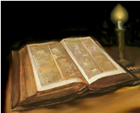 | Ealing Agreed Syllabus: guidance for teachers
 | Unit title: Religion in writing (Christianity)

Learning objectives | Suggested activities | Suggested resources

The big story: paradise
AT1 (Targets for entire unit)  Pupils are able to describe parts of the story told in the Bible.  Pupils understand that the Bible is an important guide for Christians.  Pupils complete an assessment, showing in colour, shape, drawing or collage how the Bible is relevant for Christians today. | Starter: Using the linocut by John Muafangejo, pupils list or brainstorm how the picture shows that life was good in the garden of Eden.  Development:  - Hand out a copy of the poem and read through with pupils.  (This is RE! Teacher’s Book 1 p 46 & 47)  - Pupils go back over the poem and highlight information on the following points:  - How did everything go wrong in the beginning?  - How were people helped to live more peacefully in the wilderness?  - How did God give people a final chance?  3) Pupils should then draw three pictures to show the answers to these questions.  Plenary: One thing I have learnt today is….  SEN/EAL: Use bold, italic or mark text so pupils can easily identify correct parts of the text.  Extension: Written responses to the question: Do you think that the poem helps believers to understand God’s relationship with his people?  Homework: Using the word PARADISE write an acrostic poem. | This is RE! Pupil’s Book 1, Alan Brine, Hodder Murray, p 26. ISBN 0 7195 7439 0  Pp 26-33  This is RE! Teacher’s Book 1, Cath Large, Hodder Murray, ISBN 0 7195 7520 6  P 40 ff (Background information about John Muafangejo and his work)

The big story: good times and bad
AT2 (Targets for entire unit)  Pupils are able to explain how The Big Story is relevant for today’s world.  Pupils are able to express why the stories in religious texts are important to humans.  Pupils can ask questions about belief and suggest answers.  Pupils reflect on the relevance of the Bible in today’s world. | Starter: Read the story of the golden calf from Exodus 32. Write down three key points from the story.  Development:  - Look at the painting The Adoration of the Golden Calf by Nicholas Poussin. Working in pairs using Post It notes, place a face on one of the characters in the painting. (This is so the pupils can imagine they are in the painting.)  - Pupils write down answers to the following (allow time for feeding back):  - What they can see?  - What are they doing and why?  - What are they feeling?  - What will they do when Moses sees them?  3) Write one paragraph explaining what is happening in the painting.  Plenary: pupils read their responses to the question.  SEN/EAL: paired with a more able pupil.  Extension: Hand out further questions, e.g.: Where is Moses? What is he doing? Why? Have others seen him yet? What will they do when they do? What will Moses do? Why was worshipping the golden calf considered to be a sin?  Homework: Describe a time when you have done something you shouldn’t have. | Exodus 32: 1-35 (simplify)  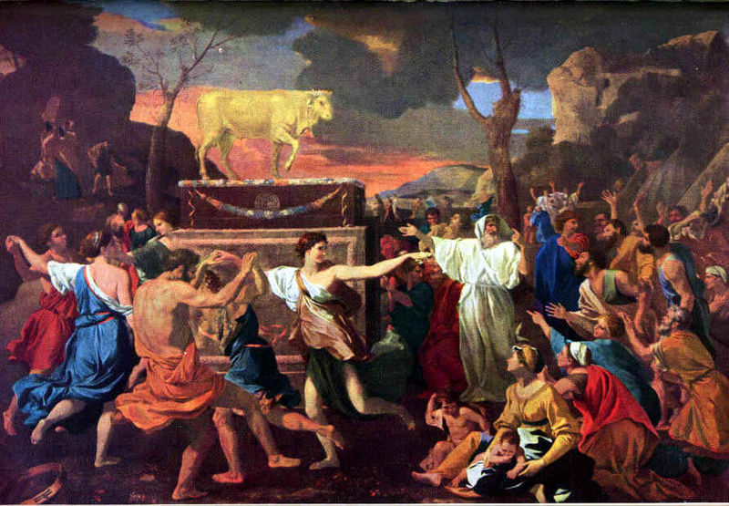  The Adoration of the Golden Calf: http://en.wikipedia.org/wiki/Image:GoldCalf.jpg

A troubled world
 | Starter: Look at the painting of Mary and Jesus by Sister Victoria Choi in the This is RE! Pupil’s Book 1. Using post-it notes pupils write down their comments and questions about the painting. Give pupils the background information about the painting.  Development:  - Show information on Amnesty International (AI) on the IWB and explain what they do, using the Amnesty International website home page. Alternatively copy and paste some information into a ‘notebook’ file. Highlight the point that AI is an apolitical organisation working for the human rights of all, regardless of nationality or religion.  - In pairs pupils are to prepare a one-minute news bulletin on the painting that was given to Amnesty by Sister Victoria (see background information for a framework for the bulletins).  Plenary: see bulletins and peer assessment. 2 stars and a wish  EAL/SEN: framework support. Paired with more able pupil.  Extension: In bulletin cover why is there so much meaning in a picture of a mother and child.  Homework: Draw around your hand and write a message for those people imprisoned, tortured or executed for their beliefs. | This is RE! Pupil’s Book 1, Alan Brine, Hodder Murray, p 30. ISBN 0 7195 7439 0  This is RE! Teacher’s Book 1, Cath Large, Hodder Murray, ISBN 0 7195 7520 6  http://www.amnesty.org/

Death and resurrection
 | Starter: Word search on the crucifixion and resurrection.  Development:  - Death – and resurrection. Read p 31 of Book 1. Focus on the part in the poem that says: ‘Hope returned, Like a small seed planted in the wilderness…’  - Pupils complete worksheet 3.8: The Garden and the Wilderness. Make a list of words that describe features in a perfect world compared to a list of features in a spoiled or imperfect world.  - Pupils also record answers to the following:  - How is the world today like the words you have listed under garden?  - How is the world today like the words you have listed under resurrection?  Plenary: on a leaf outline pupils record their hopes for the future. They could cut these out and stick them on to a tree shape with the rest of the class.  SEN/EAL: draw their ideas instead of writing.  Extension: Looking at the picture of the wood carving in the book, answer the question: Why do you think that it is called the tree of life, even though it is showing death?  Homework: find a piece of music that makes you feel hopeful. Either write down some of the words or bring in the piece of music to share with the class. | www.puzzlemaker.com  This is RE! Pupil’s Book 1, Alan Brine, Hodder Murray, p 30. ISBN 0 7195 7439 0, p31  Teacher’s resource p53

Birth of the Christian Church
 | Starter: Give pupils a copy of this part of the poem on p30 of This is RE! Pupil’s Book 1. You will need to show them a picture of the Reredos Tapestry, by John Piper, which hangs in Chichester Cathedral, in which three central panels show the trinity, while the four side panels represent the four Gospel writers. Highlight in the text words that link, e.g. tongues of fire.  Development:  - Pupils match words and pictures (p50, This is RE Teacher’s Book 1) and place in the correct order. They will then have a storyboard of Pentecost.  - In a collective exercise, the class designs a four-panelled stained glass window showing the moods of: fear / power / courage / hope. Pupils are to capture these moods in colour and pattern. Under each panel pupils write words to describe the mood and one sentence to say why they have chosen those colours and patterns.  Plenary: pupils write down five key words from the lesson; these are then shared with class. Out of these the teacher picks five to write on the board and add to their glossaries (e.g. if pupils are keeping a glossary at the back of their exercise books).  SEN/EAL: sorting exercise and framework for the drawing work.  Extension: Draw panel on plain paper to allow for freedom of design.  Homework: Write five questions you would like to ask the disciples about the story of Pentecost. | This is RE! Pupil’s Book 1, Alan Brine, Hodder Murray, p 30.  ISBN 0 7195 7439 0  This is RE! Teacher’s Book 1, Cath Large, Hodder Murray, p50  ISBN 0 7195 7520 6

The big idea
 | Starter: In groups of four—each group taking one word—brainstorm around the following words, in particular thinking about examples from the present day.  Chaos Creation  Sin Hope  Development:  - Suggest to the class that the big Christian story can be told in the four words: chaos and creation, sin and hope.  - Point out that most Christians would say that this is still relevant today in our world; every Sunday in churches around the world you will hear preachers trying to explain how this story is relevant to the modern world.  - Pupils will design an A3 poster around this theme. Give pupils a criteria sheet identifying what is required to achieve different levels for this task (see background information).  - Show pupils some examples of artists’ impressions of Christianity for today’s world. Talk about what the artist has done to get their ideas across.  Plenary: pupils to show their work and explain the meaning of the images, colour and drawings.  SEN/EAL: focus their attention to the correct level for them.  Extension: Highlight the higher level work and get them to consider how they will approach this assessment.  Homework: Work on assessment | This is RE! Pupil’s Book 1, Alan Brine, Hodder Murray, p 36.  ISBN 0 7195 7439 0
  The big Christian idea
  Without God there is chaos. Things turn bad.
  With God there is hope. Things turn good.

Key words | Paradise, Adoration, Moses, Jesus, Amnesty, Christians, Nun, Love, Crucifixion, Save, Sin, God, Resurrection Wilderness, Pentecost

Outcomes

At the end of this unit, most pupils will:

AT1 Level 4
- express religious ideas about the stories in the Bible.
- describe the impact of key stories from the Bible.
- recognise how belief in these stories can affect peoples’ lives locally, nationally.
- use religious vocabulary associated with the Bible accurately.
- interpret information from different sources.

AT2 Level 4
- discuss issues relating to the Bible.
- show what it means to belong to a faith, especially through belief in God as told through the Bible.
- ask questions about how the Bible affects the life of believers and suggest appropriate answers.
- state their view about the relevance of the Bible for Christians today.

Some pupils will have made less progress and will:

AT1 Level 3
- describe some religious stories from the Bible.
- describe their own and others beliefs about God and the stories in the Bible.
- show some ideas from the ‘Big Story’ in drawing or collage.
- show some ideas about how the world today shows chaos and creation, sin and hope.

AT2 Level 3
- discuss issues relating to the Bible in pairs.
- compare some of the things that influence them with those that influence others.
- suggest some reasons why the Bible is relevant and important for Christians today.

Some pupils will have made more progress and will

AT1 Level 5
- explain some principal beliefs and teachings in connection with the stories in the Bible and their relevance today for Christians.
- show some of the complex ideas in the Big Story and how these are relevant in today’s world.
- show their own view in comparison to the views of Christians about the relevance of the Big Story today.
- show clearly what Christians value in connection to chaos and hope, sin and hope.

AT2 Level 5
- make informed responses to the stories in the Bible and their relevance to Christians today.
- raise questions of experience, meaning and purpose in connection with the stories from the Bible.
- respond to people’s values and commitments in the light of their own learning.

Background information
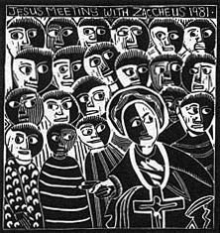  Jesus meeting with Zaccheus 1981  The John Muafangejo Trust | John Ndevasia Muafangejo (1943–1987) was born in Angola. He grew up in a traditional homestead, herding cattle during the day and playing communal and literary games—with their strong moral and philosophical content—with the elders in the evening. This period of his life clearly influenced not only his development as an artist but also the content of his work, which is strongly autobiographical.  Left with nothing after the death of her husband in 1955, his mother moved to a mission station where John joined her in 1957. He converted to Christianity at the age of fourteen and in 1964 attended St Mary’s Anglican mission school in Namibia where his artistic skills were recognized and arrangements were made for him to train at Rorke’s Drift, where he studied from 1968 to 1969 before returning to teach and establish an art school at St Mary’s. In 1971 he held his first of several solo exhibitions in Windhoek and in 1974 he took up at the position of artist-in-residence at Rorke’s Drift.  Muafangejo is best known for his linocuts of figures, religious and historical scenes. His images have a strong narrative quality and his illustrations of African traditions often have an explanatory script. His work can be seen in public galleries throughout South Africa.

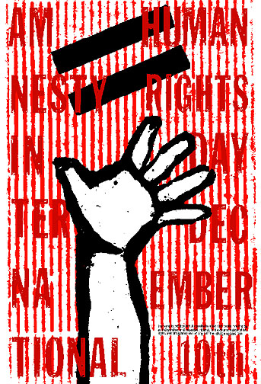  Poster for Human Rights Day  Headveins Graphics  www.headveins.com | Framework for news bulletins
  Sentences starters | Connectives | Key words
  Our story tonight is of …  Welcome to the head office of Amnesty International…  The painting donated is of…  The painting shows…  It seems appropriate that this painting was donated to Amnesty because…  Christians believe that Jesus was sent to…  This is………..  reporting for the BBC 6 o’clock news | To add more:  Also, as well as, moreover, in addition  To contrast:  Whereas, though, unlike, on the other hand, but  To emphasise:  In particular, above all, especially, indeed  To introduce:  For example, when, this shows that, on one occasion  To indicate cause and effect:  Because, so, since | Amnesty  Jesus  Christians  Nun  Love  Crucifixion  Teach  Heal  Save  Sin  God

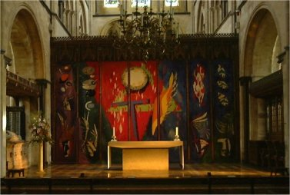  The Chichester Reredos Tapestry  John Piper, 1966  www.diochi.org.uk  A reredos (also spelled raredos) is a screen or decoration behind the altar in a church, usually depicting religious iconography or images. The word comes from the 14th century Old French term areredos, from arere behind +dos back, from Latin dorsum. | When the day of Pentecost came, they were all together in one place. Suddenly a sound like the blowing of a violent wind came from heaven and filled the whole house where they were sitting. They saw what seemed to be tongues of fire that separated and came to rest on each of them. All of them were filled with the Holy Spirit and began to speak in other tongues as the Spirit enabled them. (Acts 2: 1-4)  Pentecost comes from Greek Pentékosté, meaning ‘fiftieth’. It originally referred to Shavuot, the Jewish ‘festival of weeks’. Celebrated on the fiftieth day after Pesach, Shavuot was connected with the first-fruits of the spring grain harvest, but came to be associated in Christianity with the descent of the Holy Spirit* on the Apostles.**  In Britain the festival of Pentecost is also known as Whitsun (Whitsunday, ‘white’ Sunday), because of the white robes traditionally worn this day by those newly baptized the previous Easter. In Italy it was customary to scatter rose petals from the ceiling of churches in a symbolic re-enactment of the miracle of the fiery tongues. In France trumpets were blown during the service to recall the sound of the mighty wind that accompanied the descent of the Holy Spirit.  The Christian Pentecostal movement is so named because it emphasises the Holy Spirit is each individual; services are noted for worshippers falling into an ecstasy of inspiration and speaking in tongues.  *The doctrine of the Holy Trinity states that God is essentially one, who at the same time consists of three distinct—although inseparable—persons: Father, Son and Holy Spirit.  **Perhaps as a result of this, the festival of Shavuot also became associated in Judaism with the manifestation of spirit, in that case the gift of the Torah to Moses on Mt Sinai.
The Big Christian Story Assessment

Task: Design a poster to show the relevance of the big Christian story in today’s world.
You can use: colour and shape, drawings, images and collage materials to help you complete this task
Read the criteria to see what you need to do to achieve the level that you want.

You are working at level 3 if you can do these things:
- Show some ideas from the ‘Big Story’ in drawing or collage.
- Show in colour, shape, drawings or collage some ideas about how the world today shows chaos and creation, sin and hope.

You are working at level 4 if you can do these things:
- Show ideas about the relevance of the Big Story through colour, shape, drawing or collage.
- State my view about the relevance of the Big Story.
- Show simply what Christians value in connection to chaos and hope, sin and hope.

You are working at level 5 if you can do these things:
- Show some of the complex ideas in the Big Story and how these are relevant in today’s world.
- Show your view in comparison to the views of Christians about the relevance of the Big Story today.
- Show clearly what Christians value in connection to chaos and hope, sin and hope.

You are working at level 6 if you can do these things:
- Show an insight into how Christians are inspired by the Big Story; how they believe God can bring creation in chaos and hope where there is sin.
- Interpret Christian perspectives on values and what matters most.
- Show an insight into my own beliefs about the relevance of Christianity in today’s world.

Scheme prepared by Suzy Coles, Dormers Wells High School, London Borough of Ealing

