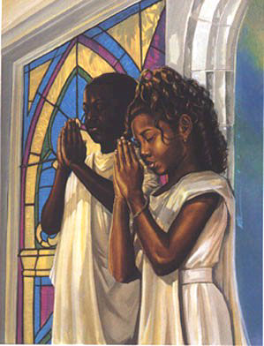 | Ealing Agreed Syllabus: guidance for teachers
 | Unit title: What belief means to me

Learning objectives | Suggested activities | Suggested resources

Believing in God: What do young people say about God?
AT1 (whole unit)  To be able to describe what belief means to the pupils and to those who follow a faith and those who hold no religious convictions.  To know that belief can mean many different things.  To explain how religious belief can make a difference to questions about God, belonging, values and identity. | Starter: Brainstorm the Word ‘GOD’  Development:  - Divide the class into pairs. Prepare sufficient sets of the statements in the grid below for each pair to have a set. (You could put these onto card, cut and place cards in envelopes.)  - In pairs pupils discuss each statement asking: What does each person believe about God, and are the reasons they give sound?  - Pupils write the number of the statement onto a grid, or place cards onto grid. (The IWB could be used to drag ideas into the grid.)  - Pupils list in their books examples of ‘good’ reasons for believing or not believing in God.  Plenary: Pupils feedback to class, then write a response to the following: If you could ask God one question what would it be, and what sort of answer do you think God would give?  EAL/SEN: Pair with a more able pupil. Simplify statements. Framework for final question.  Extension: Write own statement to match those discussed.  H/W: Write down 3-5 things that you or a believer believes about God. | 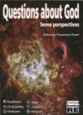  Questions about God – some perspectives, “Believing in God” (pp2-3) Edited by R Rivett,  RE Today Services  http://www.retoday.org.uk/catalogue.htm
  Believes in God | Good point well argued
  Not convinced by this point of view! | Doesn’t believe in God

Believing in God: describing God
AT2 (whole unit)  Be able to consider the importance of belief in relation to God, who we are and our place in community.  Reflect on what it means to have faith.  Reflect on what it means to belong to a community, religious or otherwise.  Express why belief is important to humans.  Pupils are able to ask questions about belief and suggest answers. | Starter: Wordsearch with key terms from the main activity: trinity, creed, Jesus, Christian, Judaism, omnipotent, eternal, Islam, tawhid, Sikhism, Mool Mantra, Ik Onkar.  Development: Jigsaw discussion activity (see background information).  - Arrange class into ‘home groups’ of four. Give each pupil an information card on a different faith.  - The task is to identify what is shared and what is different between the religious beliefs about God.  - Pupils re-form into ‘expert’ groups (e.g. all those looking at Christianity). They must identify a clear understanding of what that religion says about God. Give pupils a framework sheet to fill in.  - Pupils return to their ‘home groups’ and report back their ideas. Working together they list similarities and differences between the religions.  Extension: Work out one question about belief in God they wish to raise.  Plenary: Each home group feeds back their findings to the class.  EAL/SEN: Mixed ability home groups. Simpler materials provided. Key words defined. Pair weaker students with another pupil to work with.  Homework: Write 3-5 sentences describing the similarities and differences between religious beliefs about God. | www.puzzlemaker.com for making wordsearches, crosswords, cryptograms etc.  Questions about God – some perspectives, “Believing in God” Edited by R Rivett,  RE Today Services  http://www.retoday.org.uk/catalogue.htm  P14-19 How do religions describe God

Believing in God: experiencing God
 | Starter: Word dominoes. Pupils match words to definitions.  Development: guided story  - Settle pupils and read the guided story (Questions about God—some perspectives, p26 RE Today Publication) about receiving a message from God.  - Allow pupils to talk in pairs about their experience.  - On pale blue card pupils draw the angel they saw in the guided fantasy and on the reverse ‘What we did in RE today’.  Plenary: Framework “Today I have learnt that….”  EAL/SEN: framework for writing ‘what we did in RE today’  Homework: Images of God. Pupils consider a painting of the Trinity (from Thinking Through Religious Education) and complete the following set questions.  - Who are the people in the picture?  - Who is the most important amongst the 3?  - What do you think is in the cup on the table?  - What geometric shapes can you see in the icon?  - Does this help you to identify who they are? | Questions about God – some perspectives, “Believing in God” Edited by R Rivett,  RE Today Services, p26  http://www.retoday.org.uk/catalogue.htm  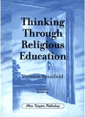  Thinking Through Religious Education  V Baumfield  Chris Kington Publishing  P75-76 “Reading Images of God”

Humanist faith and belief
 | Starter: Brainstorm the terms ‘faith’ and ‘belief’. Look at a picture of “The Thinker”, one of the French sculptor Auguste Rodin’s famous bronze sculptures; depicting a man in sober meditation battling with a powerful internal struggle, it is sometimes used to represent philosophy. Ask class for their reactions to the sculpture.  Development:  - Introduce the term Humanist to the class to describe a person who prefers to make sense of the world through reason and experience rather than through religious revelation.  - Consider the fact that the statement “I don’t believe in God” is nonetheless a statement of belief, i.e. a belief that there is no God.  - Ask class to identify ‘the golden rule’. Point out that it is possible to not believe in a God or belong to a religion at the same time as having strong moral convictions, and that for many Humanists the golden rule is an important axiom for behaviour.  - Divide the class into pairs. Ask one member of each pair to play the role of a religious believer, and the other to play the role of a Humanist. Get them to talk about what makes their life meaningful, and what common ground they can find regarding the importance of living a good life. Have the pairs report their findings back to the class.  Plenary: Point out that, as they do not believe in an afterlife, Humanists believe that they have a responsibility to make the best of this life. Ask class to think about ways life can be seen as meaningful in the absence of any religious belief. Point out that Humanists still experience faith, for example faith in the themselves and other people, or faith that they can make it through difficult times. | 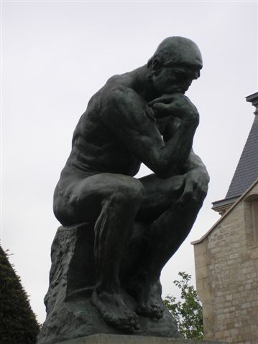  “The Thinker” by Auguste Rodin  Wikipedia  (Image courtesy Deror)

Belief means finding out who I am
 | Starter: Mind Map ‘my identity’, including sub-headings of culture, family, friends, beliefs.  Development:  - Pupils draw a simple outline of a person using the ideas from their mind map. They describe their physical appearance on the outside and feelings and character on the inside of the line drawing. (Pages 4-5)  - Pupils number the words in order of importance to them.  - Pupils compare their answers with a partner then feed back to class.  Plenary: Look at a self-portrait of an artist, e.g. LS Lowry’s “Man with Red Eyes” or van Gogh’s “Self portrait with bandaged ear”. Pupils write down or discuss in pairs what the painting tells us about the physical appearance and the person inside.  EAL/SEN: Provide a picture of a person and give pupils a choice of words to select.  Extension: The US president Abraham Lincoln said that you can’t help what you look like when you are born, but “every person can help what he or she looks like by the time they are 40.” What do you think that he meant? | 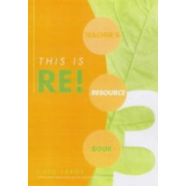  This is RE! Teachers Book 3, Julia Ingham et al., Hodder Murray, p 2-14 ISBN: 0719575249  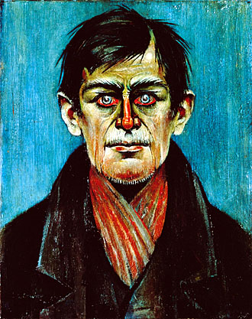  “Man with Red Eyes”, LS Lowry, 1938  The Lowry website  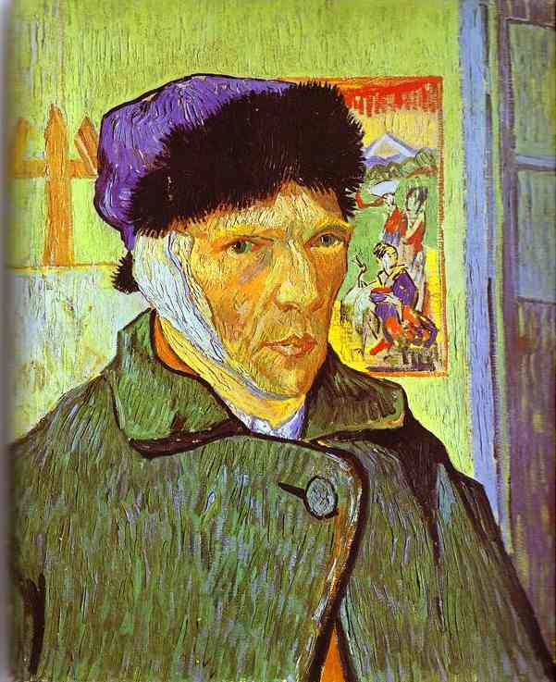  “Self portrait with bandaged ear”, Vincent van Gogh, 1889  www.abcgallery.com

How does religion add to a Jew’s identity?
 | Starter: “External things help to give us an identity. Beliefs in God and a religion help to shape who we are.” Using the preceding phrase, write it into the puzzlemaker cryptogram facility and chose to use numbers for the code.  Development:  - Read This is RE Book3 p10-11. How does religion add to a Jew’s identity? (Shabbat, circumcision and Passover)  - Brainstorm the ceremonies, symbols and actions contained in the text.  - Pupils write letter to Abby’s unborn Jewish child explaining the importance of ceremonies, symbols and actions in shaping identity. Pupils should use a framework to help them based on:  Plenary: Hot seating activity as a member of the Jewish family in the book. Spend 3 minutes preparing questions.  EAL/SEN: cloze exercise for the letter.  Extension: Write letter without framework. Choose a more able student for the hot seat activity.  H/W: Describe or draw a family celebration that shapes your identity. | This is RE! Teachers Book 3, Julia Ingham et al., Hodder Murray, p 10-11 ISBN: 0719575249  www.Puzzlemaker.com  Note: Hot seating is a role play activity where an individual takes on another persona and their peers ask them questions to explore how that person would react and feel.
  Starting sentences | Connectives | Key words
  Dear…  I am writing to tell you… | To add more  In addition, furthermore, also, | Bar Mitzvah  Shabbat  Circumcision  Passover

How does pilgrimage add to a Muslim’s identity?
 | Starter: Looking at a photograph of people on the hajj, answer the five Ws (what, when, who, where, why). (Use IWB for displaying a large photo found on Google images.)  Development:  - Read text on p13: This is RE! Teachers Book 3.  - Pupils write down five ways in which the hajj makes Muslims feel part of the ummah. Allow time for feedback.  - Pupils list or brainstorm the experiences and feelings of Soofia and Karim on the hajj.  - Sum up these ideas in an acrostic using the work UMMAH.  Plenary: Make a sentence with the following words: Hajj, Makkah, Ka’abah.  EAL/SEN: Give pupils a choice of words for the brainstorm. H/W could be drawn.  Extension: how do you think that the experience of the hajj affected Soofia and Karim’s beliefs?  H/W: Name a place that has a special meaning for you, explaining in a few sentences how it makes you feel about yourself. | This is RE! Teachers Book 3, Julia Ingham et al., Hodder Murray, p 12-13 ISBN: 0719575249  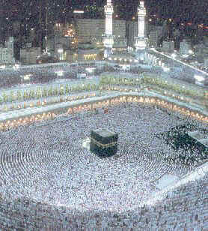  www.ummah.net
Belief means belonging to a family and community.
 | Starter: word sort. How important are the following words in terms of being a member of a community? Prioritise them.  Loved / respected / an individual / identity / things in common / shared beliefs /  a way of life / a religious faith / knowing others / worship / shared festivals / commitment / total way of life / belonging / shared history  Development:  - In pairs, read Sufyaan’s interview and highlight words and ideas that indicate the position his father holds in the community.  You are a newly qualified teacher about to teach Islam for the first time.  What questions might you ask the imam?  - Each pair takes a role play card. Pupils write the questions which the person on the card might ask the imam, then decide on the answers given.  - Pupils prepare a brief role play of a telephone conversation between the imam and the enquirer.  Plenary: listen to role plays  EAL/SEN: Give a choice of words to choose from; give a framework for role play.  Extension: Identify a question they have for the imam and compose the answer he would give.  H/W: Sufyaan’s father is a positive role model; religious leaders and founders such as Muhammad, Jesus and Guru Nanak are positive role models. Who is your role model? Describe why and how they are your role model. | 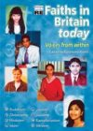  Faiths in Britain today – voices from within. Edited R Rivett, RE Today Services.  http://www.retoday.org.uk/catalogue.htm  (Sufyaan’s interview: P17)

Belief means being a member of a community
 | Starter: odd one out – family/community/identity, use IWB to display these. Pupils need to identify which one they think is the odd one out and give reasons. Then can they add any more words to the two words that have a link?  Development Paired reading activity  - Each pair will need a copy of the interview with Bilal Shafayat (pp 6-7, Relationships: Self, others and God), a copy of the target diagram and the 20 statements.  - Ask pupils to discuss where each of the possible answers to the question ‘What matters most to Bilal?’ should go on the target. There are no definitive answers.  - Pairs feedback to class their choices.  - Pairs then brainstorm 20 statements that answer the question ‘What matters most to me?’  Plenary: What I learned from this activity is…  EAL/SEN: paired with a more able pupil. Alternatively more basic information and word cards given.  Homework: Using their name as an acrostic write a poem about ‘What is important to me?’ | 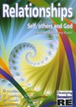  Relationships: Self, others and God, Edited by Rosemary Rivett, RE Today Services, p 6-7  http://www.retoday.org.uk/catalogue.htm

Raising a child in a religious community
 | Starter: Pupils look at a picture of infant baptism and complete the 5Ws (what, when, who, where, why). This could be on the IWB or smaller photographs stuck into books.  Development: Mystery: Why do Debbie and Mark want to have Pippa baptised?  - Pupils work in pairs to answer the mystery. The question should be visible and copies of the statements should be given out.  - Prompt pupils to discuss, decide and refine ideas. Pupils share their responses, justifying opinion.  Plenary: discuss and debrief the activity as a whole class, focussing on how it helped pupils in their thinking.  Prompt questions:  - What sort of questions came into your mind during the activity?  - How did your group work together?  - How did you organise your information?  - Did you change your mind during the activity?  - Did you disagree over anything in the group?  - If you did the activity again would you do anything differently?  SEN/EAL: give less cards  Extension: Enable more able pupils to feedback ideas on thinking skills used.  Homework: Debbie and Mark have Pippa baptised because… | Relationships: Self, others and God, Edited by Rosemary Rivett, RE Today Services, p 10-11  http://www.retoday.org.uk/catalogue.htm

Assessment, part 1
 | Starter: Word search using ideas from across the term’s work.  Development: Writing my own RE report: ‘What belief means to me’  - Hand out framework and go through with pupils.  - The framework is to help them write about the unit they have studied.  - They must write as much as they can, but use at least 10 of the sentence starters.  - They can prepare their answers but the final copy will be written up under exam conditions the following week.  - Ensure pupils have access to dictionaries.  Plenary: pupils could read out some of the answers that they have prepared.  SEN/EAL: reduce the number of sentence starters.  Extension: Encourage pupils to use more than 10 sentences and to focus on the more difficult starters, e.g. This RE topic has made me think about…., One thing that made me think was…, If I started this work again I would…, The advice I would give to someone starting this work would be…  Homework: to complete draft of report. | 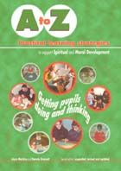  A to Z practical learning strategies to support spiritual and moral development (2nd edition), Mackley and Draycott, RE today Services  P63

Assessment, part 2
 | Pupils to work under exam conditions to write up their report.

Key words | Trinity, creed, Jesus, Christian, Judaism, omnipotent, eternal, Islam, tawhid, Sikhism, Mool Mantar, Ik Onkar, Bar Mitzvah, Shabbat, circumcision, Passover, hajj, Makkah, Ka’abah, ummah, Qur’an, wudu, Id-ul-Fitr, zakat, Ramadan, baptise, confirmed, atheist, Humanist
Points to note | NB Remember that all Y7 pupils will sit a level guidance test before you start this unit of work. This should give you an idea of their literacy level and their level of understanding.

Outcomes

At the end of this unit, most pupils will:

AT1 Level 3
- Be able to describe ideas about what belief is.
- Be able to describe their own and others’ beliefs about God, Jewish and Muslim identities and what it means to belong to a community.
- Be able to describe the Passover meal and the hajj pilgrimage.
- Be able to describe who they are and identify what is important to them.

AT2 Level 3
- Be able to discuss issues relating to belief.
- Be able to compare some of the things that influence them with those that influence others.
- Be able to suggest some reasons as to why it might be important for a believer to belong to a faith.

Some pupils will have made less progress and will:

AT1 Level 2
- Be able to say some things about religious belief.
- Be able to talk about their own beliefs about God as well as those of others.
- Know what some Jewish symbols are in the Passover meal and Muslim symbols are for the hajj.
- Be able to talk about who they are and what is important to them.

AT2 Level 2
- Be able to talk about what others believe in a respectful manner.
- Be able to talk about some things that make people ask questions about their beliefs.
- Be able to talk about what is important to them and to others who have religious belief.

Some pupils will have made more progress and will

AT1 Level 4
- Be able to express ideas about what belief is for religious people and for non-religious people.
- Be able to describe key features of belief, taking into consideration the similarities and differences between religions, as well as Humanist ideas.
- Recognise how belief can affect peoples’ lives locally, nationally.
- Be able to use religious vocabulary associated with belief accurately.
- Be able to interpret information from different sources.

AT2 Level 4
- Be able to discuss issues relating to belief.
- Be able to show what it means to belong to a faith, especially with regard to belief in God, identity and community.
- Be able to suggest basic answers to questions about the meaning and purpose of belief.
- Be able to ask questions about the life of believers and suggest appropriate answers.

Background information
Jigsaw discussion groups | In a jigsaw arrangement, students work as a group to discover information, investigate points of view or develop possible solutions to a problem from a specific point of view. They then each explain the outcome of their work to a different set of students. This strategy effectively allows students to become expert in one aspect of an issue and then exposes them to the views of several other expert groups.

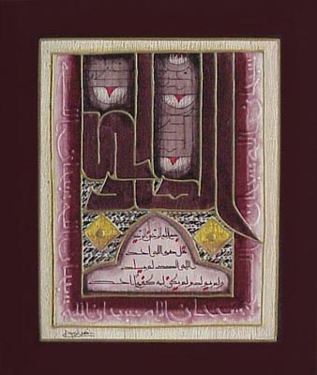 | Say: He is Allah, the One and Only;  Allah, the Eternal, Absolute;  He begetteth not, nor is He begotten;  And there is none like unto Him.  Qur’an 112: 1-4  In the Arabic language tawhid means ‘unification’, and is an assertion of the unity of God. It is is the Islamic concept of monotheism; the opposite of tawhid is shirk, which means ‘division’.  Left: Calligraphy of Surah 112, www.arabartgallery.com
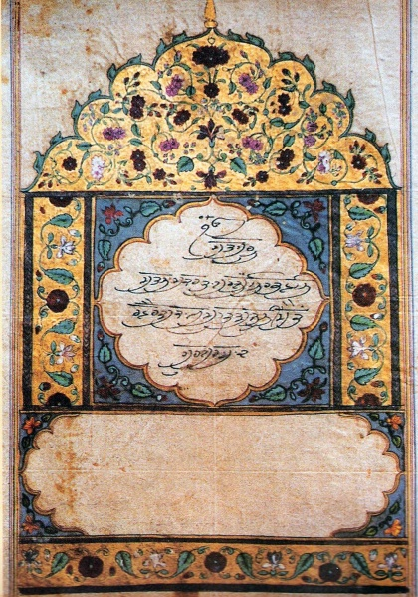 | There is but One God, the Eternal Truth, the Creator, without fear, without enmity, timeless, immanent, beyond birth and death, self-existent: by the grace of the Guru, made known.  The word mool means ‘main’, ‘root’ or ‘chief’ and mantar means ‘chant’, thus the Mool Mantar is the main chant or root verse. Said to have been uttered by Guru Nanak at the moment of his enlightenment at the age of 30, it is the most important composition contained within the Guru Granth Sahib.  Beginning Ik Onkar, “There is only one God, it is considered to be the basis of Sikhism, encapsulating the entire theology of the religion. It is this verse that all beginners to Sikhism have to learn, repeating it over and over again until it becomes an automatic process.  Left: Calligraphy of Mool Mantar, www.sikhwiki.org
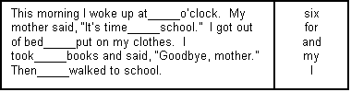

A cloze exercise is a written text with words missing in a regular pattern. For example, in the example, every seventh word is erased. A list of the missing words appears at the right. To make the exercise more challenging, the pupils aren’t given a list of the missing words.

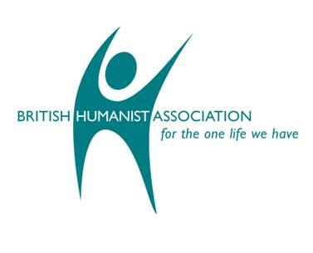  www.humanism.org.uk | Humanism is based on the idea that human beings can live good lives without religious or superstitious beliefs. Humanists make sense of the world using reason, experience and shared human values. They seek to make the most of the one life they have by creating meaning and purpose. They take responsibility for their actions and work with others for the common good.  Key points:  - Humanism is an approach to life based on humanity and reason. Humanists recognise that moral values are properly founded on human nature and experience alone. They base decisions on the available evidence and an assessment of the outcomes of their actions, not on any dogma or sacred text.  - Humanists are agnostic (literally ‘without knowledge’) because they do not believe it is possible to know whether there is a god. Because they do not believe there is evidence of a god or gods—or for an afterlife—they live their lives as atheists (literally, ‘without god’) at the same time as finding other reasons for living a good life.  - Humanists believe in individual rights and freedoms, but believe that individual responsibility, social cooperation and mutual respect are just as important.  - Humanists do not have sacred texts, traditions, dogma, prophets or any source of authority other than human experience. They look for evidence before they believe things and like to think for themselves.  - Humanists believe that we have only one life, and that it is our responsibility to make it a good life, and to live it to the full.
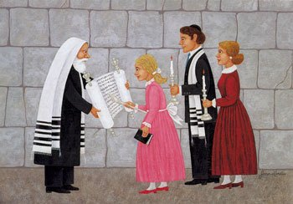  Bat Mitzvah  by Landis | Brit Milah is the Jewish covenant of male circumcision and Brit Brat, naming ceremony for Jewish girls. (For more information see: http://re-xs.ucsm.ac.uk/gcsere/revision/judaism/jud3/page6.html)  The term bar mitzvah literally means “son of a commandment,” and bat mitzvah means “daughter of a commandment.” A Jewish girl is considered responsible for keeping the commandments of the Torah when she reaches the age of 12, for a boy it is 13. The bar/bat mizvah ceremony involves the young person changing the blessing and reading from the Torah at a service in the synagogue, followed by a party or reception. In orthodox and Chasidic Judaism women are not permitted to participate in the services, so a girl’s bat mitzvah in these traditions is generally confined to the party.  The Hebrew word shabbat comes from the Hebrew verb shavat, which literally means ‘to cease,’ or shev which means ‘sit.’ Although shabbat (or its anglicized version, ‘Sabbath’) is almost universally translated as ‘rest’ or a ‘period of rest,’ a more literal translation would be ‘ceasing’, with the implication of ‘ceasing from work.’ Thus, shabbat is the day of ceasing from work.  The Jewish festival of Pesach—more commonly known by the English word ‘Passover’—commemorates the liberation of the ancient Israelites from slavery as told in the biblical book of Exodus. Typically lasting from 6-8 days, the highlight occurs on one of the first two nights, when friends and family gather for a special meal, the seder.
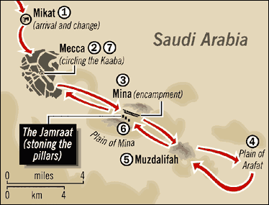  Map of the route taken during the hajj  Wikipedia | Proclaim the pilgrimage among humankind. They will come to you on foot  and on every camel made lean by travelling…  Qur’an 22:27  The hajj is the pilgrimage to Mecca in Islam. It is the fifth of the Five Pillars in Sunni Islam and one of the ten ‘branches of religion’ in Shi’a Islam. Every able-bodied Muslim who can afford to do so is obliged to make the pilgrimage to Mecca at least once in his or her lifetime.  Muslims trace the origins of the hajj to the Prophet Abraham—or Ibrahim, as he is called in Arabic. According to the Qur’an, it was Ibrahim who—together with his son Ishmael (Isma’il)— built the Ka’abah, ‘the House of God,’ the focal point toward which Muslims turn in their worship five times each day. Muslims also believe that it was Ibrahim who established the rituals of the hajj, which recall events or practices in his life and that of Hagar (Hajar) and their son Ishmael.  Umma is an Arabic word meaning community or nation. In the context of Islam, the word (often spelled ummah) is used to mean the diaspora or community of the believers (ummat al-mu'minin), and thus the whole Islamic world.
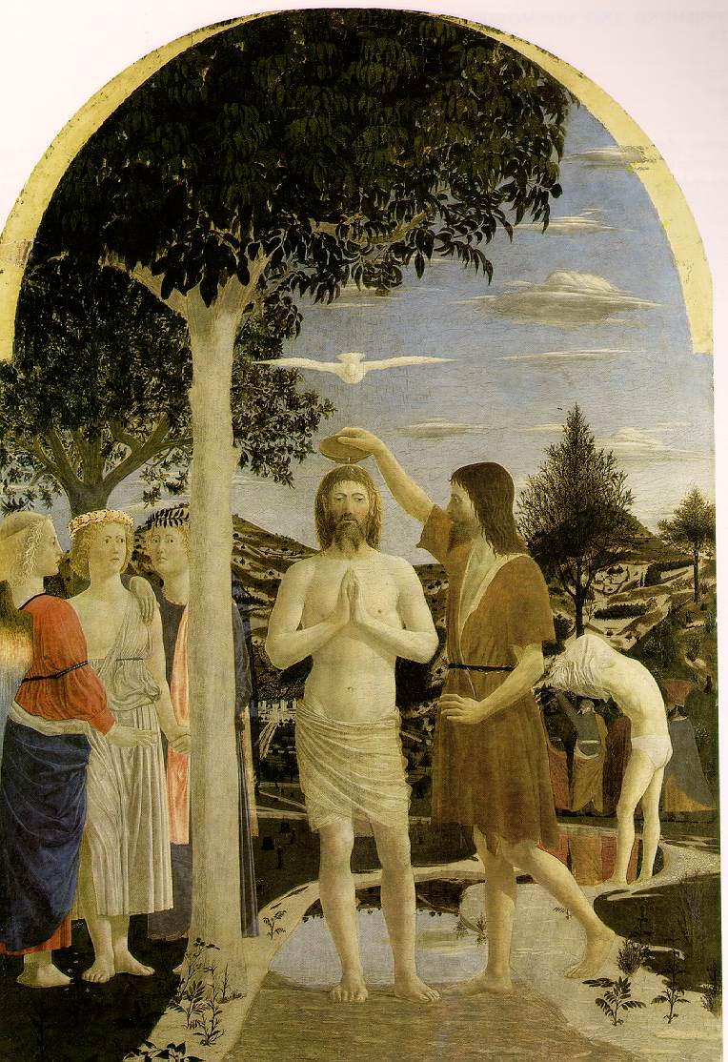  The Baptism  Pierro della Francesca, 1442  www.ibiblio.org | The liturgy in many Christian traditions makes reference to baptism as not only a symbolic burial and resurrection, but an actual transformation equivalent to the experience of Noah and the passage of the Israelites through the Red Sea. Thus baptism is not only cleansing, but also an experience of dying and rising again with Christ.  Some Christians believe that it is necessary for the cleansing of original sin, and for that reason infant baptism is a common practice. However the heart of the Christian rite of baptism is the initiation into membership of the Christian community, i.e. the Church. To be baptised is to become a Christian and experience both the blessings and the responsibilities of that commitment.  Infant baptism offers an opportunity for:  • the public naming of the child  • parents to make a public commitment to the care and well-being of their child  • the recognition of the child by chosen supporting adults as godparents and/or witnesses  • friends, family and the wider community to welcome the new arrival and voice their support for the family

Scheme prepared by Suzy Cole, Dormers Wells High School, London Borough of Ealing

