Ealing Agreed Syllabus: guidance for teachers
Unit: Moral dilemmas I

Learning objectives | Suggested activities | Suggested resources

Right and wrong: black, white and various shades of grey
AT1  To begin to understand how beliefs—religious or otherwise—impact the lives of individuals, particularly the decisions they make.  AT2  To consider the role of individual conscience when making decisions. | Starter: Discuss the following: “Is it ever right to do wrong?”  Development:  - Pupils give examples of family conflict over a range of issues, from the trivial (e.g. what to have for dinner) to more serious topics, such as mixed marriages. How do trivial arguments lead into more complex moral discussions? How are right/wrong decided in these situations?  - Create a scale on the whiteboard, with black at one end, white at the other, and with varying shades of grey in between. Pupils write down a variety of ‘deeds’ on post-it notes (e.g. ‘putting another person’s well-being before your own’, ‘telling white lies’, ‘murder’) and the class as a whole place these on the scale.  - Ask class for examples of events that have changed their beliefs about what is wrong and what is right.  - Using the example of the conversion of Saul of Taursus (see background information), ask for examples of how changing their beliefs might affect their own actions and decision-making.  Conclusion: Discuss the role that belief plays in decision-making.  Homework: Ask class to bring in a picture of a figure that has inspired them and to which they look as a moral example. Can be a real person or a fictional character.

Sources of moral authority
AT1  Pupils begin to see that their own ability to reason and a sense of conscience can be sources of moral authority.  AT2  Pupils begin to understand the factors that influence their decisions, and that these factors might be different for other people. | Starter: Display photographs/show a power point presentation of various religious and secular moral figureheads (e.g. the Pope, Dalai Lama, Harriet Tubman). Be sure to include an equal number of male and female role models; you can also use fictional examples, e.g. Captain Kathryn Janeway of “Star Trek: Voyager”, Dr Samantha Carter and Dr Daniel Jackson of “Stargate SG1”, Batman, Spiderman etc.) Ask class to share their homework examples.  Development:  - Diamond ranking exercise (see background information). Pupils to work in groups of three to place example statements on the grid. Make sure your statements include a relevant number of examples of the categories in the grid.  - Groups share with the rest of the class the way they have ranked the statements. Elicit reasons from each group for their choices, specifically with reference to any sources of moral authority they drew upon when making their decisions (e.g. religious beliefs, individual conscience).  - Individually, pupils complete the following sentences: “The example I found most reprehensible was …………. because………………… I found myself disagreeing with several classmates regarding……………………………..  - Discuss with pupils the ease or difficulty of placing some of the statements on the grid.  Conclusion: Discuss the role of moral authorities such as priest, teacher or agony aunt. As a class, write a question and response to an agony aunt. E.g. “I am a practising Hindu and have met a nice boy at school. He’s not a Hindu and asked me to go out with him. I know my parents will object. What should I do?” Is this a moral dilemma, and if so, why?  Homework: Pupils repeat the exercise, coming up with their own question and response.

Are humans inherently good or bad?
AT1  Pupils learn about various religious and philosophical viewpoints regarding the inherent ethical nature of human beings.  AT2  Pupils begin to think about when/if rules are needed. | Starter: In pairs, pupils discuss a world without rules, and what they might like to do if they had no rules or restrictions to follow. Turn the question around, asking what rules they would like to see more effectively enforced.  Development:  - Provide class with visual representations of three ‘good’ and three ‘bad’ behaviours, including some morally ambiguous ones (e.g. a poor person stealing food). Discuss:  - Why do people behave in these ways?  - If the behaviour is deemed to be bad, why do it?  - Who decides what is ‘good’ and what is ‘bad’ behaviour?  - Discuss a variety of religious and philosophical viewpoints regarding the inherent nature of human beings, e.g. the Christian concept of original sin, the philosophical view that individuals are born with a ‘clean slate’, and the Hindu and Sikh concept of karma.  - Discuss the idea that it is not the person that is bad, but rather individual choices and behaviours. Are there behaviours that are inherently bad regardless of the fact that no one (including the individual concerned) is adversely affected?  - Turning the question round, should a particular behaviour be judged morally ‘good’ if the individual would have done it anyway? For example, should a person be considered morally superior if they don’t do something that they wouldn’t want to do in any case?  Conclusion: Set up a scale with ‘good’ at one end, ‘morally neutral’ in the middle and ‘bad’ at the other, and let each class member indicate where they think humans fit on that scale.

Role of the media
AT1  Pupils begin to consider whether it is useful or dangerous to view the media as a source of moral authority.  AT2  Pupils begin to understand how the media (newspapers, films, internet etc) can affect what they think and feel. | Starter: Power point presentation of a variety of newspaper articles on the same story, showing the differing slants that can be accomplished through the wording of the headlines.  Development:  - Pass out copies of a newspaper article where the headline is misleading, i.e. it doesn’t reflect the actual events or content of the story. Discuss the ‘morality’ of this, e.g. leaving a casual reader who doesn’t bother to read the text with the wrong impression.  - Pick a story involving a moral issue (e.g. euthanasia of a terminally ill person who is suffering greatly), and then split class into groups. Get each group to write a headline and short text from differing viewpoints (e.g. ‘for’ and ‘against’, or ‘sensational’ and ‘sympathetic’).  - Class shares the various versions, discussing how the way a story is told can affect how a reader judges the event.  Conclusion: Briefly, tell the story of the wreck of the Mignonette (see background information). Discuss the fact that the sea-faring community had more sympathy with the men on trial than the panel of judges in London, who would most likely never find themselves in a similar situation. Get class to devise four banner headlines, one that encourages a moral judgement against the survivors, one that doesn’t encourage such a judgement, one that sensationalises the story and one that elicits sympathy. | Various newspapers or on-line news websites.

Absolute versus relative
AT1  Pupils begin to learn that distinctions of right and wrong are not always easy to make  AT2  Pupils begin to articulate their own ideas about what is right and what is wrong. | Starter: Using the IWB, look at a variety of pictures of mazes. Discuss the phrase “moral maze”: i.e. why is a maze a good metaphor for the difficulty encountered in making moral decisions. Consider such ideas as “learning through mistakes”, “false starts”, and “lack of clear signposts”.  Development:  - Break into groups, and get each group to come up with a few ‘signposts’ that they think might be helpful in negotiating a metaphorical moral maze. They should write their ideas down on the white board in two columns: one labelled ‘traditional signposts’ (e.g. the 10 commandments, the golden rule) and one labelled ‘other’ (e.g. their own definition of what constitutes loyalty).  - Looking at the lists, talk about which signposts (e.g. “do not kill”) can be considered ‘absolute’ or always right, or whether there are ever exceptions (e.g. killings that occur during acts of self-defence or defence of another).  - Discuss how easy/hard it is to make such a distinction.  - Introduce the terms ‘moral absolutism’ and ‘moral relativism’ (see background information), pointing out that this is an issue that has perplexed human beings throughout history.  Conclusion: As a class, see if it is possible to come up with one example of a behaviour or idea that they can all agree is absolutely good/right, and one which they can all agree is absolutely bad/wrong, with no possible exceptions. If they were to make a list of all such cases, how would it compare in length to a list of situations where no such absolute judgement could be made. | 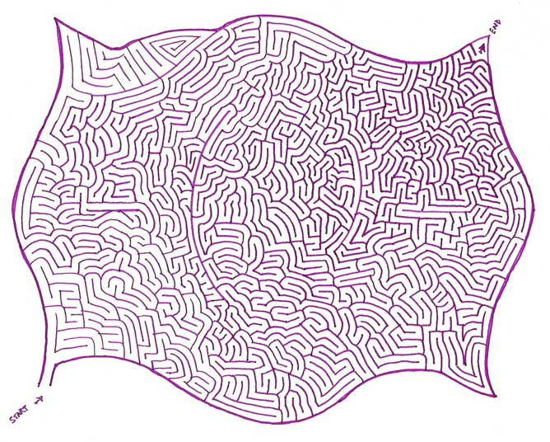  Printable examples from: http://www.ibrattleboro.com/staticpages/index.php/20050109162256584

The moral maze
 | This lesson depends on pupils having access to the Caspian Thinking Worlds RE module. If this is available in the school’s IT suite, devote the entire lesson to allowing pupils to play the game (i.e. Moral Maze sections 1-3).  In the third task of this section, students are asked to prepare for a debate or presentation on one of the four ethical issues in the previous two tasks. If the class is able to use this software and complete the 3rd task, an entire unit (Moral dilemmas II) could be devoted to activities based on the result of the students’ research.  If the software is not available, use the following:  Starter: Discuss the concept of peer pressure, asking class to volunteer examples (not necessarily ‘real’ examples that might get them into trouble.) Discuss how difficult it can be to be ‘different’, even when the pressure is just to conform (c.f. pressure to do something against one’s conscience).  Development:  - Tell class the story of the Milgram experiment (see background information).  - Discuss how class members feel about the results.  - Discuss how they feel about the morality of the experiment itself.  - Go back to the subject of ‘moral authority’, talking about how important it is to develop one’s own sense of morality, so that one is able to discriminate in the face of charismatic personalities that speak ‘with authority’, as well as to stand up against the more common experience of peer pressure (e.g. to drink when underage).  Conclusion: Summarise the various things discussed during the course of the unit. Read Matthew 7:15-18. What was Jesus trying to say about how important it is to listen with discrimination? | Caspian Thinking Worlds RE module, “Moral Maze 1-3” (This software is scheduled to be distributed to all Ealing high schools this coming academic year.)  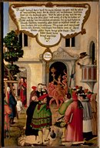  Altar piece panel illustrating Matthew 7:15  Matthias Gerung (c 1500–1568)  www.scholarsresource.com  “Watch out for false prophets. They come to you in sheep’s clothing, but inwardly they are ferocious wolves. By their fruit you will recognize them. Do people pick grapes from thorn bushes, or figs from thistles? Likewise every good tree bears good fruit, but a bad tree bears bad fruit. A good tree cannot bear bad fruit, and a bad tree cannot bear good fruit.” Matthew 7: 15–18

Key words | Moral authority, reason, conscience, moral role models, karma, original sin, journalistic slant, moral absolutism, moral relativism, peer pressure.
Points to note | It is very important during the course of this unit that teachers are honest when expressing moral values—i.e. that they clearly state that their views on a particular subject are just that, i.e. their own opinions or values.

Outcomes

At the end of this unit, most pupils will:

- Begin to appreciate the difficulty in making moral decisions.
- Be able to give examples of moral guidance from several sources.
- Have an appreciation of how their moral values have been shaped (e.g. through parental guidance, role models, religious or philosophical tradition, the media).

Some pupils will have made less progress and will:

- Understand that there are times when they will have to make decisions regarding right and wrong.
- Be able to name a few rules concerning what is ‘right’ behaviour and what is ‘wrong’ behaviour.
- Be able to name some people who are considered to be sources of moral authority.

Some pupils will have made more progress and will:

- Be able to give some examples of difficult moral decisions and state why solutions to these predicaments are not straightforward.
- Begin to make critical comparisons of moral guidance from different sources.
- Be able to articulate their own moral values and say how these have been derived.

Background information
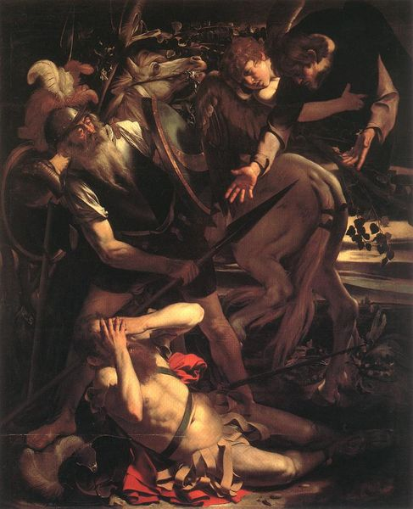  “Conversion of St Paul”  Carravagio, 1600  wikipedia | According to the book of Acts, Paul—or Saul, “an Israelite of the tribe of Benjamin” (Philippians 3:5)—was born in Tarsus in Asia Minor (modern-day Turkey). Paul’s own letters, however never mention his birthplace or his former name. The book of Acts records that Paul was a Roman citizen—a privilege he used a number of times when appealing to Rome against convictions in Judaea (Acts 22:25 and Acts 27–29); according to one biblical account (Acts 22:3) he studied in Jerusalem under the Rabbi Gamaliel (a well-known rabbi of the time), and according to his own testimony he worked as a tentmaker to support himself during his travels and while preaching.  He first appears in the pages of the New Testament as a witness to the martyrdom of Stephen (Acts 7:57–8:3). He was by his own description a persistent persecutor of the Church (I Corinthians 15:9, Galatians 1:13) until the experience on the road to Damascus that resulted in his conversion.  Paul himself is very reticent about the precise nature of his conversion (Galatians 1:11–24), though he uses it as the reason for his independence from the apostles. In Acts there are three accounts of this conversion experience:  - In the first (Acts 9:1–20) he is described as falling to the ground (as a result of a flash of light from the sky) and hearing the words, “Saul, Saul why are you persecuting me?”  - The second is Paul’s witness to the event before the crowd in Jerusalem (Acts 22:1–22).  - The third is his testimony before King Agrippa II (Acts 26:1–24).  In all the accounts, he is described as having been blinded by the light, and subsequently led to Damascus, where his sight was restored by a disciple called Ananias.

Diamond ranking exercise
Example statements:
You help a blind woman onto a bus.
You give your seat to an elderly person on the tube.
You steal £5 from a friend’s purse.
You steal £5 from an enemy’s purse.
You cheat on an exam.
You encourage a friend to eat something when you know they are fasting.
You sneak a glass of wine at a cousin’s wedding.
You deliberately hurt a person’s feelings.
You tell a white lie to spare a friend’s feelings.
You accidentally hurt a person’s feelings.
You break a confidence in order to help someone.
You steal from the rich to give to the poor.

Place nine statements onto a grid as follows.

Most righteous | 
Ethical
Ethically neutral
Unethical
Most morally reprehensible

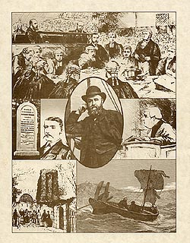  Regina v. Dudley & Stephens (1884)  (Print illustrating  details of the case)  www.forcounsel.com | The English yacht Mignonette set sail for Sydney, Australia from Southampton on 19 May 1884 with a crew of four: Tom Dudley (the captain), Edwin Stephens, Edmund Brooks and Richard Parker (the cabin boy). On 5 July, caught in bad weather, the yacht sank off the Cape of Good Hope, stranding the entire crew of four on a 13-foot lifeboat. For twelve days they survived on whatever they could catch and two tins of turnips that Dudley had recovered prior to leaving the ship.  After eight days without food or water, Dudley proposed that, if they failed to encounter another vessel by the next day, Richard Parker—who by now was immobile and possibly unconscious from hunger and the ill-effects of drinking sea-water—be sacrificed to feed the others. Brooks did not consent, Parker wasn’t asked his opinion, and on 25 July, Dudley, with the assent of Stephens, said a prayer and slit the boy’s throat.  Despite Brooks’ dissent, all of the survivors fed on the body for the next four days, when they were picked up by a German boat. They were subsequently brought to Falmouth, where Dudley and Stephens were charged with murder.  The initial trial in Exeter was in front of a sympathetic jury. Although cannibalism was by no means an accepted practice, the Exeter seafaring community was receptive to the unique perils of being cast away at sea, and it was understood amongst the naval community that in a situation where lives were to be sacrificed, the cabin boy should be the one chosen. (On the basis that they typically had no family or dependants: prior to coming to trial, Dudley was convinced that this was actually part of the law and that he would not be charged with murder—even Richard Parker’s relatives testified that the defendants were probably justified in their actions.)  In its verdict, the jury stated that they found all the facts of the prosecution’s case to be accurate, but that they were unsure whether the circumstances would constitute legal homicide, and so the question was sent to London for review, where a panel of judges found that there was ‘insufficient necessity’ for the killing. The judges argued that allowing an exception to murder for certain perilous circumstances would set a dangerous precedent. The presiding justice, Lord Coleridge, went so far as to call Dudley’s and Stephens’ actions inconsistent with the morals of civilised societies, citing as examples the virtues of Greco-Roman literature and the biblical story of Jesus.  Brooks was acquitted of any involvement, but Dudley and Stephens were found guilty and sentenced to death. However Queen Victoria, using the royal prerogative, commuted this sentence to six months’ imprisonment.
  Tree of knowledge  Lucas Cranach, 1472-1553  wikimedia  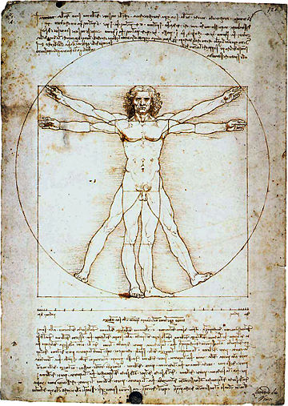  Vitruvian Man  Drawing by Leonardo da Vinci  wikipedia | Humanity has wrestled with questions of morality for thousands of years: for example, the notion that it can be dangerous for humans to take on the task of judging good from evil is central to the Garden of Eden story.  Moral absolutism is the belief that there are absolute standards against which moral questions can be judged, and that certain actions are right or wrong, regardless of the context of the act. This position is often contrasted with moral ‘relativism’ (i.e. the belief that moral truths are relative to social, cultural, historical or personal references) and ‘situational ethics’ (which holds that the morality of an act depends on the context of said act).  According to moral absolutists, morals are inherent in the laws of the universe, the nature of humanity, the will or character of God, or some other fundamental source. Moral absolutists regard actions as inherently moral or immoral; they might, for example, judge slavery, war, dictatorship, the death penalty, or childhood abuse to be absolutely and inarguably immoral, regardless of the beliefs and goals of any culture that engages in these practices.  Many religions have morally absolutist positions, believing that their system of morality has been established by a deity or deities, and regarding such systems of morality as absolute, (usually) perfect, and unchangeable. There are also many philosophies that take a morally absolutist stance, arguing that the laws of morality are inherent in the nature of human beings, the nature of life in general, or the universe itself. (For example, someone who believes absolutely in nonviolence considers it wrong to use violence even in self-defense. For another example, under some religious moral absolutist beliefs, homosexual behavior is considered fundamentally wrong, even in a committed monogamous relationship.) Many who make such claims often disregard evolving norms within their own communities.  Moral relativism is the position that moral or ethical propositions do not reflect objective and/or universal moral truths, but instead make claims relative to social, cultural, historical or personal circumstances. Some moral relativists hold that a personal and subjective moral core lies—or ought to lie—at the base of an individual’s moral acts: in this view public morality reflects social convention, and only personal, subjective morality is truly authentic.  The Greek historian Herodotus (c. 484 – 420 BCE) observed that each society regards its own belief system and way of doing things as the best, in contrast to that of others, and the assertion by Protagoras (c. 481 – 420 BCE) that ‘of all things, the measure is man’ provides another early precursor to modern moral relativism.  The 18th-century Enlightenment philosopher David Hume (1711 – 1776) distinguished between matters of fact and matters of value, and suggested that moral judgments consist of the latter, for they do not deal with verifiable facts obtained in the world, but only with our sentiments and passions. But Hume regarded some of our sentiments as universal. He denied that morality has any objective standard, and suggested that the universe remains indifferent to our preferences and our troubles.  Extracted from Wikipedia.
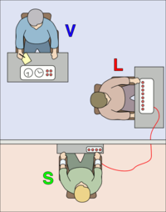  In the Milgram experiment, the experimenter (V) orders the subject (L) to give what the subject believes are painful electric shocks to another subject (S), who is actually an actor. The subjects believed that for each wrong answer, the learner was receiving actual shocks, but in reality there were no shocks. After the confederate (S) was separated from the subject, the confederate set up a tape recorder integrated with the electro-shock generator, which played pre-recorded sounds for each shock level.  wikipedia | The Milgram experiment was a series of experiments conducted by Yale University psychologist Stanley Milgram, which measured the willingness of participants to obey an authority figure who instructed them to perform acts that conflicted with their personal conscience.  The experiments began in July 1961, three months after the start of the trial of Nazi war criminal Adolf Eichmann. Milgram devised the experiments to answer this question: “Could it be that Eichmann and his million accomplices in the Holocaust were just following orders? Could we call them all accomplices?”  Milgram summarised his findings in his 1974 article, “The Perils of Obedience”:  The legal and philosophic aspects of obedience are of enormous importance, but they say very little about how most people behave in concrete situations. I set up a simple experiment at Yale University to test how much pain an ordinary citizen would inflict on another person simply because [they were] ordered to do so by an experimental scientist. Stark authority was pitted against the subjects’ strongest moral imperatives against hurting others, and, with the subjects’ ears ringing with the screams of the victims, authority won more often than not. The extreme willingness of adults to go to almost any lengths on the command of an authority constitutes the chief finding of the study and the fact most urgently demanding explanation.  Ordinary people, simply doing their jobs, and without any particular hostility on their part, can become agents in a terrible destructive process. Moreover, even when the destructive effects of their work become patently clear, and they are asked to carry out actions incompatible with fundamental standards of morality, relatively few people have the resources needed to resist authority.  Before the experiment was conducted Milgram polled 14 senior psychology students as to what the results would be. All respondents believed that only a sadistic few (average 1.2%) would be prepared to give the maximum voltage. Milgram also informally polled his colleagues and found that they believed very few subjects would go beyond a very strong shock. In contrast, in Milgram’s first set of experiments, 65% (26 out of 40) of experimental participants administered the experiment’s final 450-volt shock, though many were quite uncomfortable in doing so; everyone paused at some point and questioned the experiment, some even saying they would return the cheque for the money they were paid. No participant steadfastly refused to give further shocks before the 300-volt level. Variants of the experiment were later performed by Milgram himself and other psychologists around the world with similar results.  Milgram’s experiment raised questions about the ethics of scientific experimentation because of the extreme emotional stress suffered by the participants. In Milgram’s defense, 84% of former participants surveyed later said they were ‘glad’ or ‘very glad’ to have participated and 15% chose neutral (92% of all former participants responding).  Extracted from Wikipedia

