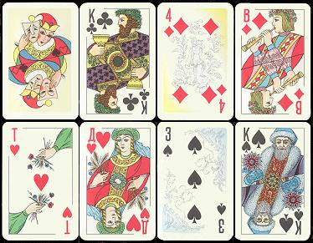 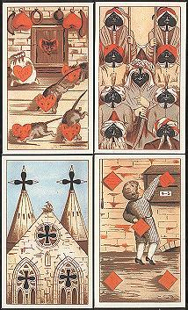 Country: When: Country: When:
Theme: Why: Theme: Why:

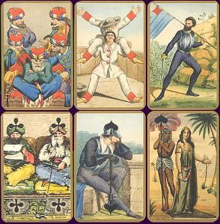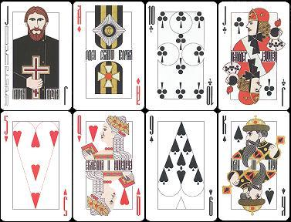
Country: When: Country: When:
Theme: Why: Theme: Why:
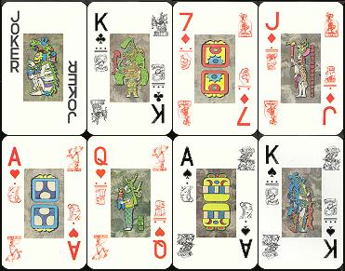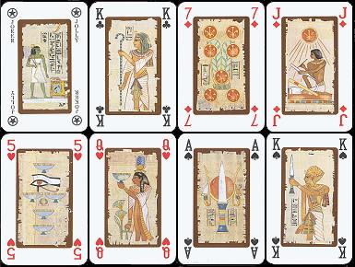
Country: When: Country: When:

Theme: Why: Theme: Why:

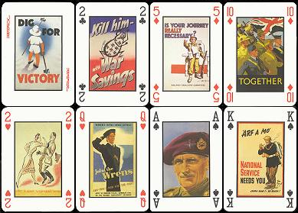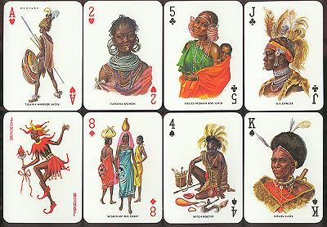
Country: When: Country: When:

Theme: Why: Theme: Why:

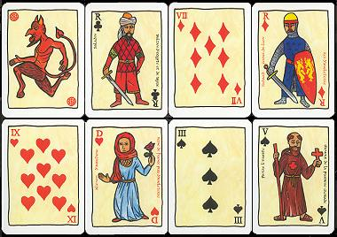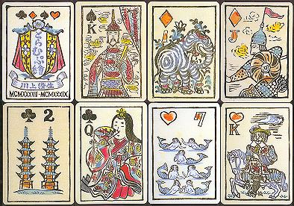
Country: When: Country: When:

Theme: Why: Theme: Why:

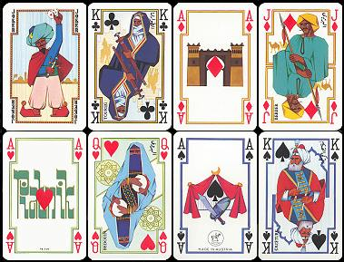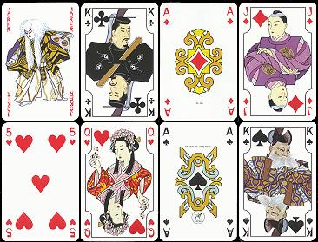
Country: When: Country: When:

Theme: Why: Theme: Why:

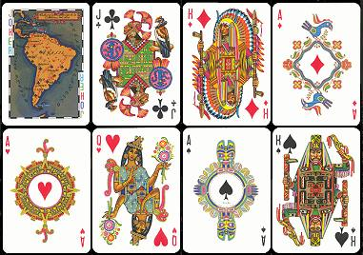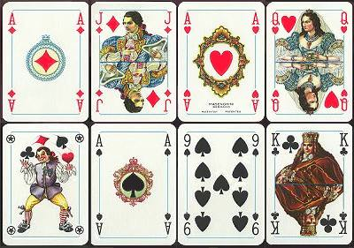
Country: When: Country: When:

Theme: Why: Theme: Why:

