
Share school recruitment videos on YouTube via Facebook, school website or X
Here is the school recruitment video playlist on YouTube:
Being a school leader in Ealing schools - YouTube
If you have a YouTube account follow this section. If you don’t have a YouTUbe account kip to the next section:
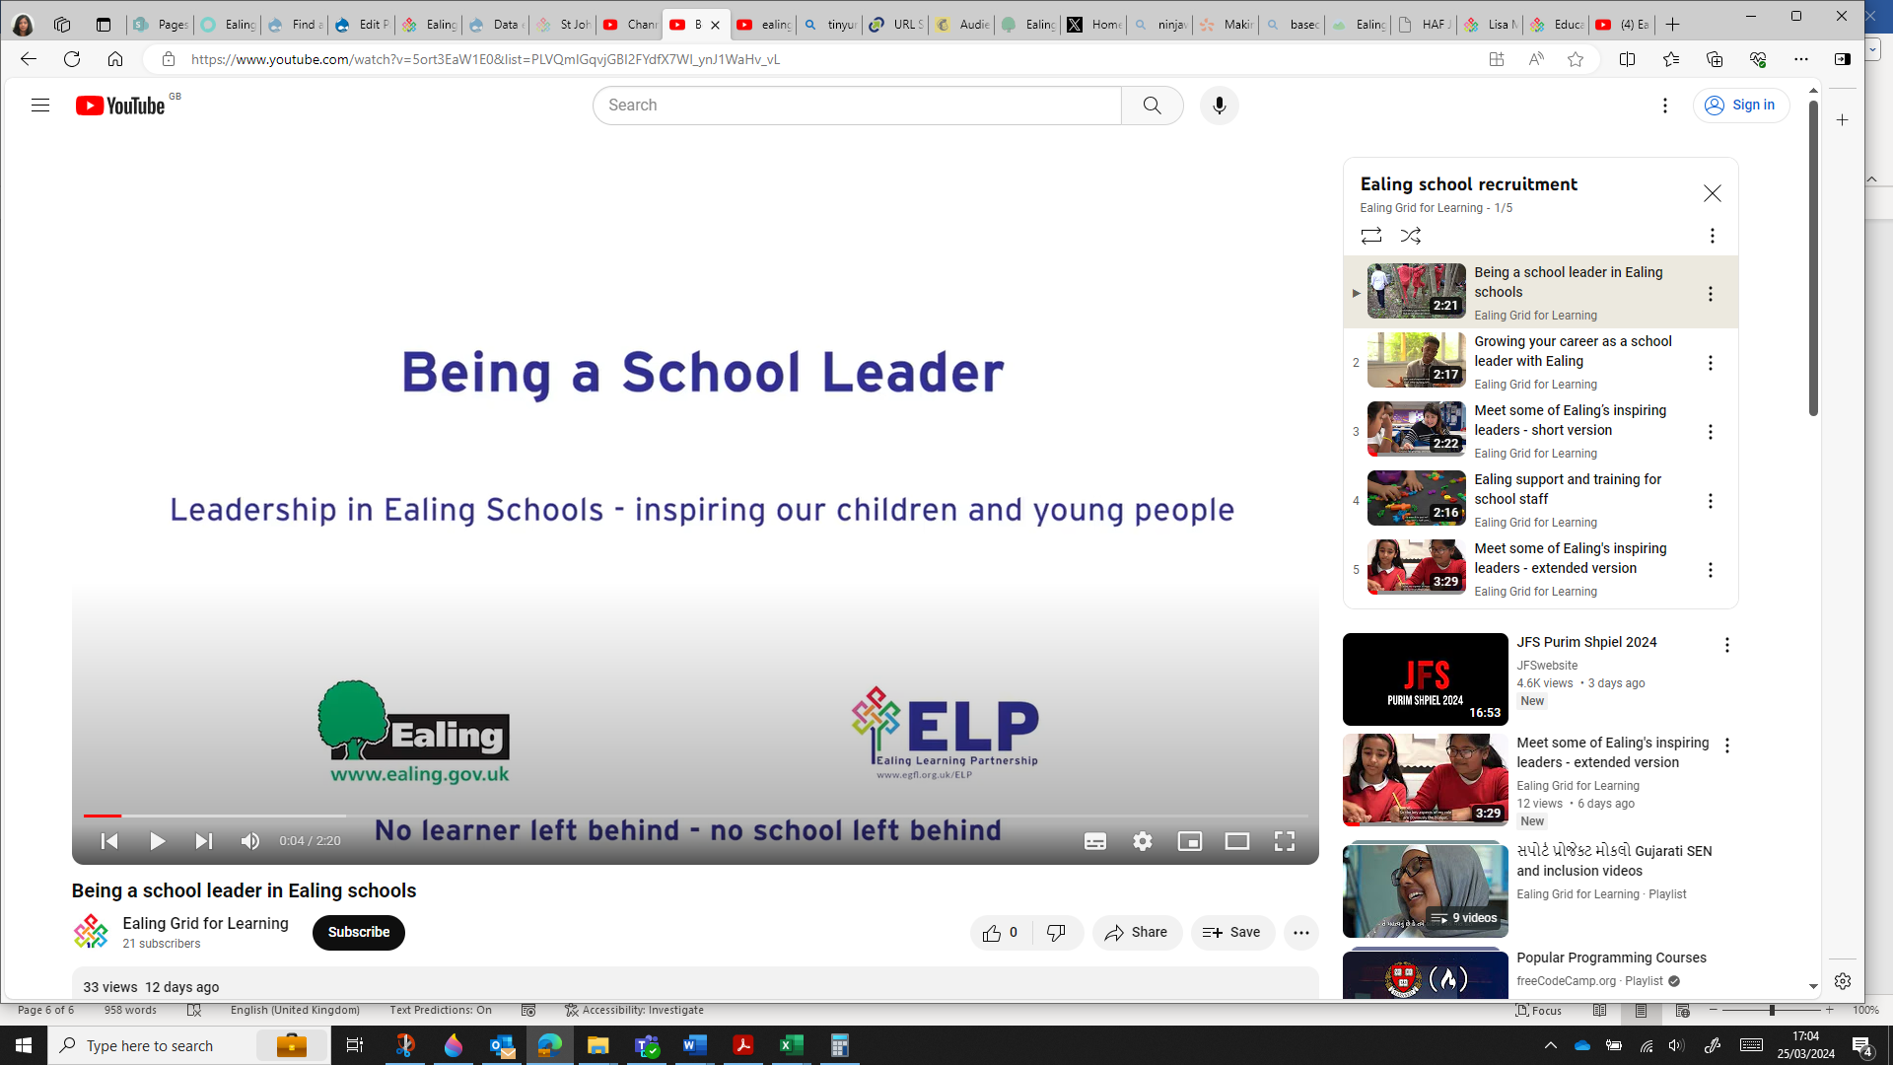

To save the complete playlist that includes all 5 videos select the 3 dots at the top of the playlist title:
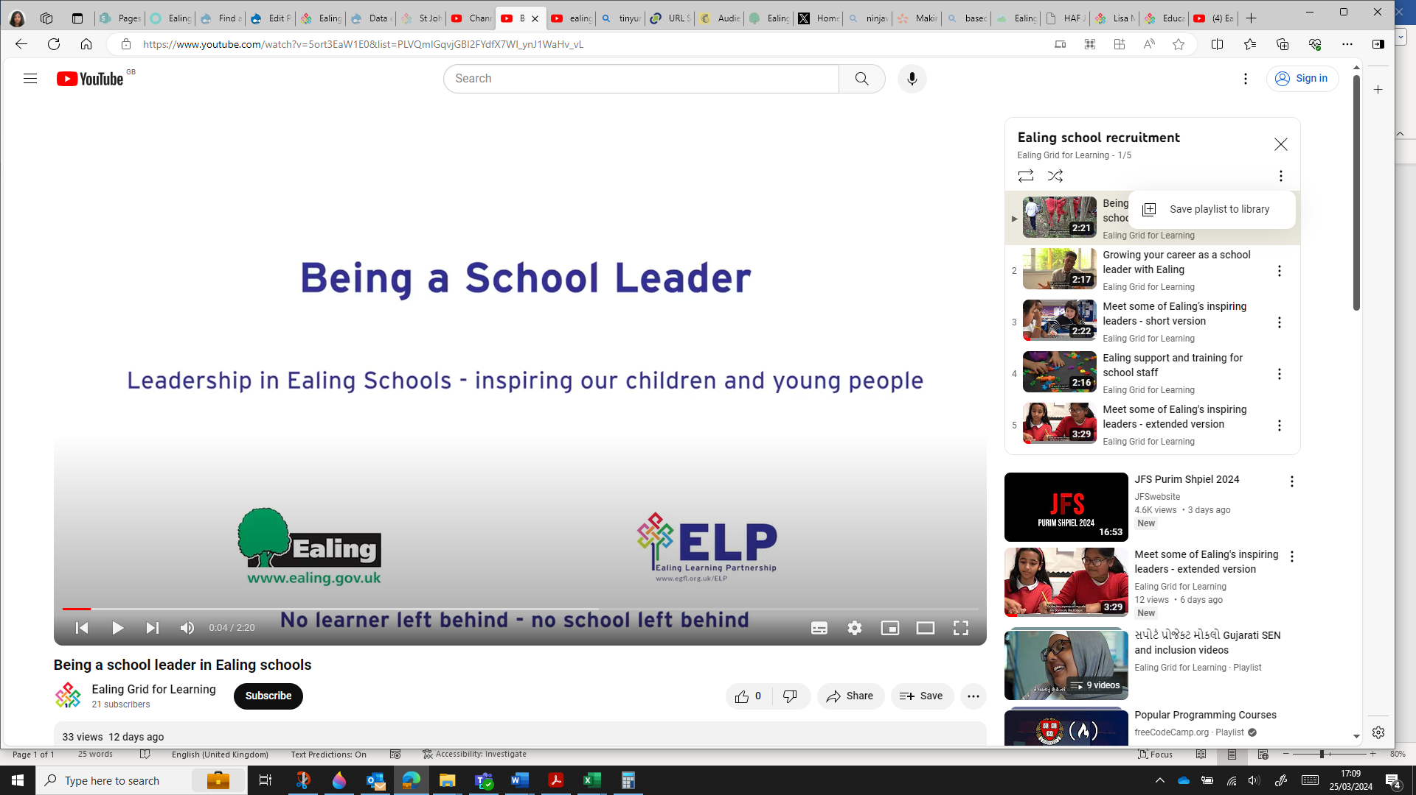
All videos will be saved to your school YouTube account.
If you don’t have a YouTube account you cn share the videos on your school website, Facebook or X school account.
Just copy the relevant video link and post on whichever social media platform. Being a school leader in Ealing schools - YouTube
https://www.youtube.com/watch?v=5ort3EaW1E0&list=PLVQmIGqvjGBI2FYdfX7Wl_ynJ1WaHv_vL
If you want the video to play from your school website, then use the embed code.
To get the embed code select share located at the bottom of the video:
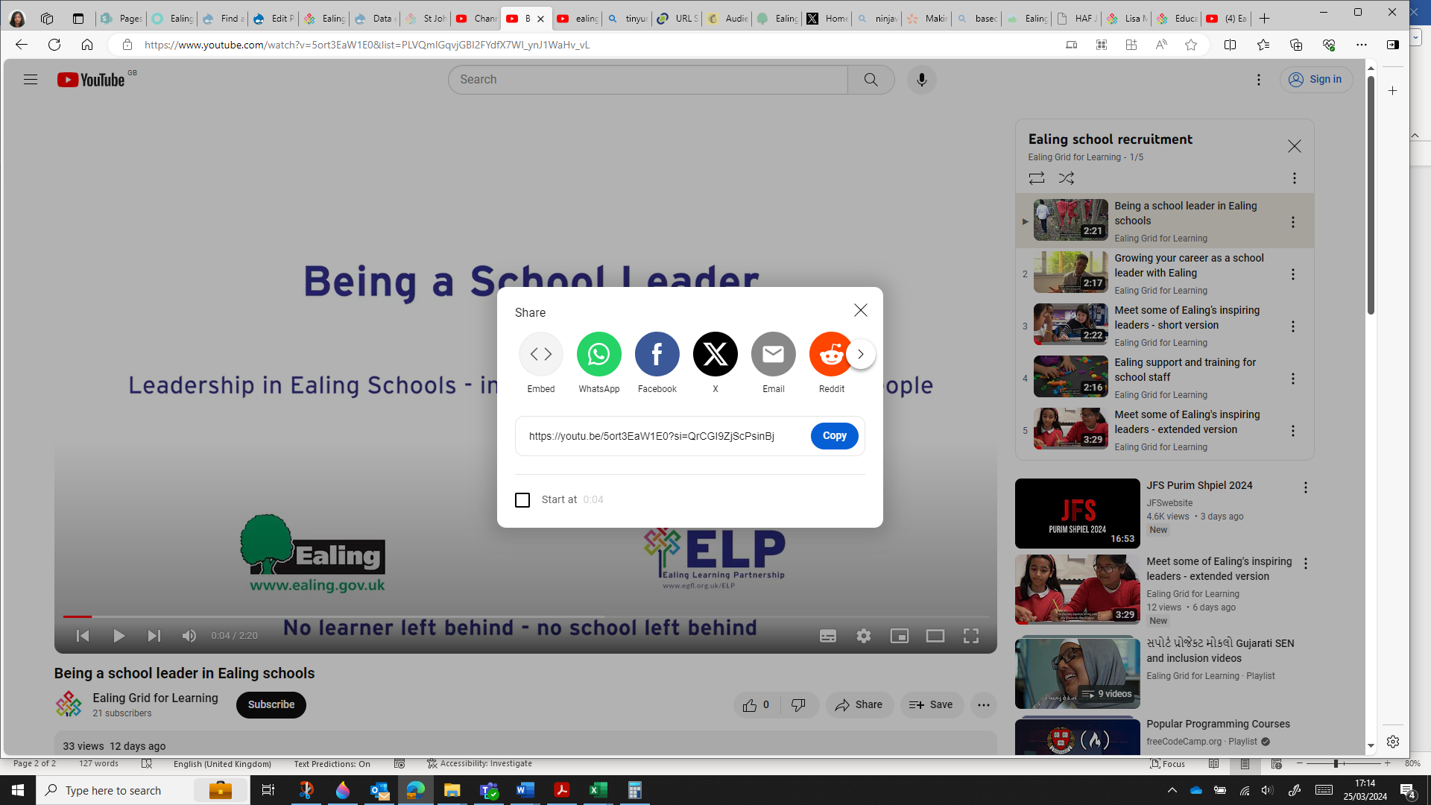
Then select Embed and copy the code to use on your school website, Facebook or X page.
Use this text if needed
Want to develop in your teaching career, working proactively with wonderfully diverse, creative communities and staff to drive great outcomes? See what our Ealing leaders, teachers and staff say about their careers in Ealing schools

