
Share school recruitment videos using X (Twitter)
Log in to you X (Twitter) account.
Go to Post and paste this text in the box:
Want to develop in your teaching career, working proactively with wonderfully diverse, creative communities and staff to drive great outcomes? See what our Ealing leaders, teachers and staff say about their careers in Ealing schools
https://www.youtube.com/playlist?list=PLVQmIGqvjGBI2FYdfX7Wl_ynJ1WaHv_vL @EalingCouncil
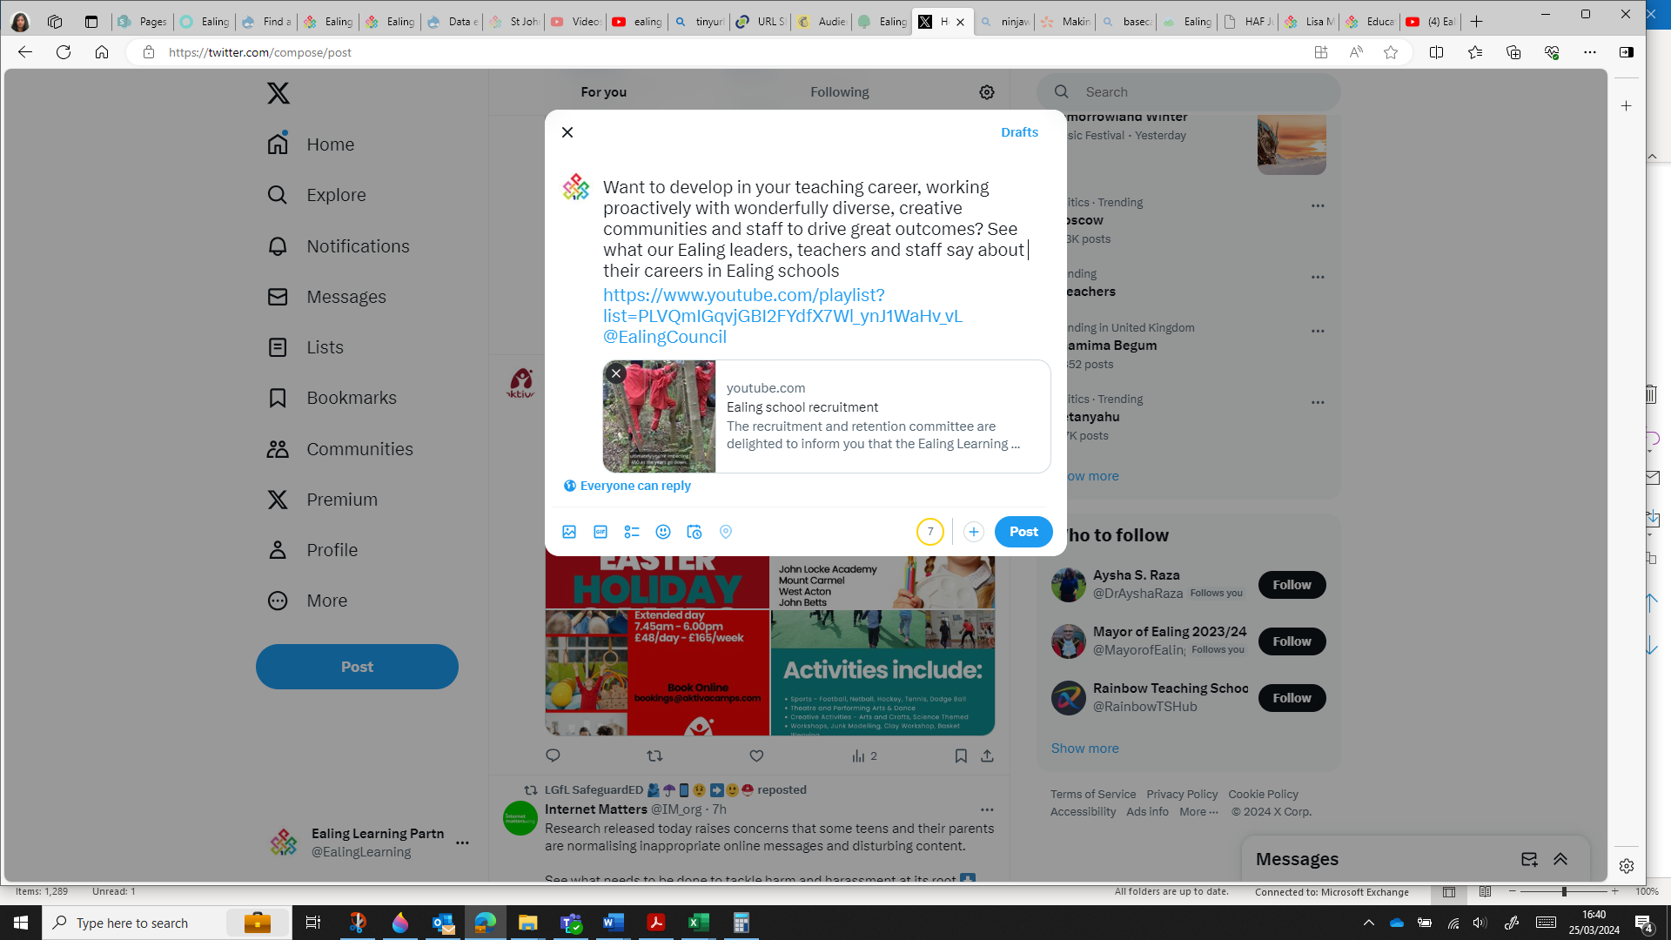
If you are ready to share your post, select Post
If you want to delay posting until a specific date or time, select the schedule icon
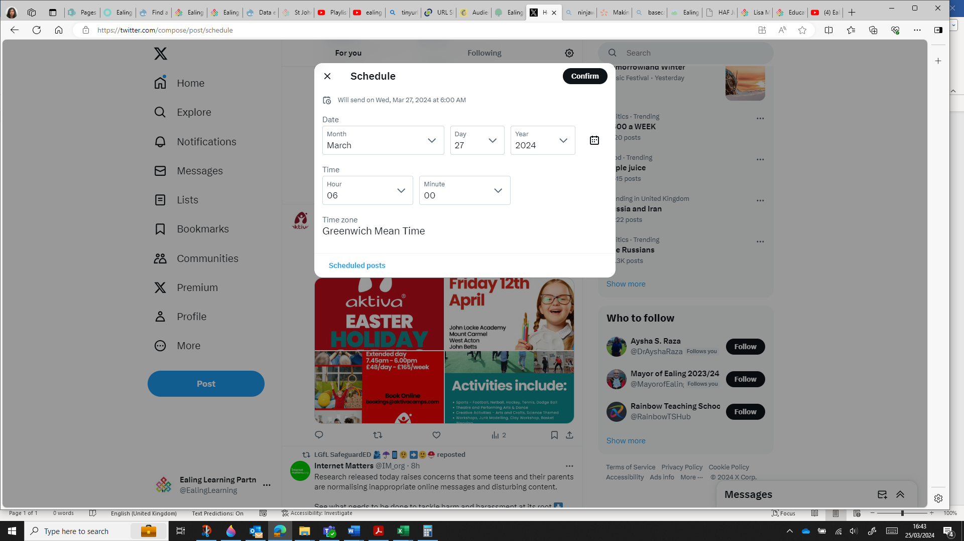In the schedule box choose the date and time and select confirm.
To confirm all is correct select Schedule
To view all scheduled posts select Post then Schedule

