**Development of Mastery Subject Knowledge - Focus on mastery teaching methods and resources: upcoming NQTs/NQT+1/Teachers changing phase**

The London Central and West Maths Hub and The University of Roehampton are offering a 4-day subject knowledge development programme for those about to be NQTs, those who have just finished their NQT year, or for teachers who are changing phase **– in a school that is already implementing mastery approaches**. This will be with an in depth focus on phase specific knowledge. This joint project will focus on Teaching for Mastery teaching methods and resources.

The first day will focus on the principles of Mastery and Problem Solving across all the Primary Phases. Days 2-4, will be year group specific, (Rec/Yr1, Yrs2/3, Yrs4/5/6) once participants know which year group they will be teaching the subsequent September. These sessions will focus specifically on place value, addition and subtraction, and multiplication and division. Intersession tasks and readings will also be given. There will be opportunities for planning and preparing for the start of term.    The sessions will involve development of subject knowledge and pedagogy through practical, collaborative tasks, with opportunities to analyse lessons, as well as planning for the new year.

To ensure delegates can attend these sessions, days 2-4 are set during the school summer holidays. Attendees will be required to **attend all 4 sessions.** There is a small charge of £75 to cover all four days. Upon booking your place, you will then receive an invoice for that figure, to be paid within 14 days of issue. It is worth noting that any cancellations post booking will incur **a charge** – per day missed.

Dates:

1. **Thurs 11th July or Friday 12th July**
2. **28th August**
3. **29th August**
4. **30th August**

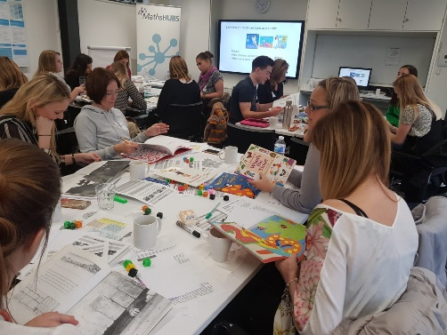

*(Once you know what year the participant will be teaching in, please let Michelle know, so we can put them in the correct*

*phase specific days in August and also we will then notify you whether the first day of the project for them will be the 11th July or 12th July)*

Times: **9.15 am till 3.30pm**

***(no lunch provided, but there are plenty of local shops to get food)***

Location:

**Fox Primary School,**

**Kensington Place,**

**London W8 7PP** (Entrance on Edge Street)

For bookings, please contact [michelle.foster@foxprimary.co.uk](mailto:michelle.foster@foxprimary.co.uk)

***Bookings can be made by student teachers, in conjunction with headteachers (of a state school for a position beginning September 2018); by headteachers, on behalf of their newly recruited NQTs, NQTs +1, or teachers changing phase (for 2019-2020).***

***\*The London Central and West Maths Hub will charge a £75 fee for non-attendance per day for cancellations to any of the sessions with less than 14 days’ notice.***