The COVID-19 vaccine is being offered to your child. Your child will receive their first COVID-19 vaccine and you may be notified about the second dose later. Further information can be found on the DfE website: https://www.gov.uk/government/publications/covid-19-vaccination-resources-for-children-and-young-people Please discuss the vaccination with your child, then complete this form by:
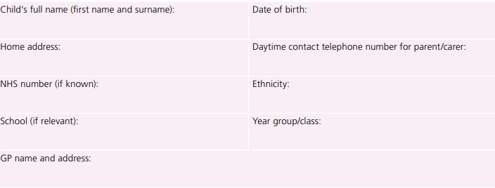Information about the vaccinations will be put on your child’s health records.
Ask ALL patients ALL questions below and tick if any apply
EXCLUSION CHECKLIST – tick any that apply
- Has your child tested positive for COVID-19 in the last 28 days (by a lateral flow test or a PCR test)?
- Has the individual experienced major venous and/or arterial thrombosis occurring with thrombocytopenia following vaccination with any COVID-19 vaccine?
- Has the individual had any vaccination in the last 7 days?
- Is the individual currently unwell with fever?
- Has the individual ever had any serious allergic reaction to any ingredients of the Covid-19 vaccines, drug or other vaccine?
- Has the individual ever had an unexplained anaphylaxis reaction?
- Does the individual have a history of heparin-induced thrombocytopenia and thrombosis (HITT or HIT type 2)?
- Does the individual have a history of capillary leak syndrome?
- None of the above

CAUTION CHECKLIST – tick any that apply
- Has the individual indicated they are, or could be pregnant?
- Has the individual informed you they are currently or have been in a trial of a potential coronavirus vaccine?
- Is the individual taking anticoagulant medication, or do they have a bleeding disorder?
- Does the individual currently have any symptoms of Covid-19 infection?
- None of the above

