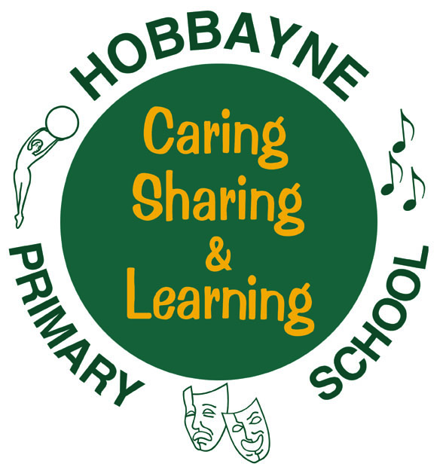
HOBBAYNE PRIMARY SCHOOL- Relegious Education Development Plan– 2014-15
PROPOSED DEVELOPMENTS – RE

To be completed by the Co-ordinator
Prepared by: Nicole Gutch Date: 22/09/14
Area of Focus | HEADLINE  DEVELOPMENT | ACTION | TIME  SCALE | SUCCESS CRITERIA
Learners and Learning | Big Talk and Big Write ideas based around RE topics | - Work with literacy coordinators in KS1 and KS2 to provide opportunities for children to demonstrate higher order thinking skills in RE (big questions, concepts, dilemmas or enquiries) through Big Talk and Big Write  - Publish relevant Big Talk topic in newsletter and any relevant Big Write pieces  - Provide teachers with three opportunities per year for pupils to write about a religion or spirituality | October 2014 July 2015 | - 1 RE focus of Big Talk or Big Write per term  - Display of children’s work and ideas collected by the teachers
Teachers and Teaching | Monitor quality of Religious Education ensure teaching in most lessons is good | - Planning and book scrutiny in Autumn 2 to ensure progression in learning is shown and new framework is being used  - Teachers to have a record of assessment to indicate learner’s progress within each key stage. RW/HF  - OFSTED criteria on what makes an outstanding lesson distributed to all teaching staff  - Pupil audit 2x a year | October 2014 July 2015 | - Teachers observed receive a good or outstanding grade in observations  - Pupil interviews reflect a good knowledge of RE topic
Curriculum | To support the implementation of the new RE syllabus Sowing the Seeds throughout the school | - Familiarize self with new resources and links that complement the new curriculum changes  - Ensure that all classes have their RE topic boxes for the year  - Share/collect ideas with other RE coordinators at the network meeting  - Support NQTs and new teachers in delivering content (meet new teachers first term of school)  - Attend network meetings and share relevant information with staff | October 2014 July 2015 | - Teachers feel confident in delivering RE lessons  - Resources are up to date and replenished and information emailed to teachers  - New teachers are aware of new curriculum and have a good understanding of the expectation of RE at Hobbayne Primary
Subject Leadership | Aspects of Religious Education embedded throughout the school | - Parent, Staff and pupils feedback about Religious education in the school (conducted Spring 2)  - Update school polices that reflect aspects of RE  - Work with PSHE coordinator to ensure there is a Spiritual, Moral, Social and Cultural policy in place  - Identify new areas that may need to be implemented in school | October 2014 July 2015 | - Key points from questionnaires highlighted and used as focus for next year
Continuing Professional Development (CPD) | Notify staff of CPD opportunities within Religious education | - Encourage teachers to participate in CPD courses and notify via email or Friday briefing  - Collect evidence that resources from courses are used  - To mentor an NQT in the summer term on subject leadership to work with you in 2015/16 | October 2014 July 2015 | - At least 1 RE CPD course has been attended by Staff and resources/notes have been communicated to colleagues.

