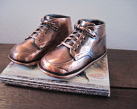 | Ealing Agreed Syllabus: guidance for teachers
 | F4: Precious things | Overall aim: to explore the concept that there are things, times and places that are ‘set apart’ as different, special or sacred.

Special objects | Pupils will | understand that people value and treat certain objects differently than normal; begin to explore the concept of showing respect.
Aim: to develop an awareness of why objects are precious to individuals. | SEN
 | Gifted
Possible activities |  |  | Suggested resources
Prior to the start of this unit, you should ask the children to bring in some object that is special to them that they would be willing to share with the class. You should also bring in something that you are willing to show/share.
Starter: Show the children an object that is special to you. Explain why it is special, and how you treat it differently from other objects. If there is one, tell a story about the object that might explain why you consider it special.
Activity 1: Talk about how people often have certain clothes that they only wear at special times. For example, a wedding dress. Or clothes that they might wear to a place of worship, their ‘best’ clothes, sometimes known as “Sunday best” because these are the clothes people would wear to church on Sunday.
Activity 2: Give children a chance to talk about their special object. Create a temporary ‘precious things’ display table and let the children put their objects on display for the day (these should be taken home at the end of the day so they don’t go missing). They can draw a picture of their precious object, making the picture itself ‘special’ with appropriate decoration with glitter pens. This picture can go on the display table at the end of the day as a stand-in for the actual object. |  |  | Paper and drawing implements; glitter pens.
Plenary: Talk about the importance of learning to show respect with the example of how you might feel if someone made fun of or damaged your special object. What are different ways people can show respect? Demonstrate with different objects, e.g. putting a protective cover on a treasured book.

My precious | Pupils will | develop vocabulary relating to objects set apart as special; explore their own feelings in relation to these objects.
Aim: to explore the feelings associated with—and language used around—special objects. | SEN
 | Gifted
Possible activities |  |  | Suggested resources
Starter: Reminding pupils of the previous lesson ask them to imagine how they would feel if they had lost their precious object.
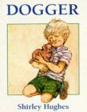Activity 1: Read Dogger by Shirley Hughes. Discuss why Dave felt so sad. (Dogger is the story of how Dave’s beloved toy Dogger was lost and found. Winner of the 1977 Kate Greenaway Medal, it shows—in simple words and detailed pictures—the distress the loss of a toy causes a child.) |  |  | Dogger  Shirley Hughes  Red Fox Publishing,  ISBN: 009992790X  http://www.amazon.co.uk/
Activity 2: Use hot seating to explore how Dave might feel about losing his precious toy. For example, model yourself or choose a child to be Dave for the Dogger story. Encourage children to ask ‘Dave’ why he looks so sad, with the person in the hot seat responding in role as Dave would to the questions posed by their peers. Questions could include the following:  - What will you do if you can’t find Dogger?  - Why do you like Dogger so much?  - What is Dogger like? |  |  | Hot seating is a role play activity in which an individual takes on another persona so that, when their peers ask them questions, they can explore how that person might feel and react.  http://www.teachprimary.com/learning_resources/view/primary-resource-hotseating-in-drama
Activity 3: Identify key words for the children to learn and ask them to write them down as labels for pictures of precious objects.
Plenary: Ask class to name an object in their home that is precious to the entire family. Why is this object special?

Objects and belief | Pupils will | learn that some objects are held in high regard by different groups and that these objects symbolise a belief that the group considers important.
Aim: to explore the relationship between special objects and belief | SEN
 | Gifted
Possible activities |  |  | Suggested resources
Note: Try to avoid the use of the word ‘artefact’ to describe these objects. Although commonly used when referring to religious objects, the word is used in archaeology and anthropology to reference objects used by past civilisations and ‘exotic’ cultures.
Starter: Introduce objects from a variety of belief traditions to the children (see examples under resources). Let them both look and touch, being sure to model a respectful way of handling the objects. |  |  | Prayer mat (Islam)  Puja plate (Hinduism)  Cross (Christianity)  Mezuzah (Judaism)  Kangha (Sikhism)  Library card (Humanism)  Packs of religious objects available from:  http://www.articlesoffaith.co.uk/  Religious Articles: Objects Used in Worship, Anita Ganeri,  Library Binding. Steck-Vaughn, ISBN 0739827596  Religious Buildings (Ganeri, Anita, What's Special to Me?)  Anita Ganeri, Raintree,  ISBN 0739827618
Activity 1: Ask the children to volunteer their knowledge or ideas about how each object is used before giving them an explanation.
Activity 2: Go through each item in turn, looking at it in a ‘secular’ sense and in a ‘sacred’ sense. For instance, a prayer mat is very like a little rug, but in Islam it is used to prepare a place for prayer. It also usually has a symbolic image on it, e.g. a niche. The puja plate is a plate, and even the little dishes on the plate are similar to dishes you see on a food thali, but the items on the plate are ‘special’ to Hindus because they are used in worship. The Mezuzah, which holds a piece of scripture, and is touched with reverence by Jewish people might be compared to other inscriptions seen in public places or in the home (e.g. Home Sweet Home cross-stitches).
Activity 3: Show the library card. Do any of the children ever visit a library with their family? Point out that anyone can have a library card, but that people who call themselves Humanists might consider a library card symbolic of their beliefs and values because they value learning and the development of the ability to think deeply about things. They don’t believe in a god or in a life after death, but they believe that it is important to live a good life and to contribute something to humanity. This is why they value education.
Plenary: Revisit the cross. Remind children that a cross is precious to Christians because it reminds them of the sacrifice that Jesus made. Ask them to draw something that reminds them of something that is precious to them.

‘How to’ | Pupils will | observe believers demonstrating how they would use certain objects; have the opportunity to ask believers about these objects.
Aim: To learn how certain objects are used in religious settings. | SEN
 | Gifted
Possible activities |  |  | Suggested resources
Starter: Select an object in the classroom that is regularly used in a school- or classroom-specific context. If this is something the teacher uses, demonstrate its use, then ask class what it means when they see/hear this object being used. Is there another way this object could be used outside the classroom?
Main activity: Ask a Hindu parent or member of staff to demonstrate the use of the diya during puja. Have them explain to the children what the actions symbolise. If appropriate, allow some pupils to role-play these actions.  Repeat this with other relevant objects, drawing on the expertise available in the classroom or school. Ask those demonstrating these actions how they feel performing the rituals. Do their feelings change depending on the setting? |  |  | Objects from previous lesson.
Plenary: Allow children to ask questions about the use of the objects. They should be encouraged to ask whatever they want, because by asking questions the ‘strange’ can become less daunting. You could also have a discussion about how you can ask questions in a respectful manner.

Ask the believer | Pupils will | have an opportunity to ask a visitor questions about their beliefs or practices; start to learn that asking questions is the first step towards having ideas.
Aim: to encourage the ability to ask questions about belief. | SEN
 | Gifted
Possible activities |  |  | Suggested resources
Starter: Before the visitor arrives, remind children of things they have learned and experienced during the unit. Tell them they should pay attention to what their visitor says, and to think of questions they want to ask. You might also suggest they pay attention to the way the visitor is dressed, or if they are wearing any special items, such as religious jewellery or a special pin or headwear. |  |  | A suitable visitor should be asked to bring at least two relevant objects with them, one a religious article the use of which they can demonstrate to the class, the other a personally important object that they are willing to share.
Activity 1: Introduce your visitor and invite class to say whether they think the person is Christian, Jewish, Hindu etc. Ask them to explain why they suggested that answer. Allow them to ask questions to get more information.
Activity 2: Ask the visitor to demonstrate some ritual action that involves the use of a special object. For instance a Sikh man who wears a turban might show children his long hair and explain how the ritual kangha is used to keep his hair tidy.
Activity 3: Allow the visitor to talk about their beliefs and how their special object reminds them of these beliefs.
Plenary: End the visit with asking the visitor to show the class another object that they consider very precious, but one that is personally precious to them. Do they feel differently about these two objects? Allow children to ask more questions, keeping a record of the most innovative questions, in order to reinforce the importance of asking questions for learning.

Make a mezuzah | Pupils will | explore a ritual related to an object considered sacred by Jews; consider the ritual in a context relevant to them.
Aim: to explore rituals associated with special objects. | SEN
 | Gifted
Possible activities |  |  | Suggested resources
Before this lesson ask children to bring in an empty matchbox or an empty Smarties tube. Have several spares in case children have forgotten,
Starter: Ask children to think of a promise that it is very important to keep. Something that they feel would make them a better person. Ask them to draw something on a piece of paper that reminds them of that promise.
Activity 1: Show class images of mezuzahs, as well as a short video of how to affix a mezuzah and how Jews touch it when they enter their home. Explain that the mezuzah contains a passage from the Jewish holy book considered to sum up their religion. It is considered so important it is used to ‘bless’ the house of a Jewish person or family. |  |  | YouTube has some animated videos about mezuzahs.
Activity 2: Remind class of the special objects they brought for the first lesson, and of the drawings of the objects that are still in the classroom. Hand out pieces of paper of appropriate size to fit the handmade mezuzahs, and ask them to make a sketch of their special object.
Activity 3: Let the children decorate their mezuzahs, whether empty Smartie tubes, matchboxes or similar container. Then children to put both sketches in their mezuzah, i.e. the sketch of their precious object, and the sketch that is a reminder of the promise they would like to keep.
Plenary: Remind class of all the things they’ve looked at and treated with respect. Ask each class to put their mezuzah on the table (where they had their precious objects in the first lesson) in a solemn manner. If they want they can kiss their fingers and touch the object as done in the video. Talk about why doing this is a sign of love and respect.

Key words | Precious, prayer mat, (Islam), puja tray, (Hinduism), cross, (Christianity), mezuzah, (Judaism), kangha, (comb) and kesh (uncut hair) (Sikhism), respect.
Points to note | - A mezuzah is placed in the right of every doorway in a Jewish home, except the bathroom.  - Not all Sikhs have uncut hair—only members of the Khalsa are prohibited from cutting their hair.  - There are many types of cross used by different Christian denominations.  - Selecting objects from the religions most commonly represented in your school will provide children with a clearer understanding of the daily lives of believers they are likely to meet.

Expected outcomes
At the end of this unit pupils are working at emerging levels if:
- they are able to name one religious object.
- They are able to talk about an object that is special to them.

At the end of this unit pupils are working at expected levels if:
- they know that religious believers have special objects.
- they can identify some of these.
- they understand and can explain why an object is special to religious believers.

At the end of this unit pupils are exceeding expected levels if:

- they understand the link between certain objects and belonging to a religion.
- they understand why some objects are special in relation to themselves and others.

Background information
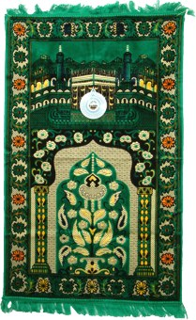  Prayer mat | Information about religious objects  The Hindu home shrine:  http://credo.ysgolccc.org.uk/arteffactau/puja.htm  Muslim religious objects:  http://www.cleo.net.uk/consultants_resources/religiouseduc/usingartefacts/islam.html  Hindu religious objects:  http://www.ngfl-cymru.org.uk/vtc/ngfl/re/m_parry_carmarthenshire/arteffactau/contents%20Hindw.htm  Jewish religious objects:  http://www.cleo.net.uk/consultants_resources/religiouseduc/usingartefacts/jewish.html  Christian religious objects:  http://www.cleo.net.uk/consultants_resources/religiouseduc/usingartefacts/christian.html
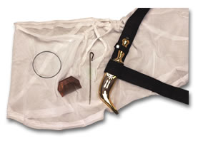  panj kakke | Sikh signs of belonging  The panj kakke, five Ks: uncut hair (kesh), comb (kangha), bracelet (kara), sword (kirpan) short trousers (kachera).  The BBC schools website has a worksheet for learning the 5Ks: http://www.bbc.co.uk/schools/religion/worksheets/sikhism_baisakhi_5ks.shtml
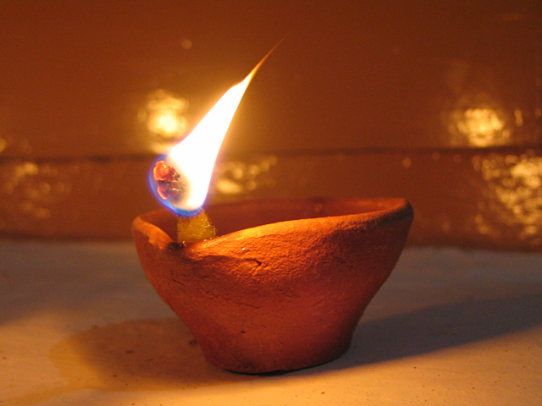  Diya | Also known as deepak or deep, a diya is a small lamp. At times made of metal or pottery, diyas are traditionally made of baked clay.  How to make a diya (uses tealights):  http://kidworldcitizen.org/2011/11/25/make-a-diya-for-diwali/
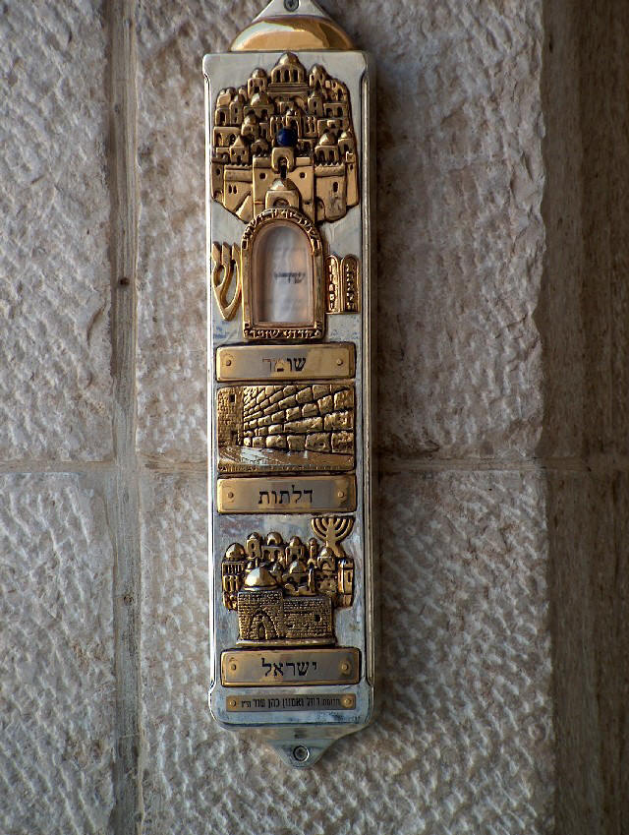  Mezuzah on Dung Gate, Jerusalem | Hear, O Israel: The LORD our God, the LORD is one. Love the LORD your God with all your heart and with all your soul and with all your strength. These commandments that I give you today are to be upon your hearts. Impress them on your children. Talk about them when you sit at home and when you walk along the road, when you lie down and when you get up. Tie them as symbols on your hands and bind them on your foreheads. Write them on the doorframes of your houses and on your gates. (Deuteronomy 6: 4-9)  The Hebrew word for doorpost (mezuzah, plural mezuzot) also came to mean the encased parchment scroll inscribed with verses from the biblical book of Deuteronomy that is affixed to gates and right-hand doorjambs of Jewish homes. The mitzvah (commandment) to place mezuzot on the doorposts is derived from the above passage, commonly known as the Shema (‘Hear’, from the first word of the passage). The Shema (Deuteronomy 6: 4-9) is written on a tiny scroll of parchment, along with the words of a companion passage, (Deuteronomy 11:13-21).  The scroll must be handwritten in a special style of writing and must be placed in the case to fulfil the mitzvah. The case and scroll are then nailed or affixed to the right side doorpost during a ceremony called Chanukkat Ha-Bayit (‘dedication of the house’). Each time a believer passes through a door with a mezuzah on it, they touch it and then kiss their fingers as an expression of love and respect for God and his commandments.  Website with instructions for making a mezuzah out of a matchbox: http://www.kveller.com/article/make-a-mezuzah/  Instructions for making a mezuzah out of empty Smarties tube: http://www.jewishmuseum.org.uk/domains/jewishmuseum.org.uk/local/media/downloads/How_To_Make_Your_Own_Mezuzah___Jewish_Museum.pdf

