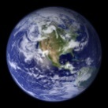 | Ealing Agreed Syllabus: guidance for teachers
 | KS1_6: Caring for our world | Overall aim: to introduce the concept of stewardship through exploring beliefs about the natural world.

The world around us | Pupils will | reflect on—and respond to—their surroundings, both natural and human-made.
Aim: to explore how we define the ‘natural world’. | SEN
 | Gifted
Possible activities |  |  | Suggested resources
Starter: Brainstorm around the words ‘nature’, ‘natural’, ‘environment’ and ‘world’. Allow the children to look out the window and draw anything that they think is part of ‘nature’. |  |  | The school and class environment.  Materials for mind maps.
Activity 1: As a class, look out the window and distinguish between living things and things made by humans. Look at the word ‘environment’. What do pupils think when they hear that word? Is a nearby tree part of the environment? What about a nearby school building? Discuss the fact that many people think only of ‘nature’ when they hear the word ‘environment’, but that it also can mean our ‘surroundings’. So looking after the environment can mean looking after the classroom.
Activity 2: Take a walk outside, and ask children to remember their feelings about things they see, smell and hear. Once inside get children to share their observations with a classmate.
Activity 3: Allow children to create a mind map/spider diagram with the words “My world” in the centre. What is the focus of their world? Do they think of their home as the focus? The classroom? Themselves?
Plenary: On the IWB do the same, using “Our World” as the focus. Let all of the children make suggestions as to what they consider important aspects of “Our world”.

Life-cycles | Pupils will | learn about some aspects of growth, development, and caring for young life.
Aim: to explore the concept of stages of growth. | SEN
 | Gifted
Possible activities |  |  | Suggested resources
Starter: Show class some pictures or videos of animal and human parents with their offspring. What is a common factor of these images? |  |  | Ten most amazing animal dads: https://www.youtube.com/watch?v=FOrvbE06Mps  Ten most amazing animal mothers:  https://www.youtube.com/watch?v=5NKFQvxap3s  Mother bird tries to teach baby to fly: https://www.youtube.com/watch?v=OEVqunue1gA  Time lapse tomato plant growth: https://www.youtube.com/watch?v=LICDb8nM5rs
Activity 1: Have an open discussion about welcoming a new life. How many children remember their parents bringing home a new baby? How many remember having a young pet, like a kitten or a puppy? Can these newly born siblings or animals look after themselves? Why not?
Activity 2: Talk about some significant moments in growth and development. For instance a welcoming ceremony or infant baptism. A toddler’s first steps. A young bird being encouraged to fly by its parents.
Activity 3: Ask class to share how they felt the first time they went to school? Was it scary? If so, why? Why do they think we need to go to school? Were there any rituals around their first day of school?
Activity 4: Show a time-lapse video of a plant growing and bearing fruit (e.g. a tomato plant). Sketch out a story board of the various stages starting with a seed.
Plenary: Pass out a sheet of paper with four panels (can be arranged 2 x2 or 1 x 4). Get class to use their imagination to depict four stages in their own lives. Obviously they will be imagining the future stages, but let them be as imaginative as possible. How would they define the different stages? What kind of help might they need at each stage? When do they think they might start helping others?

The ‘spark’ | Pupils will | learn about the Hindu ‘namaste’ greeting; think about their own responses to the ‘spark’ of life.
Aim: to explore how we respond to what is perceived as the divine ‘spark’. | SEN
 | Gifted
Possible activities |  |  | Suggested resources
Starter: Show class a video of a group of animals responding to the appearance of a new born in their midst, e.g. the video of the elephant family greeting a new born calf. Have the pupils ever experienced something like this in a different context? Ask for shares. |  |  | Elephant family rushes to welcome newborn calf:  https://www.youtube.com/watch?v=toQFhdeTwCM  Going Green: https://www.youtube.com/watch?v=8DJ45Yc3urg
Activity 1: If there are children in the class from a Hindu family, or if there is a Hindu member of staff, ask them to demonstrate the Namaste greeting. Explain that the greeting is a way of saying “I recognise the ‘divine’ in you.”
Activity 2: Show pictures of fresh green grass, or vivid green leaf buds on trees in spring. Talk about how the colour green makes people think of hope and new beginnings.
Activity 3: Play the Earth Day song “Going Green”. Explain how some people call working to save the environment from bad things happening to it as “going green”. Talk about how doing simple things like recycling could be a form of ‘namaste’. That is, by picking up a piece of rubbish and throwing it away in the proper place, or recycling it if it is something that can be recycled is a way of saying I value my environment: I see the ‘spark’ and I want to honour and protect it.
Plenary: On the IWB write down a list of things that could be a way of saying Namaste. What are other ways that the class can show that they ‘honour the spark’? Perhaps they can decide on one thing that will be their way of saying Namaste.

Origin stories | Pupils will | hear stories about the beginning of the world from both religious and scientific perspectives; they will think about how they imagine the world to have come into being.
Aim: to look at some stories told about the origin of the world. | SEN
 | Gifted
Possible activities |  |  | Suggested resources
Starter: Play the interactive, illustrated version of the Genesis story (see link right), being sure to point out that this story is told in the Jewish and Christian holy books. Add that people from other traditions with a belief in a god share the belief that God (or gods) created our world. |  |  | For an interactive, illustrated version of the Genesis story see:  http://kids4truth.com/Dyna/Creation/English.aspx  Animated video explaining Big Bang theory:  https://www.youtube.com/watch?v=wNDGgL73ihY  From the Big Bang to me (suitable for all ages):  https://www.youtube.com/watch?v=nYkdDniQJyw  http://www.indigenouspeople.net/legend.htm
Activity 1: Show an animated version of the Big Bang theory, explaining that this is the way scientists think the world came into being based on the results of their studies and experiments.
Activity 2: Read another creation/origin story from a different culture or faith, e.g. the story of Tiddalik from New Zealand (see background information). You could role play this version.
Activity 3: As an open discussion, ask children why they think there are different stories about the origin of the world. Make sure that they understand that you aren’t looking for one ‘true’ answer. If someone volunteers an opinion, ask if anyone has another opinion or idea, making it clear that it is fine to have different ideas about things.
Activity 4: Go back to the Genesis version, in particular the part where God gives dominion over the land and animals to humans. Could this mean that the story is told so that humans will learn to look after their environment? Point out that even though there are many people who don’t believe in a god, these people can also believe that it is very important to look after the environment. That this is an ideal that is shared by many religious and non-religious people alike.
Plenary: As a class, try to agree on one way that we can care for the environment. Make this the class “green pledge.”

Caring for our planet | Pupils will | learn about the work of environmental charities; understand that both religious and secular organisations work to protect the Earth and its inhabitants.
Aim: to explore the idea of ‘charity’ as it applies to the environment. | SEN
 | Gifted
Possible activities |  |  | Suggested resources
Starter: Use posters, leaflets, websites and simple materials from charities and other organisations so pupils see what work is being done to protect the environment and care for life in different parts of the world. |  |  | www.wateraid.org  www.oxfam.org/en/  http://www.christian-aid.org.uk/  www.wwf.org.uk  David Sheldrick Wildlife Trust (saving orphan animals):  https://www.sheldrickwildlifetrust.org/asp/orphans.asp  https://www.youtube.com/user/dswtkenya  Saving UK hedgehogs: http://www.wildlifeaid.org.uk/savingharry?gclid=CNnn1ZCpjckCFYIcGwod99kDfA
Activity 1: Watch some of the videos on the David Sheldrick Wildlife Trust YouTube channel about the trust’s work with orphaned African animals.
Activity 2: Ask if any of the pupils have ever seen a hedgehog. Play the video “Saving Harry” on the Wildlife Aid UK website (see link right). Explain that while the orphaned animals (elephants, rhinos, giraffes) saved by the DSWT are very cute and worthy of being saved, there are also animals closer to home that are in danger, such as the hedgehog.
Activity 3: As a class pick a charity that they would like to support. They can invent one if they like. Give pupils a strip of thin card and ask them to make a wristband with an appropriate slogan that defines the work being done by this charity; alternatively give them a sticker to draw a design. Ask them to write simple messages of support or prayers on behalf of the object of the charity. These could be posted in a special box or put in a class reflective corner.
Plenary: Have an open discussion about the inspiration for their chosen charity. Are their reasons religious, scientific or personal? Does it matter what the reason is if the children can all work together for a common goal?

Key words | Creation, mind map, life cycle, environment, stewardship, charity
Points to note | When discussing creation stories it is important to remind children of the previous lessons they have had on learning from stories, especially with children with EAL or SEN.

Expected outcomes
Pupils are working at emerging levels if they can:
- describe ways in which they could look after their environment.
- retell a story about the creation of the world and talk about it.
- name something about their surrounds that they find beautiful or of interest.

Pupils are working at expected levels if they:
- understand that there is a need to protect and care for the world.
- know that religions have stories about the creation of the world.
- can talk or write about the beauty and complexity of the world.

Pupils are exceeding expectations if, in addition to all of the above, they:
- can give examples of dangers to the environment.
- are starting to understand the concept of stewardship.
- can state one difference between religious stories of creation and the scientific theory of the big bang.

Background information
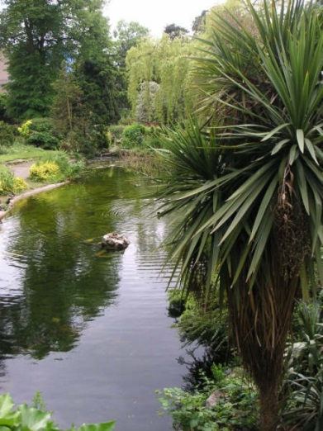 | Information about the work of Ealing’s park rangers: http://www.ealing.gov.uk/info/200073/parks_and_open_spaces/639/park_rangers  Information about Brent Lodge Animal Centre in Hanwell:  http://www.ealing.gov.uk/info/200073/parks_and_open_spaces/628/animal_centre  Nature conservation in Ealing: http://www.ealing.gov.uk/info/200588/nature_conservation  Left, Walpole park, Ealing | 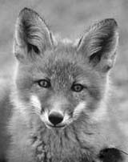  Urban fox
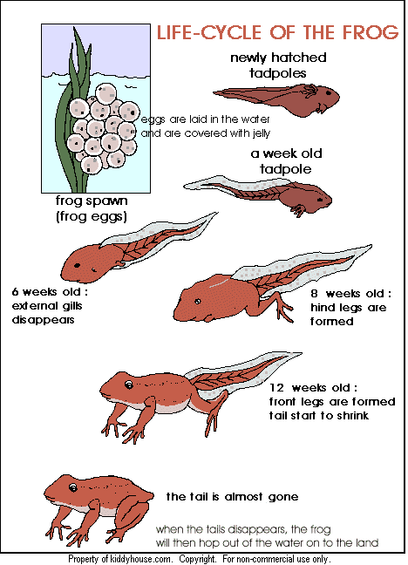 | Resources for ks1 about lifecycles can be found at: http://www.everyschool.co.uk/science-key-stage-1-life-cycles.html  The BBC website has a little interactive programme where children can watch a plant grow—as long as they continue to keep it watered!  http://www.bbc.co.uk/schools/scienceclips/ages/5_6/growing_plants.shtml  Life cycle of a frog (left): http://www.kiddyhouse.com/Themes/frogs/lifecycle.html
Buddhism teaches that all living things are interconnected and that destroying one part of it damages the whole. The creation story in the biblical book of Genesis teaches that the world that God created was very good and that humans are responsible for it. Hinduism focuses on the sacred nature of rivers, mountains, trees and space. Islam teaches that Allah created the world and that all parts of the world are precious. Sikhism emphasises the importance of living simply and without causing harm and giving service to the world. Humanists believe it is important to care for the planet and all living creatures for the sake of future generations and because it is the right thing to do.

http://www.arcworld.org/arc_and_the_faiths.asp
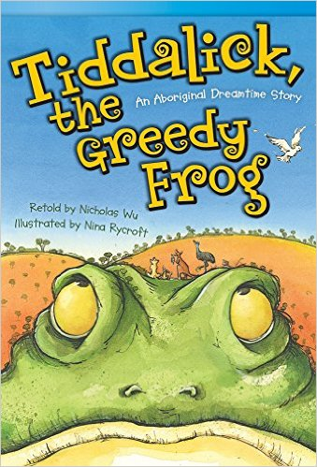 | The aboriginal story of Tiddalik is a myth about a flood. Tiddalik, the largest frog ever known, awoke one morning with an unquestionable thirst. He commenced drinking and drank so much that there was no water left in the whole world. The land began to dry up, the trees shed their leaves and it was clear that if an action were not taken soon, the animals would begin dying. A council was called and searched in vain for a way out, until a wise old wombat suggested that if Tiddalik could be made to laugh, the water would flow from his mouth and they would be saved. Creature after creature tried to amuse the giant frog, but he just blinked his eyes and ignored them. Finally, the eel or a snake began to dance. The shapes he twisted himself into were so comical that Tiddalik shook with laughter. Out gushed the water from his mouth, and flowed off to replenish the earth.  Tiddalik the Greedy Frog, available from:  www.amazon.co.uk

